**Assignment 3**

Ameer Ashraf Louly – G3

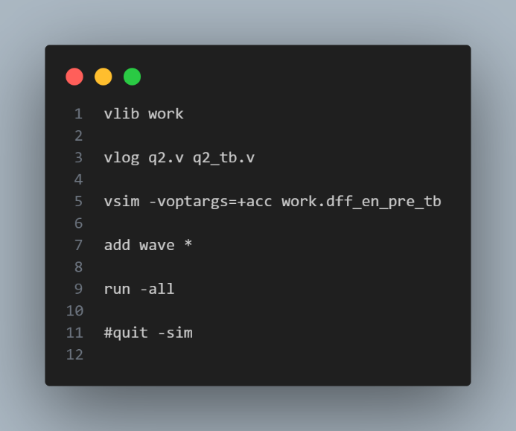Question 1:

Figure TB Code

Figure DO File

Figure 3 Questa Lint

Question 2:

Write a testbench for question 5 part C in assignment 2. Test the parameterized asynchronous FlipFlop using 2 testbenches, testbench 1 that overrides the design with FF_TYPE = “DFF” and the testbench 2 overrides parameter with FF_TYPE = “TFF”.

Figure DFF TB

Figure TFF TB

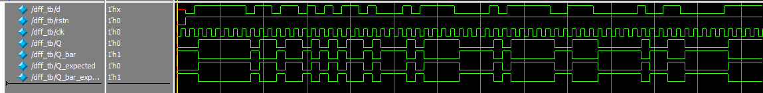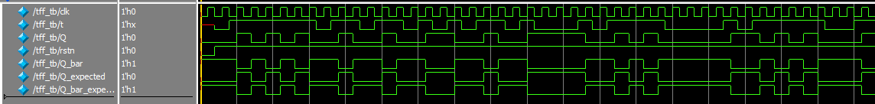Figure DO Files

Question 3:

Implement BCD up counter (MOD 10 counter), where the counter has 10 states. The counter will divide the clock frequency by 10.

Figure BCD Counter Code

Figure TB Code

Figure DO File

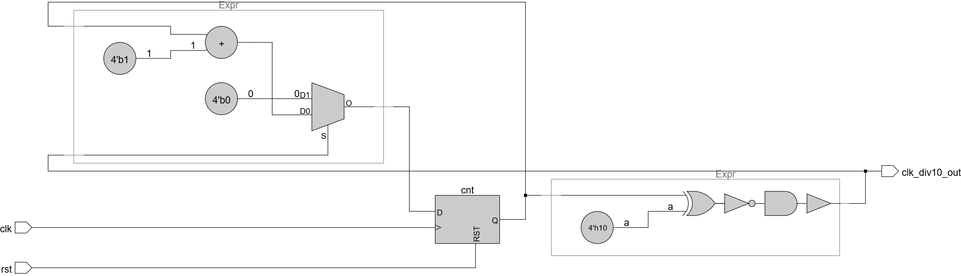

Figure BCD Counter Schematic

Figure Waveform Output

Question 4: Ripple Counter

Figure Ripple Counter Code

Figure Ripple Counter TB

Figure Do File



Figure Waveform

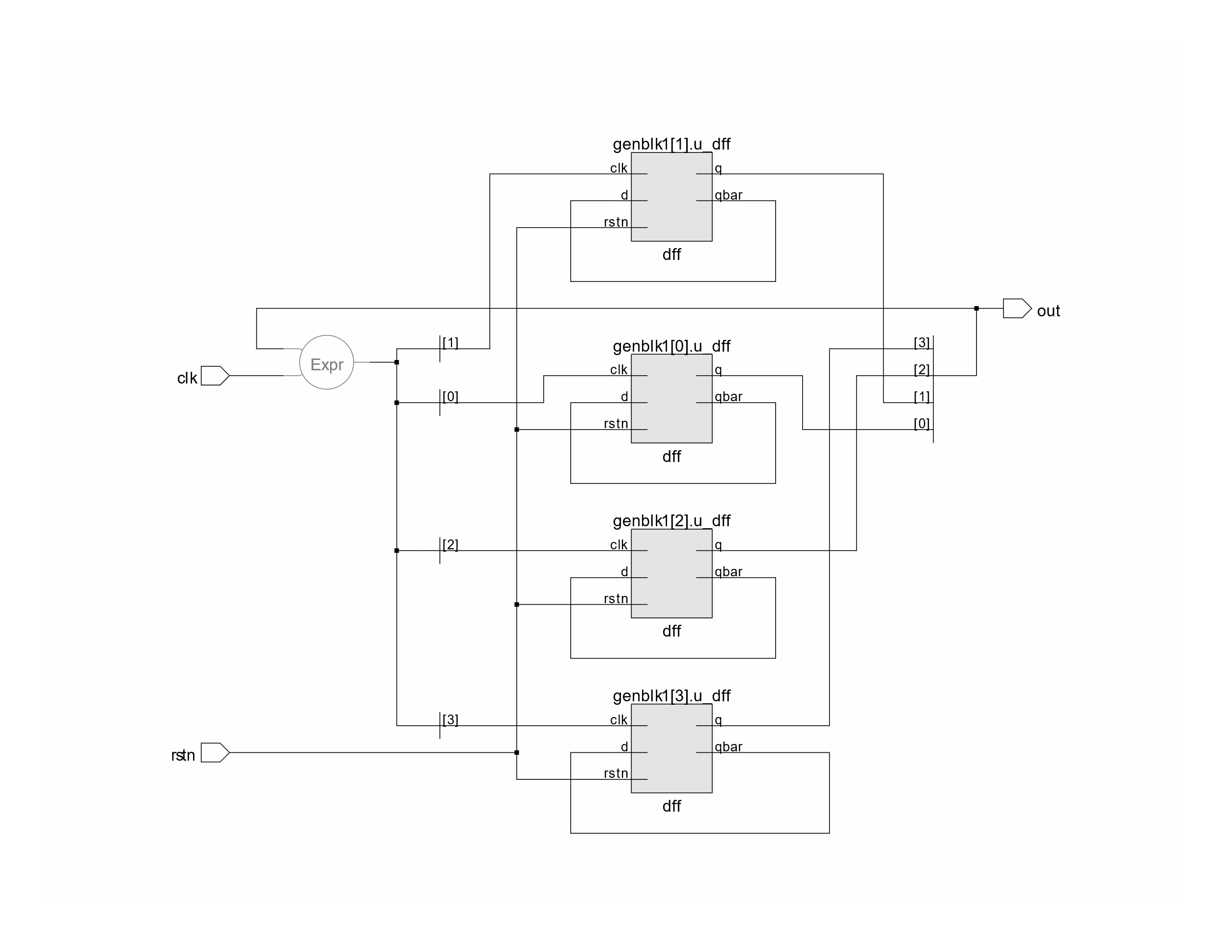

Figure Ripple Counter Schematic

Question 5:

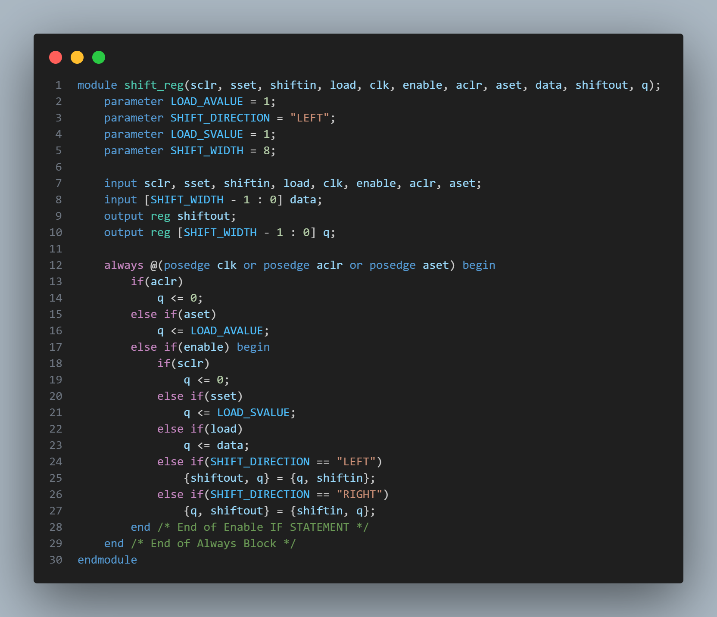

Figure SLE Shift Register Code