**Lab 1**

RC Filter and MOSFET Characteristics

Part 1: RC Filter

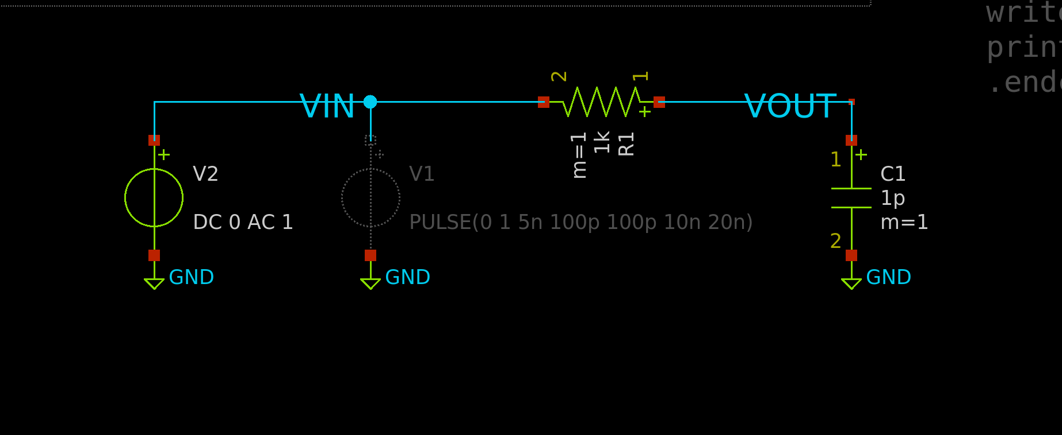

Figure RC Filter Schematic Testbench

1. Transient Analysis:

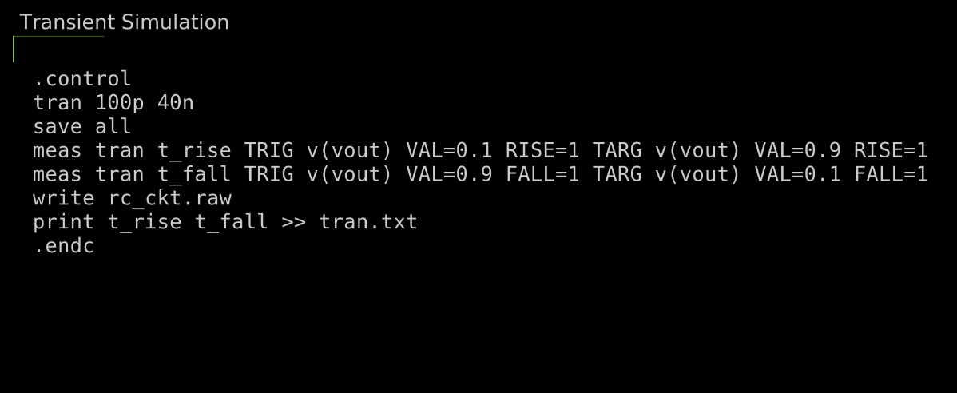

Figure Output Setup

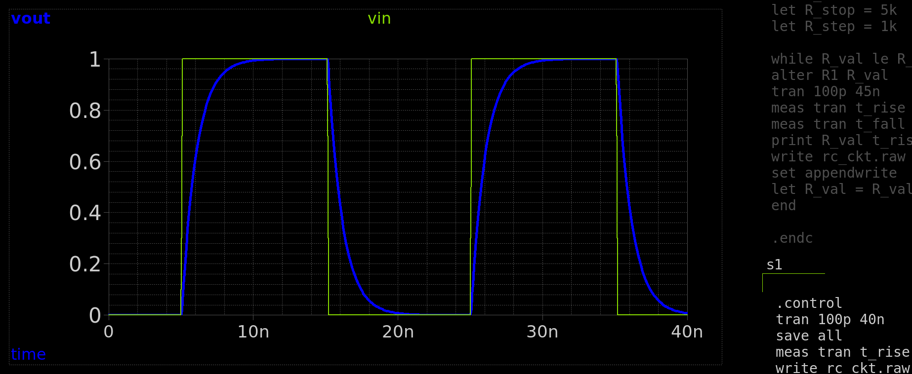

Figure Two Periods of the Filter

Figure Rise and Fall Time simulation Results

**Analytic Calculation for Rise and Fall Time:**

**Charging:**

**Discharging:**

* 1. Rise and Fall Time Comparison:

|  |  |  |  |
| --- | --- | --- | --- |
| **Test** | **Output** | **Simulation** | **Analytic** |
| **ITI_Analog:Lab1_RC:1** | Fall Time | 2.964E-09 | 2.2e-09 |
| **ITI_Analog:Lab1_RC:1** | Rise Time | 2.1955E-09 | 2.2e-09 |

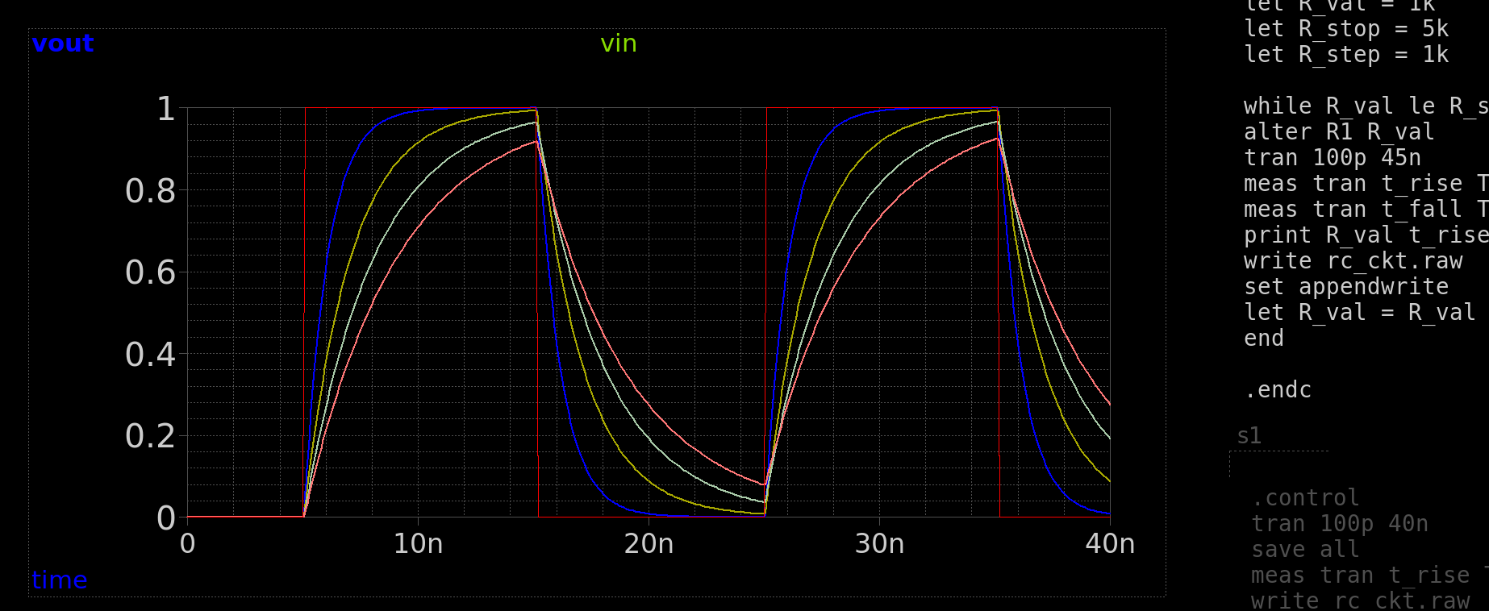1.2 Parametric Sweep:

**Comment:** Increasing the R increases the time constant thus increasing the rise and fall time, making the square wave less pronounced as R increases and the rise and fall times increase.

Figure R Parametric Sweep

1. AC Analysis:

Figure AC Simulation Code

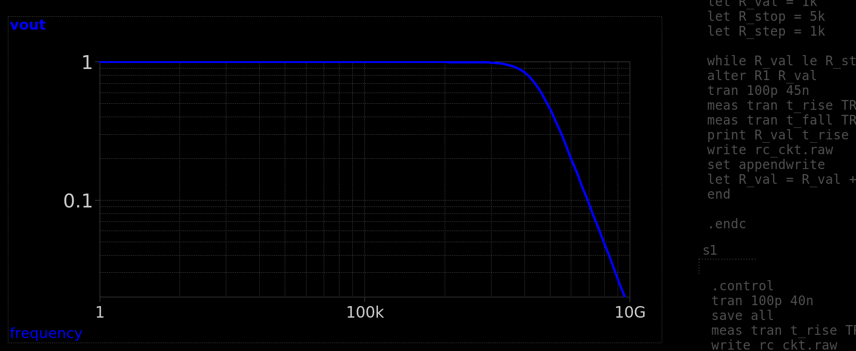

Figure RC Filter Bode Plot (Phase in Degree)

Figure Max gain and BW from SImulation

**Analytic Calculation for DC gain and BW:**

**DC Gain = 1** Cap is O.C in DC, VIN = VOUT

**Bandwidth:**

|  |  |  |  |
| --- | --- | --- | --- |
| **Test** | **Output** | **Simulation** | **Analytic** |
| **ITI_Analog:Lab1_RC:1** | Bandwidth | 159.255MHz | 159.155MHz |
| **ITI_Analog:Lab1_RC:1** | Gain | 1 | 1 |

Parametric Sweep for R = 1, 10, 100, 1000KΩ

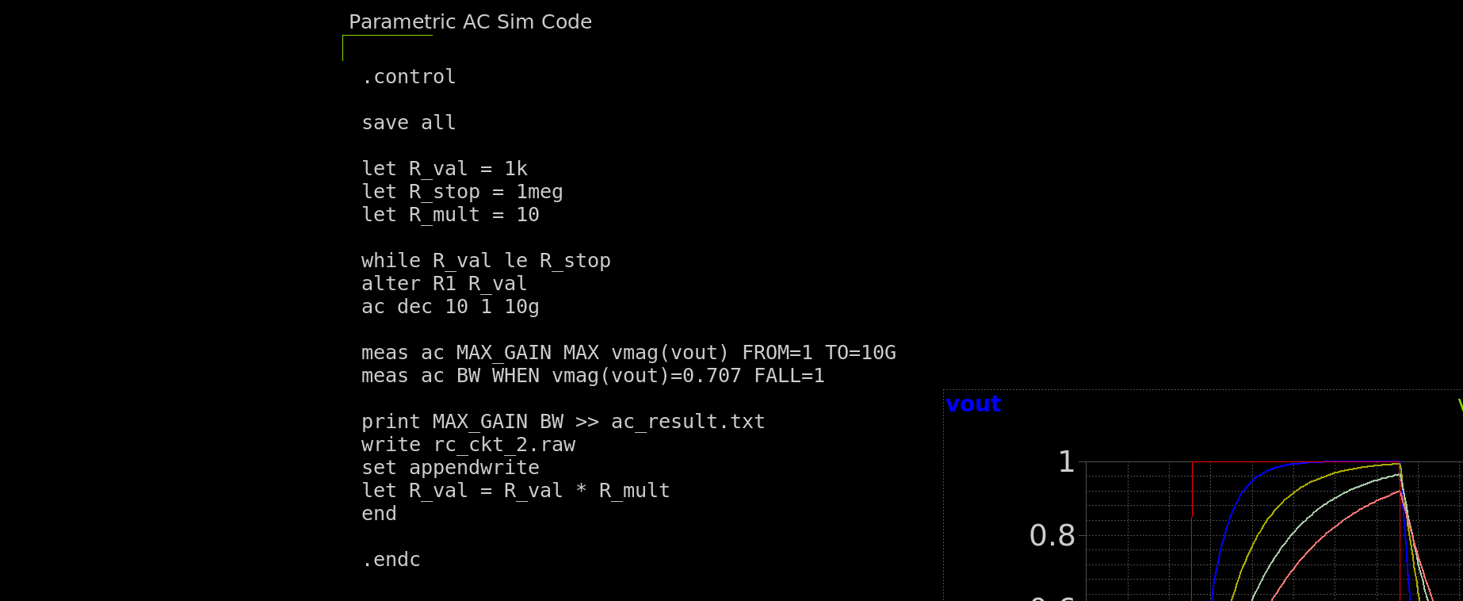

Figure Parametric AC Sweep Code

Figure Parametric AC Sweep Bode Plot (Mag)

Figure Parametric AC Sweep Bode Plot (Phae in Degrees)

**Comment:** Increasing The Resistance gradually increases the Time Constant this lowering the 3dB cut off frequency decreasing the bandwidth and causing a noticeable shift for both Bode Plot graphs.

DC gain is not affected though as it does not depend on the Time Constant rather on the circuit itself.

Part 2: MOSFET Characteristics

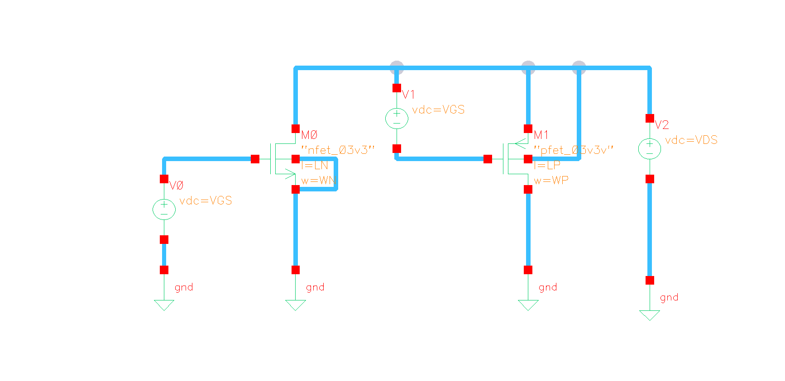

Figure MOSFET Characteristics Schematic Testbench

Using **VDD = 3v,** Short-Channel: **W/L =** **6u/300n,** Long-Channel: **W/L =**  **60u/3u**

1. ID vs VGS

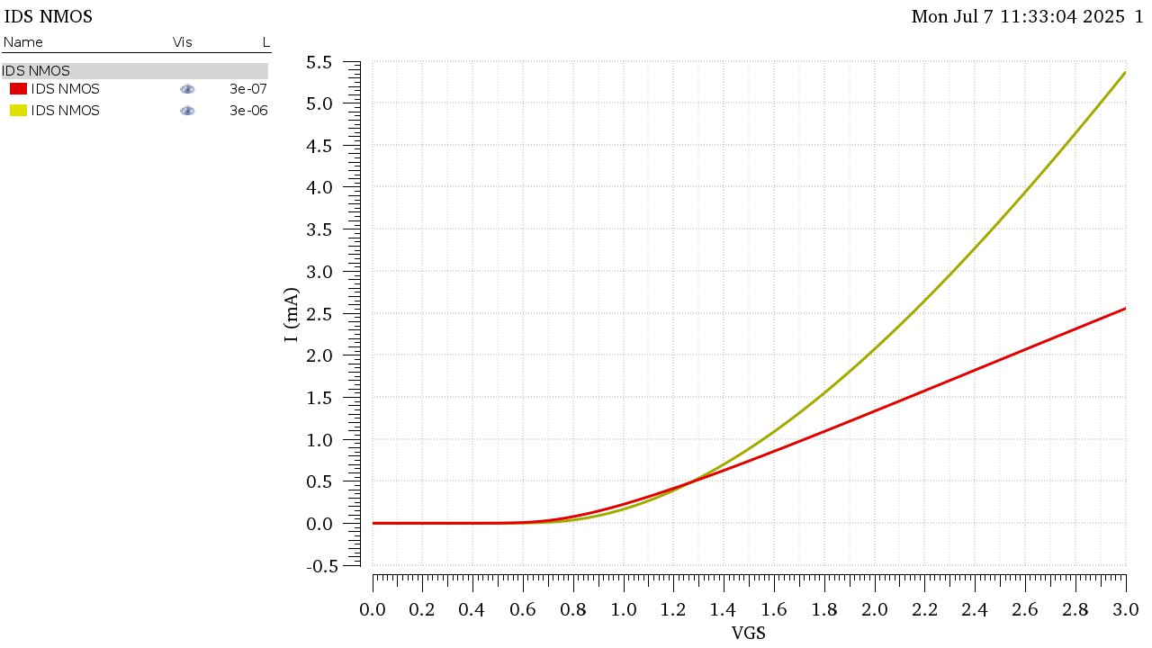

Figure NMOS ID vs VGS, Yellow: Long-Channel, Red: Short-Channel

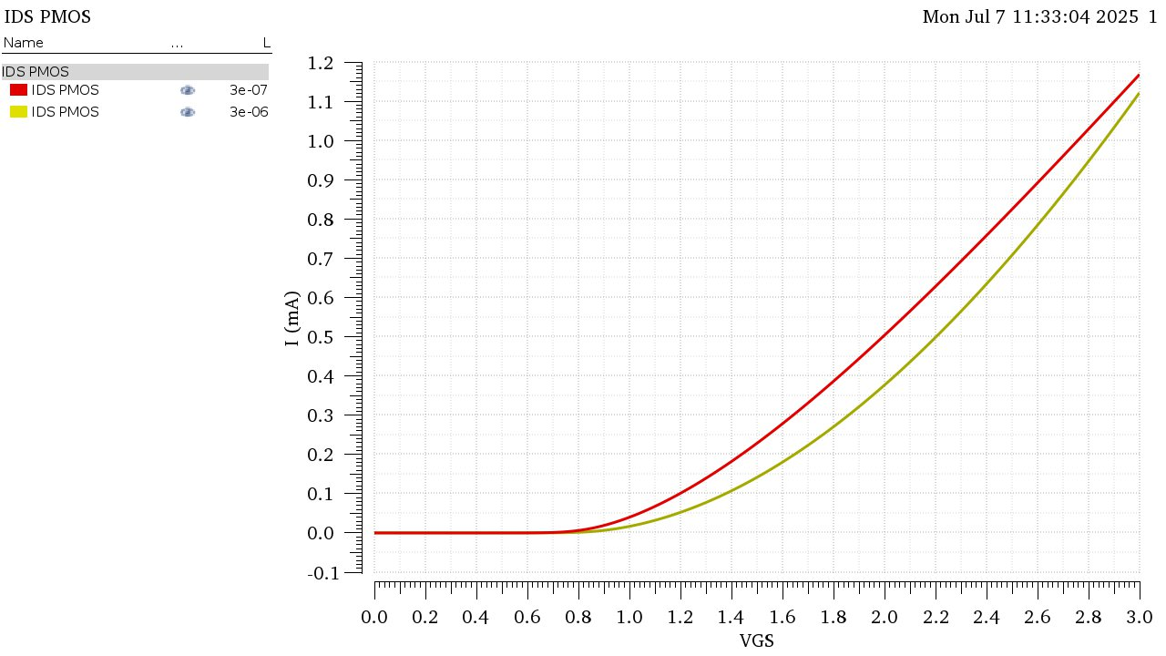

Figure PMOS ID vs VGS, Yellow: Long-Channel, Red: Short-Channel

Comment on the differences between short channel and long channel results.

**• Which one has higher current? Why?**

The Long Channel Device has higher current, due to the lower electric field in the channel allowing carriers to move more freely, While in short-channel the carriers’ velocity saturates limiting the current.

The effect is more noticeable in NMOS devices due to the higher carrier mobility.

**• Is the relation linear or quadratic? Why?**

Long-Channel: Has a quadratic relation as per the square-law Id = K*Vov2/2

Short-Channel: Has a linear relation as per the velocity saturation law.

Comment on the differences between NMOS and PMOS.

**• Which one has higher current? Why?**

NMOS, due to the higher mobility of electrons (Majority Carrier).

**• What is the ratio between NMOS and PMOS currents at VGS = VDD?**

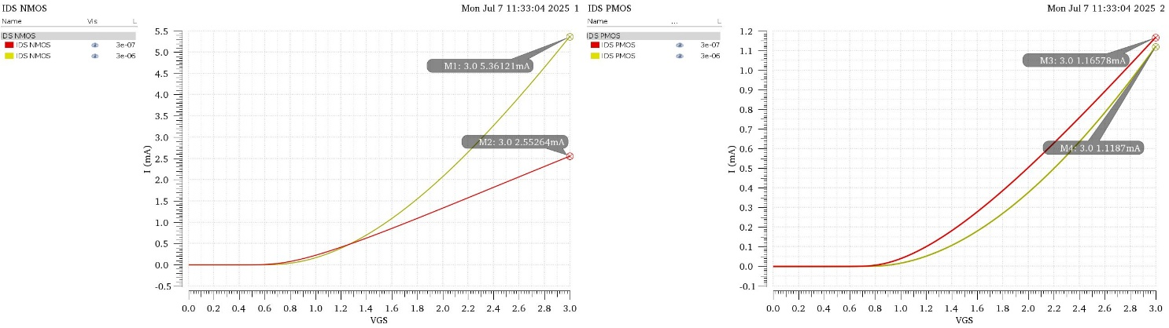

Figure Values of ID at VDD for both NMOS and PMOS

Long-Channel Current Ratio:

Short-Channel Current Ratio:

**• Which one is more affected by short channel effects?**

NMOS is more affected, due to the electrons (NMOS Majority Charge Carrier) having a higher mobility than Holes (PMOS Majority Charge Carrier).

1. gm vs VGS

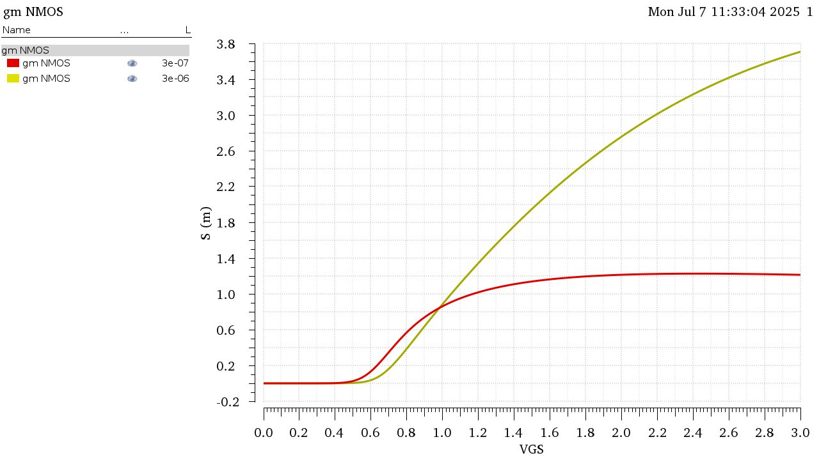

Figure NMOS gm vs VGS, Yellow: Long-Channel, Red: Short-Channel

Comment on the differences between short channel and long channel results.

**• Does 𝑔𝑚 increase linearly? Why?**

As the device turns on when VGS = Vth, gm starts increasing approximately linearly in both short and long channel as gm = k * (Vgs – Vov), but in short channel the linear increase stops early.

**• Does 𝑔𝑚 saturate? Why?**

It Does saturate, as Vov increases past VDSAT, gm starts to saturate, its value can be evaluated via

1. IDS vs VDS

Sweeping over: **VDS = 0:10m:VDD**, and **VGS = 0:0.2:VDD**

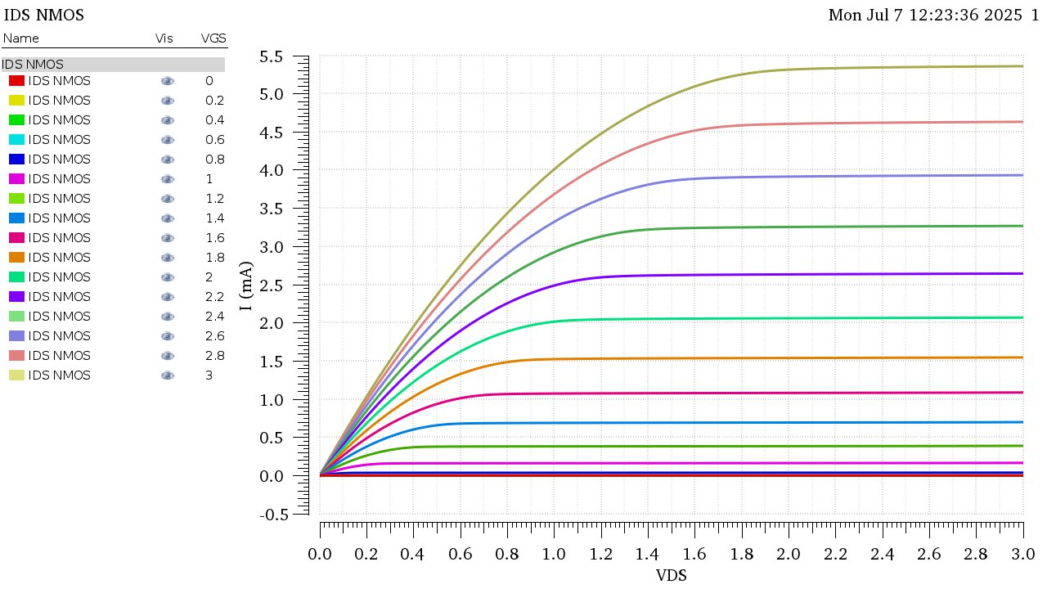

Figure NMOS IDS vs VDS - Long Channel

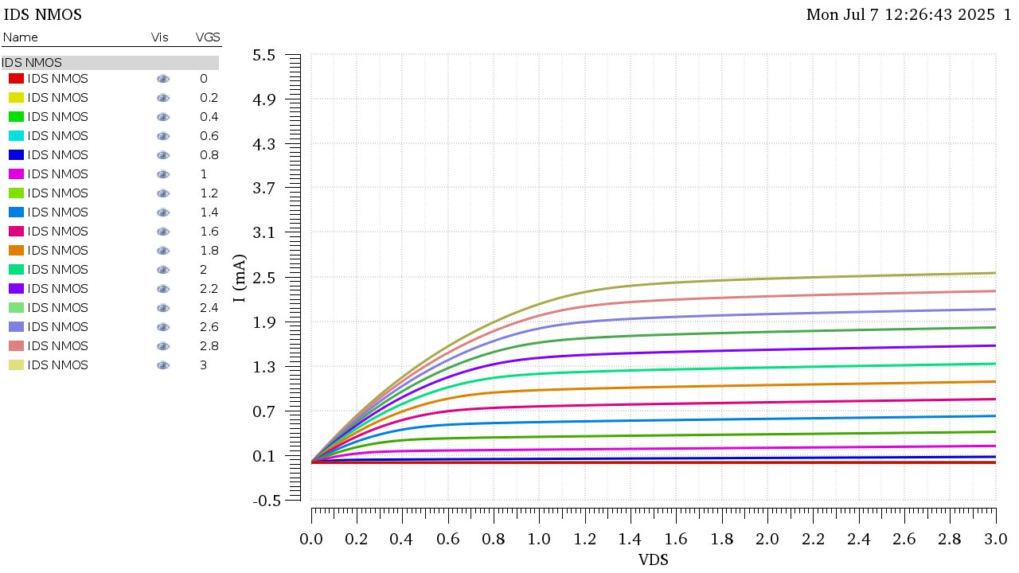

Figure NMOS IDS vs VDS - Short Channel

Comment on the differences between short channel and long channel results.

**• Which one has higher current? Why?**

Long-Channel has noticeably higher current, This is due to it operating in Pinch-Off saturation which has a quadratic relation for the current as opposed to the Short-Channel NMOS which operate in Velocity Saturation which has a linear relation for the current.

**• Which one has higher slope in the saturation region? Why?**

Short-Channel has a higher slope in the saturation region, Due to the effect of ro.

As the length of the channel decreases the resistance between the drain and source decreases and becomes more noticeable in the short channel device.

But in the long channel device this resistance is very large, approximately infinite. resulting in no slope appearing in the saturation region.