**Lab 3**

Cascode Amplifier

Part 1: Sizing Chart

Required Spec:

|  |  |
| --- | --- |
| 𝑨 𝒗 = 𝒈𝒎𝒓𝒐 | 50 |
| 𝒈𝒎/𝑰𝑫 | 10 𝑆/𝐴 |
| Supply (𝑽𝑫𝑫) | 1.8 𝑉 |
| Quiescent (DC) output voltage | 𝑉𝐷𝐷/2 = 0.9 𝑉 |
| Bias Current | 20 uA |

Analytic Calculations:

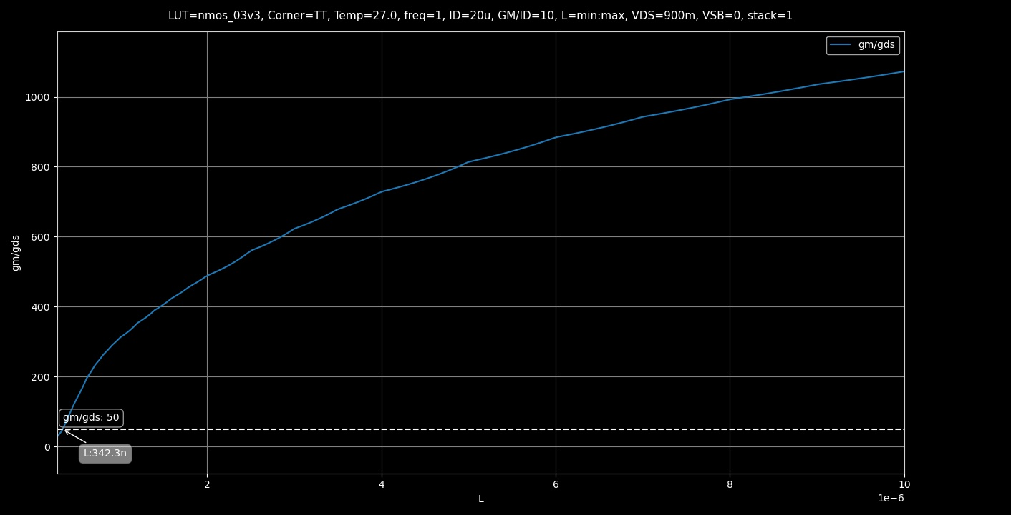

Figure gm/gds vs L

Figure Remaining Parameters @ L = 350nm

**6) W using SA:**

**7)**

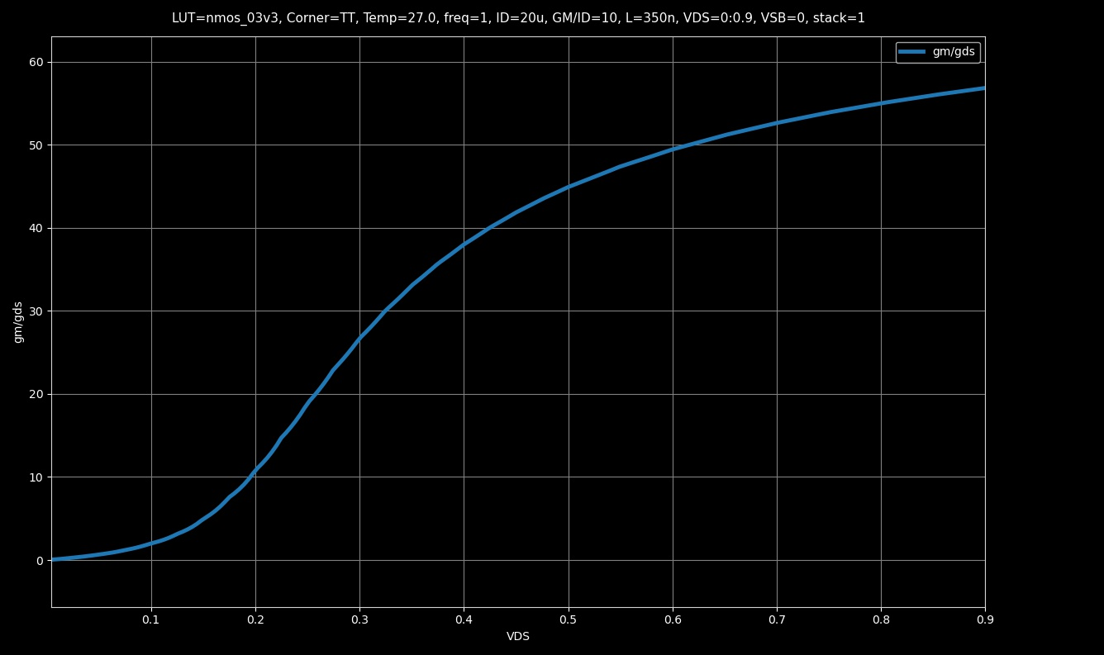

Figure gm/gds vs VDS Graph

**8) gm/gds will be slightly lower approximately equal to 41.83**

Figure Expected gm/gds

Part 2: Cascode for Gain

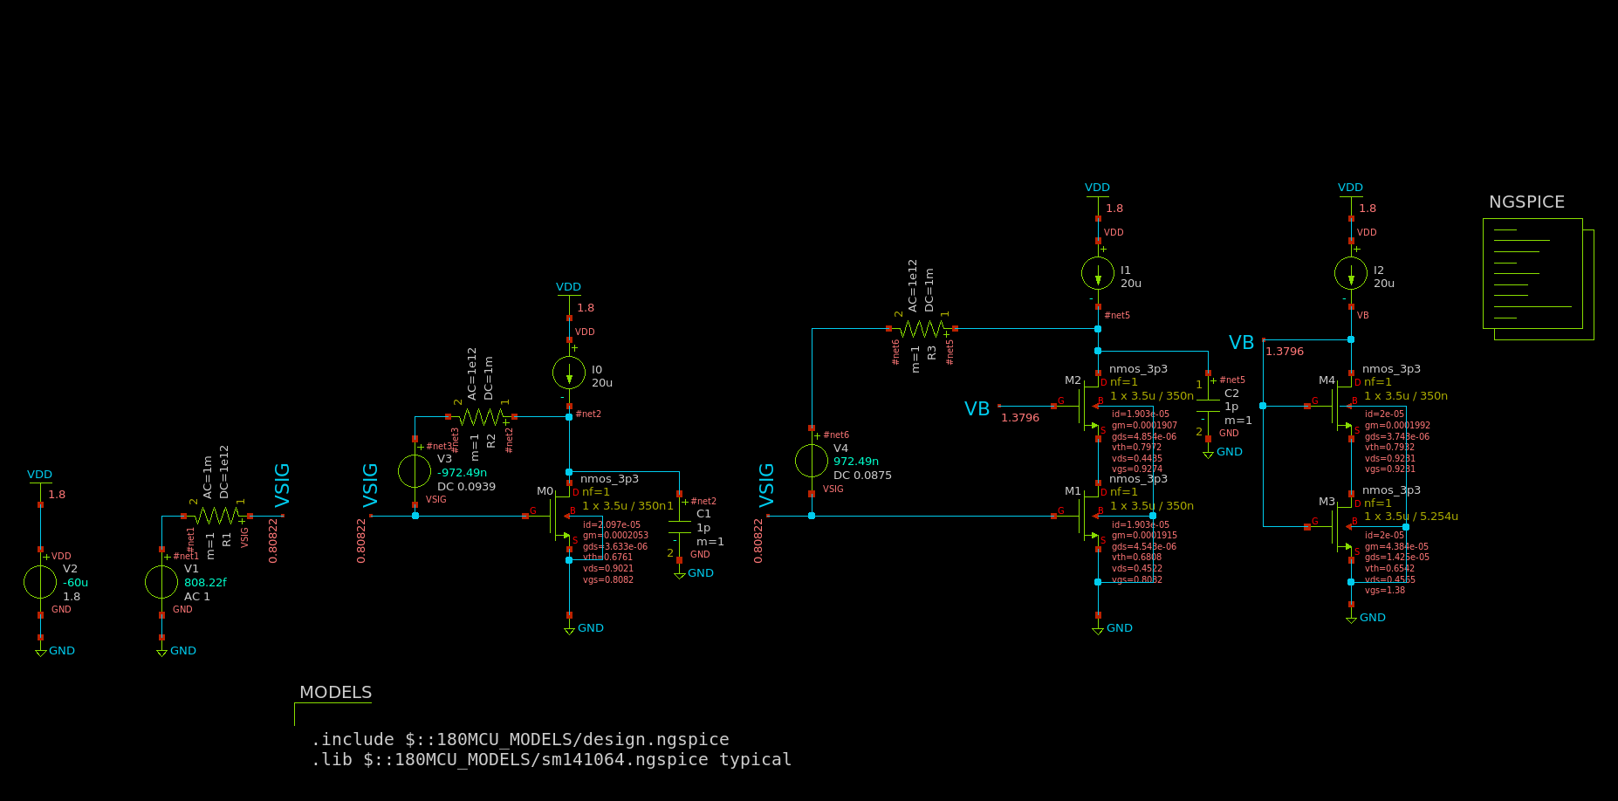

Figure Testbench Schematic

Finding VG0 and VGS1 for V3 and V4 (ADT):

Calculating VB:

We can get VGS2 using ADT by putting VDS = 0.45 and accounting for body effect so VSB = 0.45 and inputting the dimensions calculated previously.

Figure VGS2 using ADT

Getting L of M3:

Figure VGS vs L (ADT) for M3

DC Operating Point:

Figure DC Voltages Annotated on Schematic

9) OP parameters for M0 to M4

To get these quickly I exported the results to a CSV and displayed the results here as follows:

|  |  |  |  |  |  |
| --- | --- | --- | --- | --- | --- |
|  | M0 | M1 | M2 | M3 | M4 |
| cdb | -3.11E-16 | -3.09E-16 | -2.39E-16 | -9.57E-15 | -2.36E-16 |
| cgd | 1.65E-17 | 1.16E-17 | 1.49E-17 | -5.63E-15 | 2.13E-17 |
| cgs | -2.60E-15 | -2.56E-15 | -2.62E-15 | -5.18E-14 | -2.63E-15 |
| csb | -4.66E-16 | -4.61E-16 | -3.56E-16 | -1.25E-14 | -3.54E-16 |
| gds | 3.72E-06 | 4.36E-06 | 4.82E-06 | 1.33E-05 | 3.76E-06 |
| gm | 2.09E-04 | 1.88E-04 | 1.87E-04 | 4.45E-05 | 1.99E-04 |
| gmbs | 5.99E-05 | 5.40E-05 | 4.13E-05 | 1.73E-05 | 4.38E-05 |
| id | 2.16E-05 | 1.84E-05 | 1.84E-05 | 2.00E-05 | 2.00E-05 |
| vds | 8.96E-01 | 4.60E-01 | 4.30E-01 | 4.63E-01 | 9.16E-01 |
| vdsat | 1.67E-01 | 1.60E-01 | 1.64E-01 | 5.59E-01 | 1.66E-01 |
| vgs | 8.02E-01 | 8.02E-01 | 9.19E-01 | 1.38E+00 | 9.16E-01 |
| vth | 6.67E-01 | 6.79E-01 | 7.92E-01 | 6.55E-01 | 7.86E-01 |

* Check that all transistors operate in saturation.

All Operate in saturation except for M3 operates in triode, The cascode configuration is meant to increase the length of the equivalent transistor that we can get from the series connection of the transistors, as the voltage of the middle point is too low for M3 to operate in saturation especially when M4 pulls it down to operate in saturation.

* Do all transistors have the same vth? Why?

M0, M1 and M3 have similar Vth as they are not affected much by body effect but M2 and M4 being cascode devices have a higher Vth than the others due to body effect.

* What is the relation (≪, <, =, >, ≫) between gm and gds?

gm >> (Much Greater Than) gds, except for M3 it’s only greater than (>)

* What is the relation (≪, <, =, >, ≫) between gm and gmb?

gm > (Greater Than) gmb

* What is the relation (≪, <, =, >, ≫) between cgs and cgd?

Cgs >> (Much Greater Than) Cgd except for M3 the ratio is about 9.2 so only almost much greater than it

* What is the relation (≪, <, =, >, ≫) between csb and cdb?

Csb > (Greater Than) cdb

AC Analysis:

**

Figure Bode Plots of both CS and Cascode Amplifiers

|  |  |  |
| --- | --- | --- |
|  | CS | Cascode |
| Gain (dB) | 35.14 | 65.56 |
| Gain | 57.2 | 1.9 K |
| BW | 523.3 KHz | 16.98 KHz |
| GBW | 29.936 MHz | 32.338 MHz |
| UGF | 30.134 MHz | 32.371 MHz |

All Results:

Hand Analysis:

CS Amplifier:

Cascode Amplifier:

|  |  |  |  |  |
| --- | --- | --- | --- | --- |
|  | **CS** | | **Cascode** | |
|  | Simulation | Analytic | Simulation | Analytic |
| **Gain (dB)** | 35.14 | 35 | 65.56 | 66.2 |
| **Gain** | 57.2 | 56.182 | 1.9 K | 2 K |
| **BW** | 523.3 KHz | 592.05 KHz | 16.98 KHz | 14.65 KHz |
| **GBW** | 29.936 MHz | 33.263 MHz | 32.338 MHz | 29.31 MHz |
| **UGF** | 30.134 MHz | 33.263MHz | 32.371 MHz | 29.31 MHz |

Comparison of Results:

Comments:

* Simulation and Analytic Results are nearly identical! Whilst a bit far in the frequency calculations due to neglecting transistor capacitances
* Cascode amplifier has a much greater gain than the CS Amplifier. Due to the higher output resistance
* The Bandwidth of the Cascode Amplifier is much lesser than the CS Amplifier also due to the higher output resistance.
* This results in both amplifiers having nearly identical Gain-Bandwidth-Product as well as Unity Gain Frequency.

Part 3: Cascode for BW:

Calculating VRD:

OP Point:

Figure DC OP with Points Annotated

All Results:

|  |  |  |  |  |  |  |
| --- | --- | --- | --- | --- | --- | --- |
|  | M0 | M1 | M2 | M3 | M4 | M5 |
| cdb | -3.08E-16 | -3.10E-16 | -2.39E-16 | -9.64E-15 | -2.37E-16 | -3.08E-16 |
| cgd | 1.63E-17 | 1.15E-17 | 1.78E-17 | -5.91E-15 | 2.13E-17 | 1.61E-17 |
| cgs | -2.57E-15 | -2.57E-15 | -2.62E-15 | -5.18E-14 | -2.63E-15 | -2.57E-15 |
| csb | -4.62E-16 | -4.62E-16 | -3.56E-16 | -1.26E-14 | -3.55E-16 | -4.62E-16 |
| gds | 3.57E-06 | 4.43E-06 | 4.41E-06 | 1.39E-05 | 3.75E-06 | 3.63E-06 |
| gm | 2.01E-04 | 1.89E-04 | 1.89E-04 | 4.41E-05 | 1.99E-04 | 1.99E-04 |
| gmbs | 5.77E-05 | 5.45E-05 | 4.19E-05 | 1.72E-05 | 4.39E-05 | 5.72E-05 |
| id | 2.03E-05 | 1.86E-05 | 1.86E-05 | 2.00E-05 | 2.00E-05 | 2.00E-05 |
| vds | 8.87E-01 | 4.58E-01 | 5.04E-01 | 4.59E-01 | 9.20E-01 | 8.07E-01 |
| vdsat | 1.63E-01 | 1.61E-01 | 1.64E-01 | 5.60E-01 | 1.66E-01 | 1.63E-01 |
| vgs | 8.07E-01 | 8.07E-01 | 9.21E-01 | 1.38E+00 | 9.20E-01 | 8.07E-01 |
| vth | 6.78E-01 | 6.82E-01 | 7.94E-01 | 6.54E-01 | 7.90E-01 | 6.79E-01 |

* Check that all transistors operate in saturation.

All Operate in saturation except for M3 operates in triode, The cascode configuration is meant to increase the length of the equivalent transistor that we can get from the series connection of the transistors, as the voltage of the middle point is too low for M3 to operate in saturation especially when M4 pulls it down to operate in saturation.

AC Analysis:

Figure Bode Blot Blue: Cascode, Red: CS

Figure Simulation Values of DC Gain, BW, UGF, GBW (1 is CS and 2 is Cascode)

Hand Analysis:

CS Amplifier:

Cascode Amplifier:

|  |  |  |  |  |
| --- | --- | --- | --- | --- |
|  | **CS** | | **Cascode** | |
|  | Simulation | Analytic | Simulation | Analytic |
| **Gain (dB)** | 17.84 | 17.83 | 18.413 | 18.588 |
| **Gain** | 7.8 | 7.792 | 8.33 | 8.5 |
| **BW** | 1.695 MHz | 1.917 MHz | 3 MHz | 3.0965 MHz |
| **GBW** | 13.233 MHz | 14.939 MHz | 25 MHz | 26.32 MHz |
| **UGF** | 13.182 MHz | 14.939 MHz | 24.86 MHz | 26.32 MHz |

Comparison of the Results:

Comments:

* The cascode for bandwidth has slightly higher gain than CS
* It has better Bandwidth than CS as well as higher GBW as well as higher UGF
* The higher bandwidth is due to the severe reduction of the miller effect in this configuration
* Overall better performance than the CS Amplifier