**Lab 4**

Common Drain Amplifier

Part 1: Sizing Chart

Required Spec:

|  |  |
| --- | --- |
| L | 1um |
| V* | 200mV |
| Quiescent (DC) Input Voltage | 0 𝑉 |
| Supply Voltage | 1.8 𝑉 |
| Bias Current | 10 uA |

Analytic Calculations:

Sizing Using ADT:

Inputting the Design parameters into ADT SA we get:

Figure 1 Sizing Using ADT

Part 2: Common Drain Amplifier

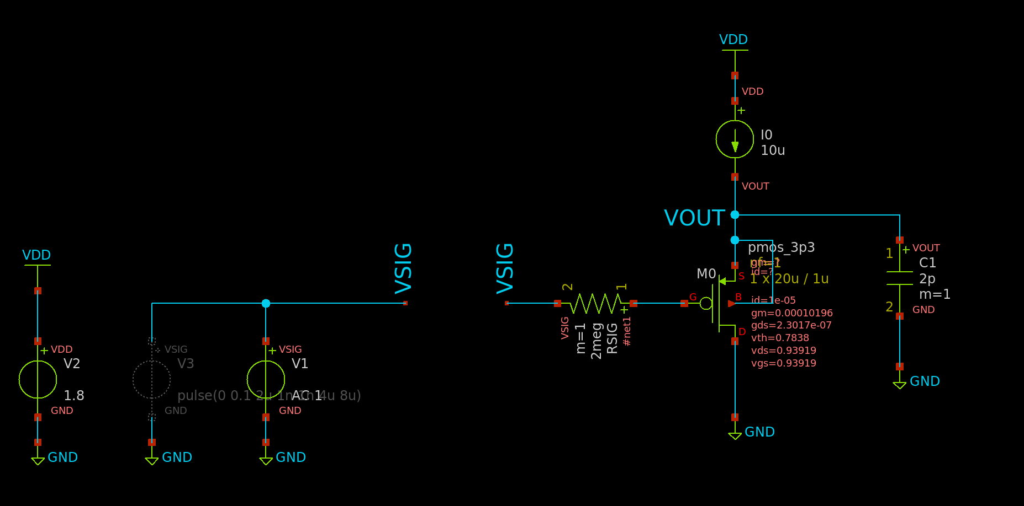

Figure 2 Testbench Schematic for both AC and Tran Analysis

Operating Point:

|  |  |  |  |  |  |  |  |  |  |  |  |  |
| --- | --- | --- | --- | --- | --- | --- | --- | --- | --- | --- | --- | --- |
|  | id | vgs | vds | vth | vdsat | gm | gds | gmbs | Cdb | Cgd | Cgs | Csb |
| M0 | 10uA | 0.94V | 0.94V | 0.785V | 0.153V | 102uS | 230nS | 48.2uS | 9.97fF | 14.2aF | 51.1fF | 14.9fF |

Transistor Operates in Saturation!

AC Analysis:

**Outputs:** 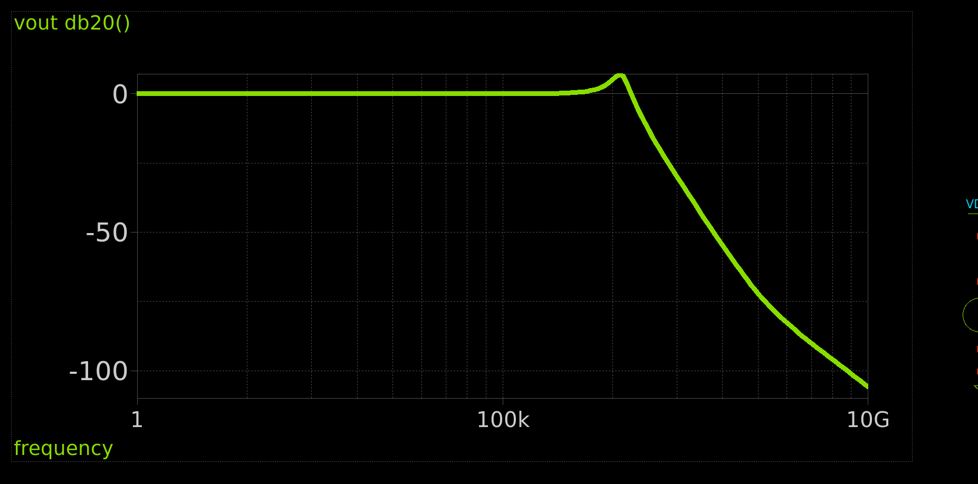

Figure 3 Bode Plot of Common Drain Amplifier

* Do you notice frequency domain peaking? How much is the peaking?

Yes, there is peaking. Its value is about **2 in magnitude** or around **6dB**



Figure 4 Value of Peaking from Simulation

Quality Factor Calculation:

Part 3: Cascode for BW:

Calculating VRD:

OP Point:

Figure 5 DC OP with Points Annotated

All Results:

|  |  |  |  |  |  |  |
| --- | --- | --- | --- | --- | --- | --- |
|  | M0 | M1 | M2 | M3 | M4 | M5 |
| cdb | -3.08E-16 | -3.10E-16 | -2.39E-16 | -9.64E-15 | -2.37E-16 | -3.08E-16 |
| cgd | 1.63E-17 | 1.15E-17 | 1.78E-17 | -5.91E-15 | 2.13E-17 | 1.61E-17 |
| cgs | -2.57E-15 | -2.57E-15 | -2.62E-15 | -5.18E-14 | -2.63E-15 | -2.57E-15 |
| csb | -4.62E-16 | -4.62E-16 | -3.56E-16 | -1.26E-14 | -3.55E-16 | -4.62E-16 |
| gds | 3.57E-06 | 4.43E-06 | 4.41E-06 | 1.39E-05 | 3.75E-06 | 3.63E-06 |
| gm | 2.01E-04 | 1.89E-04 | 1.89E-04 | 4.41E-05 | 1.99E-04 | 1.99E-04 |
| gmbs | 5.77E-05 | 5.45E-05 | 4.19E-05 | 1.72E-05 | 4.39E-05 | 5.72E-05 |
| id | 2.03E-05 | 1.86E-05 | 1.86E-05 | 2.00E-05 | 2.00E-05 | 2.00E-05 |
| vds | 8.87E-01 | 4.58E-01 | 5.04E-01 | 4.59E-01 | 9.20E-01 | 8.07E-01 |
| vdsat | 1.63E-01 | 1.61E-01 | 1.64E-01 | 5.60E-01 | 1.66E-01 | 1.63E-01 |
| vgs | 8.07E-01 | 8.07E-01 | 9.21E-01 | 1.38E+00 | 9.20E-01 | 8.07E-01 |
| vth | 6.78E-01 | 6.82E-01 | 7.94E-01 | 6.54E-01 | 7.90E-01 | 6.79E-01 |

* Check that all transistors operate in saturation.

All Operate in saturation except for M3 operates in triode, The cascode configuration is meant to increase the length of the equivalent transistor that we can get from the series connection of the transistors, as the voltage of the middle point is too low for M3 to operate in saturation especially when M4 pulls it down to operate in saturation.

AC Analysis:

Figure 6 Bode Blot Blue: Cascode, Red: CS

Figure 7 Simulation Values of DC Gain, BW, UGF, GBW (1 is CS and 2 is Cascode)

Hand Analysis:

CS Amplifier:

Cascode Amplifier:

|  |  |  |  |  |
| --- | --- | --- | --- | --- |
|  | **CS** | | **Cascode** | |
|  | Simulation | Analytic | Simulation | Analytic |
| **Gain (dB)** | 17.84 | 17.83 | 18.413 | 18.588 |
| **Gain** | 7.8 | 7.792 | 8.33 | 8.5 |
| **BW** | 1.695 MHz | 1.917 MHz | 3 MHz | 3.0965 MHz |
| **GBW** | 13.233 MHz | 14.939 MHz | 25 MHz | 26.32 MHz |
| **UGF** | 13.182 MHz | 14.939 MHz | 24.86 MHz | 26.32 MHz |

Comparison of the Results:

Comments:

* The cascode for bandwidth has slightly higher gain than CS
* It has better Bandwidth than CS as well as higher GBW as well as higher UGF
* The higher bandwidth is due to the severe reduction of the miller effect in this configuration
* Overall better performance than the CS Amplifier