**Lab 5**

Current Mirrors

Part 1: Sizing Chart

Required Spec:

|  |
| --- |
| Parameter |
| Current direction (source/sink) | Sink |
| Input Current | 10𝜇𝐴 |
| Output Current | 20𝜇𝐴 |
| % Change in Current for 𝚫𝑽𝒐𝒖𝒕 = 𝟏𝑽 | < 10% |
| Percent mismatch: 𝝈(𝑰𝒐𝒖𝒕)/𝑰𝒐𝒖𝒕 | ≤ 2% |
| Compliance voltage | ≤ 150𝑚𝑉 |
| Area | Minimize |

2) Sinking Current Means?

NMOS Transistor

3) Required Lambda

5) Mismatch from ADT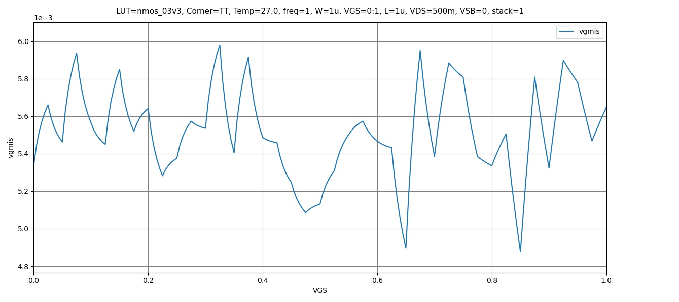

Figure 1 VGMIS vs VGS

From the graph we can find the approximate value of

6) Mismatch from PDK

The value from ADT is slightly higher, this is possibly due to inaccuracies that occur when calculating and estimating random values.

7) Design Parameters vs vstar at different mismatch

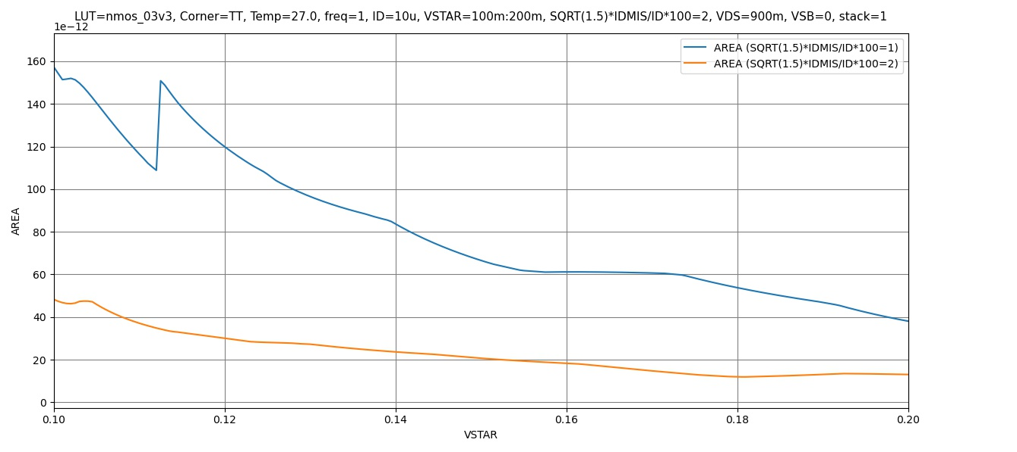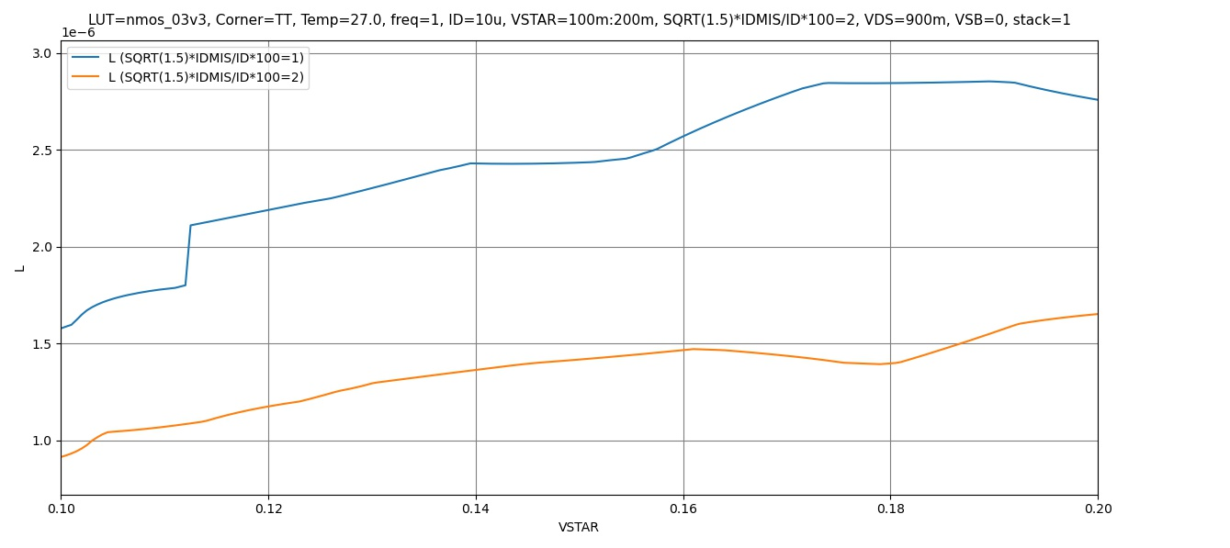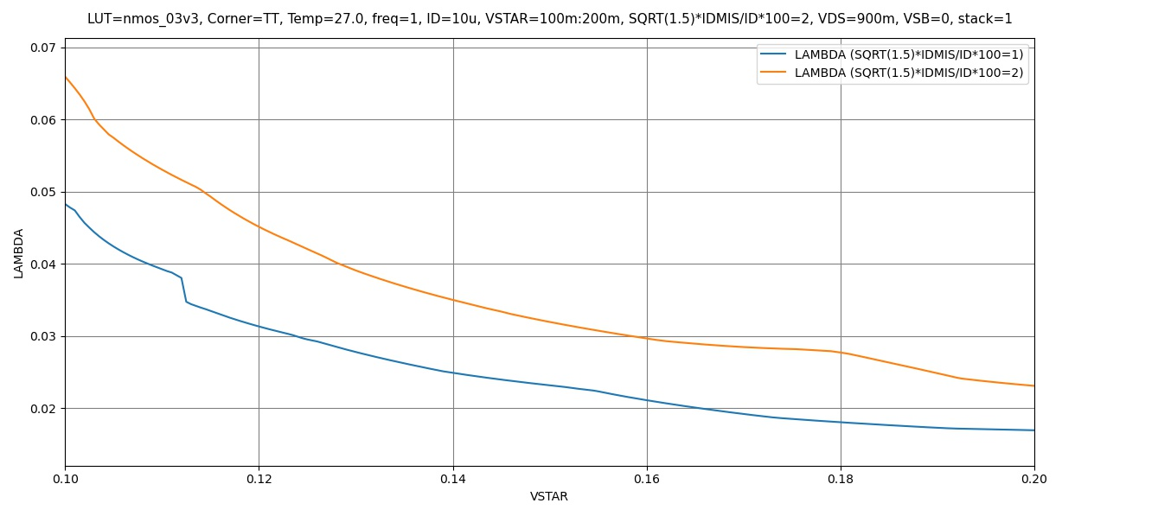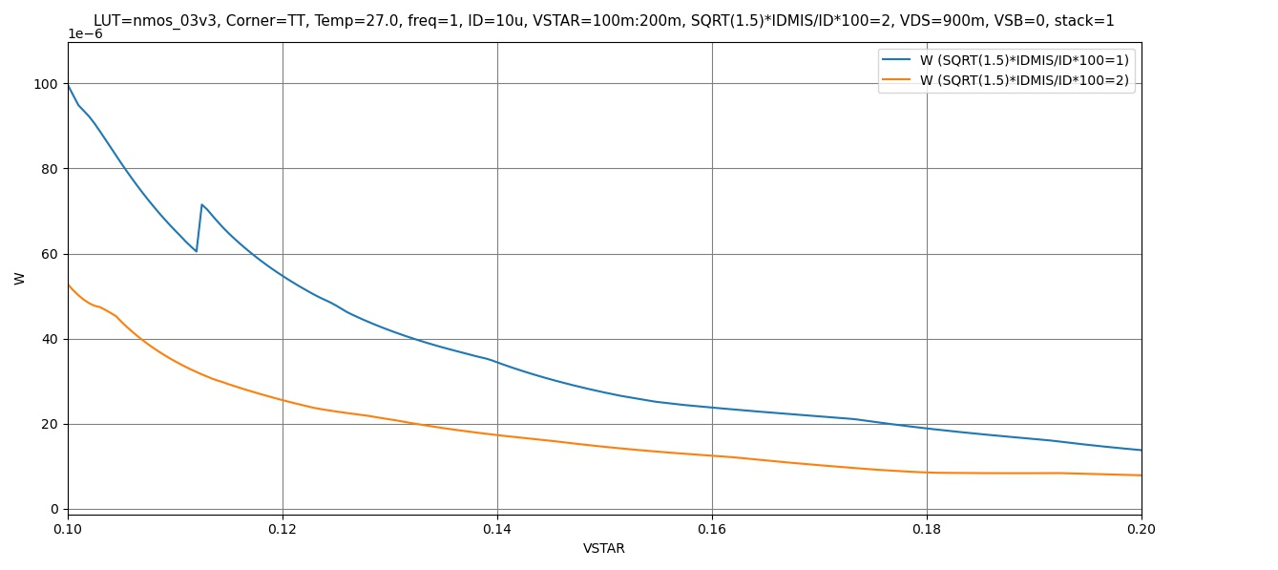

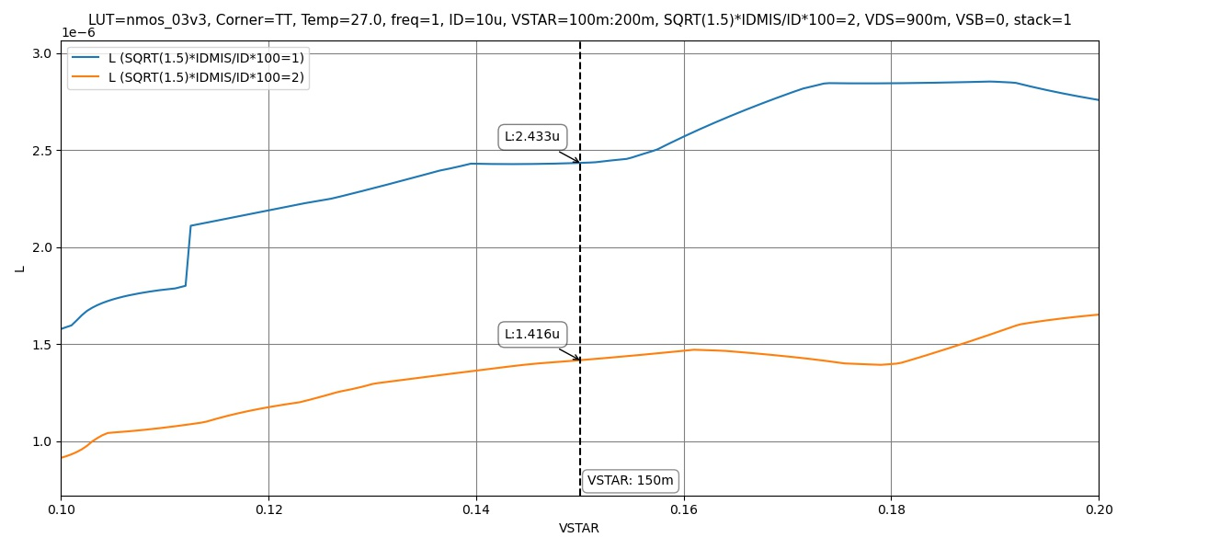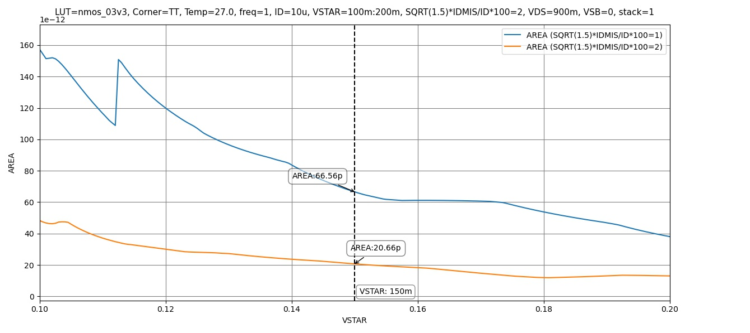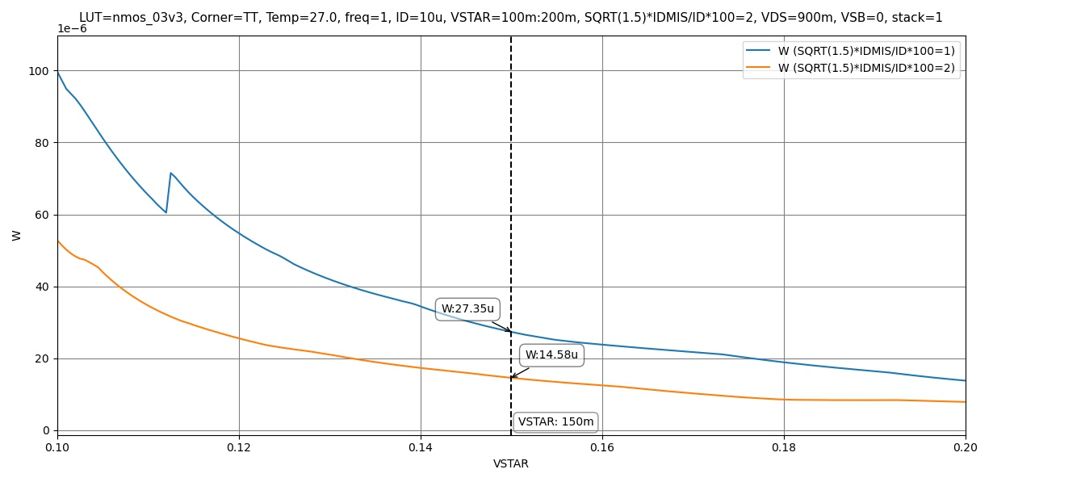

From the Graphs we notice both values of the mismatch current satisfy the Lambda Constraint

Thus we will choose the dimensions corresponding with the mismatch value which has the lower area

9) What if Lambda constraints is not met?

By inputting the required exact value for lambda () we can calculate the mismatch corresponding to it using the same expression used before.



11) Report Device Sizing and Mismatch percentage

Selected design points @

|  |  |
| --- | --- |
|  | 2% |
| L | 1.42um |
| W | 14.58um |

Part 2: Current Mirror Simulation

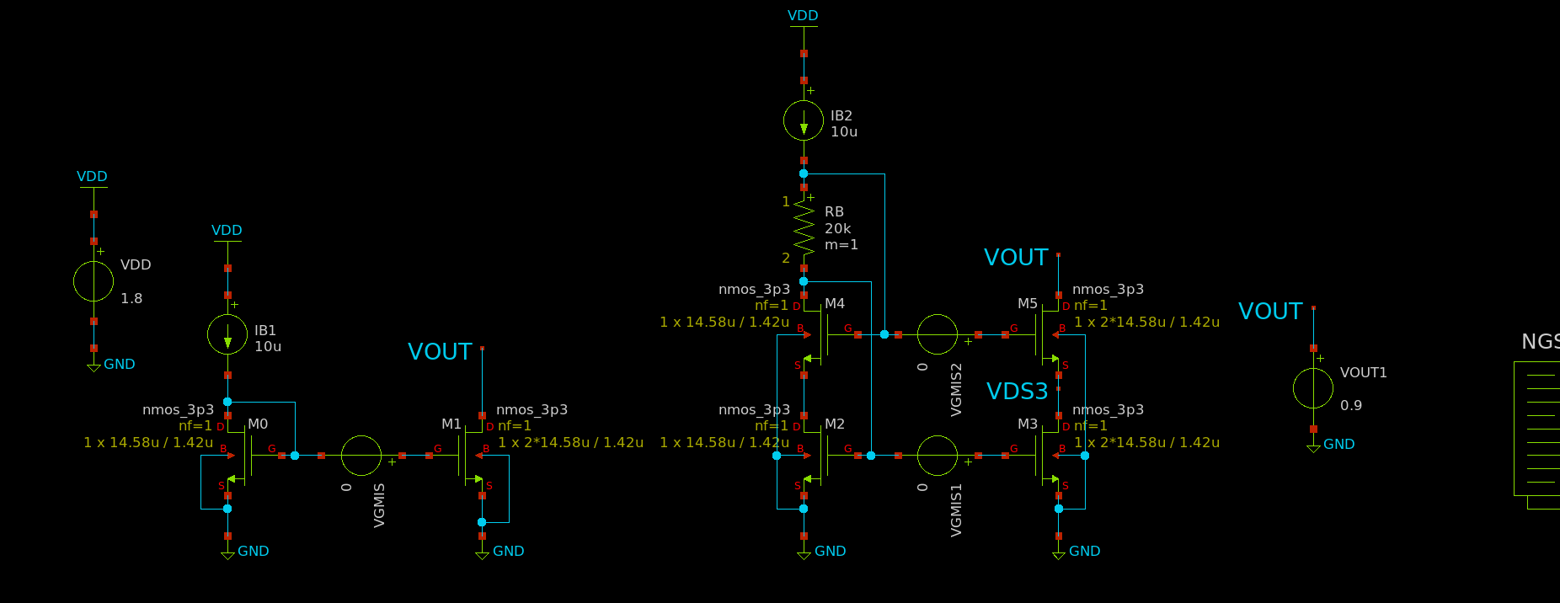

Figure 2 Current Mirror Schematic Testbench

Design and OP Analysis

1. Finding RB analytically
2. Finding RB through Simulation

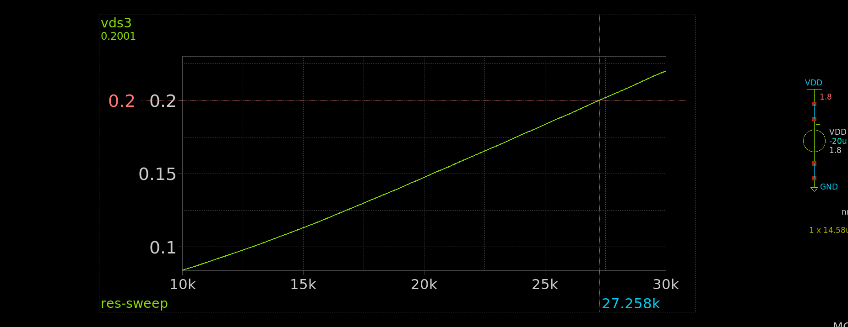

Figure 3 Value of RB from simulation

The value of RB calculated from the simulation is larger than the one calculated analytically, this is due to the analytic solution not accounting for body effect which makes the difference in VGS have a value thus increasing the required RB.

1. OP Analysis

Op Analysis was done using the value of RB from the simulation

|  |  |  |  |  |  |  |
| --- | --- | --- | --- | --- | --- | --- |
|  | M0 | M1 | M2 | M3 | M4 | M5 |
| ID | 10.0u | 20.1u | 10.0u | 20.0u | 10.0u | 20.0u |
| VGS | 757.3m | 757.3m | 760.3m | 760.3m | 813.0m | 812.7m |
| VDS | 757.3m | 900.0m | 147.3m | 147.5m | 613.0m | 752.5m |
| VTH | 678.4m | 678.4m | 678.4m | 678.4m | 733.9m | 734.0m |
| VDSAT | 119.7m | 119.7m | 121.5m | 121.5m | 121.5m | 121.2m |
| gm | 134.4u | 269.9u | 130.7u | 261.6u | 134.5u | 269.3u |
| gds | 328.3n | 630.5n | 5.2u | 10.3u | 345.8n | 646.6n |
| gmbs | 52.4u | 105.2u | 50.9u | 102.0u | 48.8u | 97.6u |

1. Do All Transistor operate in Saturation?

They all operate in saturation.

DC Sweep

Figure 4 Iout for both CMs vs VOUT

The cascode IOUT is more consistent and always equal to IB*2 almost during the entire sweep, while an evident error is visible in IOUT1 from the simple CM as VDS increases.

Estimate V Compliance

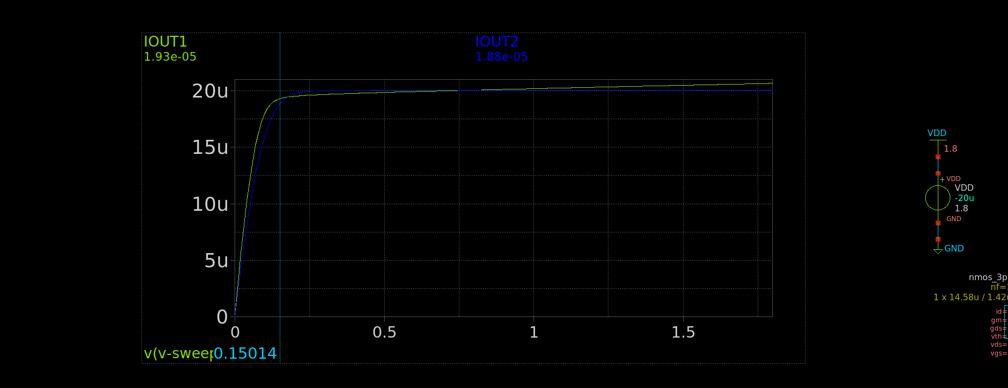

Figure 5 VCOMP of Simple CM

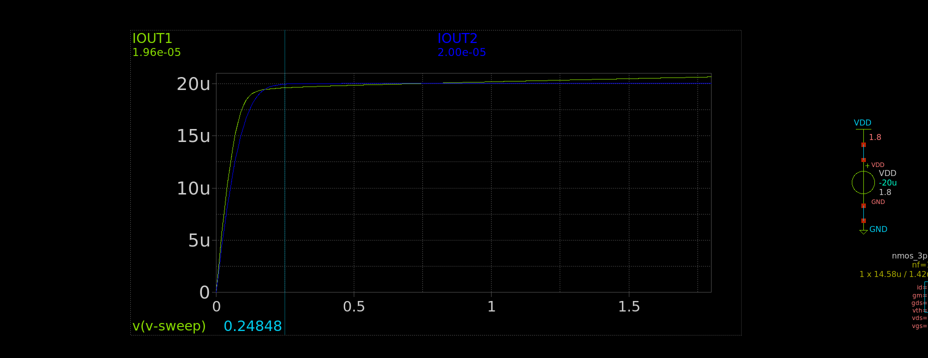

Figure 6 V compliance of Cascode Current Mirror

Figure 7 Value at which Iout1 equals IB*2 Exactly

Iout1 equals IB*2 exactly at around **0.75758mV** as this is the value at which VDS of both transistor are equal each other eliminating the error

2. Simple current Mirror Error

Figure 8 Error Calculated in Simulation

The value is consistent with the results from Part one as it corresponds with the value calculated from ADT for Lambda

3. Percentage of Error for both CMs

Figure 9 Current Error for both configurations

The error in the simple CM is fairly larger and fluctuates as VDS changes, it becomes zero at VDS0=VDS1 the same value calculated previously at which IOUT1=IB*2 exactly. While the cascode error is consistently zero throughout the sweep.

1. ROUT vs VOUT

Figure 10 ROUT1 and ROUT2 vs VOUT

Cascode Current Mirror has significantly higher ROUT.

Yes Rout changing slightly with VOUT due to the change of operation regions of the transistors at the beginning of the sweep it has a much smaller value due to transistors operating in triode instead of saturation and even in saturation ROUT changes due to its dependance on VDS.

1. Analytic Calculation for ROUT