**Lab 8**

Feedback Amplifier

Part 1: Feedback with Behavioral OTA

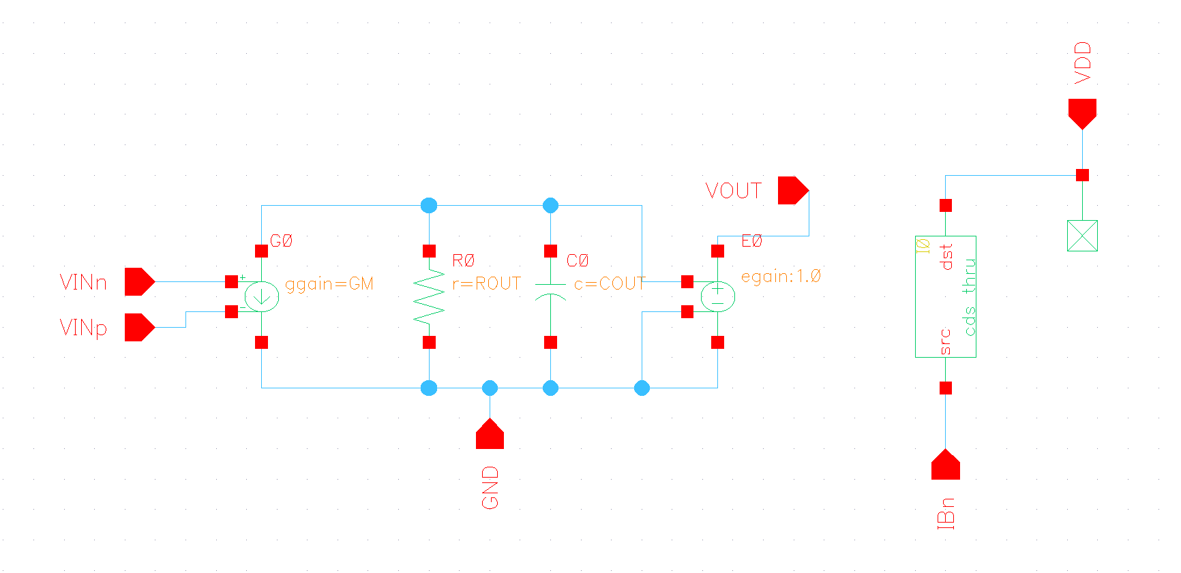

Figure Behavioral Model Schematic

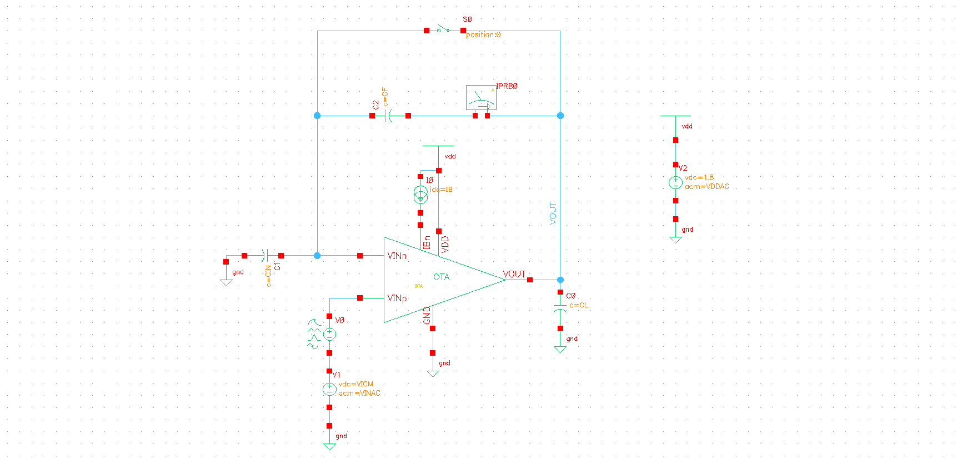

Figure Testbench Schematic

* 1. Closed Loop Gain vs Frequency:

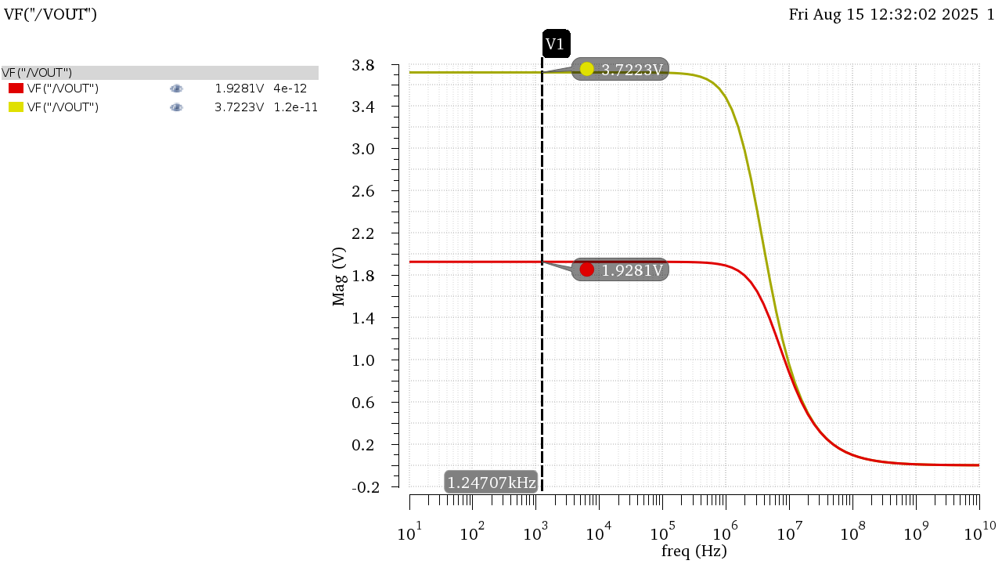

Figure DC Gain in Mag

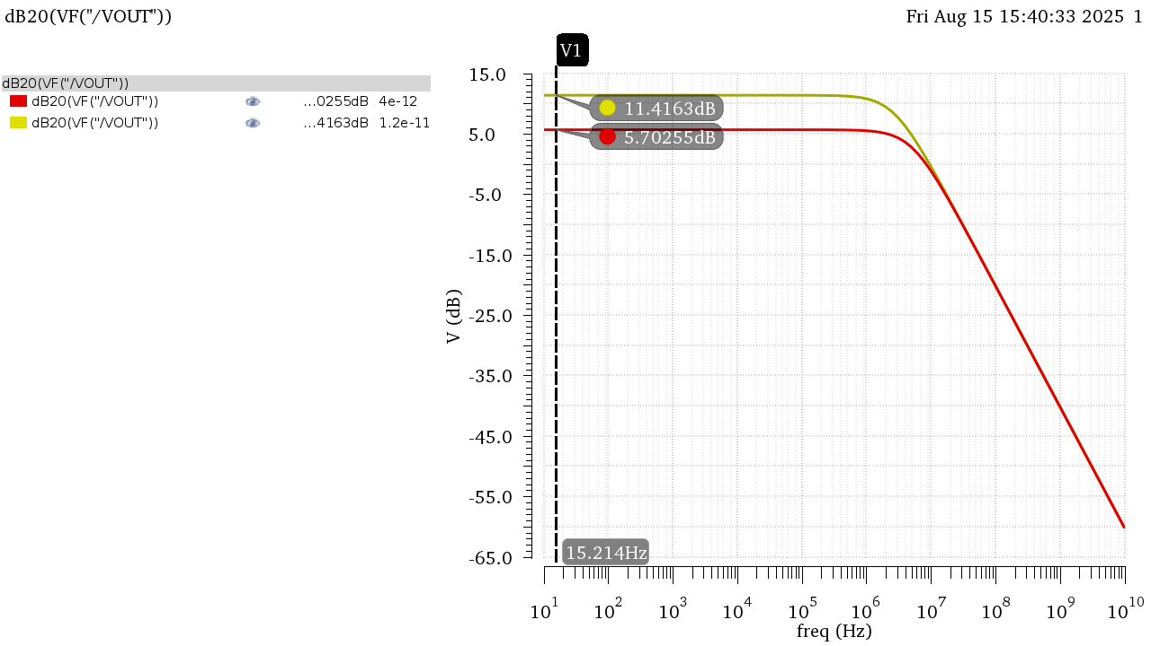

Figure DC Gain in dB

Figure Gain Bode Plot Annotated CIN = 4pF

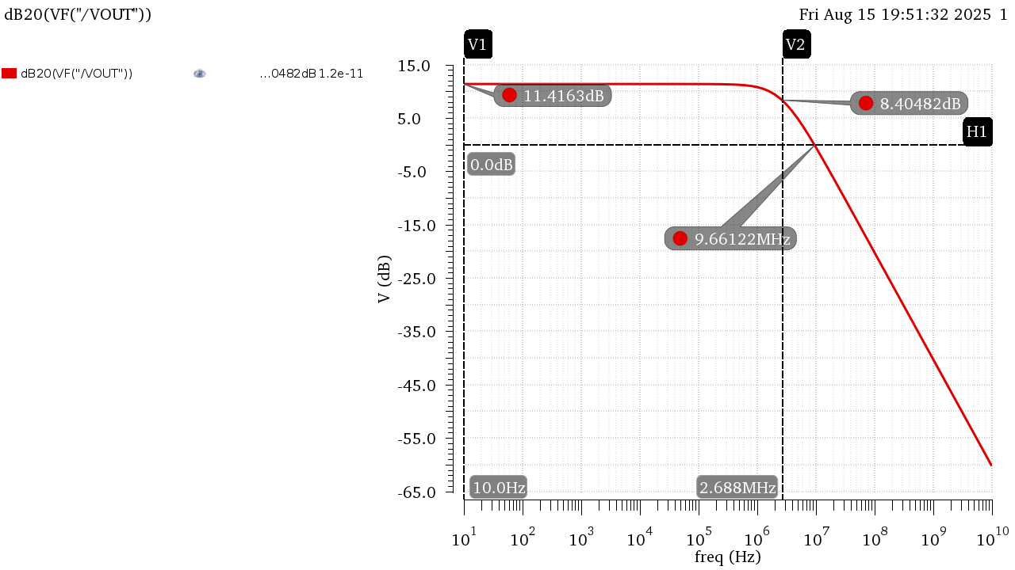

Figure Gain Bode Plot Annotated CIN = 12pF

|  |  |  |
| --- | --- | --- |
|  | CIN = 4pF | CIN = 12pF |
| DC Gain (dB) | 5.703 | 11.42 |
| DC Gain | 1.928 | 3.722 |
| BW | 5.19E+06 | 2.69E+06 |
| UGF | 8.61E+06 | 9.69E+06 |
| GBW | 10E+06 | 10E+06 |

Table Results from Simulation

Hand Analysis:

Open Loop Parameters from Last Lab:

$$A_{OL}≈53, BW_{OL}=191KHz, GBW≈10.12MHz$$

$$β=\frac{Z_{in}}{Z_{in}+Z_{f}}=\frac{C_{f}}{C_{f}+C_{in}}=\frac{1}{2}, \frac{1}{4} (For Both Values of C_{in})$$

$$DC Gain=A_{CL}=\frac{A_{OL}}{1+βA_{OL}}=1.927 , 3.72$$

$$BW_{CL}=\left(1+βA_{OL}\right)BW_{OL}=5.25MHz, 2.721MHz$$

$$GBW_{CL}=10.1167MHz, 10.122MHz$$

|  |  |  |  |  |
| --- | --- | --- | --- | --- |
|  | **CIN = 4pF** | | **CIN = 12pF** | |
|  | Simulation | Analytic | Simulation | Analytic |
| **DC Gain (dB)** | 5.703 | 5.698 | 11.42 | 11.41 |
| **DC Gain** | 1.928 | 1.9272 | 3.722 | 3.72 |
| **BW** | 5.19E+06 | 5.25E+06 | 2.69E+06 | 2.72E+06 |
| **GBW** | 1.00E+07 | 1.01E+07 | 1.00E+07 | 1.01E+07 |

Analytic Results Agree with simulated ones in both cases of the input capacitor!

* 1. Loop Gain vs Frequency:



Figure LG Overlaid in Mag

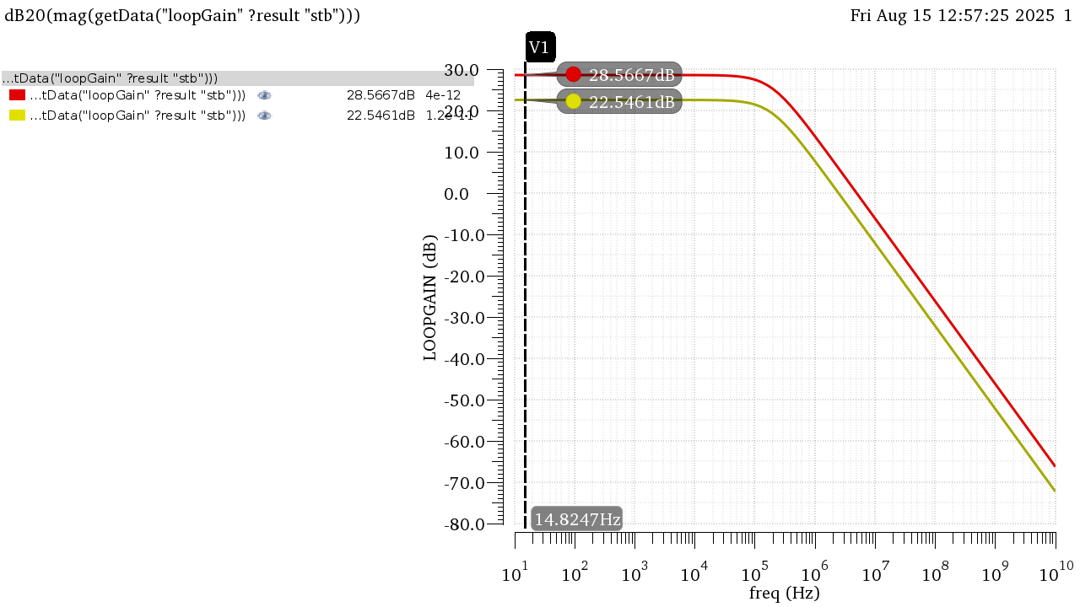

Figure LG Overlaid in dB

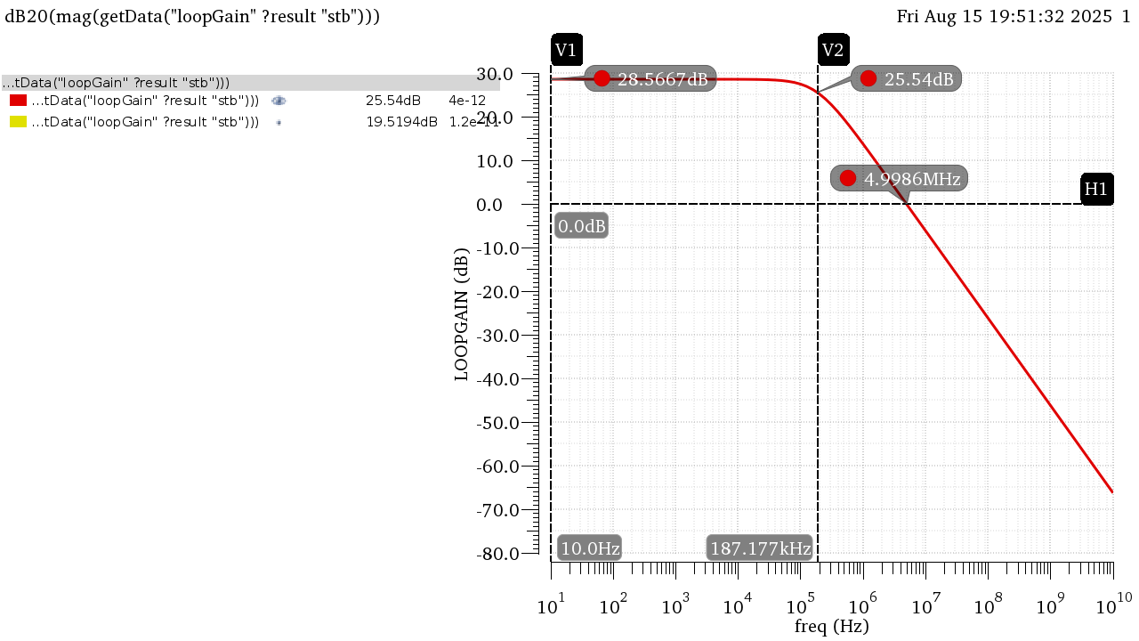

Figure LG Bode Plot Annotated CIN = 4pF

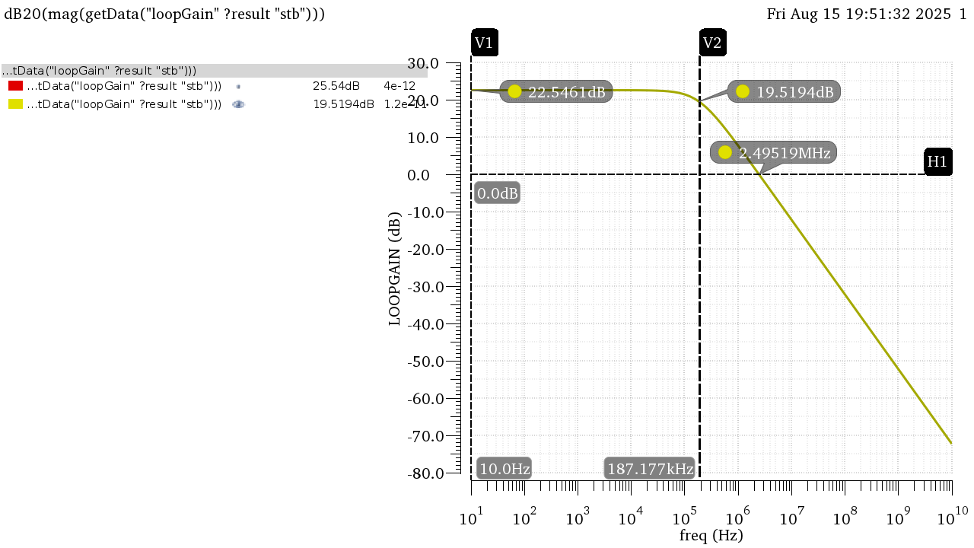

Figure LG Bode Plot Annotated CIN = 12pF

|  |  |  |
| --- | --- | --- |
|  | CIN = 4pF | CIN = 12pF |
| DC Gain (dB) | 28.57 | 22.55 |
| DC Gain | 26.81 | 13.41 |
| BW | 187.17 KHz | 187.17 KHz |
| UGF | 5 MHz | 2.5 MHz |

Table 2 Results from Simulation

Hand Analysis:

Open Loop Parameters from Last Lab:

$$A_{OL}≈53, BW_{OL}=191KHz, GBW≈10.12MHz$$

$$β=\frac{Z_{in}}{Z_{in}+Z_{f}}=\frac{C_{f}}{C_{f}+C_{in}}=\frac{1}{2}, \frac{1}{4} (For Both Values of C_{in})$$

$$DC LG Gain=LG=βA_{OL}=26.5 , 13.25→28.465dB, 22.444dB$$

$$BW_{LG}=BW_{OL}=191KHz$$

$$ω_{u}=GBW_{LG}=5.0615MHz, 2.53MHz$$

|  |  |  |  |  |
| --- | --- | --- | --- | --- |
|  | **CIN = 4pF** | | **CIN = 12pF** | |
|  | Simulation | Analytic | Simulation | Analytic |
| **DC Gain (dB)** | 28.57 | 28.465 | 22.55 | 22.444 |
| **DC Gain** | 26.81 | 26.5 | 13.41 | 13.25 |
| **BW** | 187.17 KHz | 191 KHz | 187.17 KHz | 191 KHz |
| **UGF** | 5 MHz | 5.0615 MHz | 2.5 MHz | 2.53 MHz |

Analytic Results Agree with simulated ones in both cases of the input capacitor!

* 1. Gain Desensitization:

To sweep the gain, I can either sweep GM or ROUT, I tried both and both resulted in similar results:

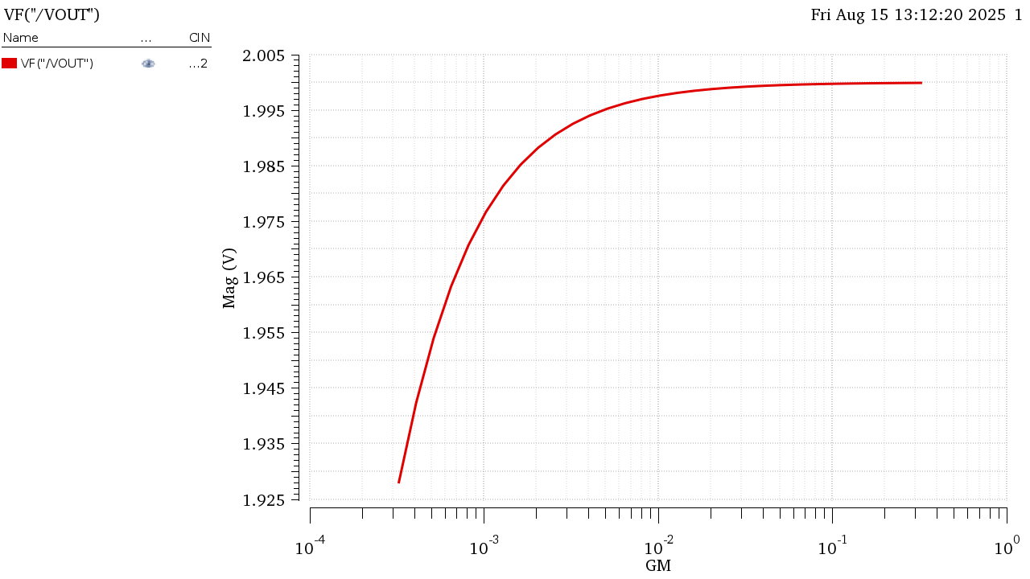

Figure Gain Sweeping GM

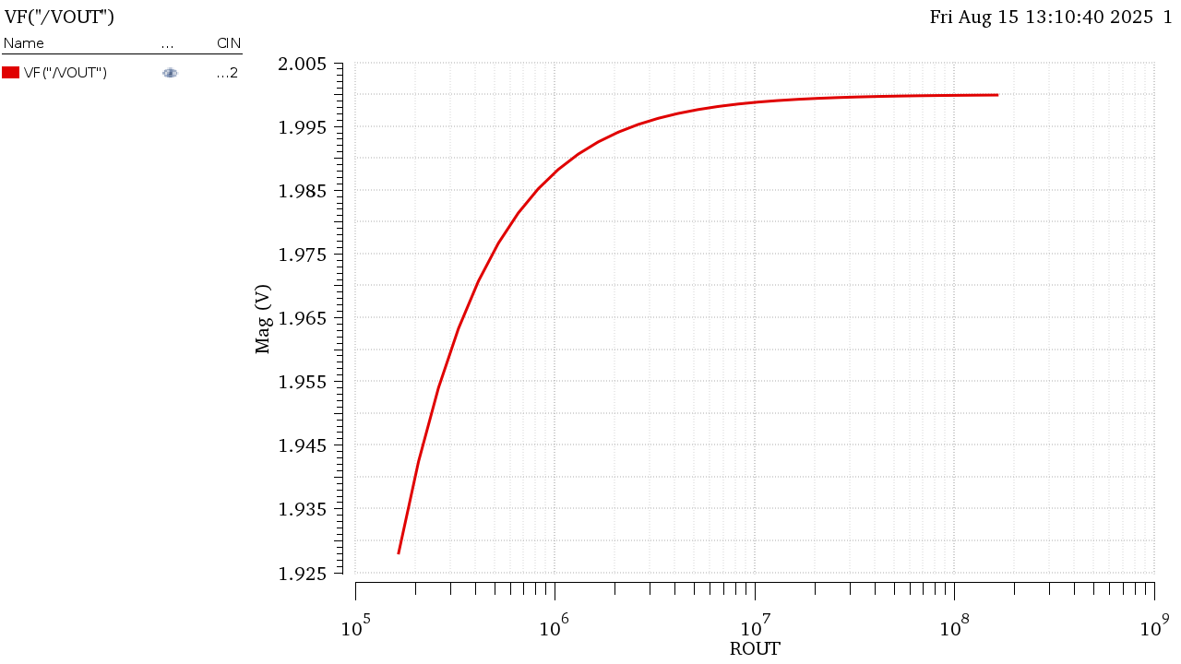

Figure Gain Sweeping ROUT

$$A_{CL}\%=\frac{1.99982-1.928}{1.928}*100=3.725\%$$

The Gain is much closer to its ideal value now (Ideal Value = 2) as we increase the Open Loop gain of the amplifier it easier to approximate closed loop gain as $\frac{1}{β}$. The percentage change would be even if we calculate for higher gains like the case of CIN = 4pF

Part 2: Feedback with Real 5T OTA

2.1 Closed Loop Gian vs Frequency:

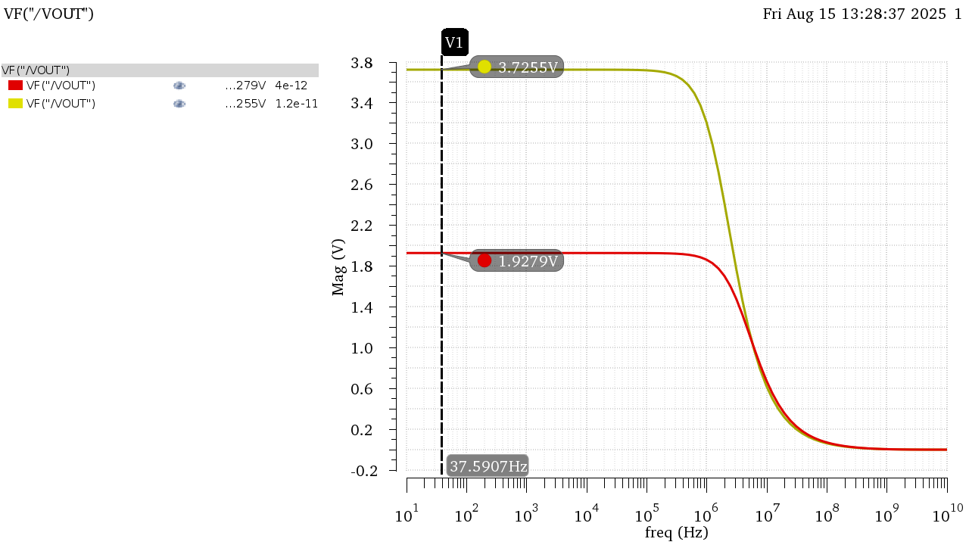

Figure Gain in Mag

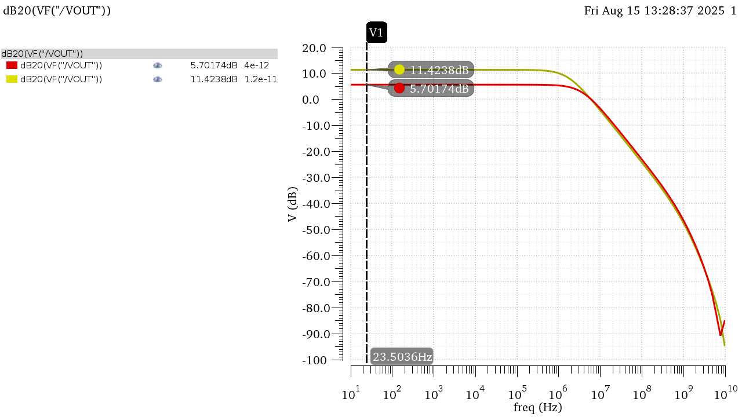

Figure Gain in dB