**Lab 8**

Feedback Amplifier

Part 1: Feedback with Behavioral OTA

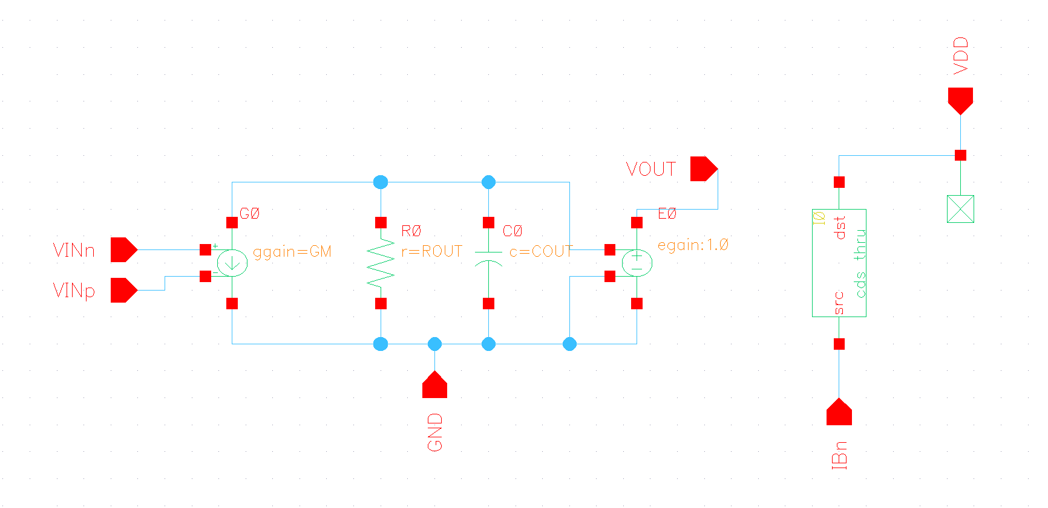

Figure Behavioral Model Schematic

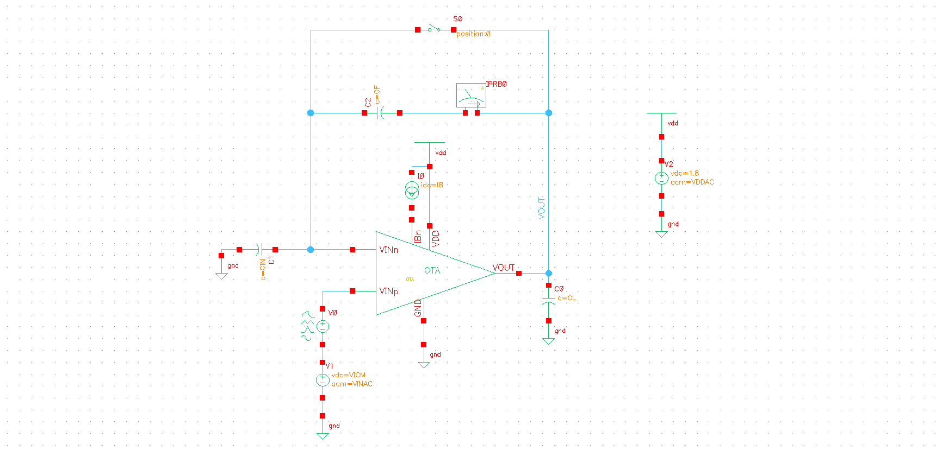

Figure Testbench Schematic

* 1. Closed Loop Gain vs Frequency:

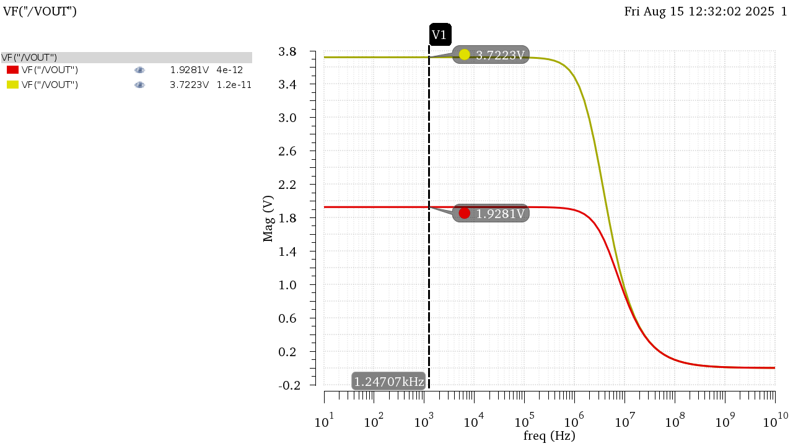

Figure DC Gain in Mag

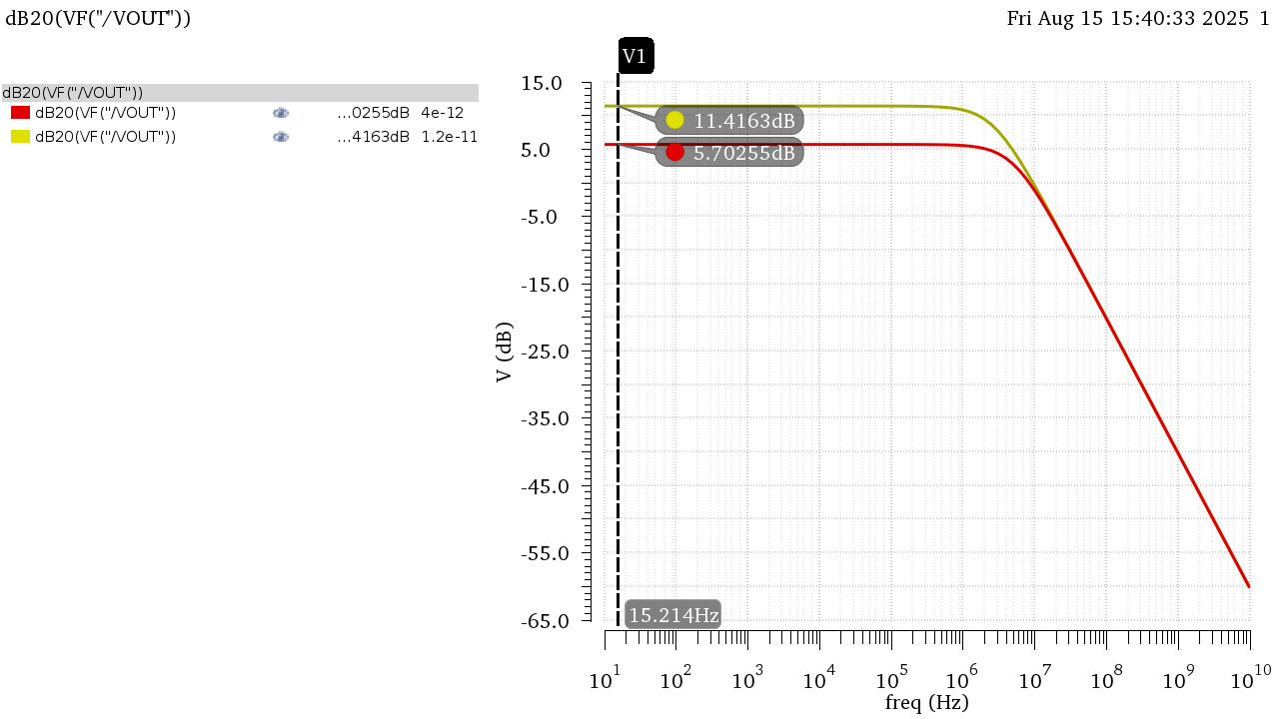

Figure DC Gain in dB

Figure Gain Bode Plot Annotated CIN = 4pF

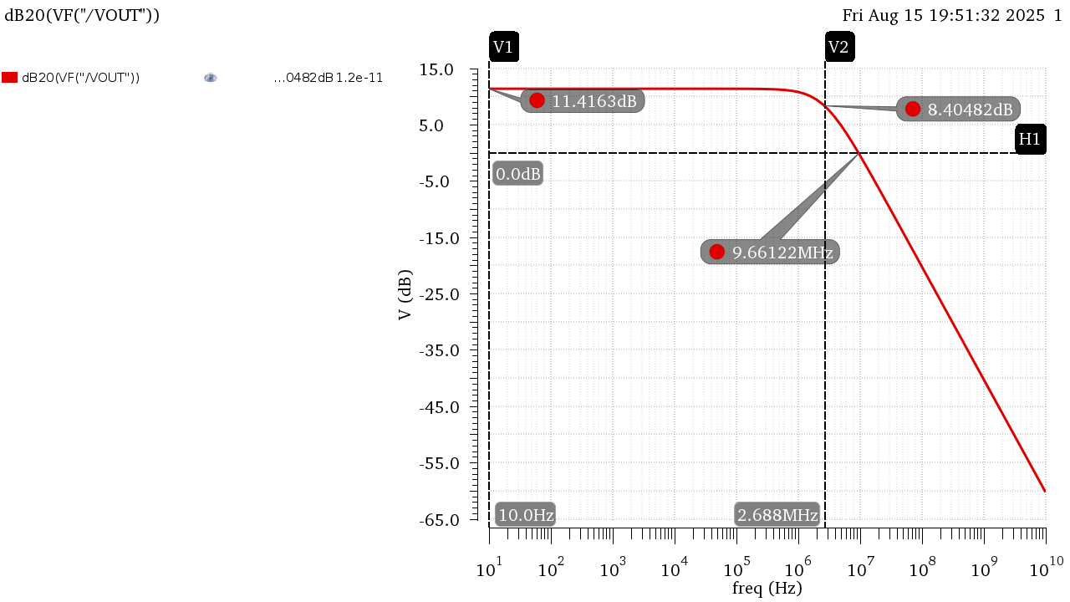

Figure Gain Bode Plot Annotated CIN = 12pF

|  |  |  |
| --- | --- | --- |
|  | CIN = 4pF | CIN = 12pF |
| DC Gain (dB) | 5.703 | 11.42 |
| DC Gain | 1.928 | 3.722 |
| BW | 5.19E+06 | 2.69E+06 |
| UGF | 8.61E+06 | 9.69E+06 |
| GBW | 10E+06 | 10E+06 |

Table Results from Simulation

Hand Analysis:

Open Loop Parameters from Last Lab:

|  |  |  |  |  |
| --- | --- | --- | --- | --- |
|  | **CIN = 4pF** | | **CIN = 12pF** | |
|  | Simulation | Analytic | Simulation | Analytic |
| **DC Gain (dB)** | 5.703 | 5.698 | 11.42 | 11.41 |
| **DC Gain** | 1.928 | 1.9272 | 3.722 | 3.72 |
| **BW** | 5.19E+06 | 5.25E+06 | 2.69E+06 | 2.72E+06 |
| **GBW** | 1.00E+07 | 1.01E+07 | 1.00E+07 | 1.01E+07 |

Analytic Results Agree with simulated ones in both cases of the input capacitor!

* 1. Loop Gain vs Frequency:



Figure LG Overlaid in Mag

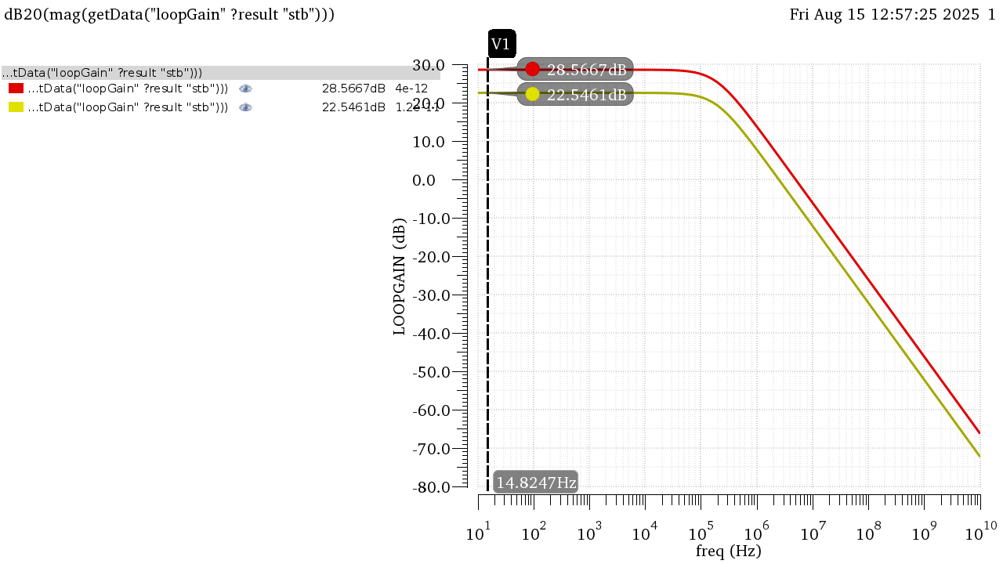

Figure LG Overlaid in dB

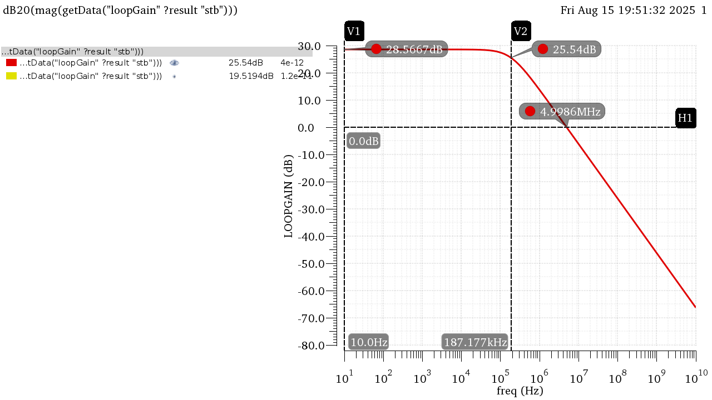

Figure LG Bode Plot Annotated CIN = 4pF

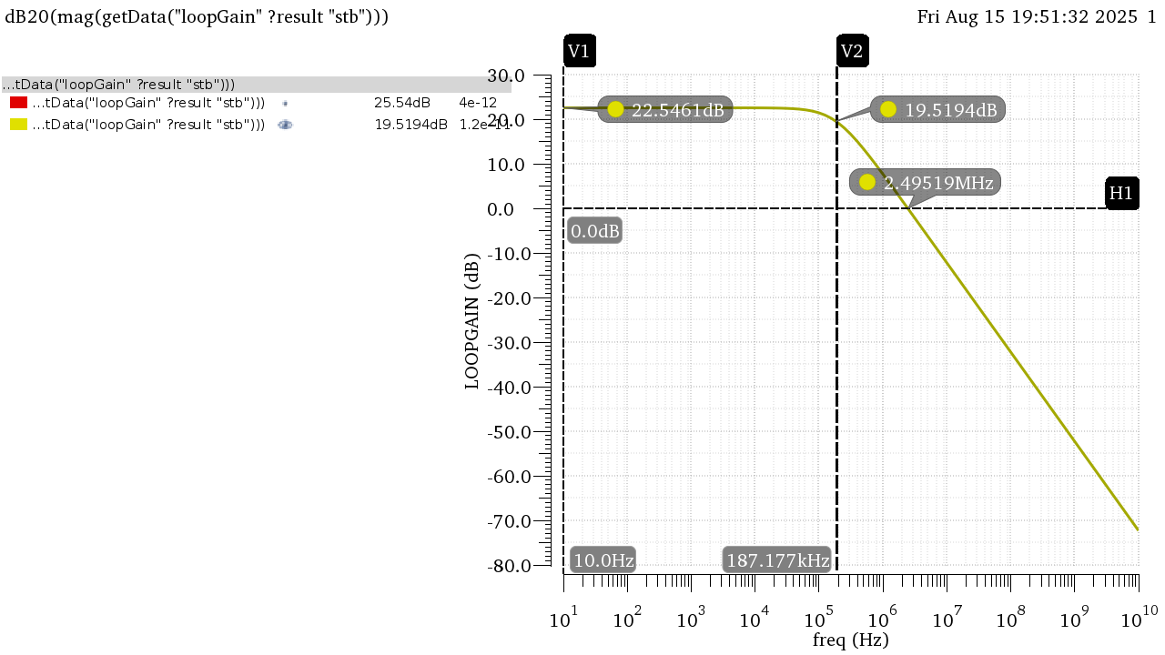

Figure LG Bode Plot Annotated CIN = 12pF

|  |  |  |
| --- | --- | --- |
|  | CIN = 4pF | CIN = 12pF |
| DC LG (dB) | 28.57 | 22.55 |
| DC LG | 26.81 | 13.41 |
| BW | 187.17 KHz | 187.17 KHz |
| UGF | 5 MHz | 2.5 MHz |

Table 2 Results from Simulation

Hand Analysis:

Open Loop Parameters from Last Lab:

|  |  |  |  |  |
| --- | --- | --- | --- | --- |
|  | **CIN = 4pF** | | **CIN = 12pF** | |
|  | Simulation | Analytic | Simulation | Analytic |
| **DC LG (dB)** | 28.57 | 28.465 | 22.55 | 22.444 |
| **DC LG** | 26.81 | 26.5 | 13.41 | 13.25 |
| **BW** | 187.17 KHz | 191 KHz | 187.17 KHz | 191 KHz |
| **UGF** | 5 MHz | 5.0615 MHz | 2.5 MHz | 2.53 MHz |

Analytic Results Agree with simulated ones in both cases of the input capacitor!

* 1. Gain Desensitization:

To sweep the gain, I can either sweep GM or ROUT, I tried both and both resulted in similar results:

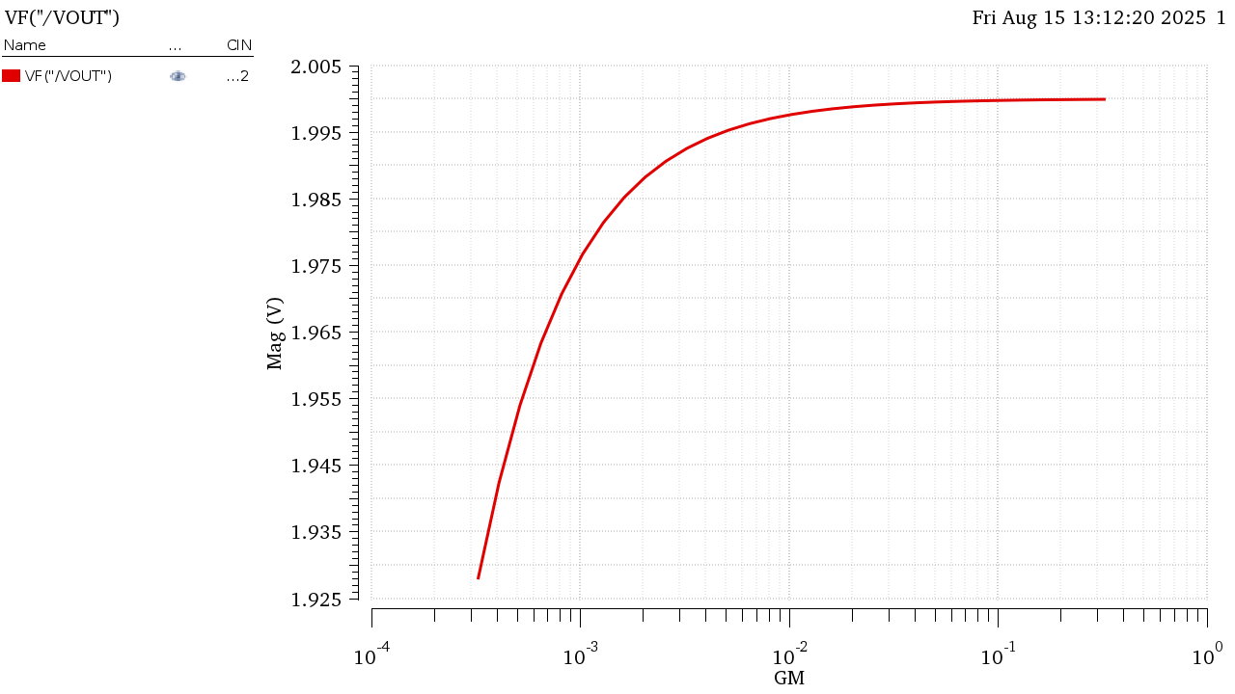

Figure Gain Sweeping GM

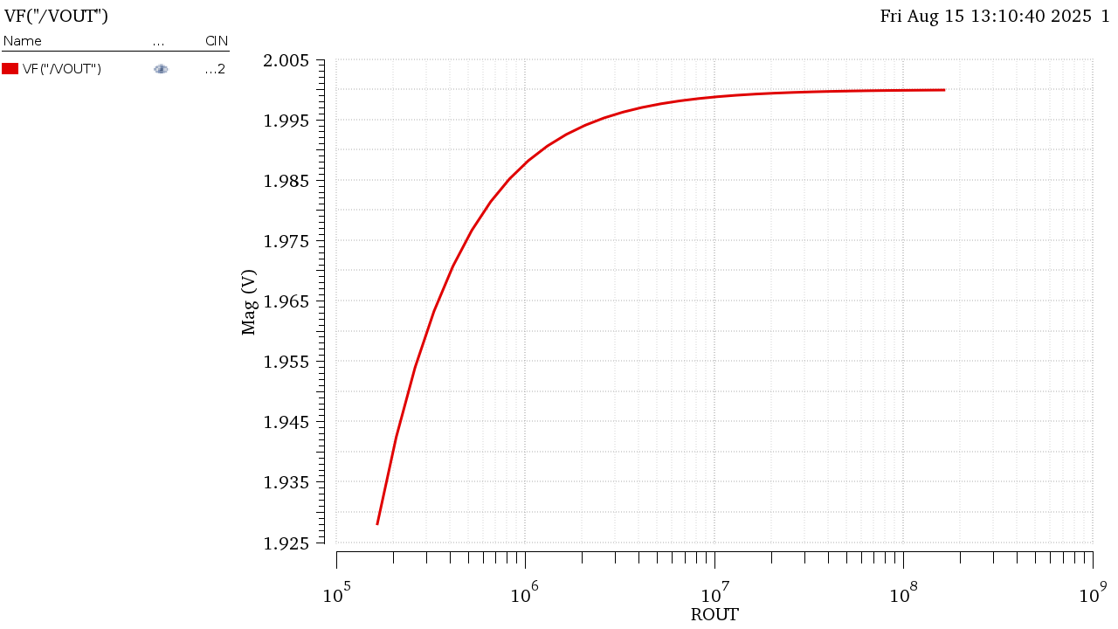

Figure Gain Sweeping ROUT

The Gain is much closer to its ideal value now (Ideal Value = 2) as we increase the Open Loop gain of the amplifier it easier to approximate closed loop gain as . The percentage change would be even if we calculate for higher gains like the case of CIN = 4pF

Part 2: Feedback with Real 5T OTA

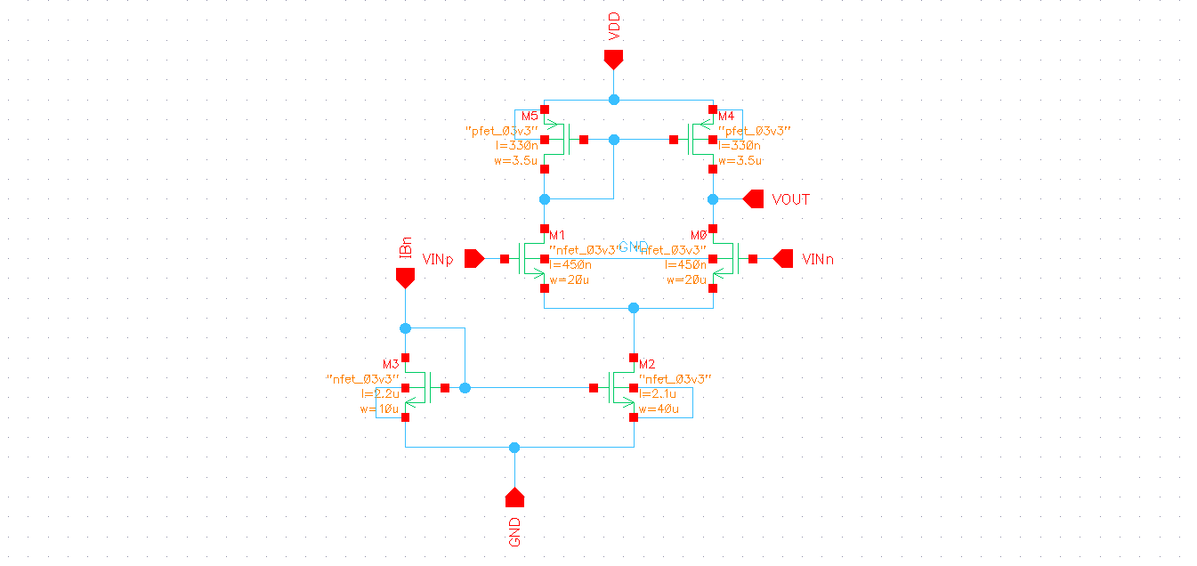

Figure Real OTA Schematic



Figure TB Schematic (Same as Part 1)

2.1 Closed Loop Gian vs Frequency:

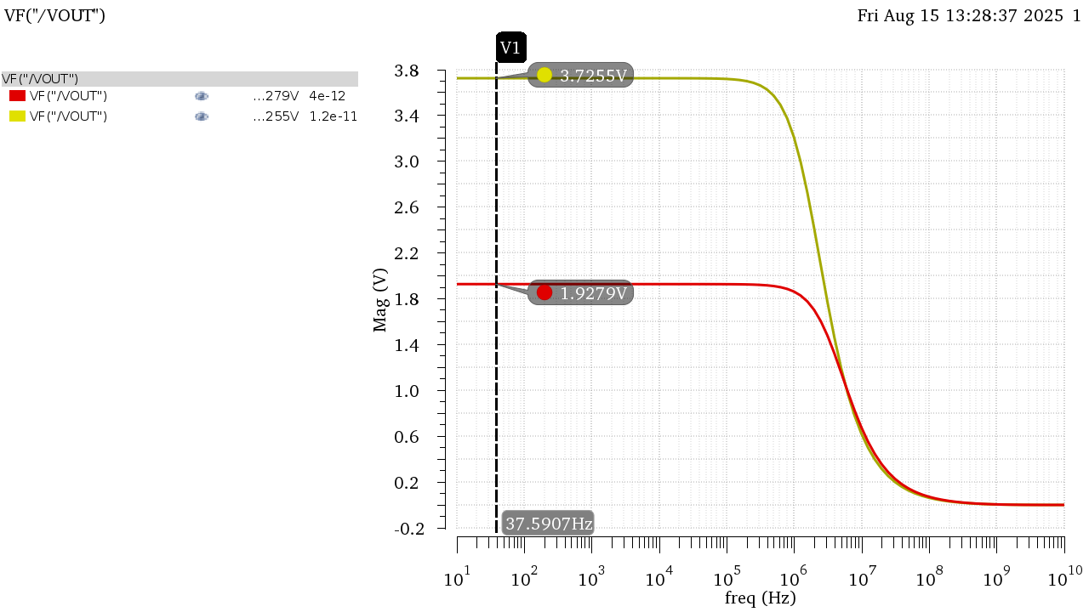

Figure Gain in Mag

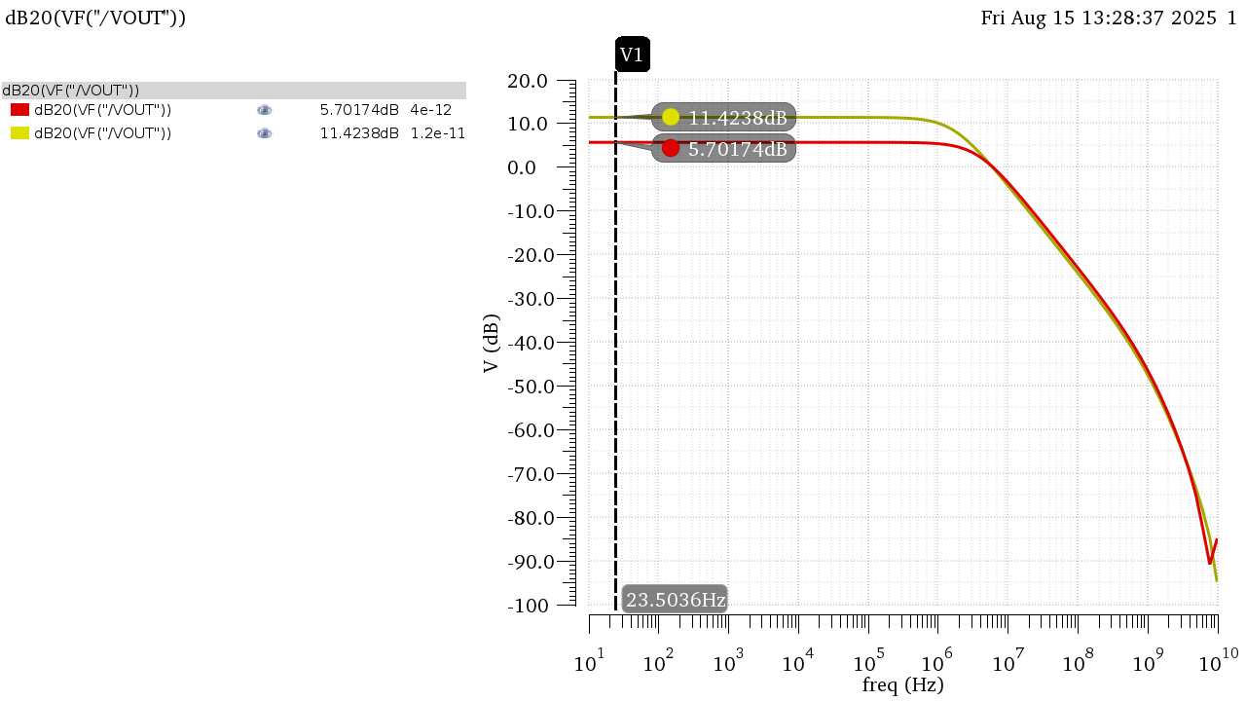

Figure Gain in dB

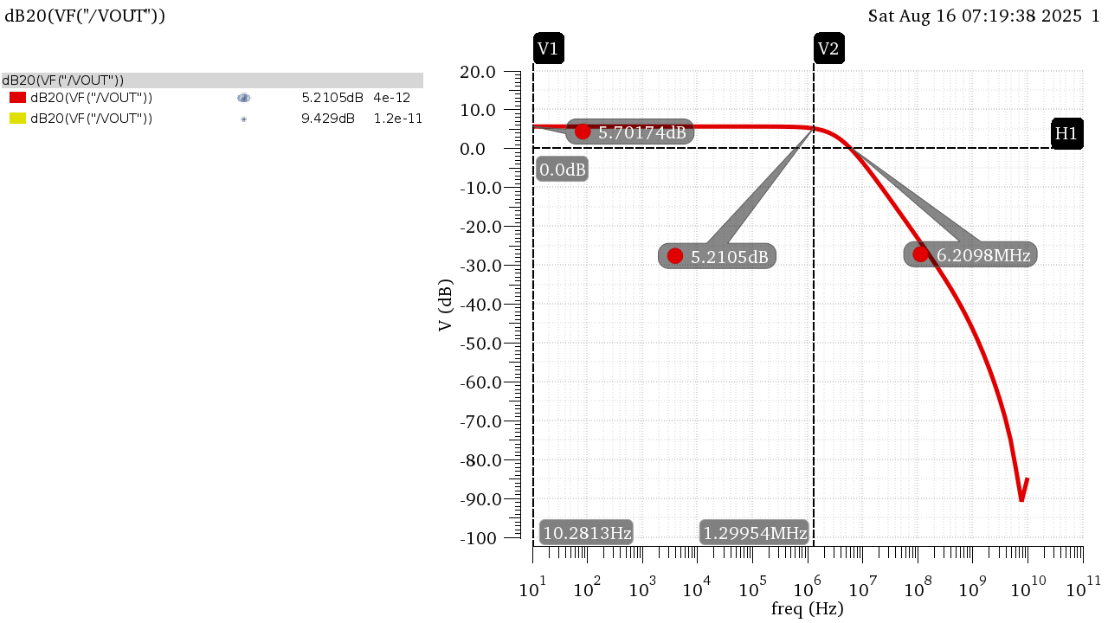

Figure DC LG Bode Plot Annotated at CIN = 4pF

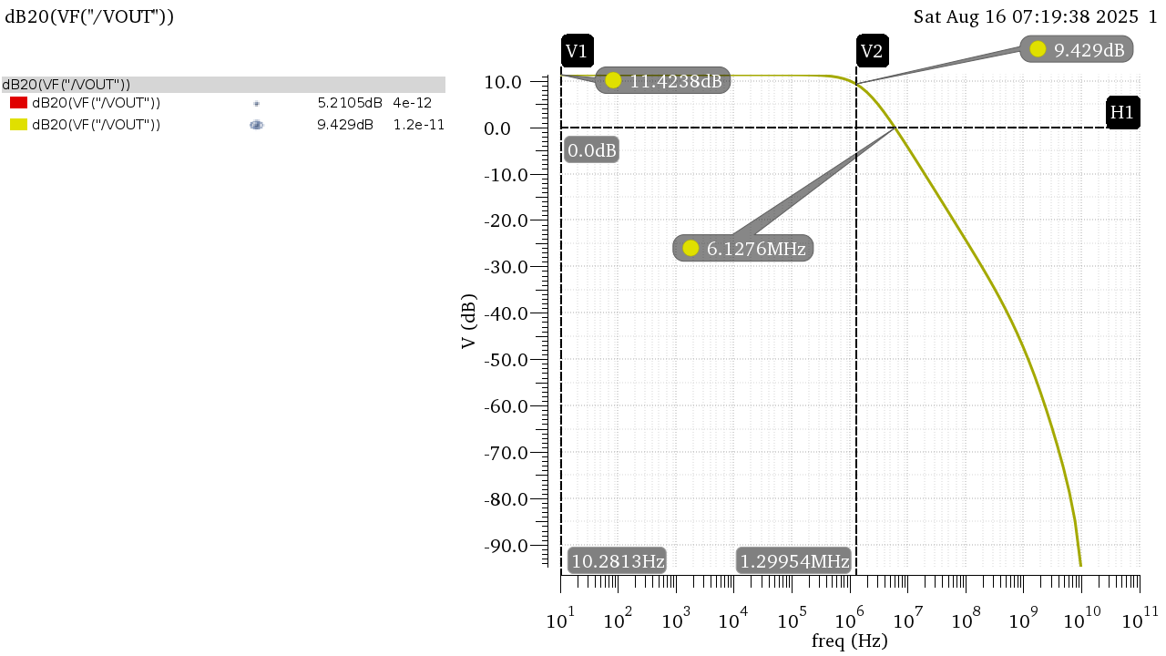

Figure DC LG Bode Plot Annotated at CIN = 12pF

|  |  |  |  |  |
| --- | --- | --- | --- | --- |
|  | **CIN = 4pF** | | **CIN = 12pF** | |
|  | Behavioral | 5T OTA | Behavioral | 5T OTA |
| **DC Gain (dB)** | 5.703 | 5.702 | 11.42 | 11.42 |
| **DC Gain** | 1.928 | 1.928 | 3.722 | 3.726 |
| **BW** | 5.19E+06 | 3.76E+06 | 2.69E+06 | 1.70E+06 |
| **GBW** | 1.00E+07 | 7.27E+06 | 1.00E+07 | 6.37E+06 |

The Bandwidth and consequently the GBW are much smaller than Part 1:

The bandwidth in the OTA is much smaller because the Behavioral model took only CL in consideration when calculating the bandwidth due to the buffer in the behavioral model making ROUT = thus the effect of the loading effect is not seen. While in the real OTA , the ROUT seen in the actual ROUT of the amplifier thus contributing to the pole of the output node making it smaller.

2.2 Loop Gain vs Frequency:

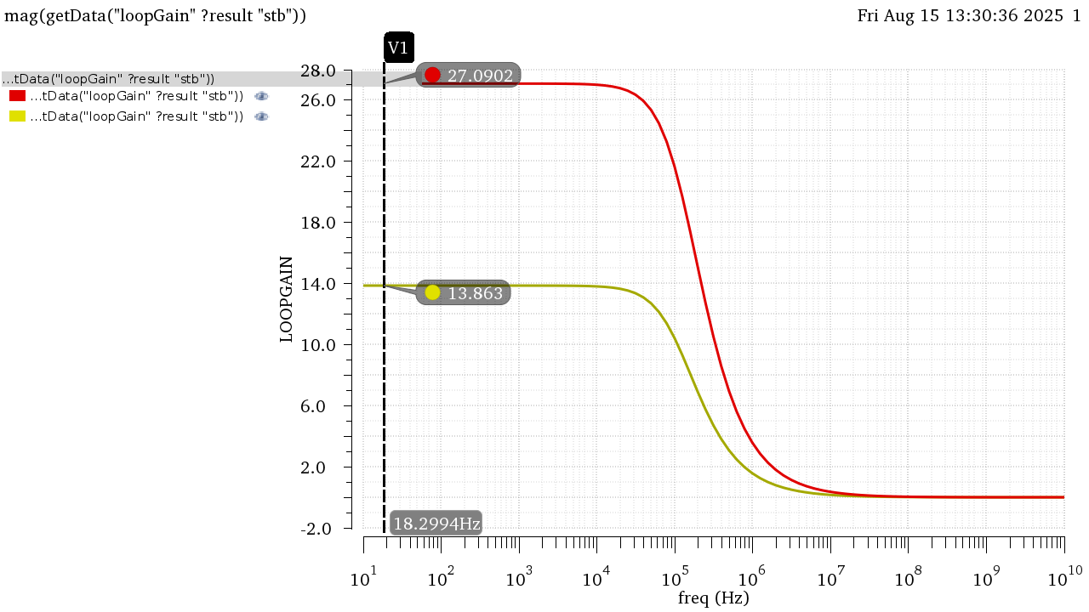

Figure LG in Mag

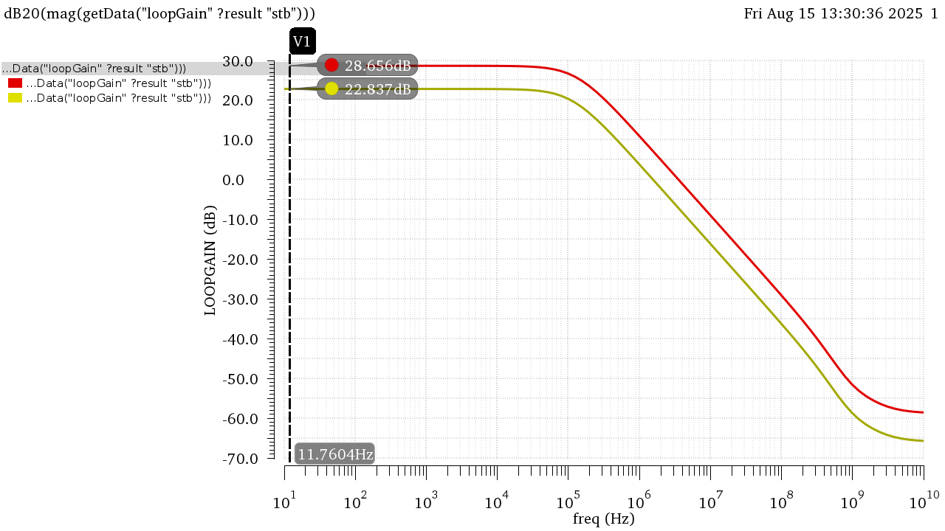

Figure LG in dB

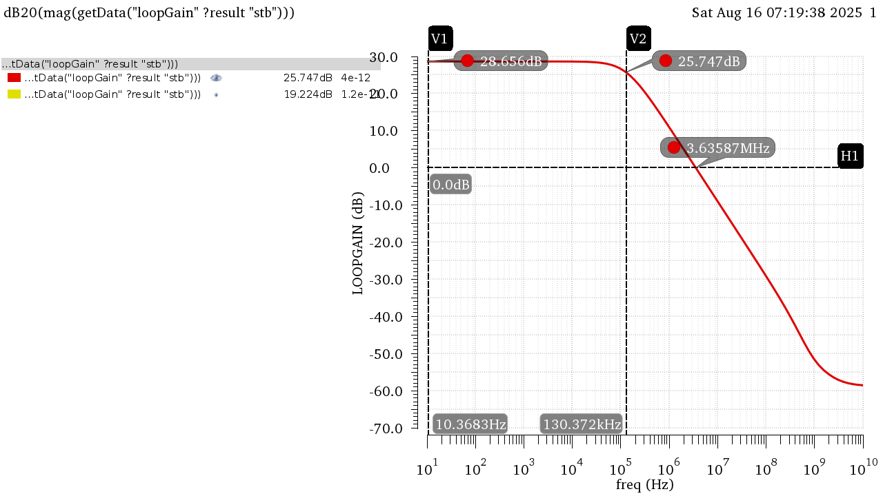

Figure LG Bode Plot Annotated at CIN = 4pF

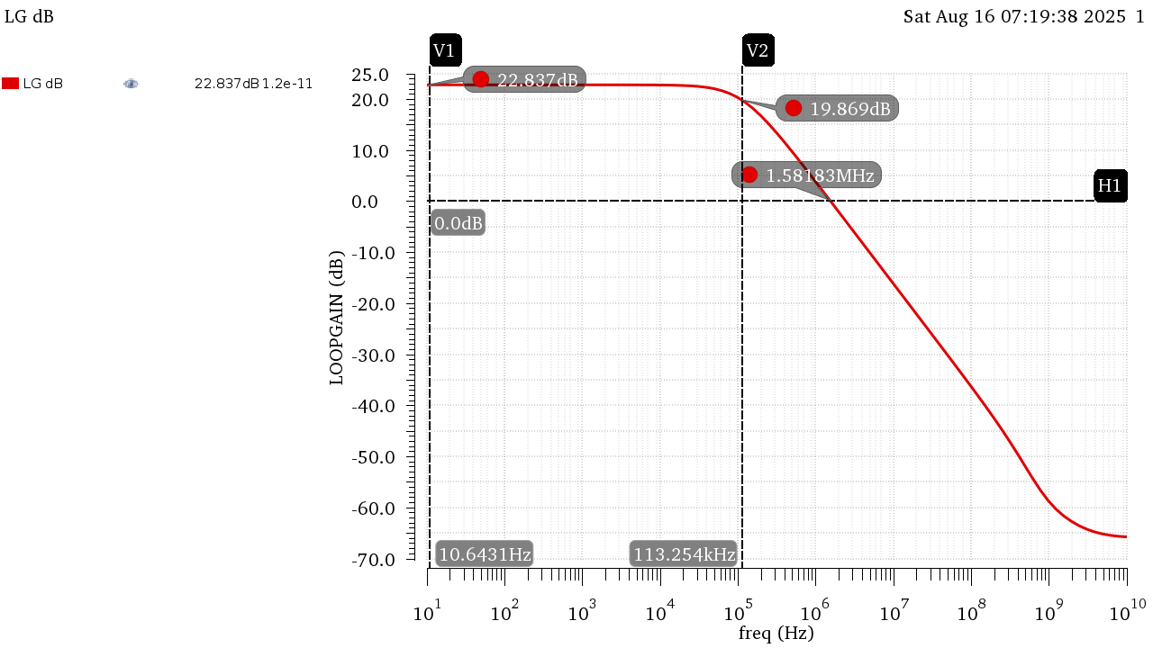

Figure LG Bode Plot Annotated at CIN = 12pF

|  |  |  |  |  |
| --- | --- | --- | --- | --- |
|  | **CIN = 4pF** | | **CIN = 12pF** | |
|  | Behavioral | 5T OTA | Behavioral | 5T OTA |
| **DC LG (dB)** | 28.57 | 28.66 | 22.55 | 22.84 |
| **DC LG** | 26.81 | 27.09 | 13.41 | 13.86 |
| **BW** | 187.17 KHz | 1.34E+05 | 187.17 KHz | 1.15E+05 |
| **UGF** | 5 MHz | 3.66E+06 | 2.5 MHz | 1.58E+06 |

UGF is much smaller than in Part 1:

Due to the same reason stated previously, The buffer isolated Rout from seeing the loading effect thus only CL contributed to the Pole, but in the real OTA at the output node the loading effect of the added capacitors is seen such that the capacitance seen is Contributing to a lower bandwidth thus a lower UGF.

2.3 Gain Desensitization:

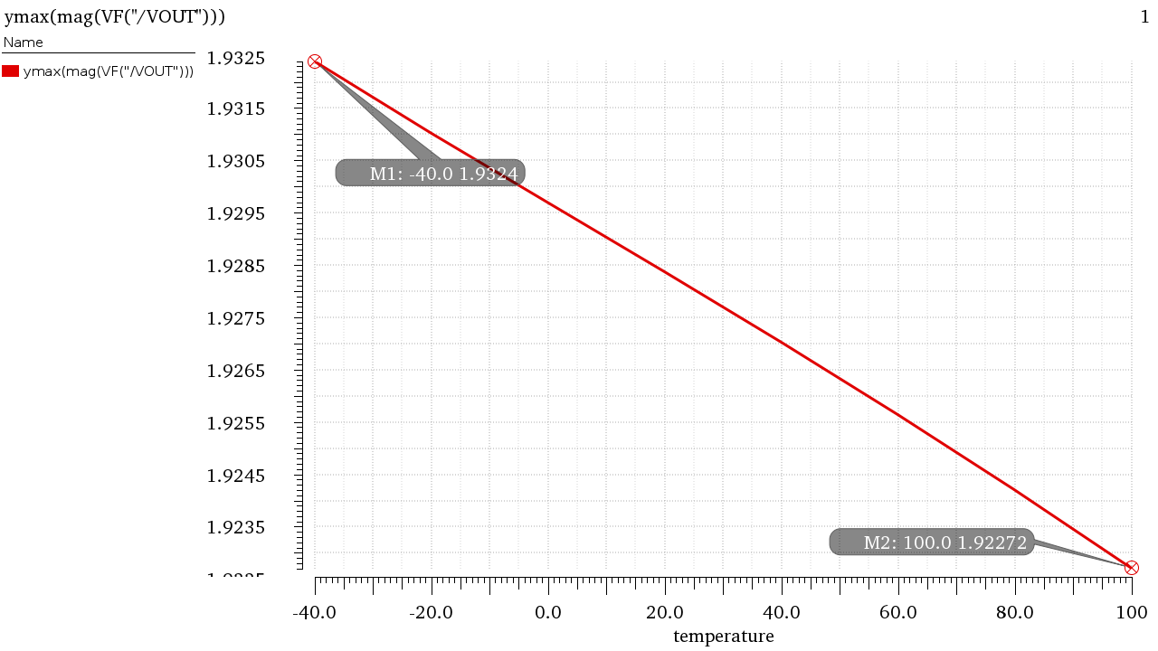

Figure ACL in Mag vs Temp (Extreme Points Annotated)

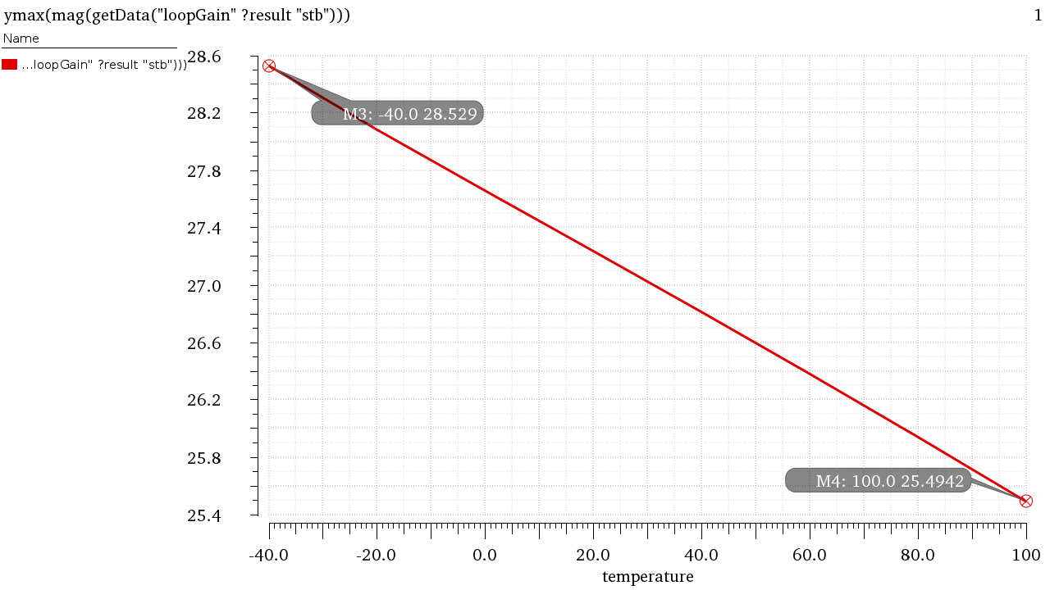

Figure LG in Mag vs Temp (Extreme Points Annotated)

The percentage change in LG is much more pronounced than the percentage change of ACL, as ACL depends on the ratio of capacitances (Which isn’t affected by temperature much) much more heavily due to the big gain of AOL while LG depends on AOL which depends on the active components of the circuit whose parameters change heavily by temperature and process variations. This demonstrates the importance of feedback in desensitizing against PVT.

2.4 Transient Analysis:

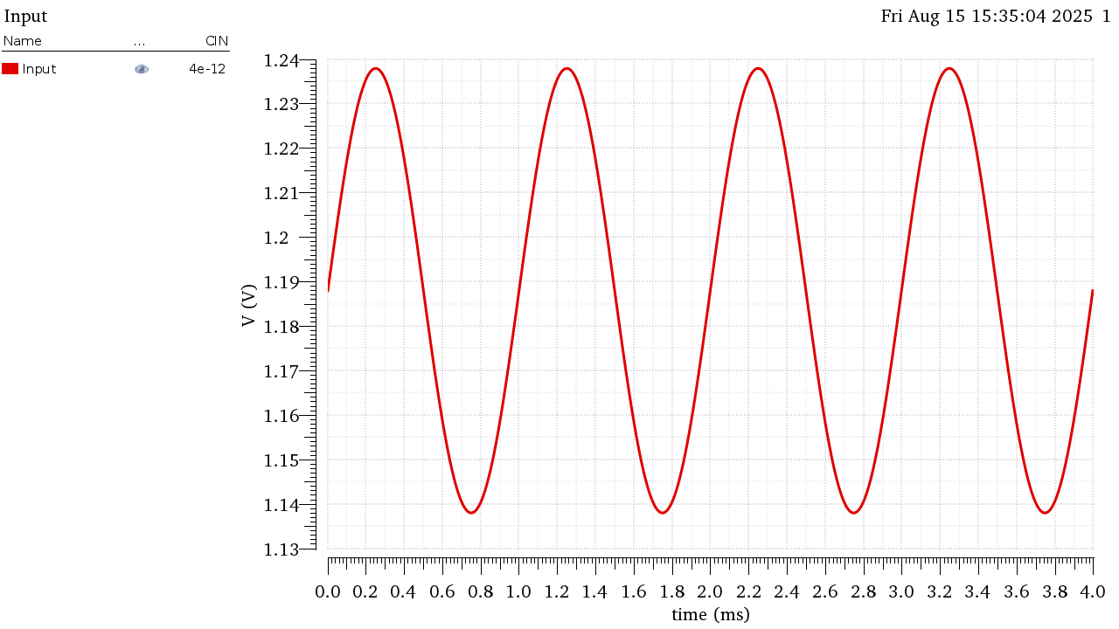

Figure Input Signal

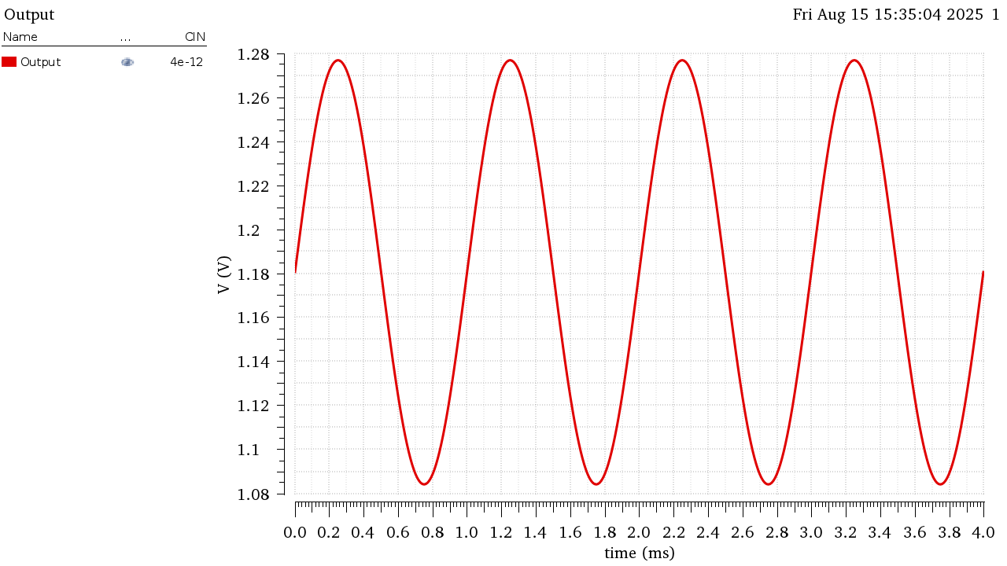

Figure Output Signal

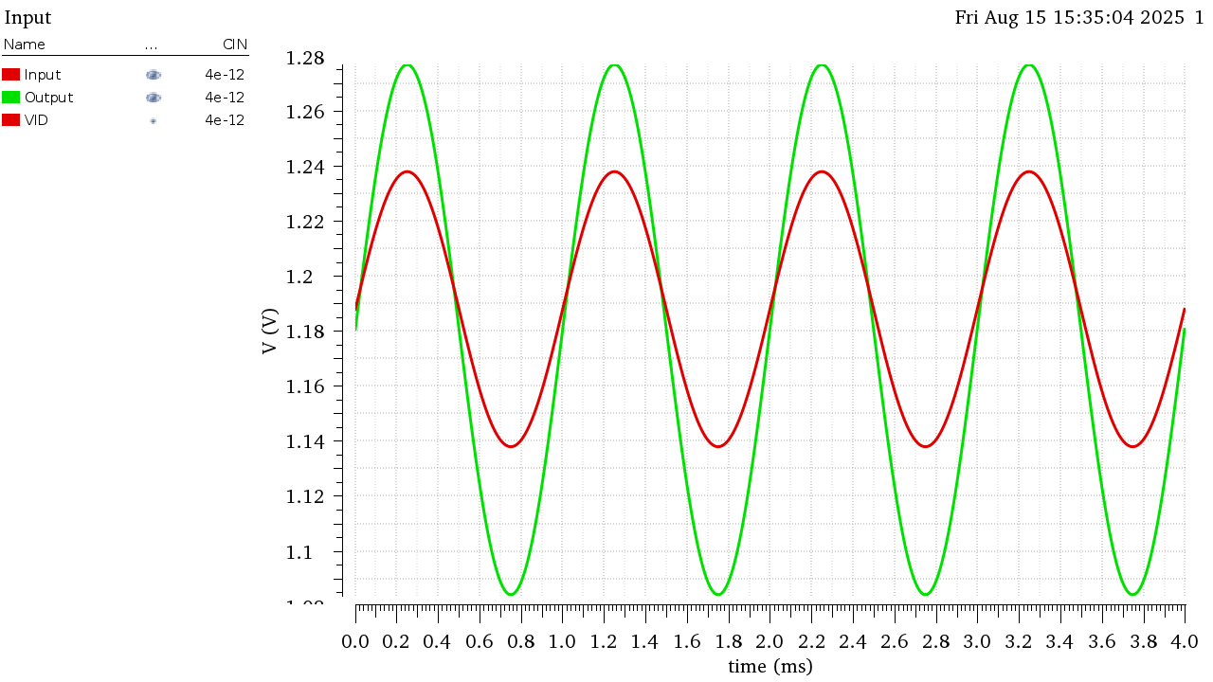

Figure VIn and Vout Overlaid (To Showcase Gain)

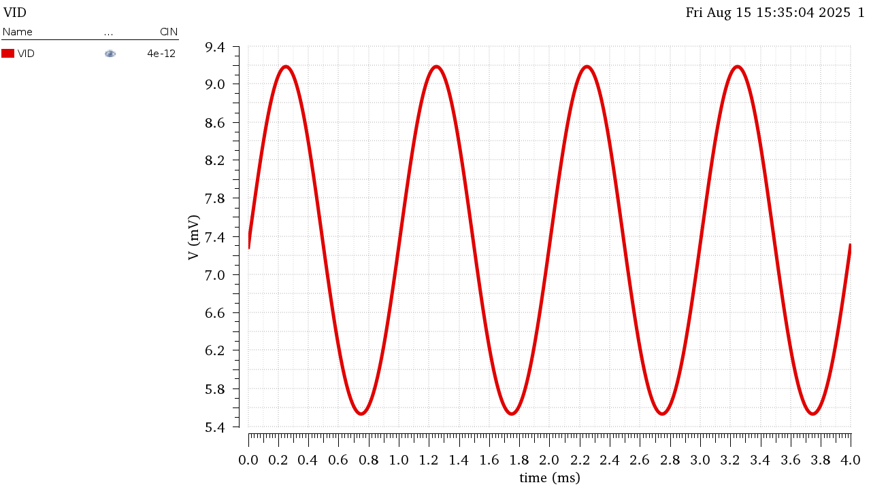

Figure Verror (VP-VN)

|  |  |  |  |
| --- | --- | --- | --- |
|  | VIN | VOUT | VID |
| Peak to Peak (V) | 1.00E-01 | 1.93E-01 | 3.66E-03 |

The relationship between the Output Voltage and Error Voltage or the Differential Input voltage of the amplifier is the Open Loop Gain.

Using FIN=BWOL=134KHz

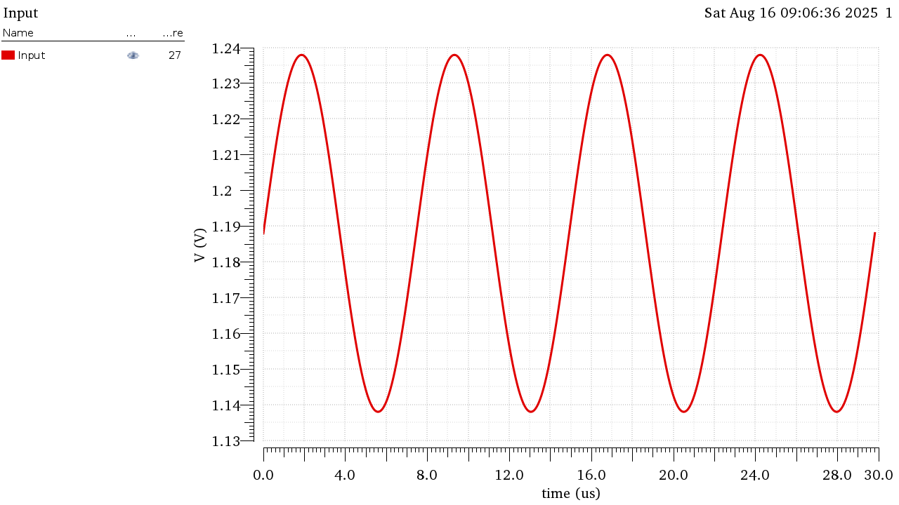

Figure Input Signal at FIN=134KHz

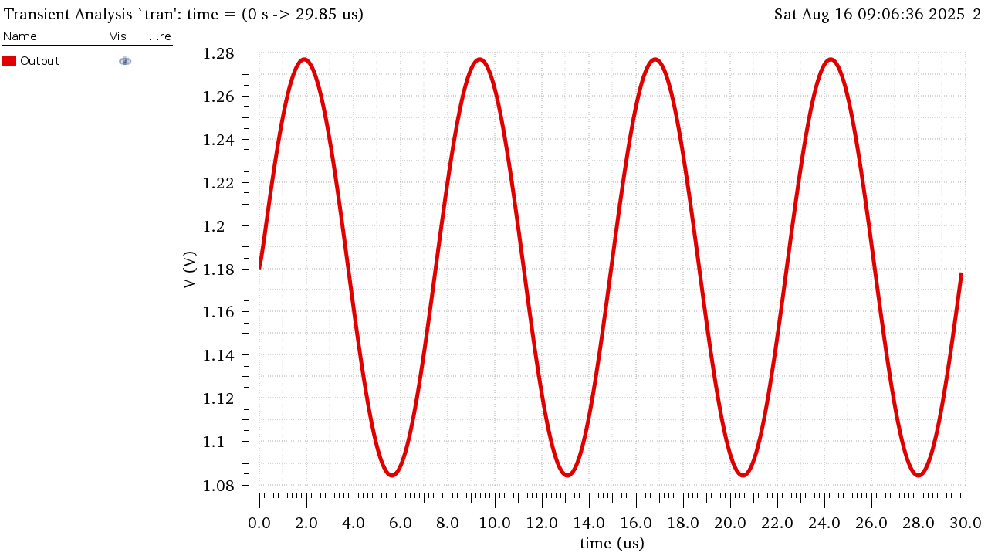

Figure Output Signal at FIN=134KHz

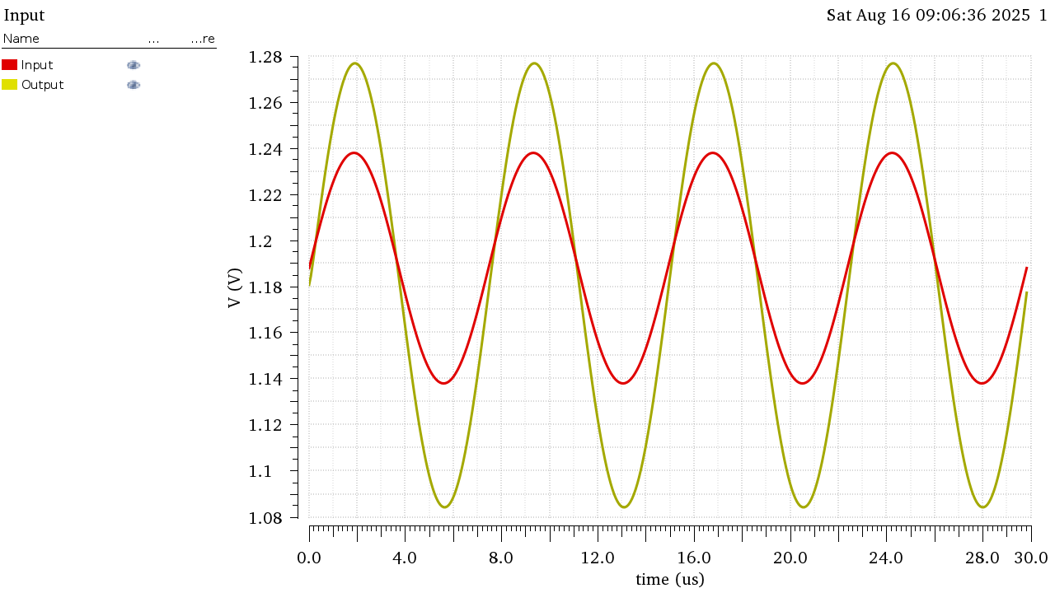

Figure Vout and Vin Overlaid FIN=134KHz

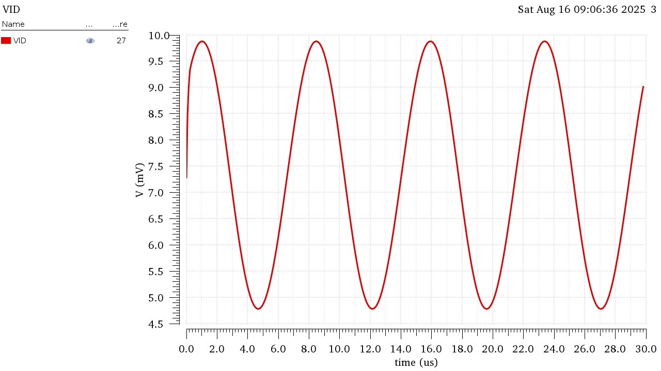

Figure Verror at FIN=134KHz

|  |  |  |  |
| --- | --- | --- | --- |
|  | VIN | VOUT | VID |
| Peak to Peak (V) | 1.00E-01 | 1.93E-01 | 5.10E-03 |

The relationship between the Output Voltage and Error Voltage or the Differential Input voltage of the amplifier is the Open Loop Gain divided by root 2 as the Input signal is at the cutoff frequency.

Using FIN=BWCL= 3.76MHz

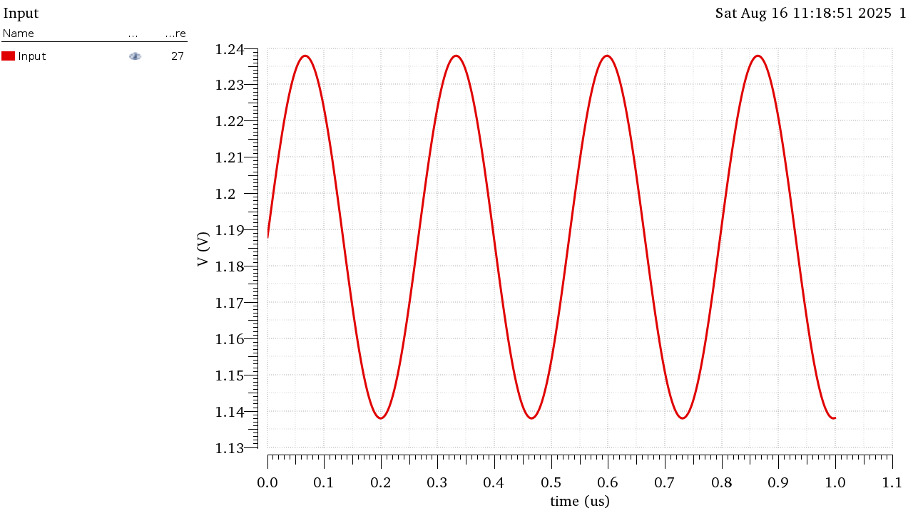

Figure Input Signal at FIN = 3.76MHz

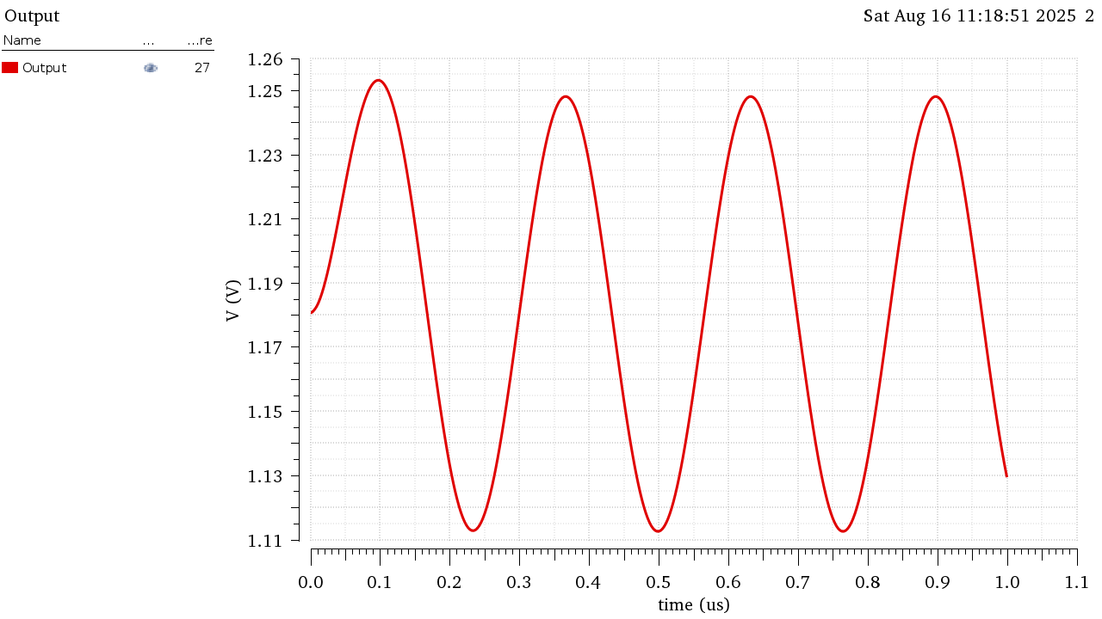

Figure Output Signal at FIN = 3.76MHz

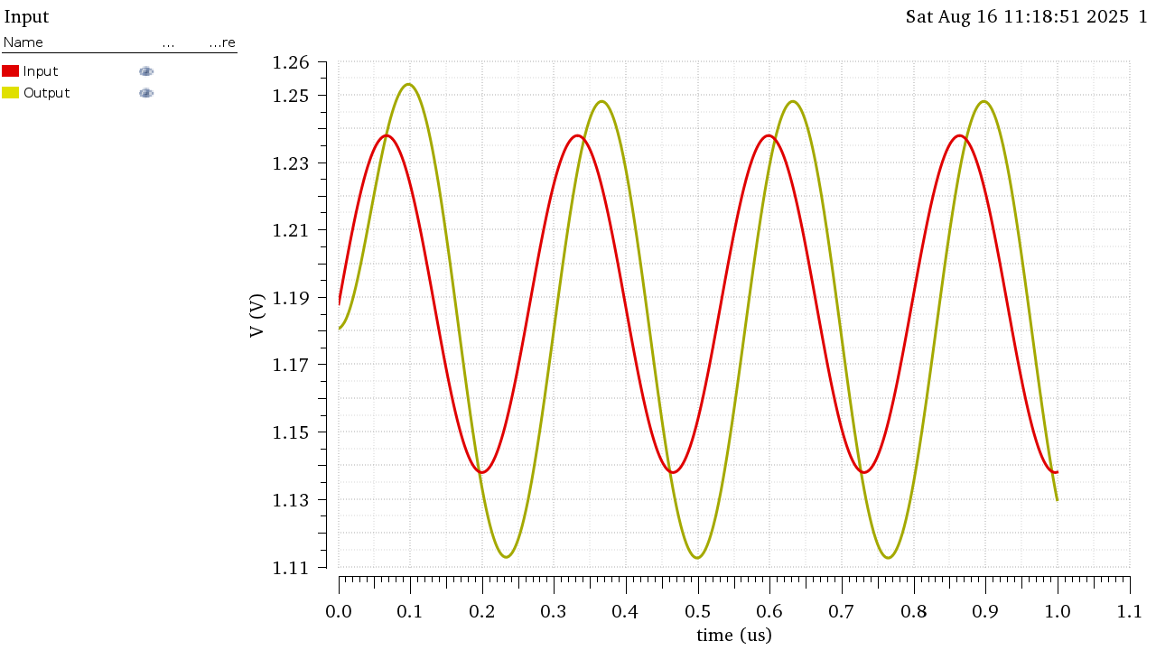

Figure Vin and Vout Overlaid at FIN = 3.76MHz

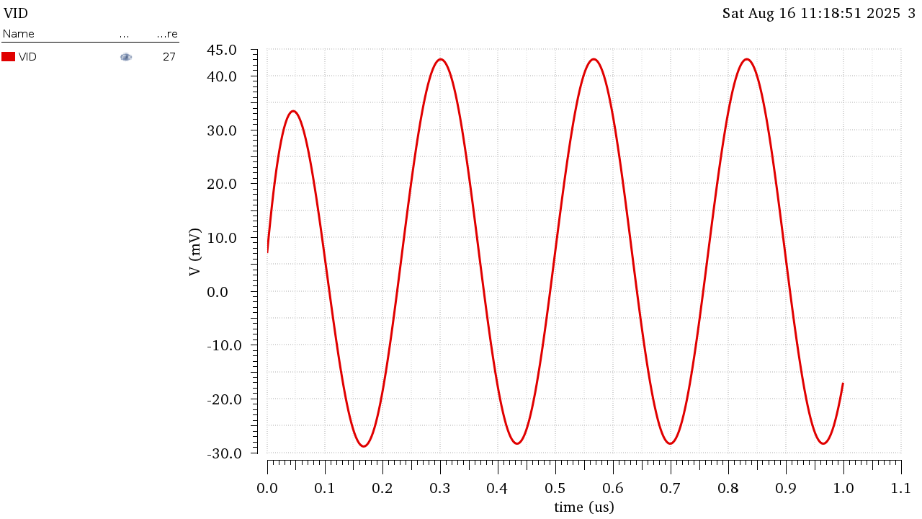

Figure VID (Verror) at FIN=3.76MHz

|  |  |  |  |
| --- | --- | --- | --- |
|  | VIN | VOUT | VID |
| Peak to Peak (V) | 1.00E-01 | 1.41E-01 | 7.20E-02 |

The Closed loop gain dropped by approximately a factor of root 2 as this is the bandwidth of the Closed Loop Gain.

This is also the Unity Gain Frequency for the Loop Gain thus and since is constant and doesn’t depend on frequency, drops to be approximately equal to but we notice it is still less than the actual value of the feedback factor.

This is because we didn’t account for the phase shift in this approximation as the LG is actually (-j) not 1 at this frequency as also seen from figure 35 the input and output are 90 degrees out of phase making the feedback factor slightly smaller and the closed loop gain slightly larger.