Design Challenge 1
Digitally Controlled VGA

Part 1: OTA Design
Required Specifications:
Technology | 65nm
Supply voltage | 2V
Reference current seed | Use a single 20uA ideal reference current source.
Output type | Single ended
External load | 500 fF
Feedback type | Capacitive (use 500fF unit capacitors ONLY)
Digital control | Single bit signal (D0)
Closed loop gain | D0 = 0: 6 dB D0 = 1: 12 dB
LG PM (worst case) | > 60o
DC LG | > 54 dB
Closed loop BW | > 10 MHz
Output swing | > 1.6 V pk-to-pk
Power Consumption | Minimize

Design Observations:
- Required Loop gain is large: 2 Stage OTA works better
- Digitally controlled: A switch is needed
- Single Ended
- Wide Output swing: I need Vout at middle of VDD (1V) and Vin at the same voltage using feedback thus nmos input stage is best to sustain the bigger input voltage.
A Miller 2 Stage OTA works best of this design with capacitive feedback and a switch to control the gain.
- No spec on CMIR: Use NMOS for the NMOS stage and PMOS for the second stage
- Use Inverting configuration for better performance
Design Parameters:
$$LG=54dB→501.187≈500=βA_{OL}$$
$$Worst Case β=\frac{1}{5}→A_{OL_{worst case}}=2500→68dB$$
$$BW_{OL}=\frac{BW_{CL}}{1+LG}≈20KHz→GBW_{OL}=50MHz$$
Worst case Cout:
$$C_{OUT}=C_{in}+C_{L}=2.5pF$$
$C_{C}=0.5*C_{OUT}=1.25pF$
Input Transistors:
$$A_{OL}=68→divide into 2 for both stages$$
$$A_{OL}\left(First Stage\right)=34dB→50$$
$$GBW_{OL}=\frac{gm_{input}}{2πC_{C}}→gm_{input}≈400μS$$
$$A_{v}≈gm_{input}\frac{ro}{2}=50→ ro≈255KΩ$$
Assume MI $\frac{gm}{I_{d}}=15$
$$\frac{gm}{I_{D}}=15→I_{D}=26μA$$
$$Assume I_{D}≈40μA higher margin for the big BW required and easier mirroring$$
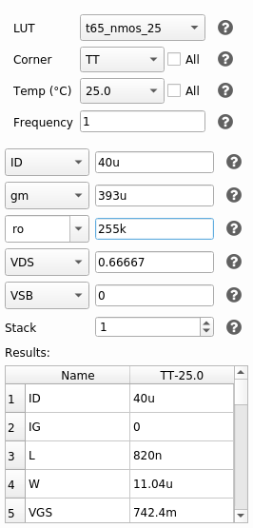
Figure 1 Input pair Sizing from ADT SA
$L=820nm , W=11μm$
PMOS Current Mirror Load:
From previous device:
$$I_{D}=40μA , ro=255KΩ$$
Since there is not spec on the CM input range, I’ll assume moderate inversion:
$$\frac{gm}{I_{D}}=15$$
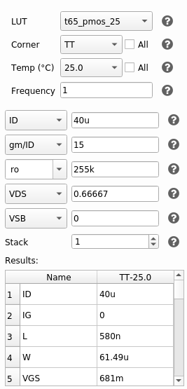
Figure 2 Sizing of PMOS Load from ADT
$$L=580nm , W=61.5μm$$

Tail Current Mirror Sizing:
From Previous Parts:
$$I_{D}=80μA$$
$$Assume\frac{gm}{I_{D}}=10 \left(Weak Inversion\right)$$
$$Assume Long L=1μm (For accurate Mirroring)$$
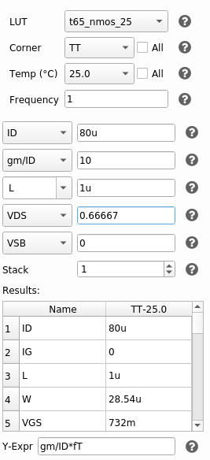
Figure 3 Sizing of Tail Current Mirror from ADT
$$L=1μm , W=28.54μm , ro=143KΩ$$

Current Mirror:
For the Tail current Mirrors I just used multipliers to get accurate and quick mirroring of the currents in each stage.
I assumed $I_{B2}=4*I_{B1}$ for better Stability.
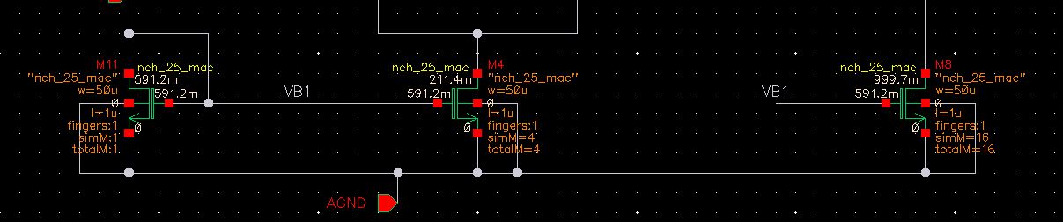
Figure 4 Tail Current Mirror
Second Stage CS Amplifier:
$$I_{D}=I_{B2}=320μA$$
And Putting $V_{DS}=\frac{V_{DD}}{2}=0.9V$
And Using ro from the previous device to calculate the gain and get ro for the output device
$$A_{v}=34dB→50≈{gm}_{output}\left(ro//143K\right)→ro=10KΩ$$
And using the same value of VGS for the PMOS Current Mirror Load to avoid latching:
$$V_{GS}=681mV$$

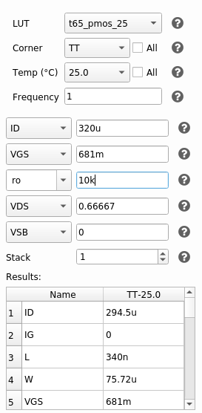
Figure 5 Output PMOS device Sizing from ADT
$$L=340nm , W=75.72μm$$

Feedforward Zero:
Finally, finding the value of the resistor to cancel the feedforward zero is simple enough:
$$R_{C}=\frac{1}{gm_{output}}≈300Ω$$
Initial Design Point:
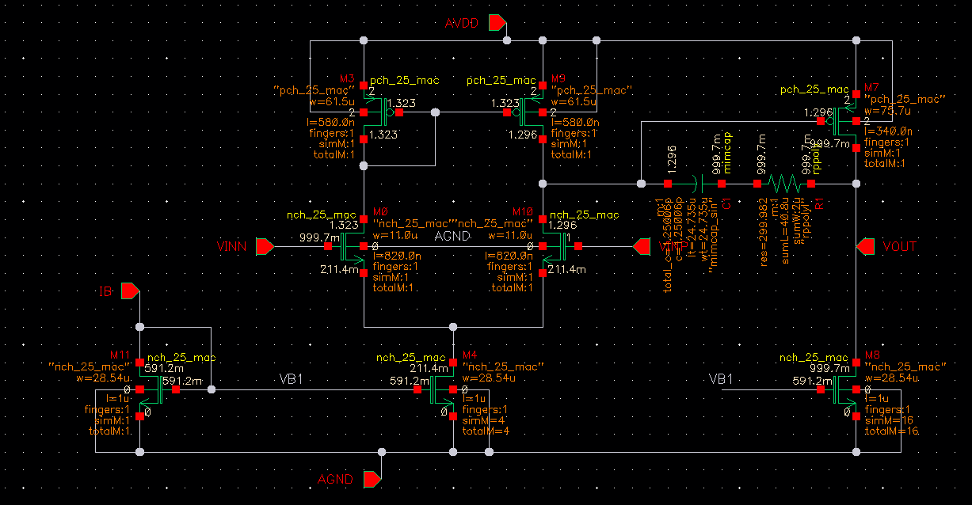
Figure 6 Final Design Schematic with initial sizing of all devices

Simulation and Design Iteration:
The results obtained from the first design point were satisfactory but below the required spec, so I had to do some fine tuning. I increased the widths of the input devices of both stages to get better LG as well as some devices lengths and widths for more accurate results.

I tested the OP point as well as some open loop parameters first in an Open Loop testbench for my design iterations to take a good understanding of what to expect with the circuit before I move to closed loop analysis in the next part
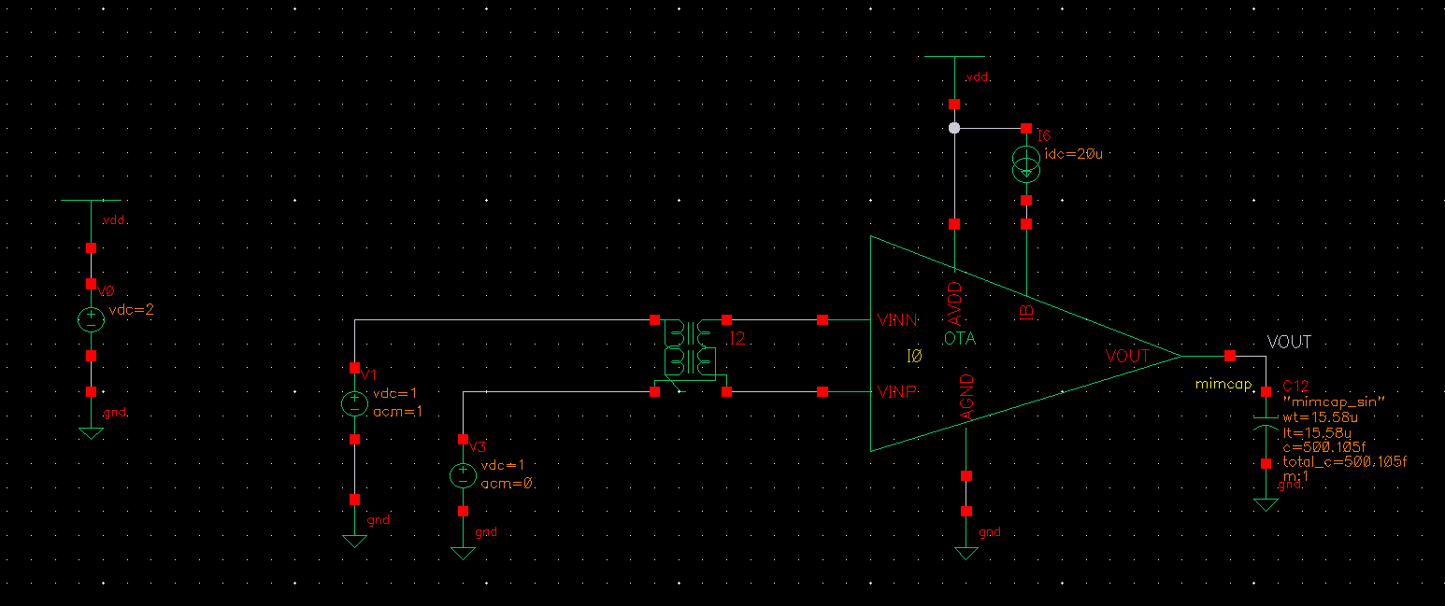
Figure 7 Initial Open Loop Testbench

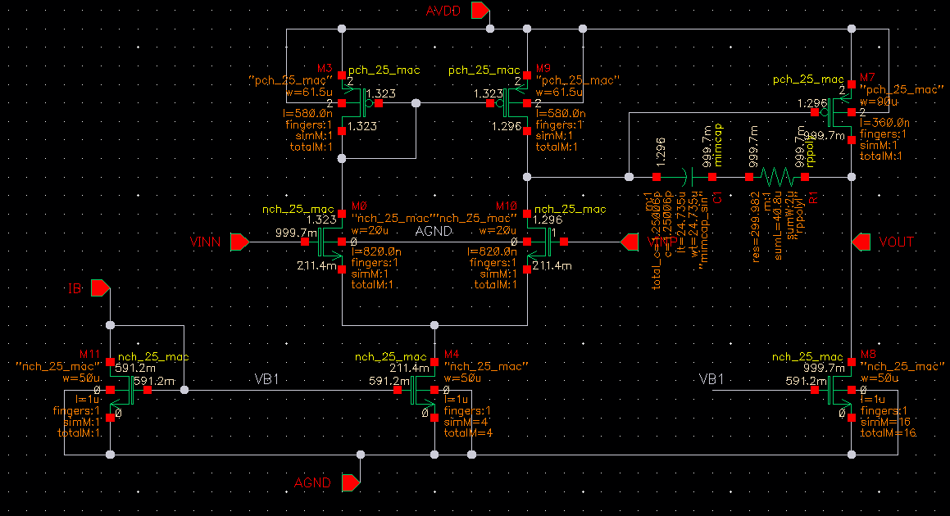
Figure 8 Final Sizing for all devices

Testbench:
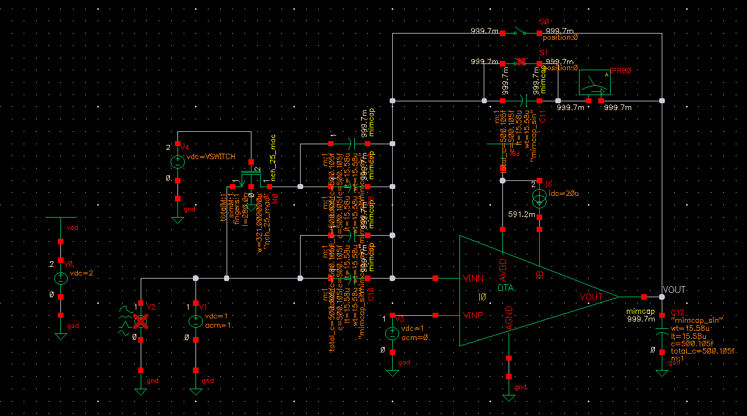
Figure 9 Closed Loop Testbench
As required, I used unit capacitors of 500fF each and configured the testbench in the Inverting configuration.

Switch Sizing:
Last Device required to be sized.
I need its turned-on resistance to be a good margin away from the impedance of the capacitor in the worst-case scenario
$$Ron≪X_{C}(@10MHz)$$
$$Assum Ron=\frac{X_{C}}{1000}=\frac{1}{2πfC*1000}≈16Ω$$
Using Minimum L and VDS and VGS = 2V
And using an NMOS device for the switch to be turned on when VGS is equal to VDD (2v: Digital High)
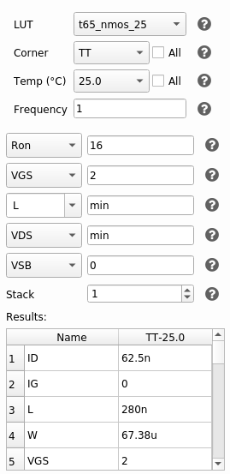
Figure 10 Sizing of Switch from ADT
During Simulation I used even Larger W for even lower RON
Part 1 (Continued): Simulation:
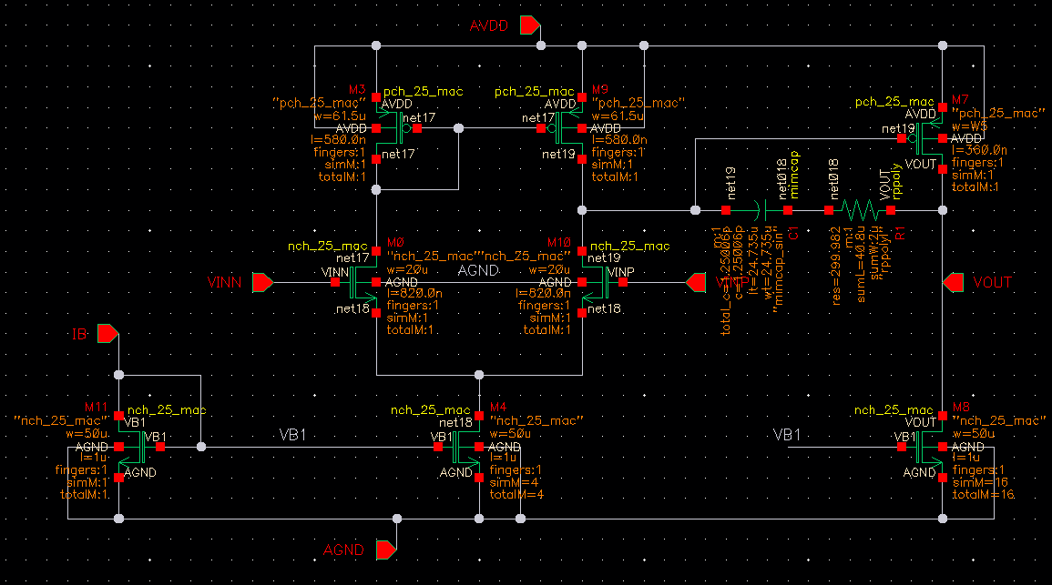
Figure 11 Final Schematic Sizing
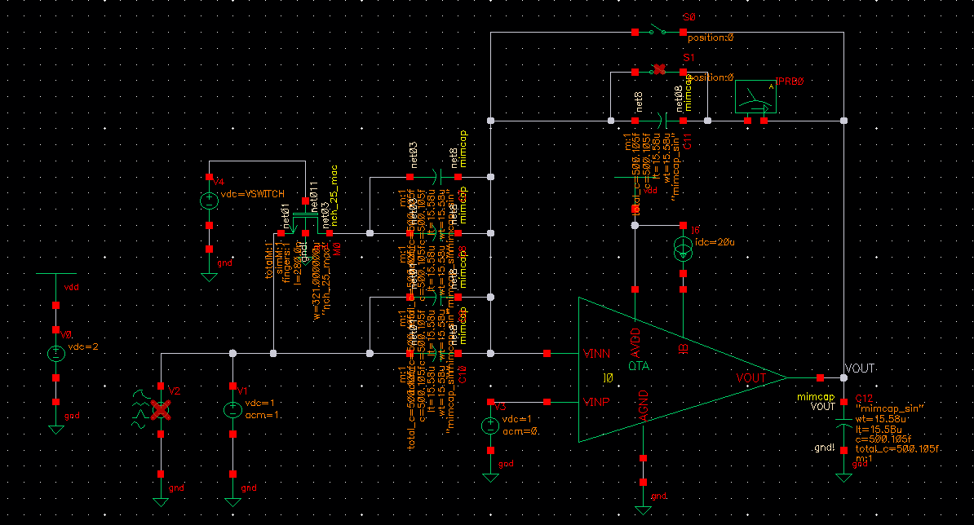
Figure 12 Testbench Schematic

OP Analysis:
. 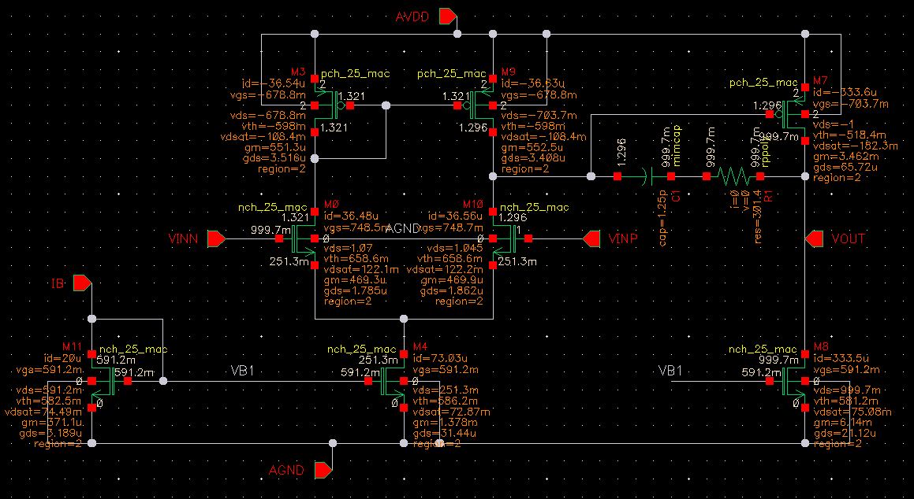
Figure 13 OP Point and DC Voltages Annotated on OTA Schematic
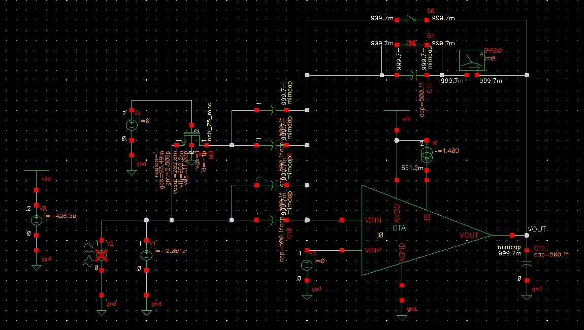
Figure 14 DC Voltages and OP Point annotated on Testbench Schematic

Phase Margin At worst case scenario:
Phase margin is worst in unity gain configuration; I simulated this with a switch shorting the Feedback Capacitor and switch is switched on:
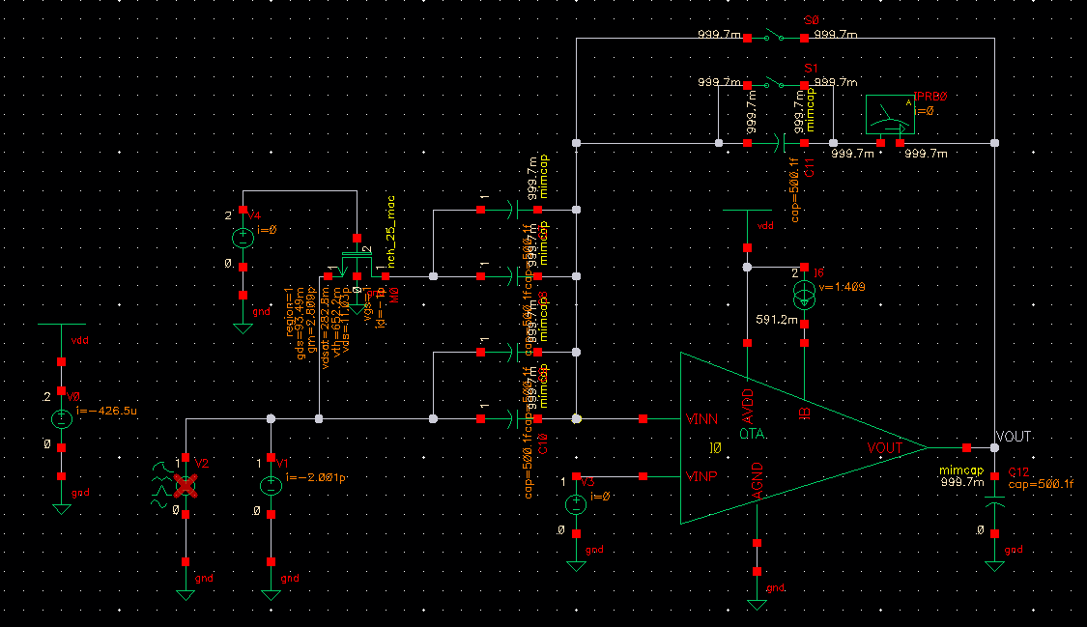
Figure 15 Testbench Configured for Unity Gain Configuration Sim
Running STB Simulation from 1Hz to 10GHz with 10 Points per decade:
Figure 16 Phase Margin from Simulation
$$PM={66.69}^{o}$$
Phase Margin Meets the Spec!

CL Gain, BW, LG, and PM:
Running both STB and AC analysis from 1Hz to 10GHz
When Switch is closed (D0:1): Worst Case Scenario for LG
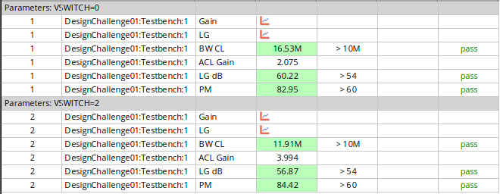
Figure 17 Simulation Results
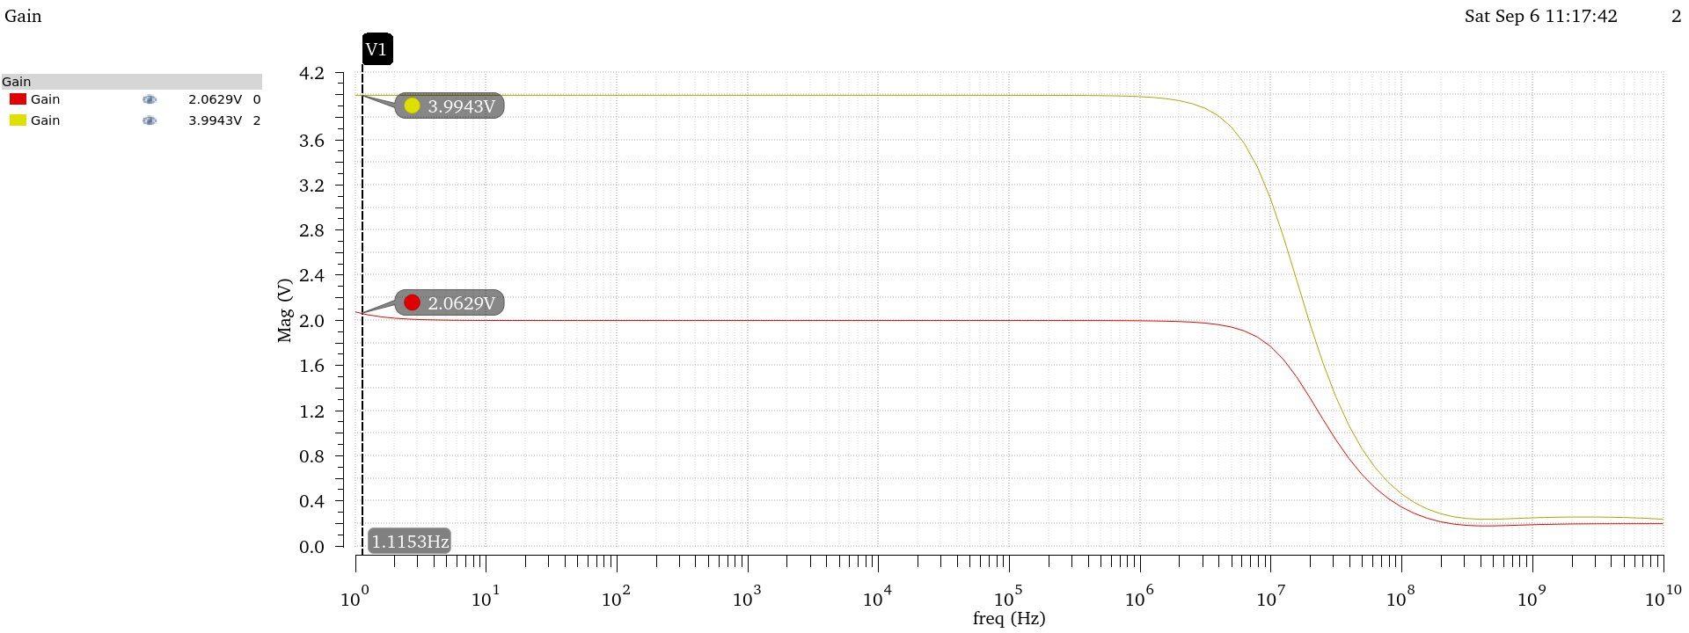
Figure 18 ACL Gain Magnitude
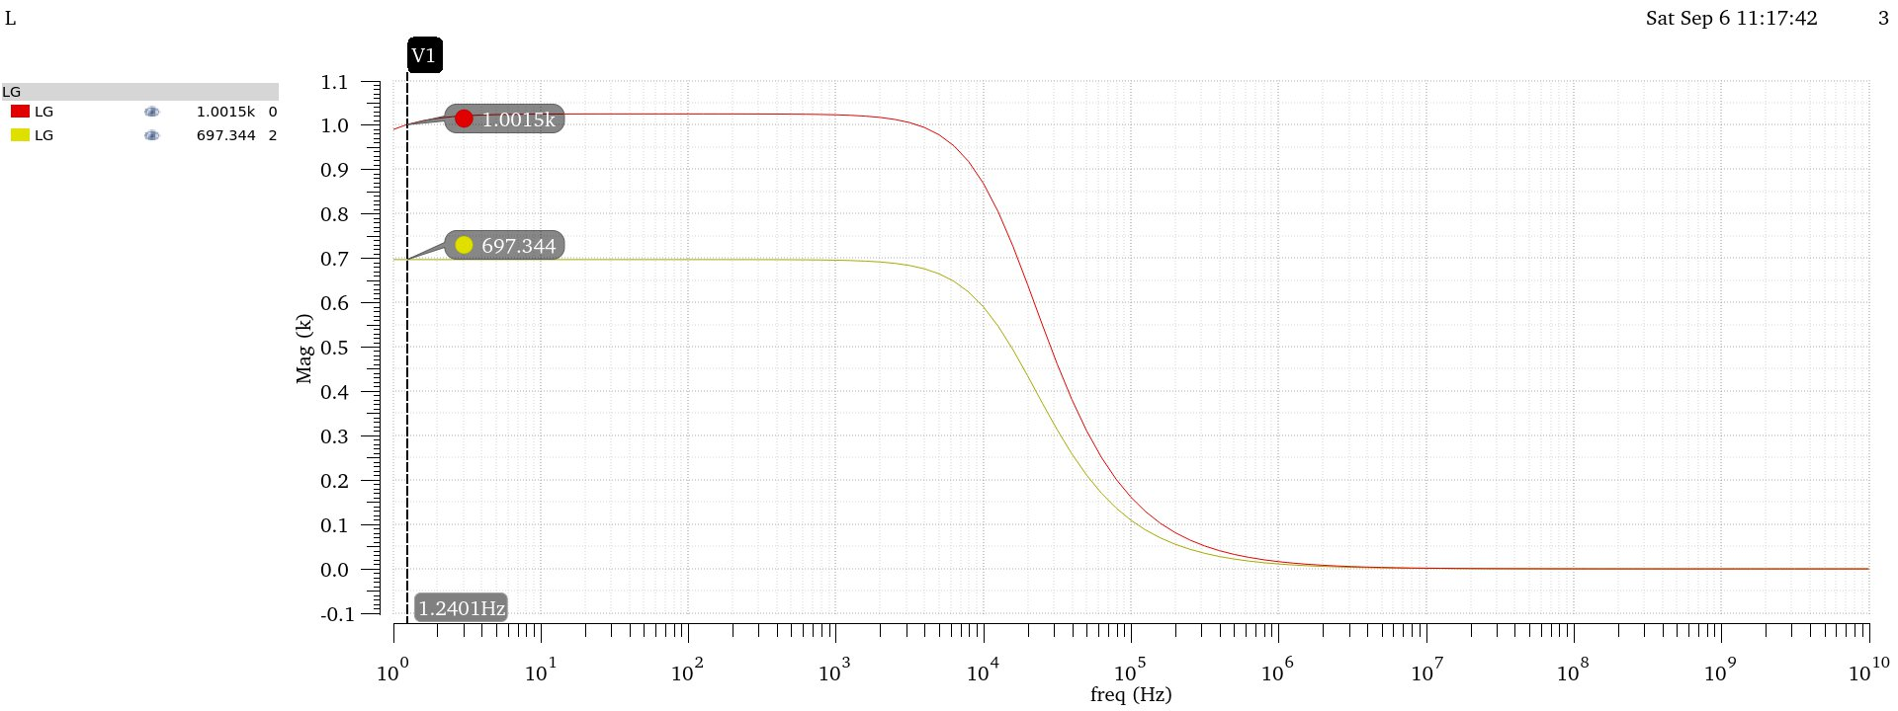
Figure 19 LG in Magnitude
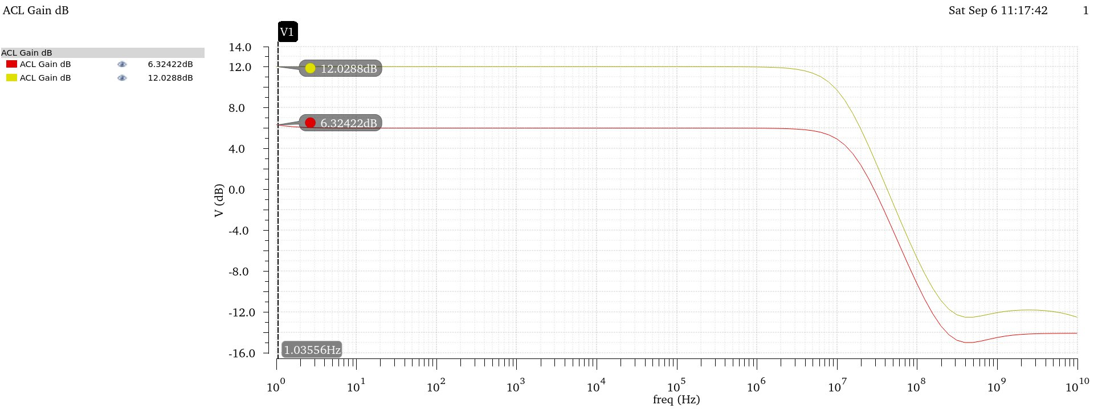
Figure 20 ACL in dB
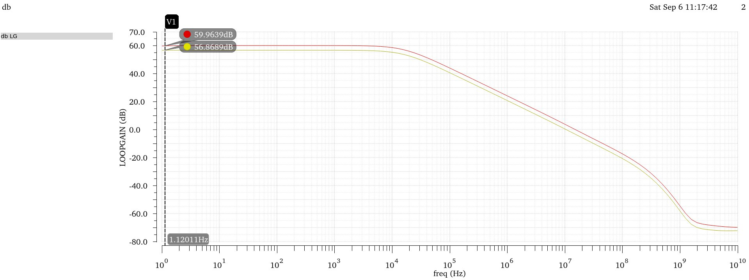
Figure 21 LG in dB
All Specs are Met!

Transient Simulation:
Running Transient simulation using the required source parameters,
Stop Time = 4us and step 10ns

Choosing Peak-To-Peak voltage 0.8V for Gain = 2 Config and 0.4V for Gain = 4 to achieve maximum Swing:
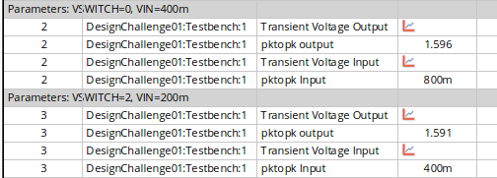
Figure 22 Simulation Results
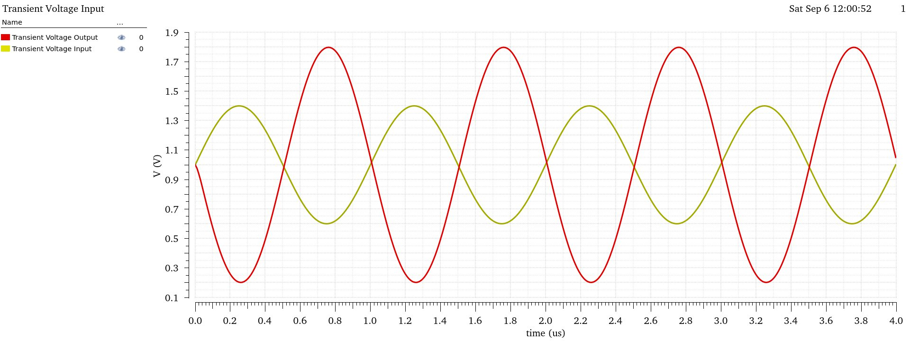
Figure 23 Transient Output and Input Overlaid at Gain = 2 Config
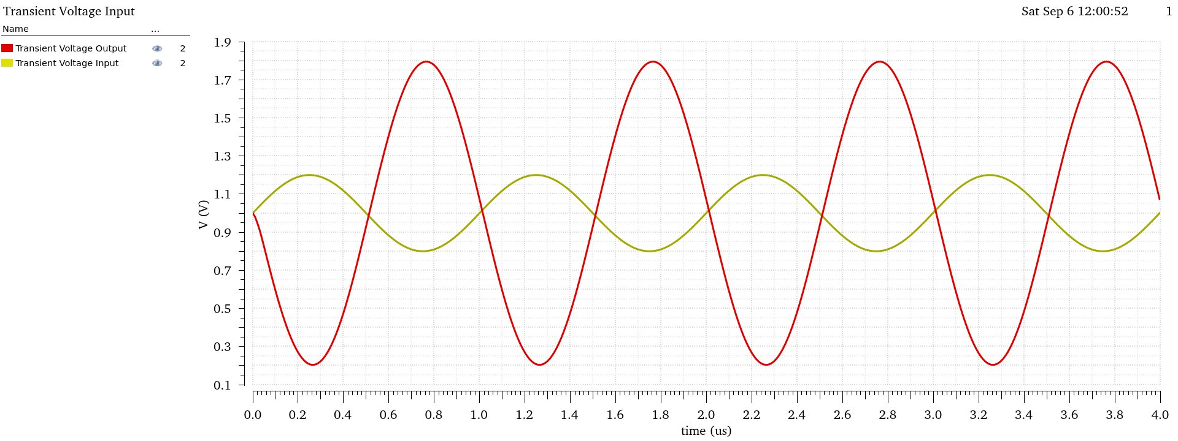
Figure 24 Transient Output and Input Overlaid at Gain = 4 Config
Output swing spec is met!
Spec | Required | Achieved
Closed loop gain | D0 = 0: 6 dB  D0 = 1: 12 dB | D0 = 0: 6.34 dB  D0 = 1: 12.028 dB
LG PM (Worst Case) | > 60º | 66.69º
DC LG (Worst Case) | > 54 dB | 56.87 dB
Closed loop BW | > 10 MHz | 11.91 MHz
Output swing | > 1.6 V pk-to-pk | 1.591 V pk-to-pk
Power Consumption | Minimize | 403uA
Part 1: Design Conclusion

All specs appear to be met, Albeit Current Consumption is on the higher side, this is due to the High-Speed requirement of the circuit thus high GBW, Current could be optimized to be a little less than what was achieved but not by a huge margin so I opted to keep it as it is to avoid certain complications in other circuit parameters that have stricter requirements.

Given more time I’d revisit this design and decrease power consumptions by designing a current mirror more accurately and for minimal current consumption as well as attempting to decrease the areas of each device to achieve smaller area instead of aggressively increasing widths to improve certain specs albeit this gives higher margin for the device to behave well across corners.
Part 2: THD and Corners
Total Harmonic Distortion:
Using the previous transient simulation to calculate THD with the following settings:
Figure 25 THD Output setup
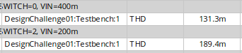
Figure 26 Simulation Results
THD Appears to be Minimal!

Corner Simulation:
I had already replaced all passives with PDK passives throughout this entire report.

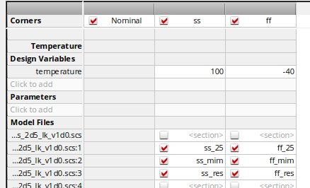
Figure 27 Corner Setup
Optimally corners should be ran across all device combinations and across all temperatures and VDD Variations, but for this challenge I will run only across the 2 requested corners.

DC LG, ACL and BW across Corners:

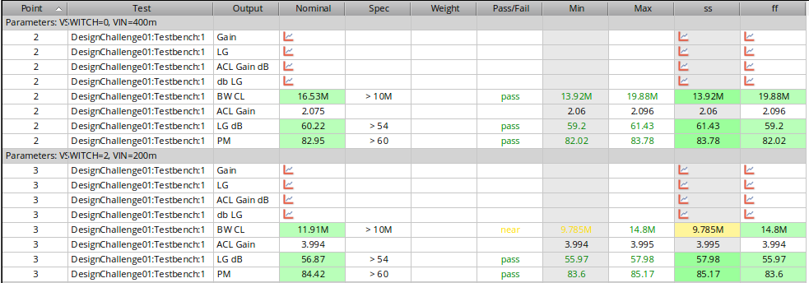
Figure 28 Closed Loop parameters across Corners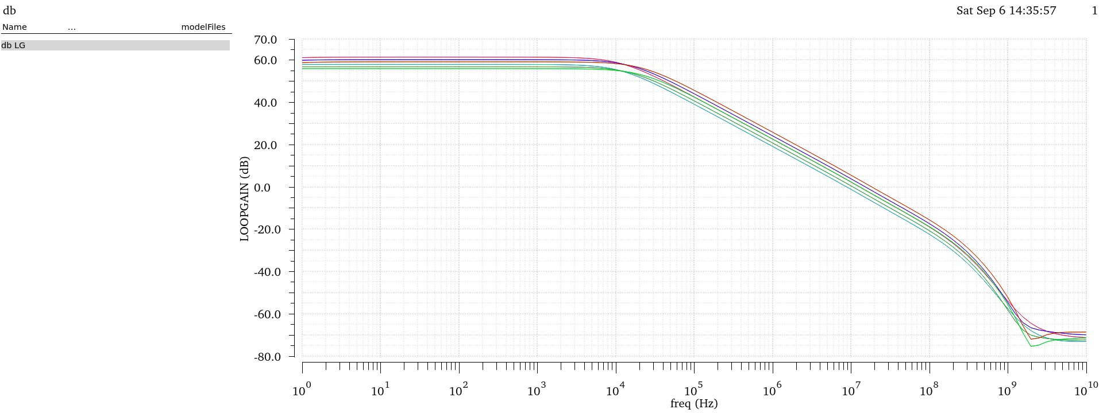
Figure 29 Loop Gain Across Corners and Configurations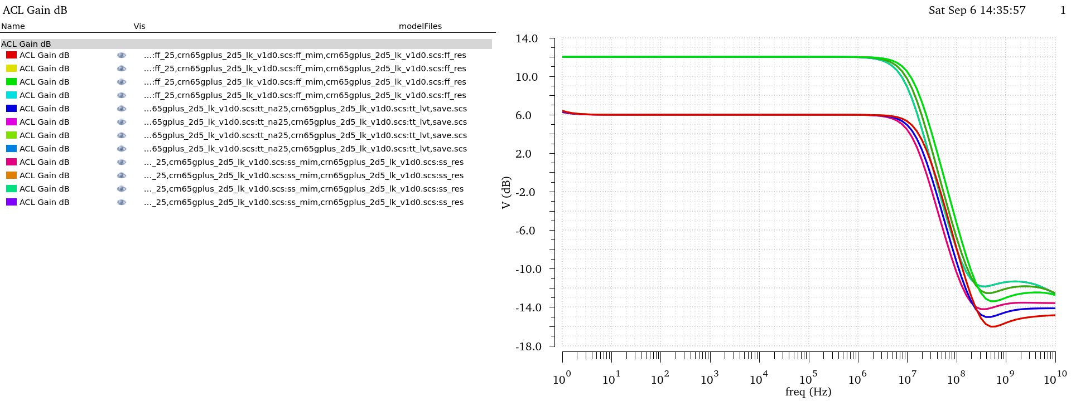
Figure 30 Closed Loop Gain Across Corners and Configurations
All Parameters seem to be satisfied across corner and configurations except for the BW in the Slow Corner but it is still acceptably near.

Phase Margin Across Corners:
I turned on the switch shunting the feedback capacitor again to measure the PM at the worst case across corners and configurations:
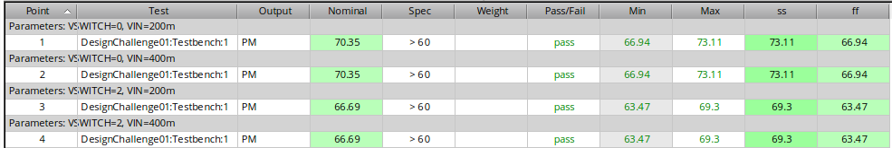
Figure 31 Phase Margin Across Corners and configurations

Transient Parameters across Corners
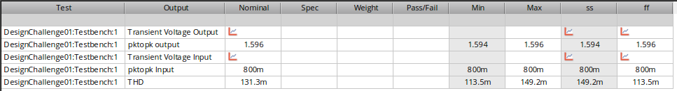
Figure 32 THD and PkToPk across Corners Gain = 2 Config
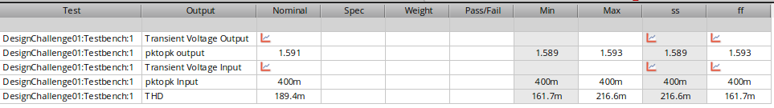
Figure 33 THD and PkToPk across corners Gain = 4 Config
THD Appears to be minimal across corners except in the SS corner where it is a bit higher

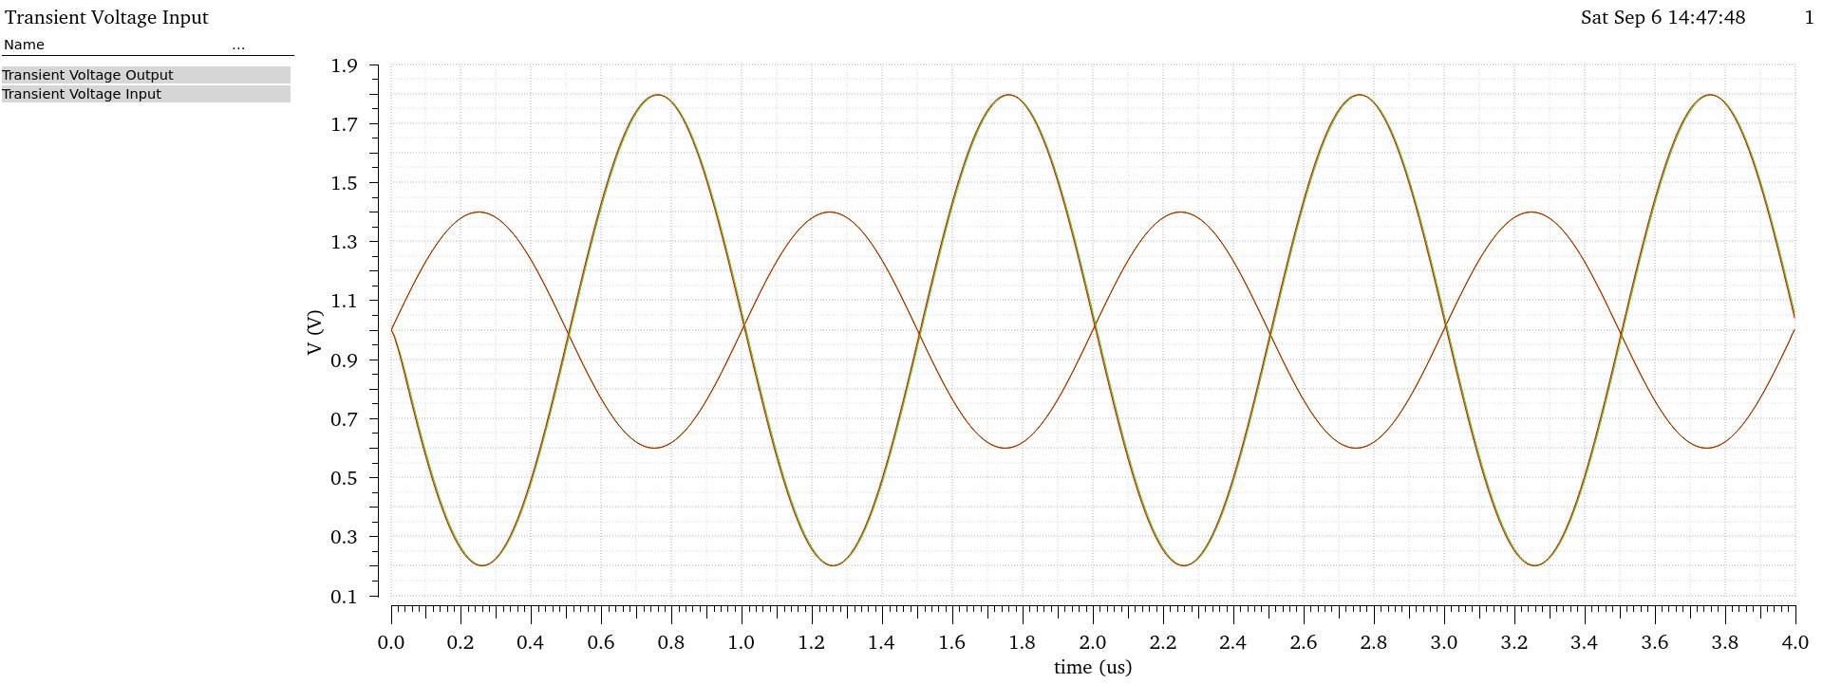
Figure 34 VOUT and VIN overlaid across corners gain = 2
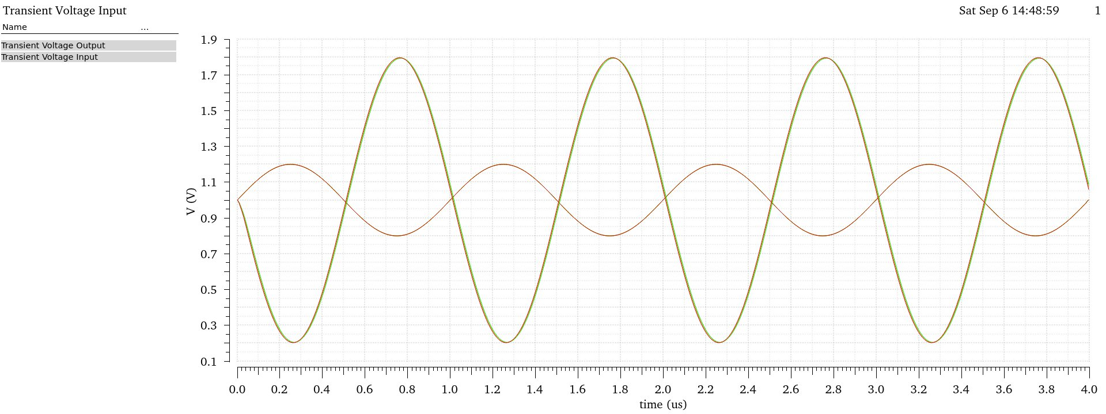
Figure 35 VOUT and VIN overlaid across corners gain = 4
No Visible distortion and all results are overlaying each other perfectly!

