Lab 8
Feedback Amplifier

Part 1: Feedback with Behavioral OTA
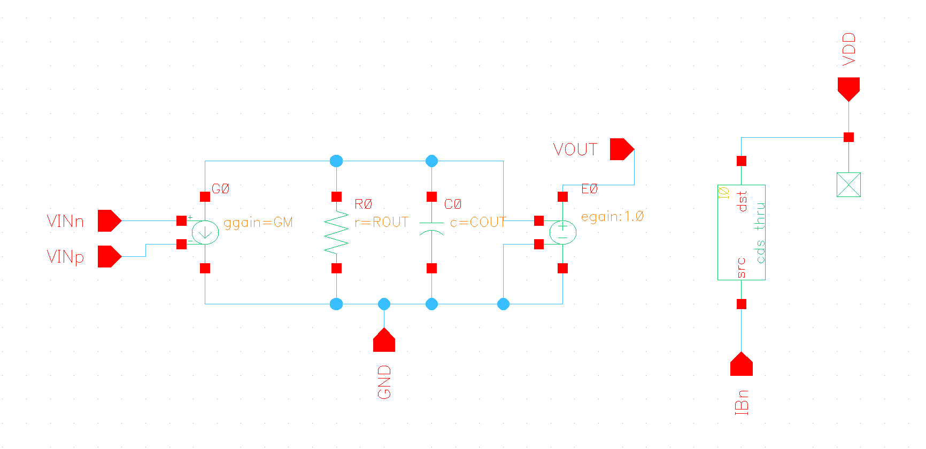
Figure 1 Behavioral Model Schematic
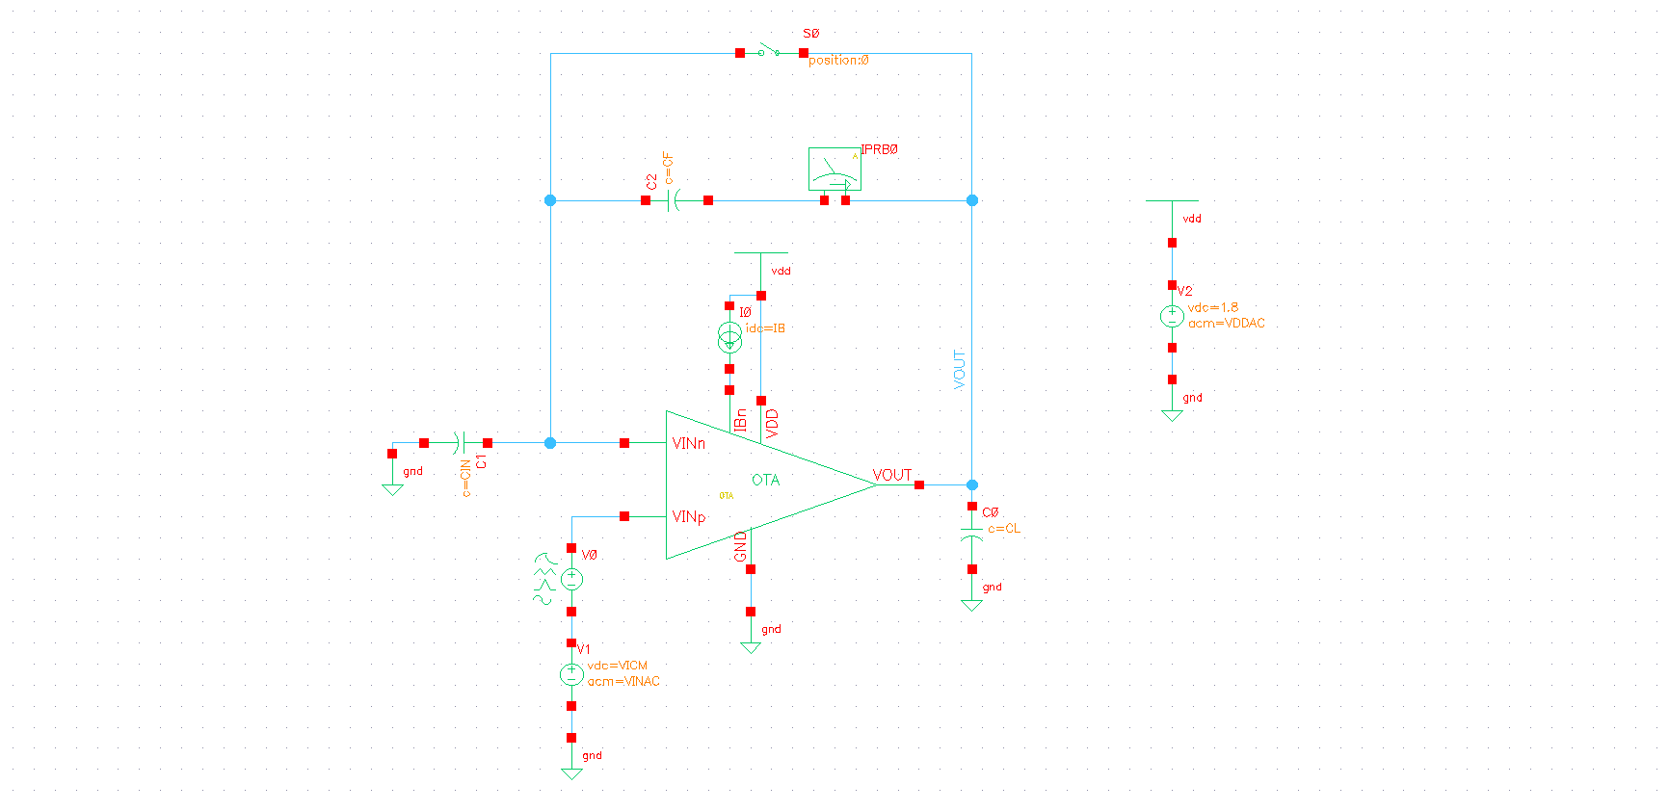
Figure 2 Testbench Schematic

  - Closed Loop Gain vs Frequency:
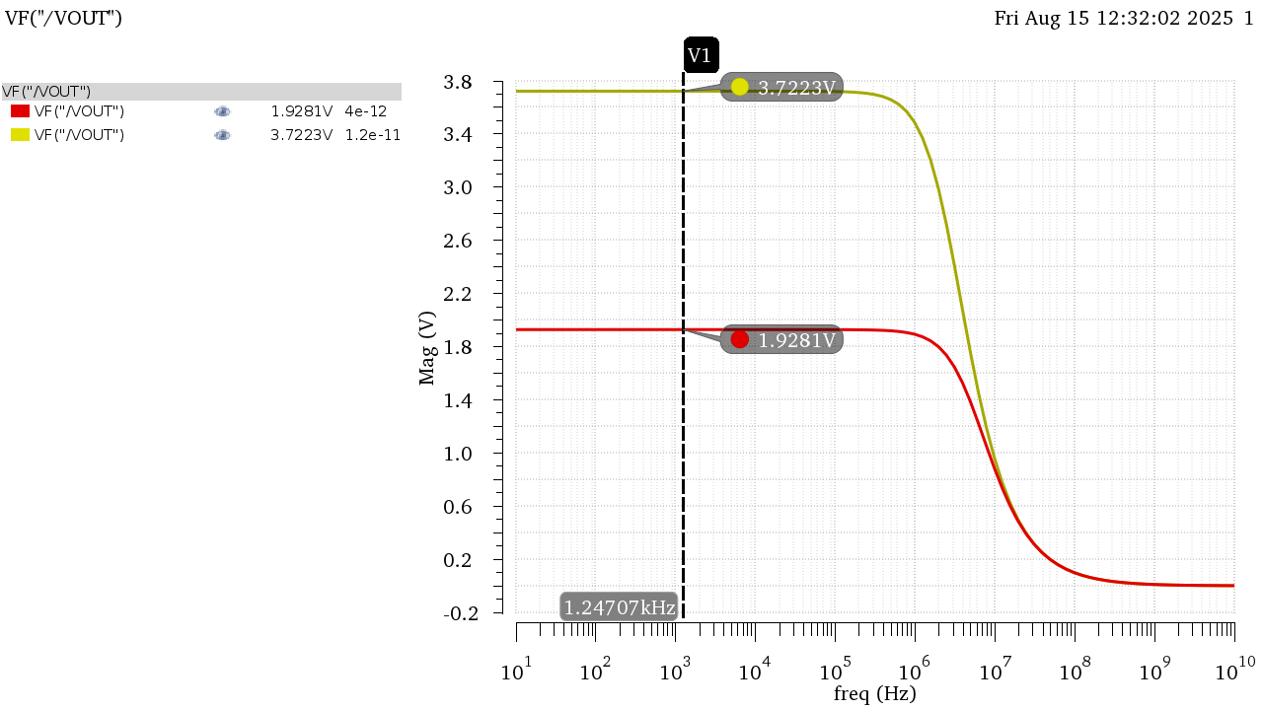
Figure 3 DC Gain in Mag
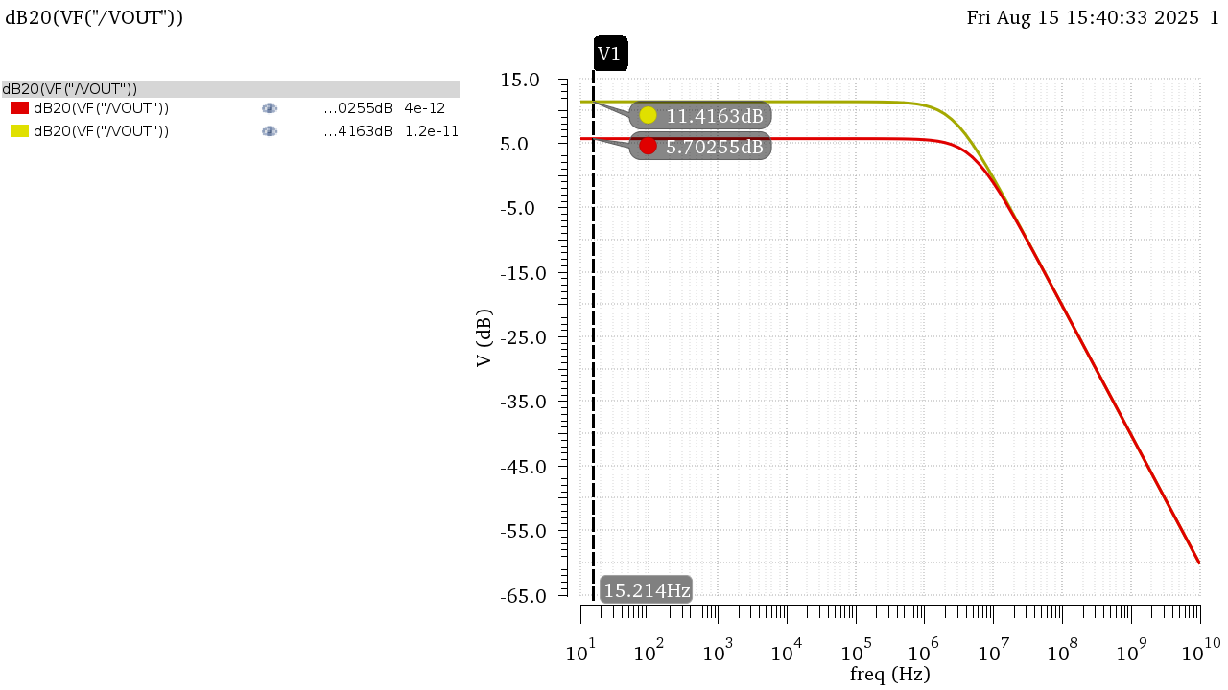
Figure 4 DC Gain in dB

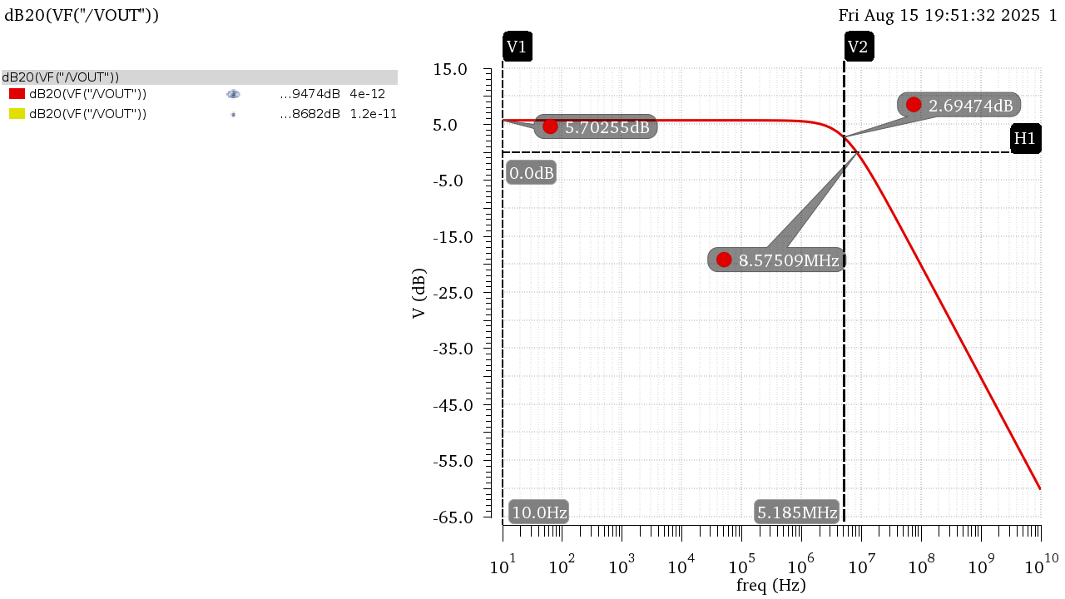
Figure 5 Gain Bode Plot Annotated CIN = 4pF
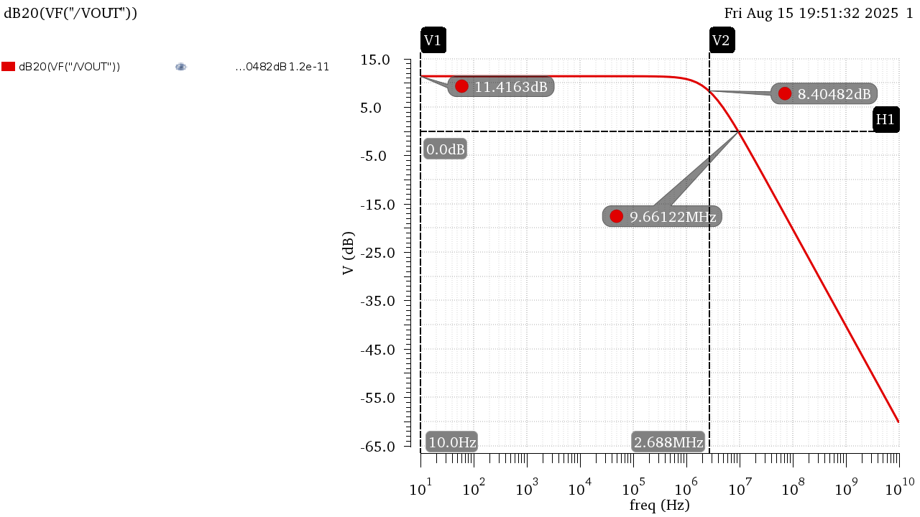
Figure 6 Gain Bode Plot Annotated CIN = 12pF

 | CIN = 4pF | CIN = 12pF
DC Gain (dB) | 5.703 | 11.42
DC Gain | 1.928 | 3.722
BW | 5.19E+06 | 2.69E+06
UGF | 8.61E+06 | 9.69E+06
GBW | 10E+06 | 10E+06
Table 1 Results from Simulation
Hand Analysis:
Open Loop Parameters from Last Lab:
$$A_{OL}≈53, BW_{OL}=191KHz, GBW≈10.12MHz$$
$$β=\frac{Z_{in}}{Z_{in}+Z_{f}}=\frac{C_{f}}{C_{f}+C_{in}}=\frac{1}{2}, \frac{1}{4} (For Both Values of C_{in})$$
$$DC Gain=A_{CL}=\frac{A_{OL}}{1+βA_{OL}}=1.927 , 3.72$$
$$BW_{CL}=\left(1+βA_{OL}\right)BW_{OL}=5.25MHz, 2.721MHz$$
$$GBW_{CL}=10.1167MHz, 10.122MHz$$

 | CIN = 4pF |  | CIN = 12pF
 | Simulation | Analytic | Simulation | Analytic
DC Gain (dB) | 5.703 | 5.698 | 11.42 | 11.41
DC Gain | 1.928 | 1.9272 | 3.722 | 3.72
BW | 5.19E+06 | 5.25E+06 | 2.69E+06 | 2.72E+06
GBW | 1.00E+07 | 1.01E+07 | 1.00E+07 | 1.01E+07

Analytic Results Agree with simulated ones in both cases of the input capacitor!

  - Loop Gain vs Frequency:

Figure 7 LG Overlaid in Mag
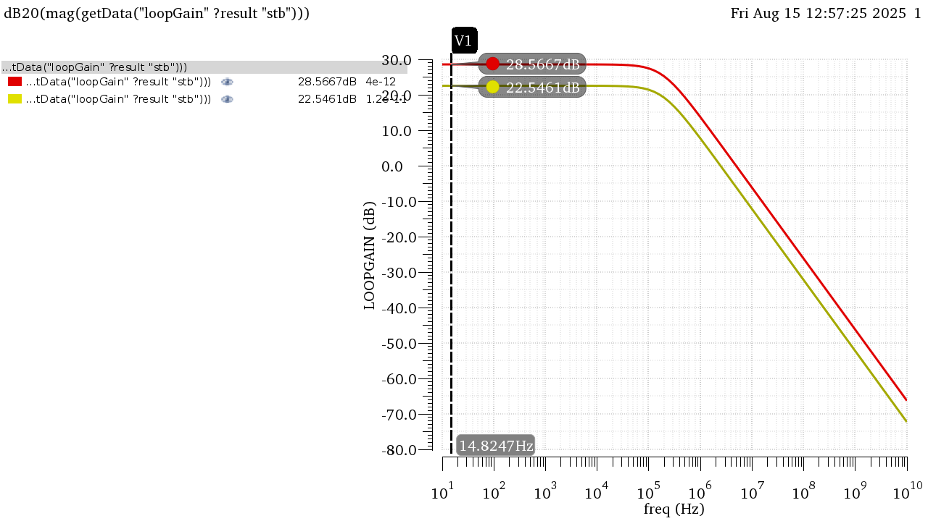
Figure 8 LG Overlaid in dB

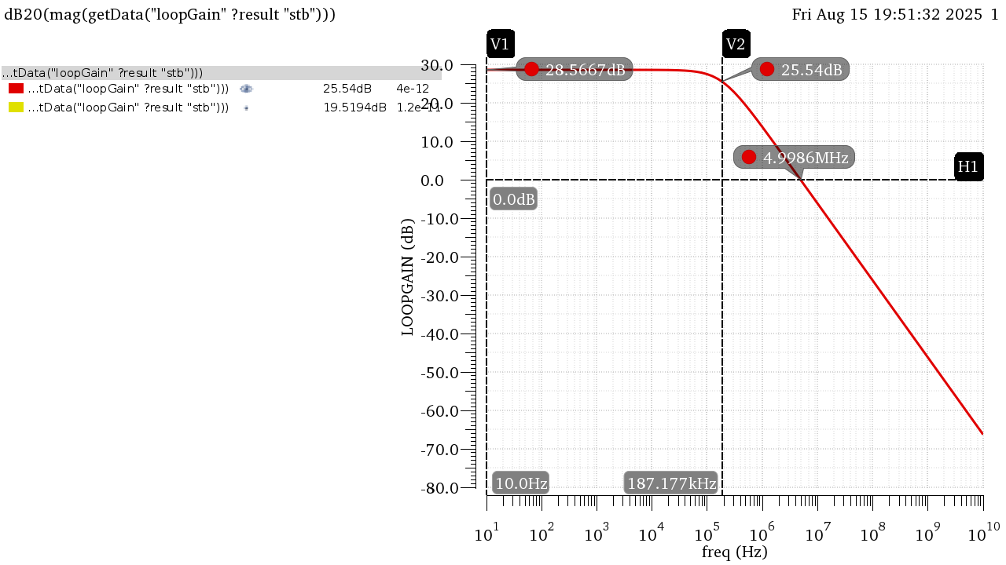
Figure 9 LG Bode Plot Annotated CIN = 4pF

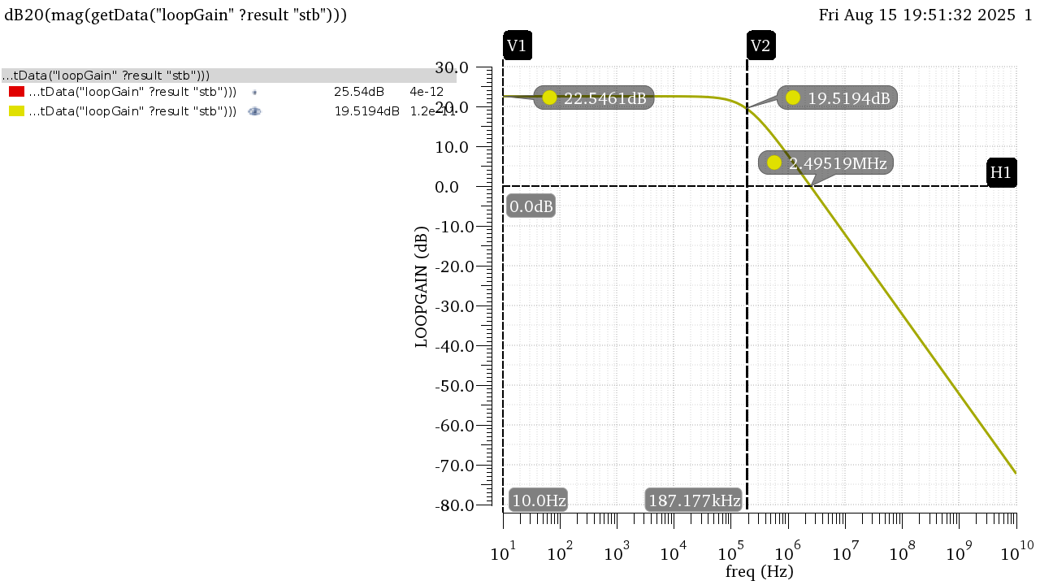
Figure 10 LG Bode Plot Annotated CIN = 12pF

 | CIN = 4pF | CIN = 12pF
DC LG (dB) | 28.57 | 22.55
DC LG | 26.81 | 13.41
BW | 187.17 KHz | 187.17 KHz
UGF | 5 MHz | 2.5 MHz
Table 2 Results from Simulation
Hand Analysis:
Open Loop Parameters from Last Lab:
$$A_{OL}≈53, BW_{OL}=191KHz, GBW≈10.12MHz$$
$$β=\frac{Z_{in}}{Z_{in}+Z_{f}}=\frac{C_{f}}{C_{f}+C_{in}}=\frac{1}{2}, \frac{1}{4} (For Both Values of C_{in})$$
$$DC LG=LG=βA_{OL}=26.5 , 13.25→28.465dB, 22.444dB$$
$$BW_{LG}=BW_{OL}=191KHz$$
$$ω_{u}=GBW_{LG}=5.0615MHz, 2.53MHz$$

 | CIN = 4pF |  | CIN = 12pF
 | Simulation | Analytic | Simulation | Analytic
DC LG (dB) | 28.57 | 28.465 | 22.55 | 22.444
DC LG | 26.81 | 26.5 | 13.41 | 13.25
BW | 187.17 KHz | 191 KHz | 187.17 KHz | 191 KHz
UGF | 5 MHz | 5.0615 MHz | 2.5 MHz | 2.53 MHz

Analytic Results Agree with simulated ones in both cases of the input capacitor!

  - Gain Desensitization:
To sweep the gain, I can either sweep GM or ROUT, I tried both and both resulted in similar results:
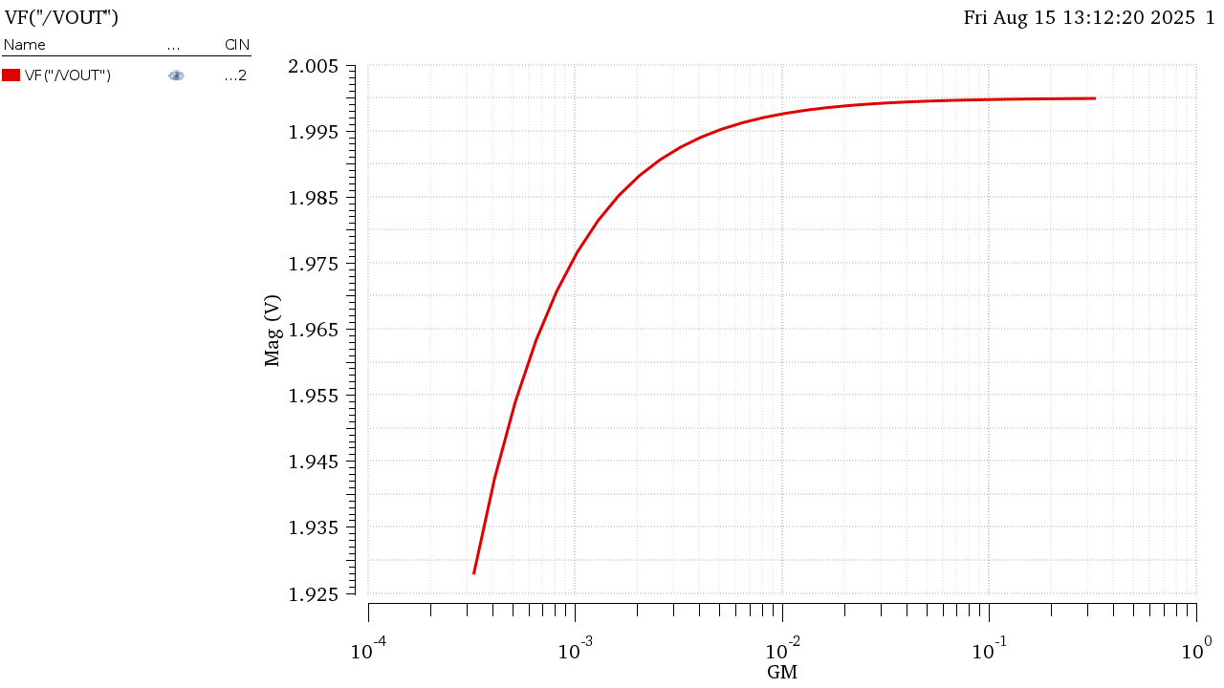
Figure 11 Gain Sweeping GM
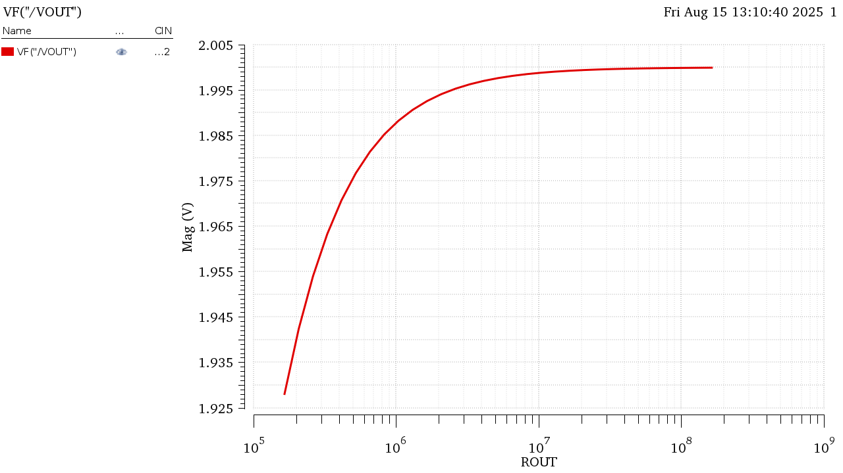
Figure 12 Gain Sweeping ROUT
$$A_{CL}\%=\frac{1.99982-1.928}{1.928}*100=3.725\%$$
The Gain is much closer to its ideal value now (Ideal Value = 2) as we increase the Open Loop gain of the amplifier it easier to approximate closed loop gain as $\frac{1}{β}$. The percentage change would be even if we calculate for higher gains like the case of CIN = 4pF
Part 2: Feedback with Real 5T OTA
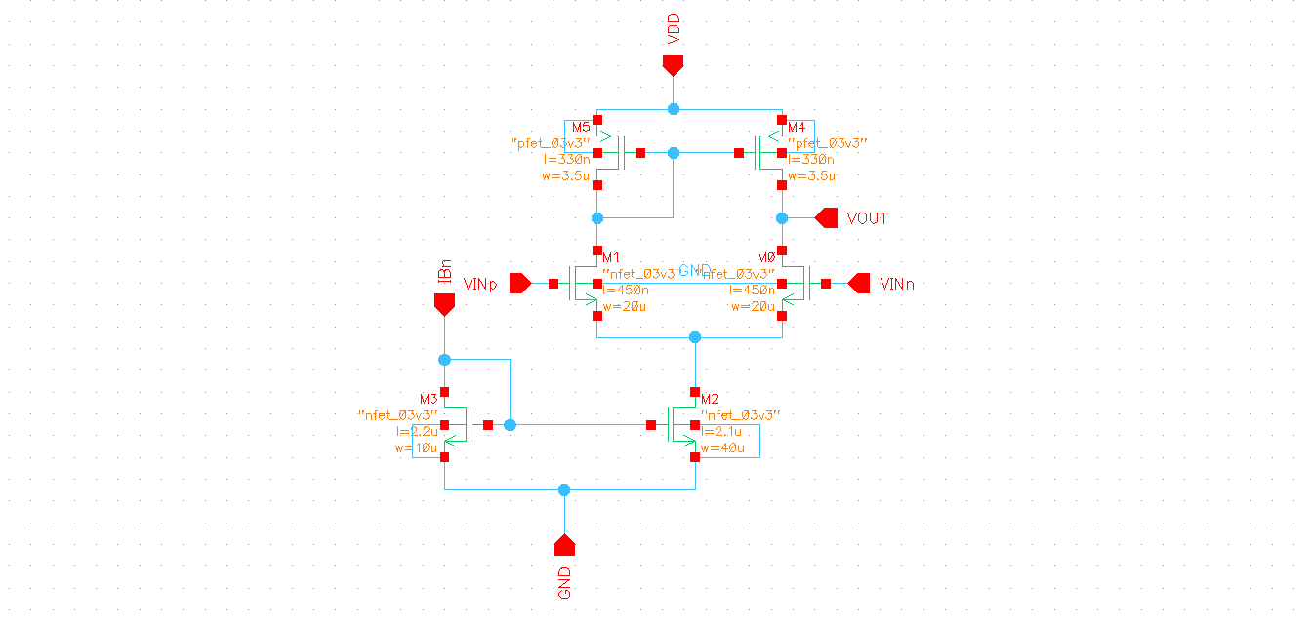
Figure 13 Real OTA Schematic

Figure 14 TB Schematic (Same as Part 1)

2.1 Closed Loop Gian vs Frequency:
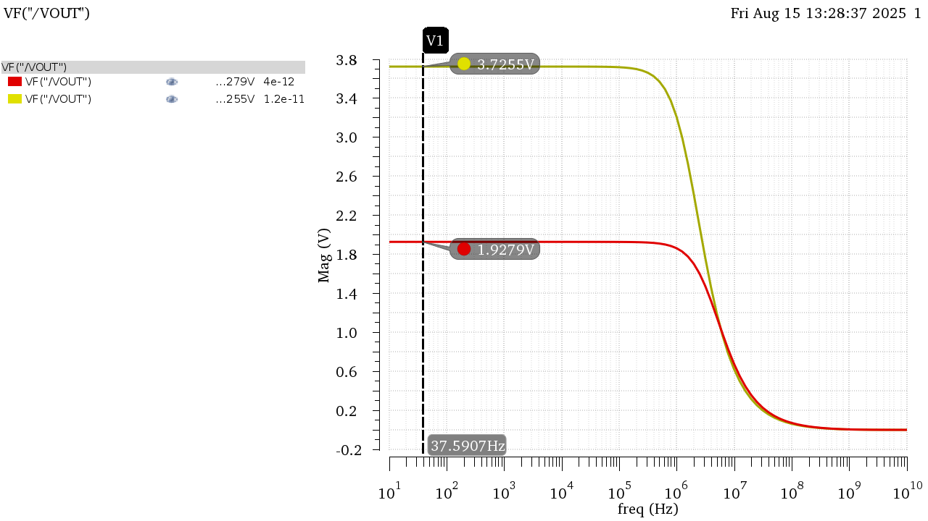
Figure 15 Gain in Mag
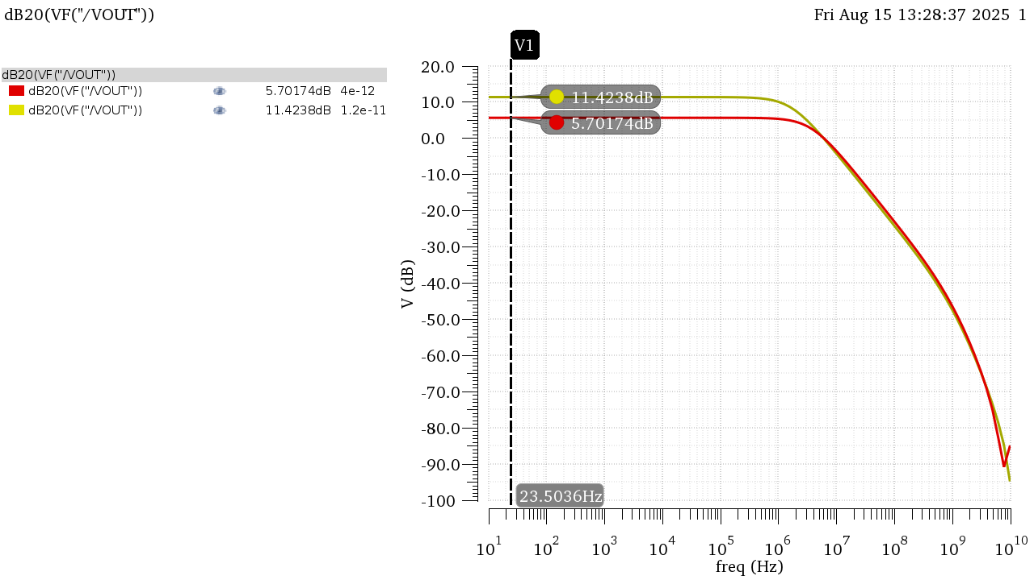
Figure 16 Gain in dB

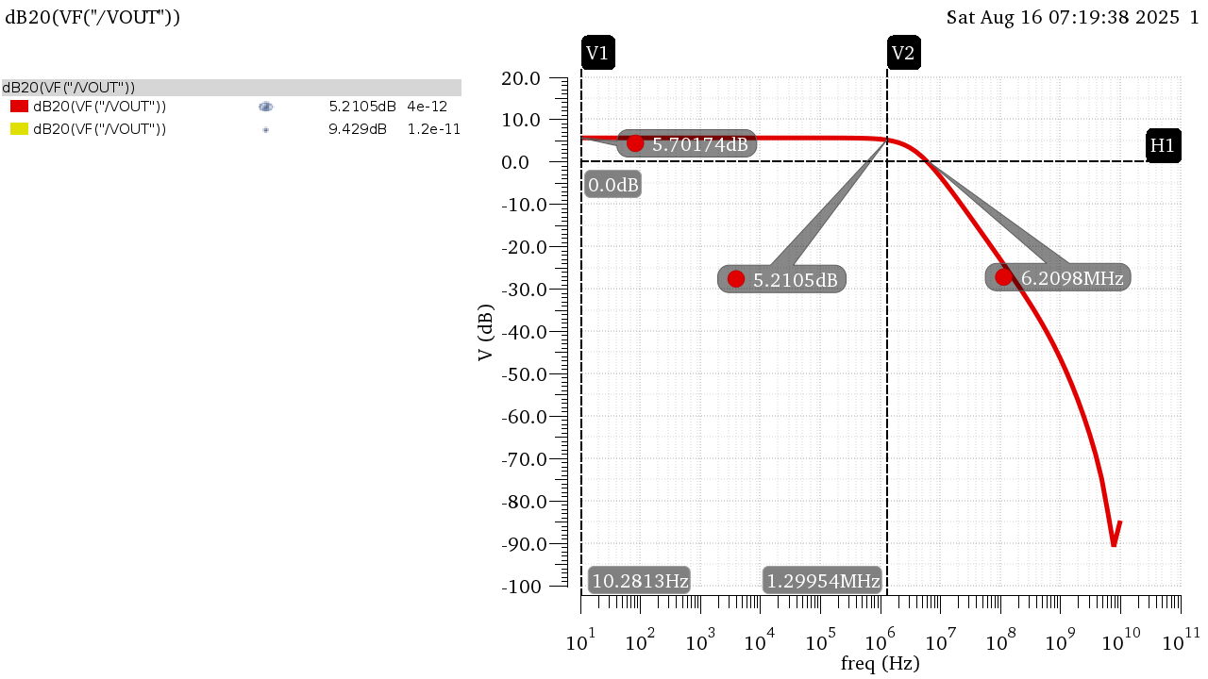
Figure 17 DC LG Bode Plot Annotated at CIN = 4pF
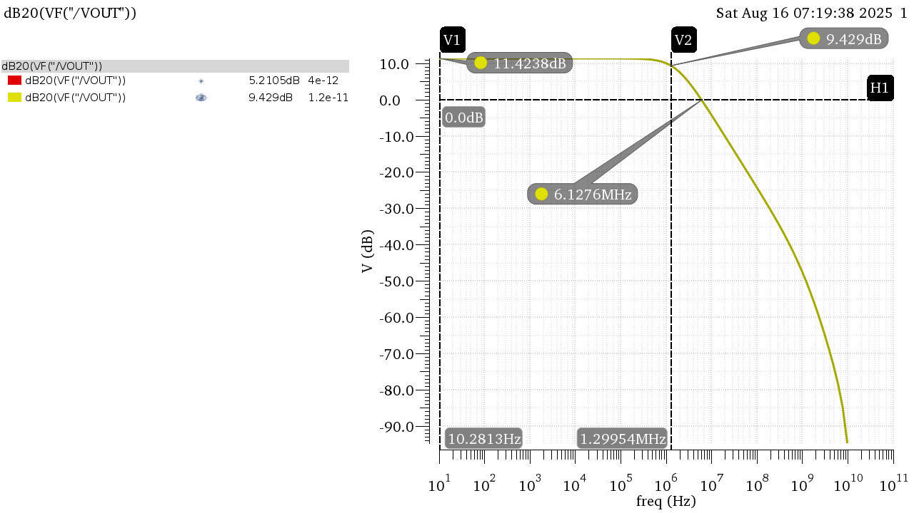
Figure 18 DC LG Bode Plot Annotated at CIN = 12pF

 | CIN = 4pF |  | CIN = 12pF
 | Behavioral | 5T OTA | Behavioral | 5T OTA
DC Gain (dB) | 5.703 | 5.702 | 11.42 | 11.42
DC Gain | 1.928 | 1.928 | 3.722 | 3.726
BW | 5.19E+06 | 3.76E+06 | 2.69E+06 | 1.70E+06
GBW | 1.00E+07 | 7.27E+06 | 1.00E+07 | 6.37E+06

The Bandwidth and consequently the GBW are much smaller than Part 1:
The bandwidth in the OTA is much smaller because the Behavioral model took only CL in consideration when calculating the bandwidth due to the buffer in the behavioral model making ROUT = $∞$thus the effect of the loading effect is not seen. While in the real OTA , the ROUT seen in the actual ROUT of the amplifier thus contributing to the pole of the output node making it smaller.

2.2 Loop Gain vs Frequency:
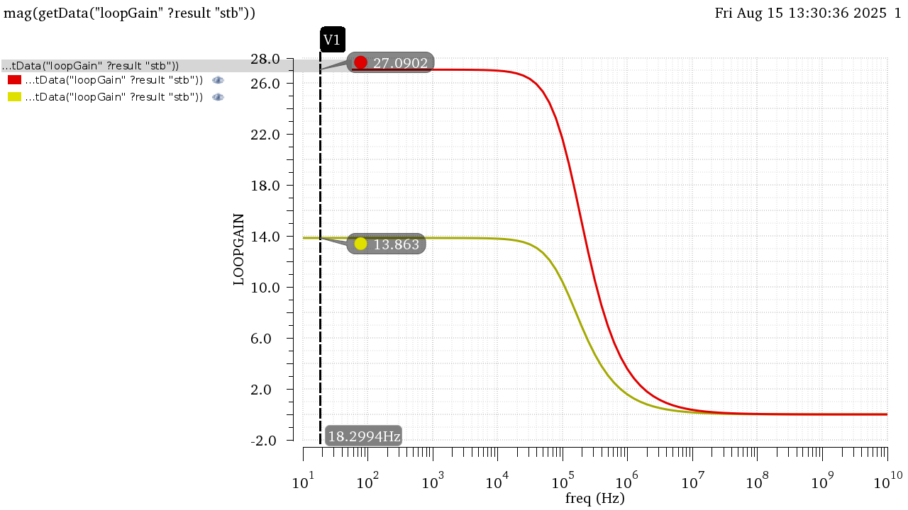
Figure 19 LG in Mag
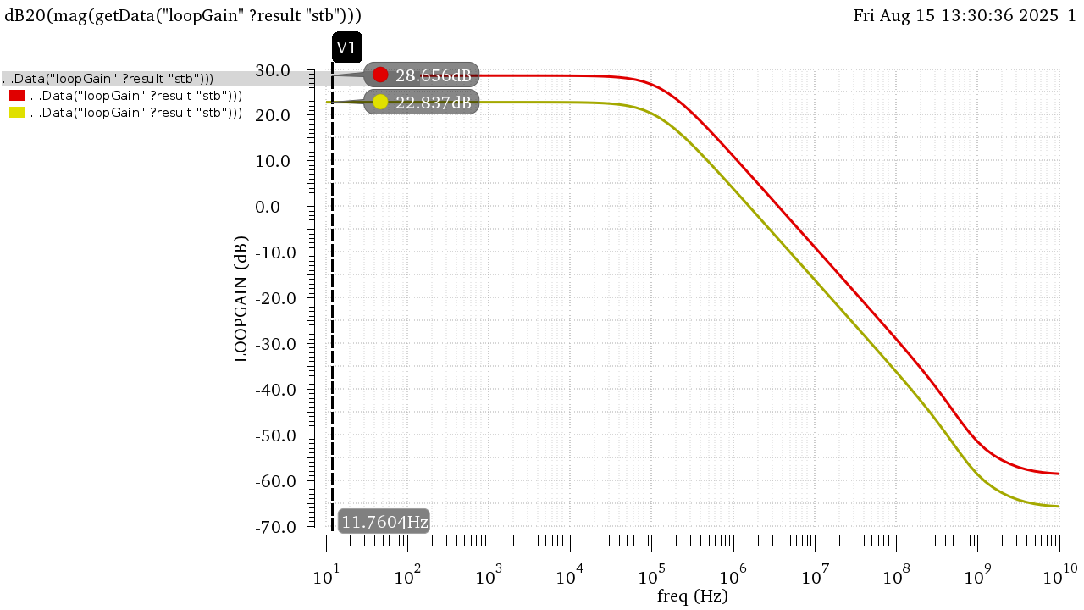
Figure 20 LG in dB

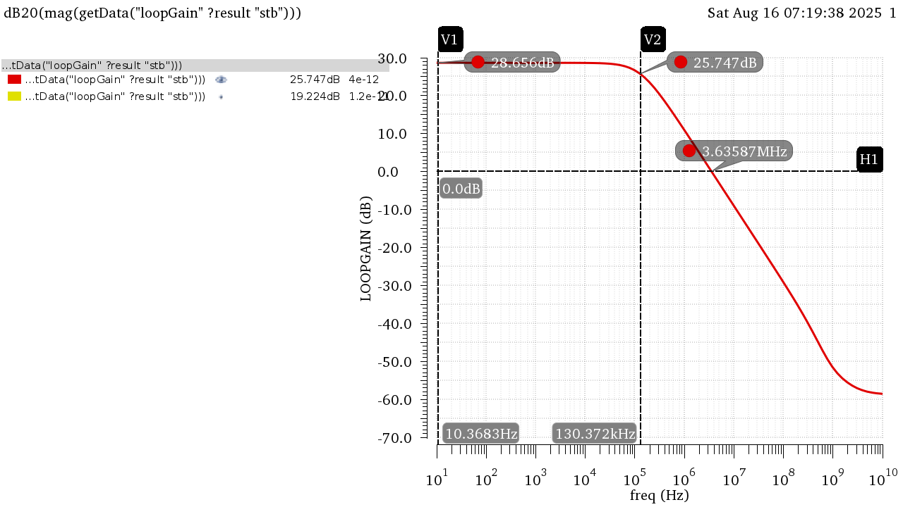
Figure 21 LG Bode Plot Annotated at CIN = 4pF
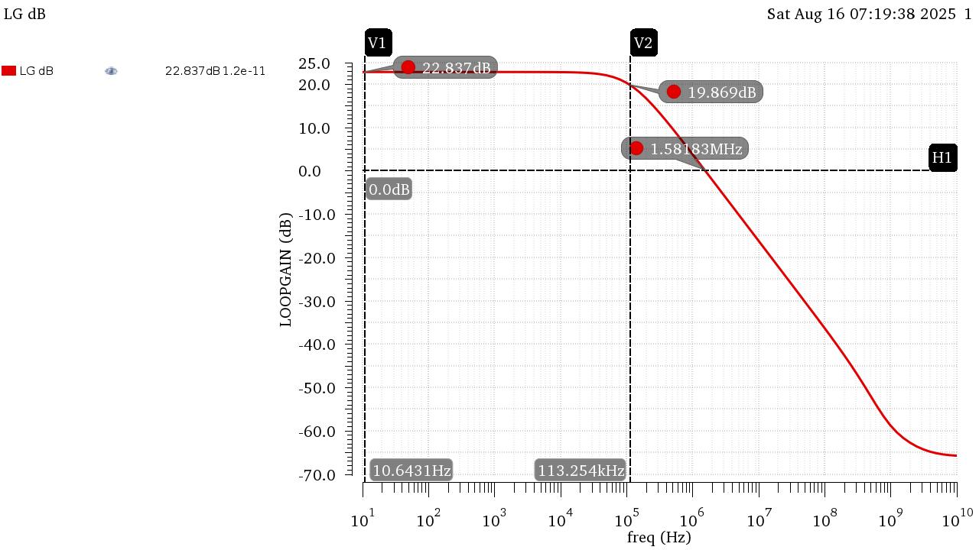
Figure 22 LG Bode Plot Annotated at CIN = 12pF

 | CIN = 4pF |  | CIN = 12pF
 | Behavioral | 5T OTA | Behavioral | 5T OTA
DC LG (dB) | 28.57 | 28.66 | 22.55 | 22.84
DC LG | 26.81 | 27.09 | 13.41 | 13.86
BW | 187.17 KHz | 1.34E+05 | 187.17 KHz | 1.15E+05
UGF | 5 MHz | 3.66E+06 | 2.5 MHz | 1.58E+06

UGF is much smaller than in Part 1:
Due to the same reason stated previously, The buffer isolated Rout from seeing the loading effect thus only CL contributed to the Pole, but in the real OTA at the output node the loading effect of the added capacitors is seen such that the capacitance seen is $C_{L}+\left(C_{in}//C_{f}\right)$Contributing to a lower bandwidth thus a lower UGF.

2.3 Gain Desensitization:
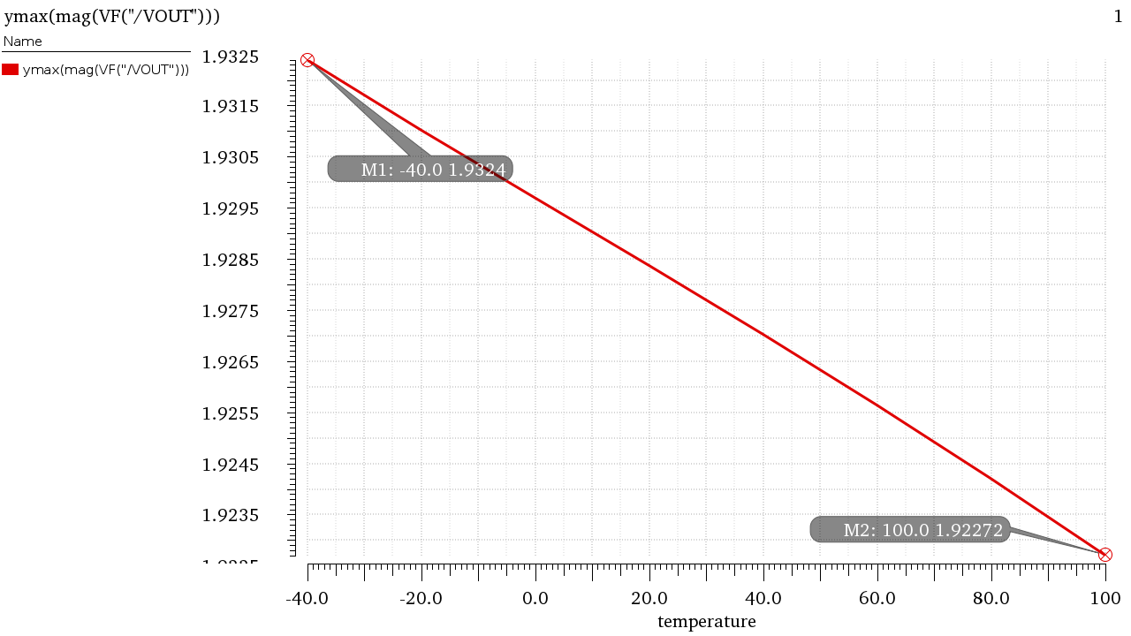
Figure 23 ACL in Mag vs Temp (Extreme Points Annotated)
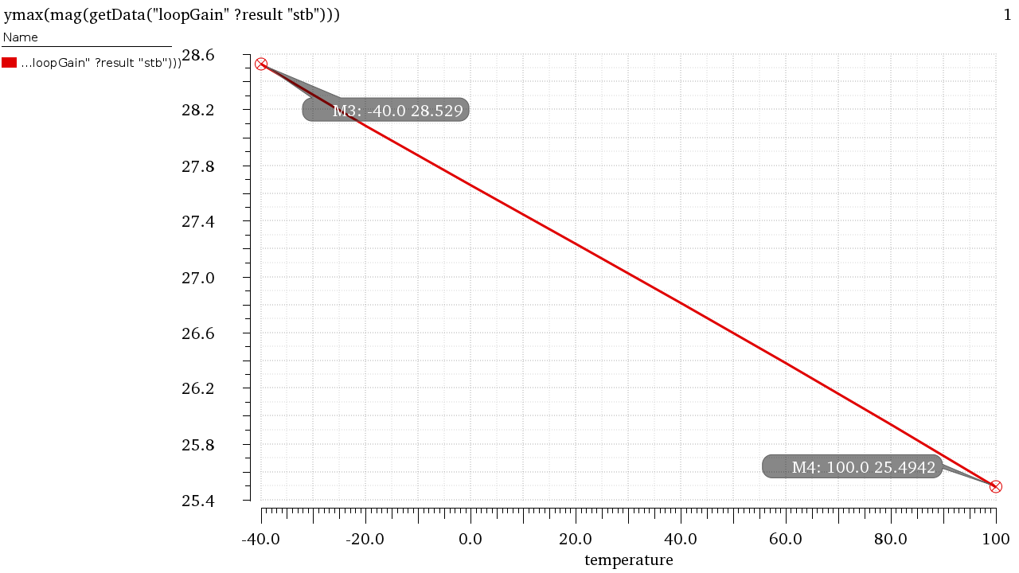
Figure 24 LG in Mag vs Temp (Extreme Points Annotated)
$$A_{CL}\%_{temp}=\frac{1.9324-1.92272}{1.928}*100=0.5\%, LG\%_{temp}=\frac{28.529-25.4942}{27.09}*100=11.2\%$$
The percentage change in LG is much more pronounced than the percentage change of ACL, as ACL depends on the ratio of capacitances (Which isn’t affected by temperature much) much more heavily due to the big gain of AOL while LG depends on AOL which depends on the active components of the circuit whose parameters change heavily by temperature and process variations. This demonstrates the importance of feedback in desensitizing against PVT.
2.4 Transient Analysis:
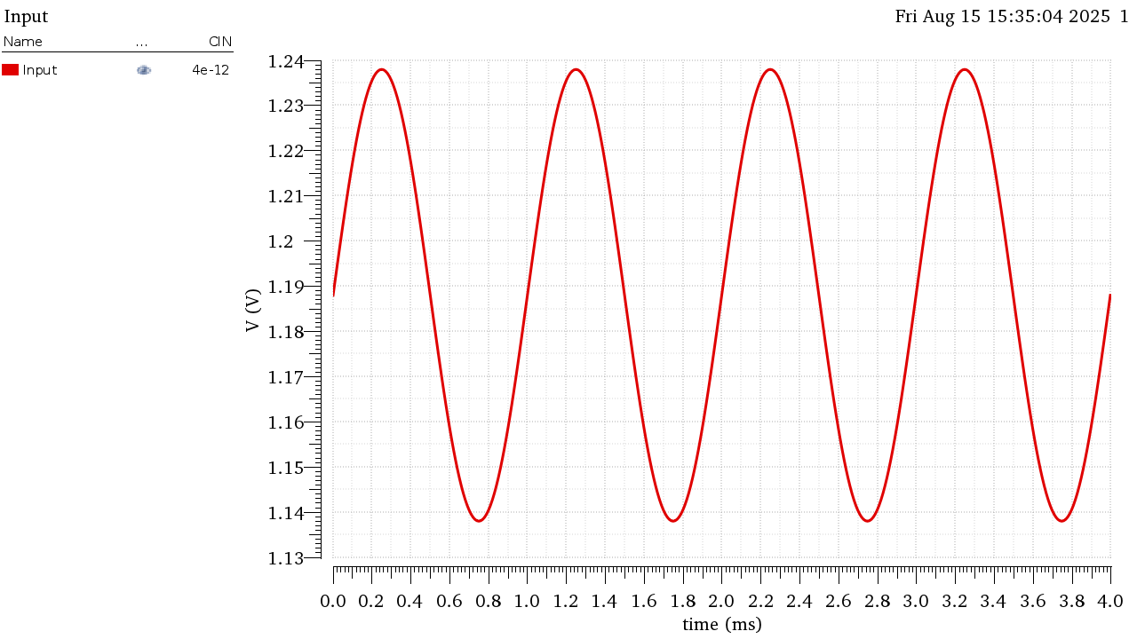
Figure 25 Input Signal
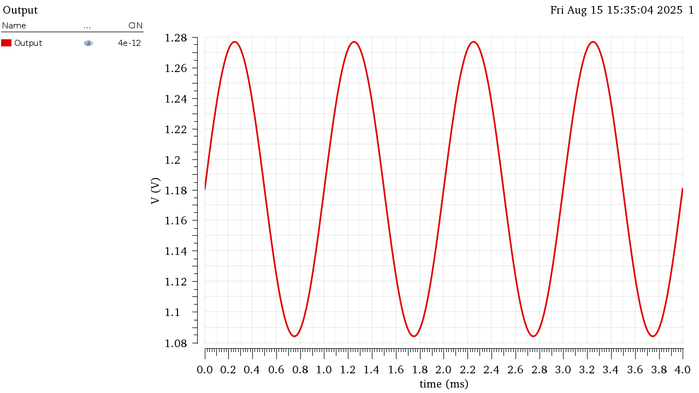
Figure 26 Output Signal

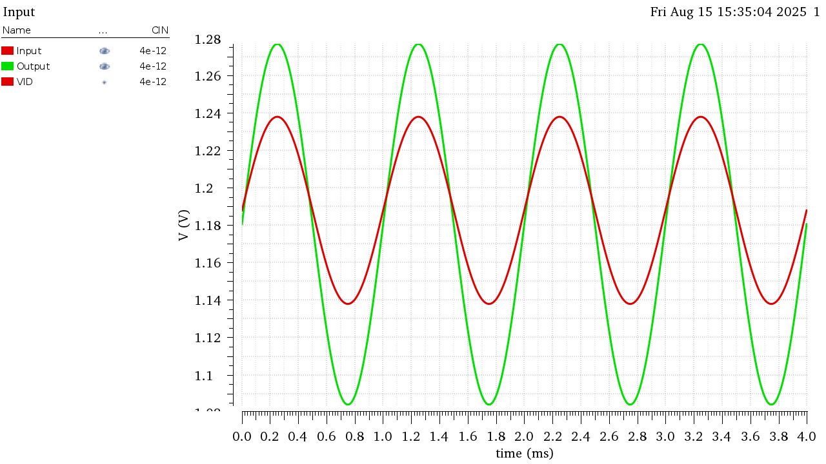
Figure 27 VIn and Vout Overlaid (To Showcase Gain)
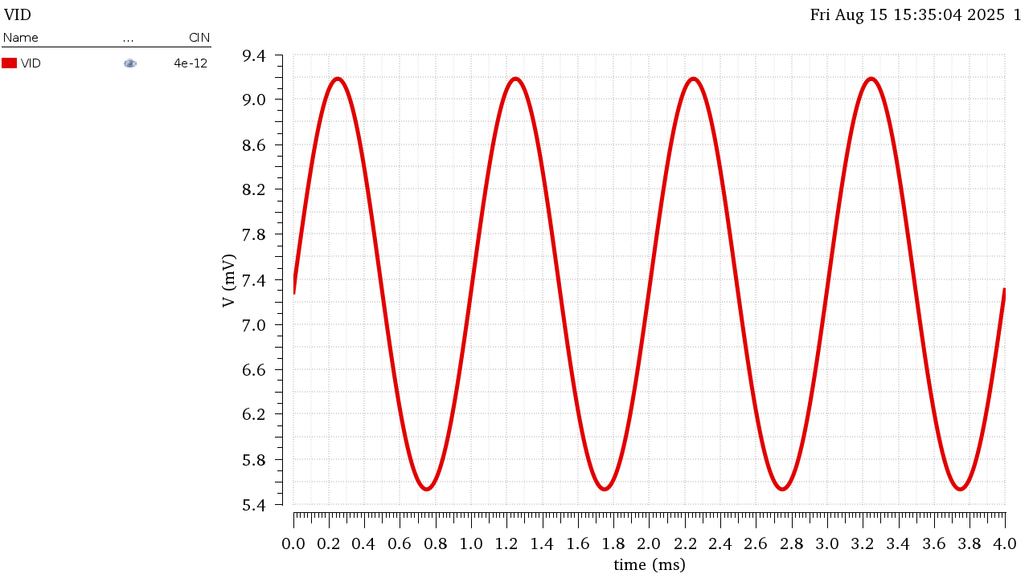
Figure 28 Verror (VP-VN)

 | VIN | VOUT | VID
Peak to Peak (V) | 1.00E-01 | 1.93E-01 | 3.66E-03

$$\frac{V_{OUT}}{V_{err}}=\frac{193m}{3.66m}=52.732=A_{OL}$$
The relationship between the Output Voltage and Error Voltage or the Differential Input voltage of the amplifier is the Open Loop Gain.

Using FIN=BW_{OL}=134KHz
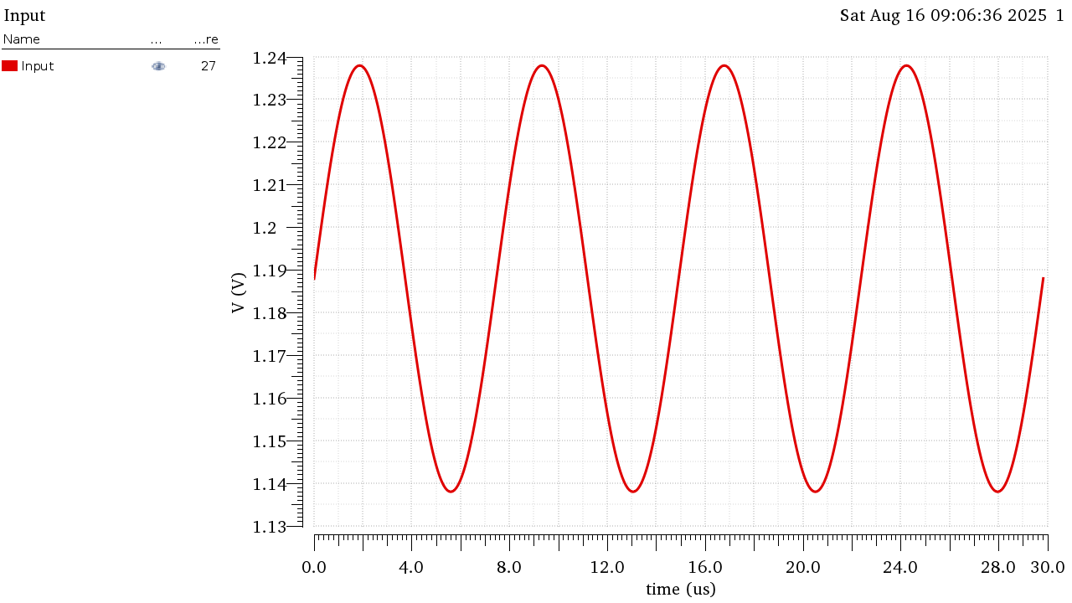
Figure 29 Input Signal at FIN=134KHz
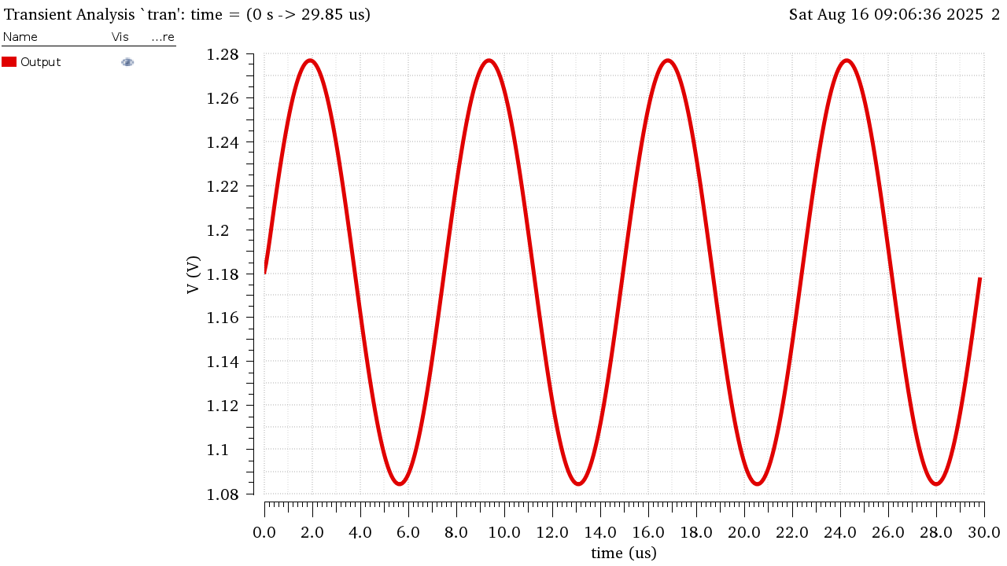
Figure 30 Output Signal at FIN=134KHz

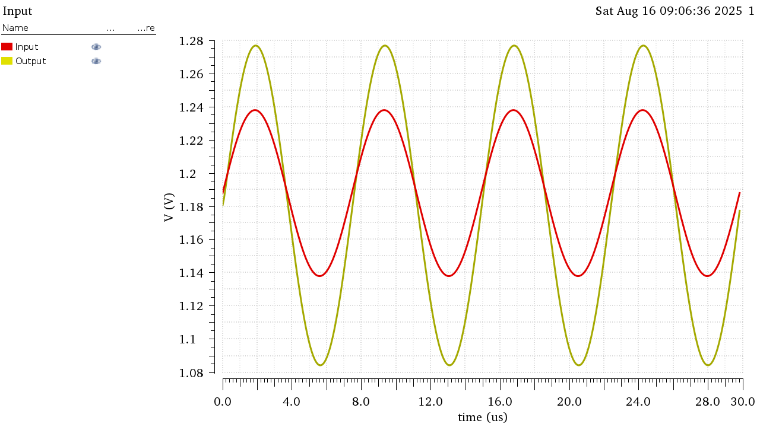
Figure 31 Vout and Vin Overlaid FIN=134KHz
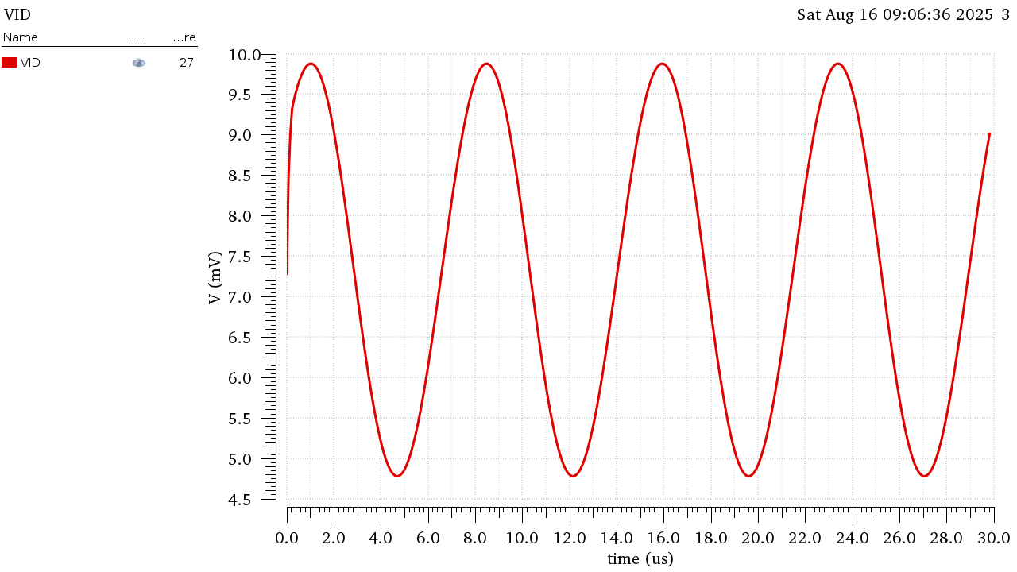
Figure 32 Verror at FIN=134KHz

 | VIN | VOUT | VID
Peak to Peak (V) | 1.00E-01 | 1.93E-01 | 5.10E-03

$$\frac{V_{OUT}}{V_{err}}=\frac{193m}{5.1m}=37.671=\frac{52.732}{\sqrt{2}}=\frac{A_{OL}}{\sqrt{2}}$$
The relationship between the Output Voltage and Error Voltage or the Differential Input voltage of the amplifier is the Open Loop Gain divided by root 2 as the Input signal is at the cutoff frequency.

Using FIN=BW_{CL}= 3.76MHz
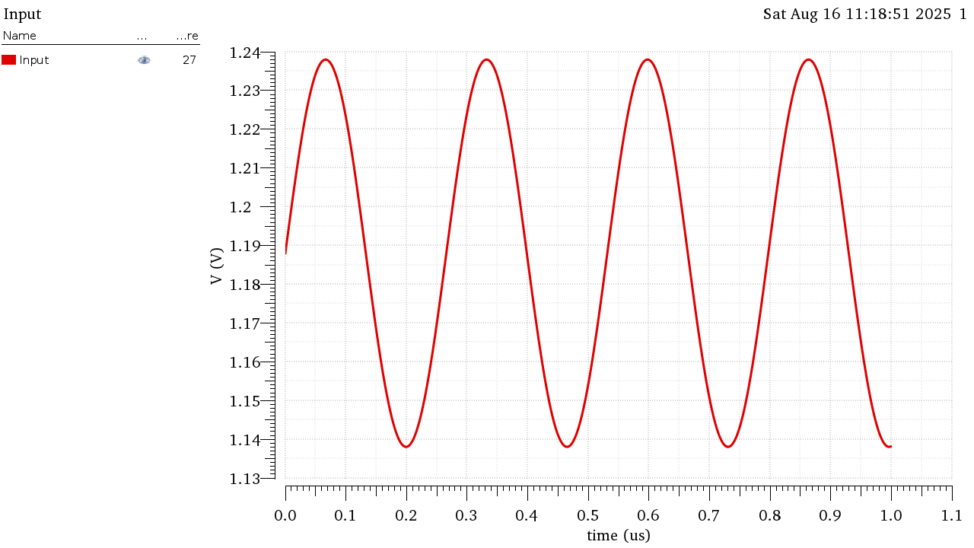
Figure 33Input Signal at FIN = 3.76MHz
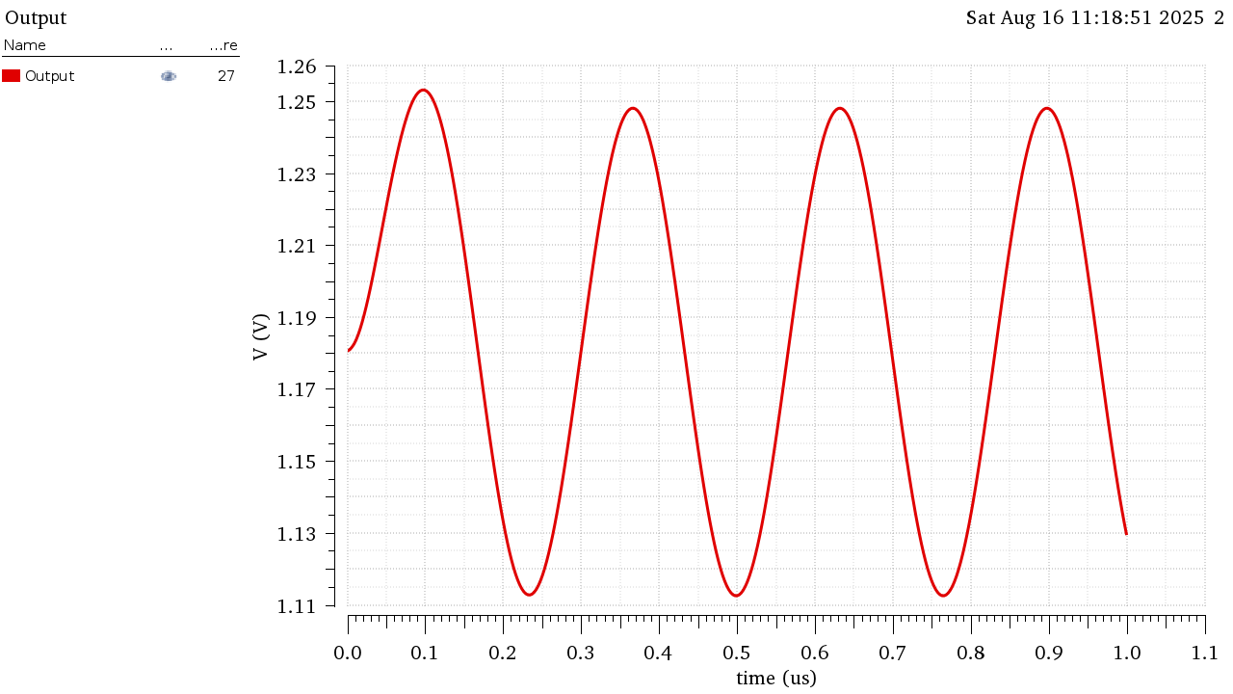
Figure 34 Output Signal at FIN = 3.76MHz

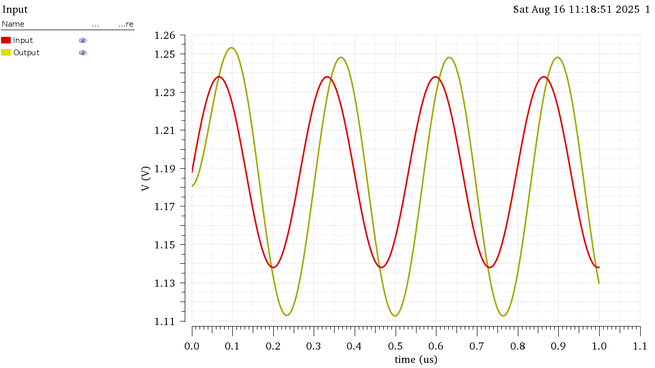
Figure 35 Vin and Vout Overlaid at FIN = 3.76MHz
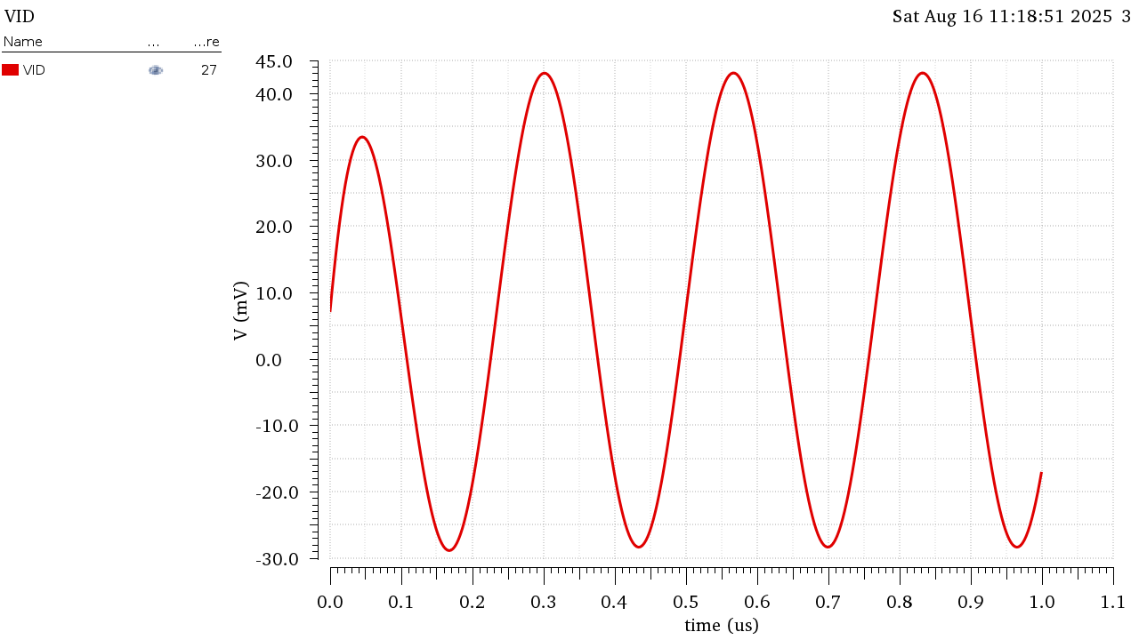
Figure 36 VID (Verror) at FIN=3.76MHz

 | VIN | VOUT | VID
Peak to Peak (V) | 1.00E-01 | 1.41E-01 | 7.20E-02

$$A_{CL_{@f}=3.76MHz}=\frac{V_{OUT}}{V_{in}}=\frac{141m}{100m}=1.41≈\frac{A_{CL}}{\sqrt{2}}$$
$$A_{OL@f=3.76MHz }=\frac{V_{out}}{V_{err}}=\frac{141m}{72m}=1.9583≈\frac{1}{β}$$
The Closed loop gain dropped by approximately a factor of root 2 as this is the bandwidth of the Closed Loop Gain.
This is also the Unity Gain Frequency for the Loop Gain thus $βA_{OL@f=3.76MHz}≈1$ and since $β$ is constant and doesn’t depend on frequency, $A_{OL}$ drops to be approximately equal to $\frac{1}{β}$ but we notice it is still less than the actual value of the feedback factor.
This is because we didn’t account for the phase shift in this approximation as the LG is actually (-j) not 1 at this frequency as also seen from figure 35 the input and output are 90 degrees out of phase making the feedback factor slightly smaller and the closed loop gain slightly larger.

