Mini Project 1
Two Stage OTA Design

Part 1: gm/ID Design Charts
NMOS Charts:
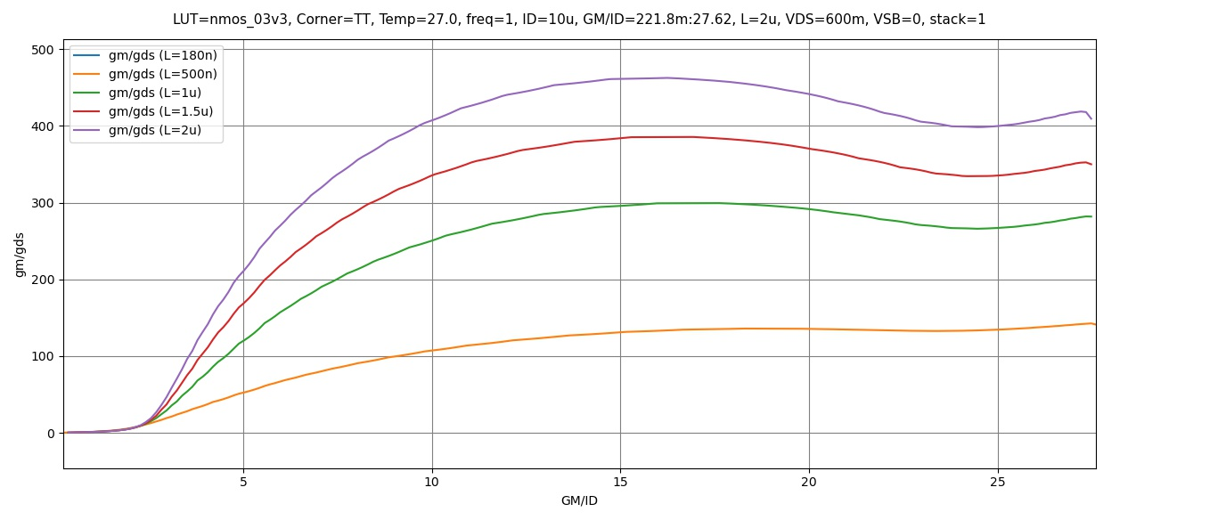
Figure 1 gm/gds vs gm/id

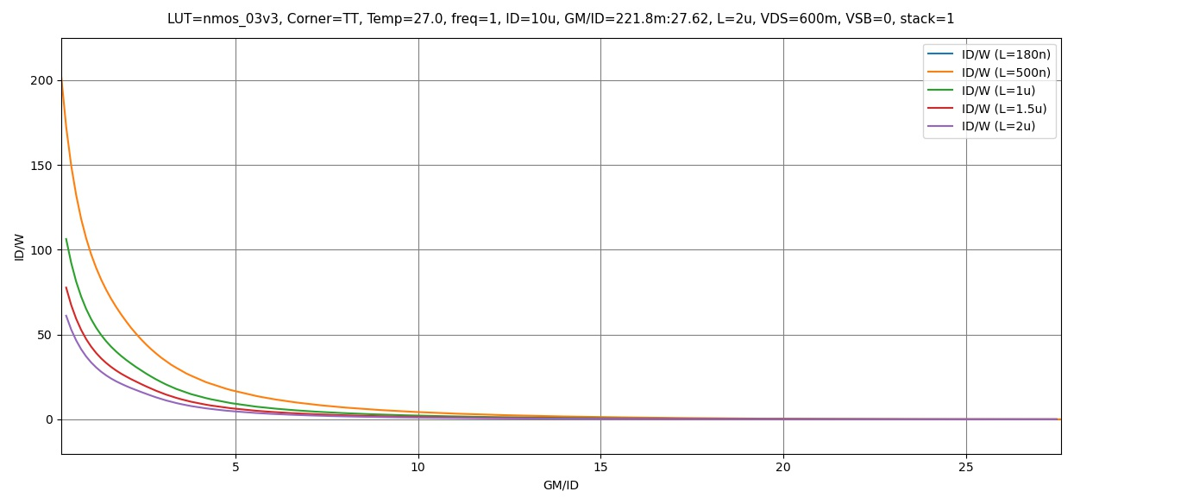
Figure 2 ID/W vs gm/ID

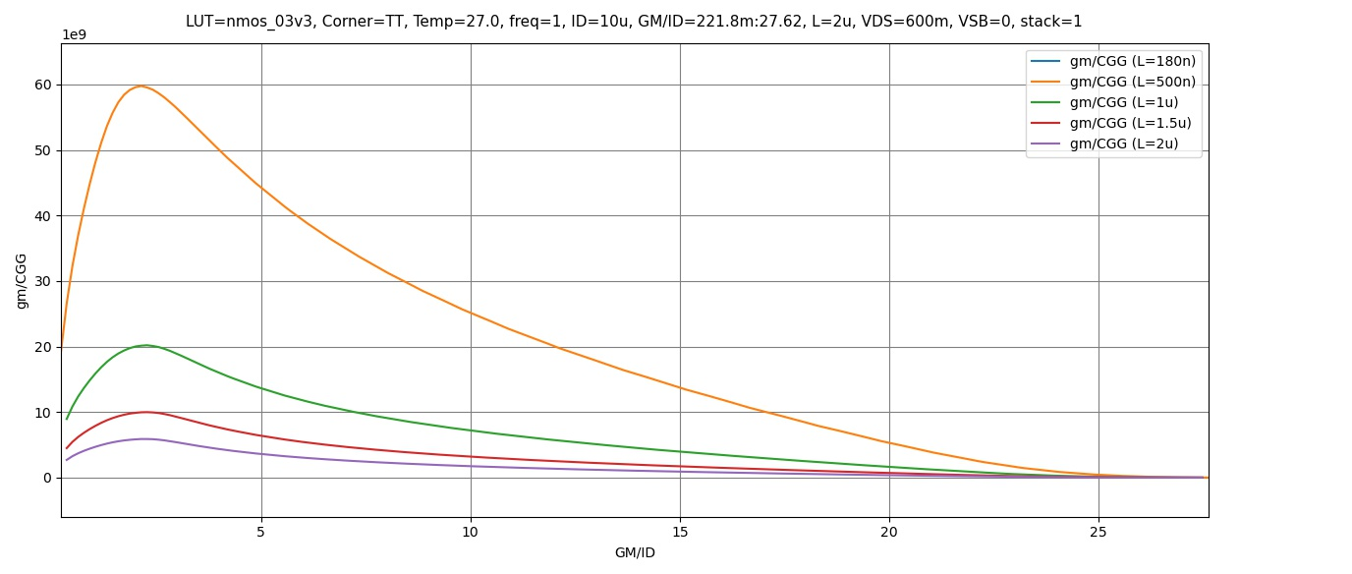
Figure 3 gm/Cgg vs gm/ID

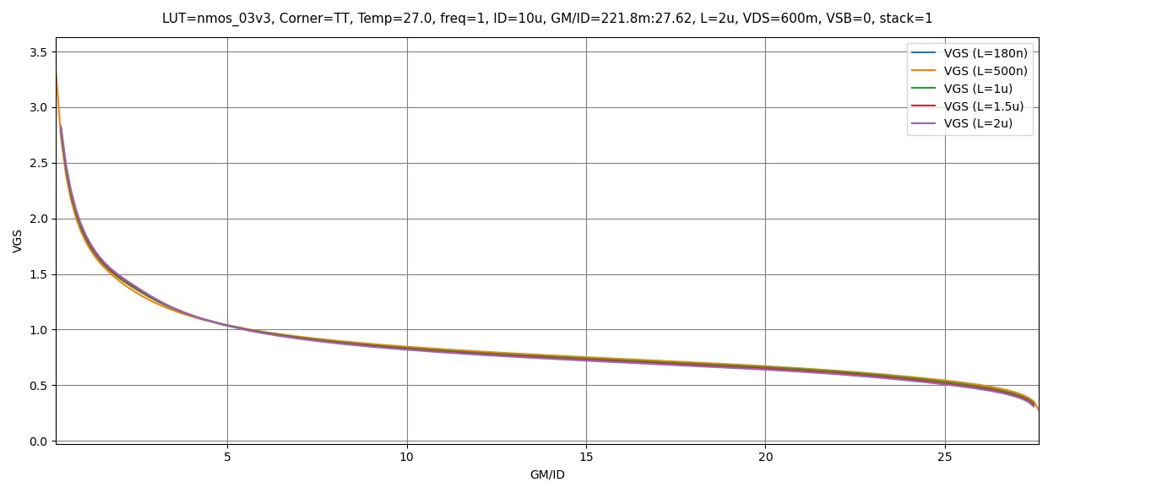
Figure 4 VGS vs gm/ID

PMOS Charts:
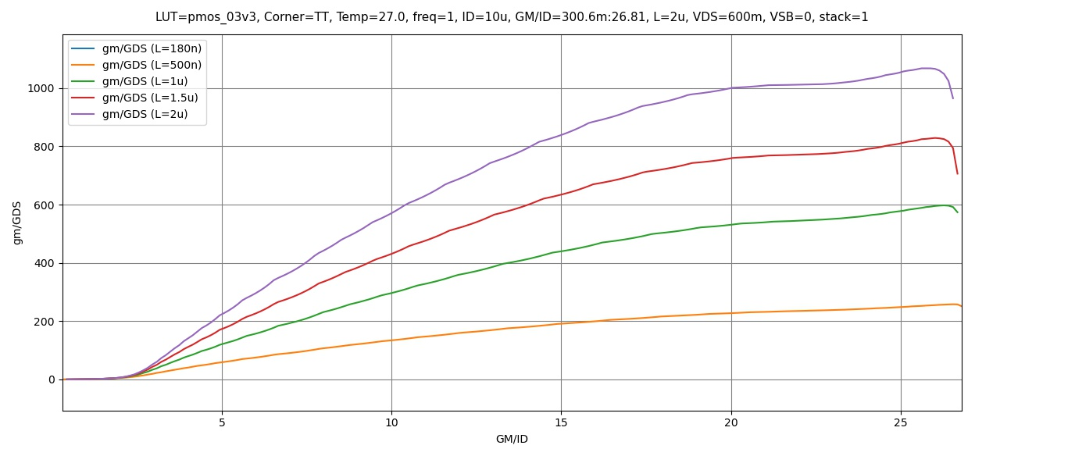
Figure 5 gm/gds vs gm/ID

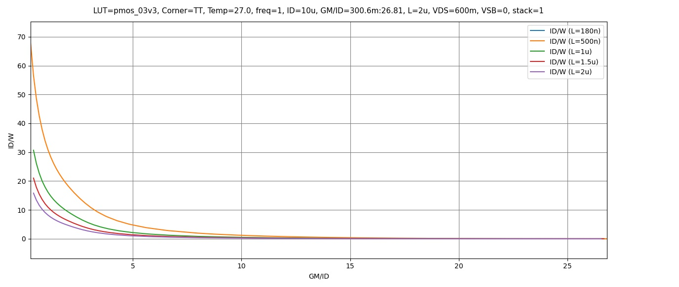
Figure 6 ID/W vs gm/ID

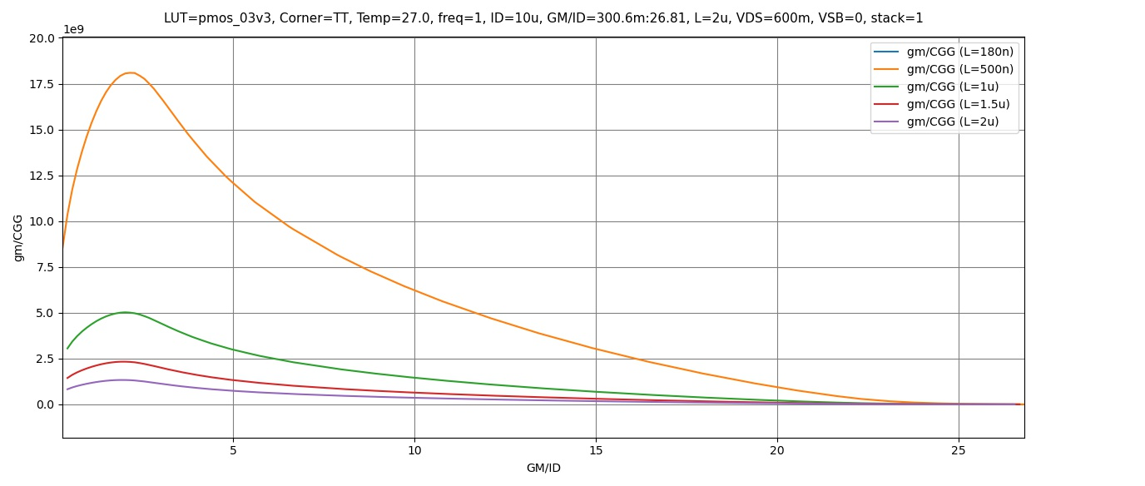
Figure 7 gm/Cgg vs gm/ID

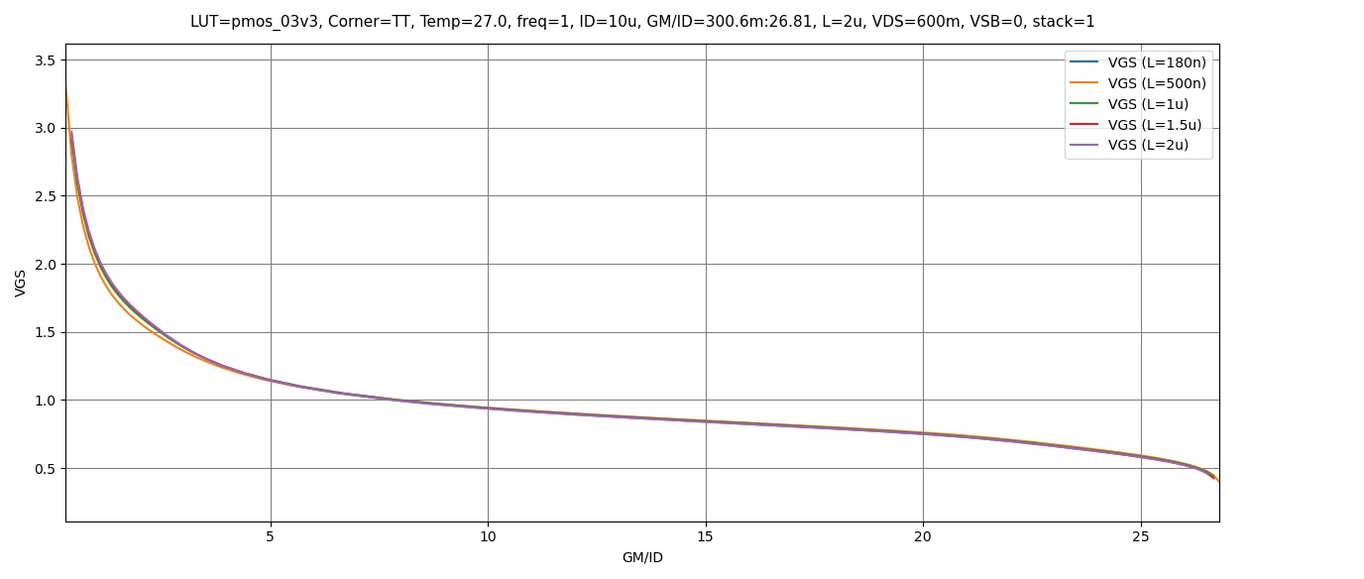
Figure 8 VGS vs gm/ID

Part 2: OTA Design
Required Specifications:
Technology | 0.18um
Supply voltage | 1.8V
Static gain error | <= 0.05%
CMRR @ DC | >= 74dB
Phase margin (avoid pole-zero doublets) | >= 70º
OTA current consumption | <= 60uA
CMIR – high | >= 1V
CMIR – low | <= 0.2V
Output swing | 0.2 – 1.6V
Load | 5pF
Buffer closed loop rise time (10% to 90%) | <= 70ns
Slew rate (SR) | 𝟓𝑽/𝝁𝒔

Design Observations:
$$Static Gain Error=\frac{1}{LG}=\frac{1}{A_{OL}β}∵β=1∴\frac{1}{A_{OL}}=\frac{0.05}{100}→A_{OL}=2000$$
- The Open Loop Gain required is large and should be achieved by a two stage OTA
- The CMIR required is close to the Ground Rail, thus a PMOS input stage is preferred.
- The output swing is quite large, thus a CS amplifier with a current source load is preferred for the output stage
- The requirement for the differential input would be suited better by a 5T-OTA.
A Miller-OTA topology will be used
It is required to size about 4 pairs of MOSFETS.
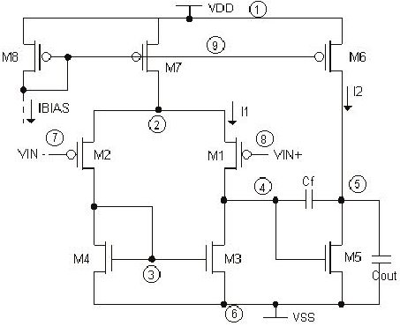

Figure 9 Miller OTA Topology
Miller Capacitance:
A reasonable choice for Miller Capacitance is $0.5*C_{L}$
$$C_{C}=0.5*5p=2.5pF$$
Input Transistors:
$$t_{rise}=70ns=2.2τ→τ=31.82ns=\frac{1}{ω_{u}}$$
$$ω_{u}=31.427Mrad=\frac{gm_{1,2}}{C_{C}}→gm_{1,2}=78.567μS≈80μS$$
Open Loop Gain can be divided between the two stages:
$$A_{OL}≥66dB=36 \left(5T OTA Gain\right)+30 (CS Gain)$$
$$63.1≈\frac{gm_{1,2}ro}{2}\left(Assuming Both NMOS and PMOS have the same gds\right)$$
$$→ro=1.5774MΩ≈1.6MΩ$$
Using the spec of Slew Rate:
$$SR=\frac{I_{B1}}{C_{C}}=\frac{5V}{μS}→I_{B1}=12.5μA→I_{D1,2}=6.25μA$$
Assuming the Voltage Drop is divided equally across all 3 transistors in branch, VDS of each transistor = 0.6V
Using these three parameters we can get the width and length of the input pair quickly using ADT:
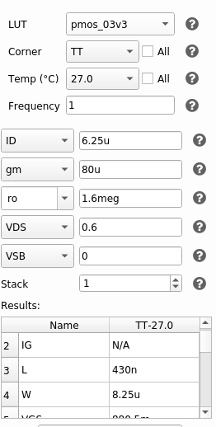
Figure 10 Intial Values for the input pair from SA
$$L=430nm , W=8.25μm$$
These are acceptable values for the Input Pair and decent for initial design!

PMOS Current Mirror Load:
Using CMIR-Max:
$$CMIR_{LOW}=0.2=-Vth_{1,2}+Vgs_{3,4} \left(Using Value of Vth_{1,2} from SA\right)$$
$$→ Vgs_{3,4}=0.98≈1V$$
The value for VGS is slightly large so I’ll use a lower value of 0.9V to get more reasonable dimensions
Using assumptions from the previous part:
$$ro=1.6MΩ , V_{DS}=0.6V , I_{D}=6.25μA$$
Plugging in these Values in ADT SA we get:
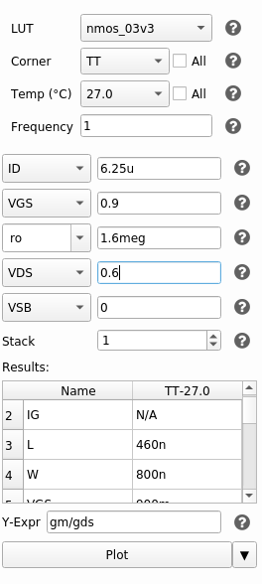
Figure 11 Initial Values for the PMOS Current Mirror Load Pair from SA
$$L=460nm , W=800nm$$
Width might be a bit small so we can approximate it to about $1μ$ to account for CMIR-LOW later.
$$L=460nm , W=1μm$$
Tail Current Mirror Sizing:
For the purposes of this design, I will use a simple current mirror at the tail.

Using the spec for CMRR:
$$CMRR=74dB=A_{diff}-A_{CM}→A_{CM}=-38dB$$
$$→A_{CM}=0.0126≈\frac{1}{2gm_{3,4}ro_{5}}→\frac{1}{ro_{5}}=gds_{5}≈1.33μs (Using Values of gm_{3,4} from SA)$$
Using the Spec for CMIR-Low:
$$CMIR_{HIGH}=0.8V=V_{DD}-V_{GS1,2}-V_{5}^{*}→V_{5}^{*}=119.3mV≈120mV$$
$$Giving it a higher margin→V_{5}^{*}≈150mV$$
$$I_{D}=I_{B1}=12.5μs→From previous assumption of the input stage$$

Plugging in these Values into ADT SA:
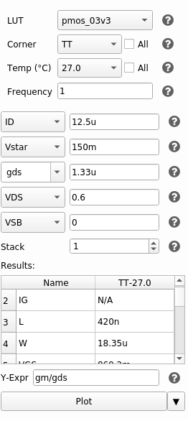
Figure 12 Initial Values for the Tail Current Mirror Load Pair from SA
$$L=420nm , W=18.35μm$$
Current Mirror:
The current tail mirror is easy to size, Using the sizing for the first mirror we can size the left and right one:
$$I_{B2}=60μ-12.5μ=47.5≈4I_{B1}$$
Thus, we can give the second current mirror the same sizing as M5 but with 4 multipliers. And sizing M8 (Left Transistor) is simple as well:
$$\frac{18.35μ}{W}=\frac{12.5μ}{10μ}→W=14.68μ≈14.5μ$$
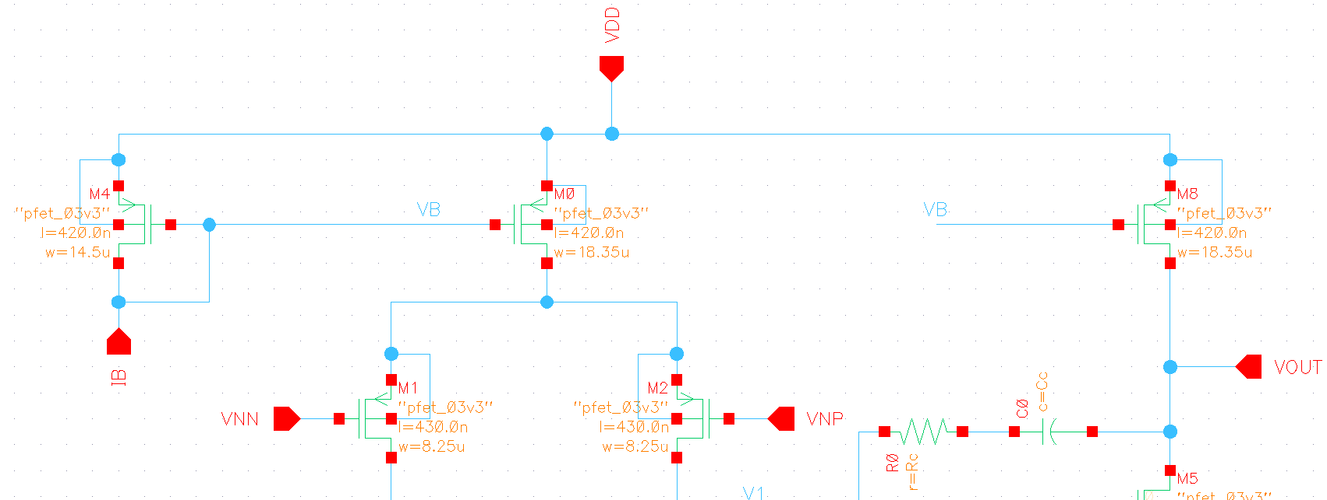
Figure 13 Tail Current Mirror
Second Stage CS Amplifier:
$$I_{D}=I_{B2}=47.5μA$$
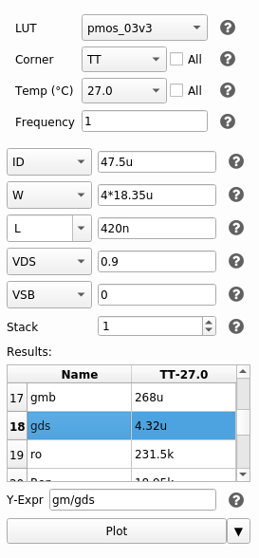
And Putting $V_{DS}=\frac{V_{DD}}{2}=0.9V$
Figure 14 gds of Second Current Mirror
$$A_{v}=30dB→31.622≈\frac{gm_{6}ro}{2}$$
Since the current mirror of the second stage uses the same sizing as the first stage one, we can its dimensions into ADT to get its value of gds

Moving on the value of gm for the second stage transistor can be calculated
$$A_{v}=30dB→31.622≈\frac{gm_{6}ro}{2}→gm_{6}=273.2μS$$
Plugging in every thing into ADT to get the dimensions:
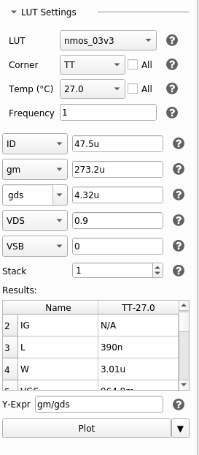
Figure 15 Sizing for CS Second Stage Transistor
$$L=390nm , W=3.01μm$$
Using this though would result in the circuit latching due to the output swing of the first stage not matching the input of the second stage (Systematic Mismatch) thus the node between the two stages is floating and the voltage is not set, hence the second current mirror gets out of saturation
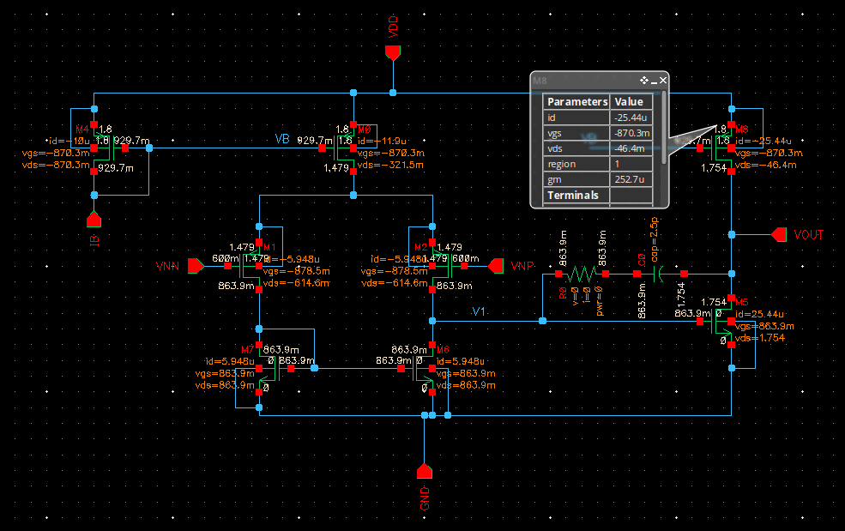
Figure 16 Circuit Latching using the calculated dimensions
To fix this we can either resize the NMOS Current Mirror Load with the new value of VGS at VDS or just sweep W for the CS transistor till the current source gets into saturation.
And to take the Output Swing Spec into consideration we will also look for the point exactly where VOUT=0.9V for the best result.
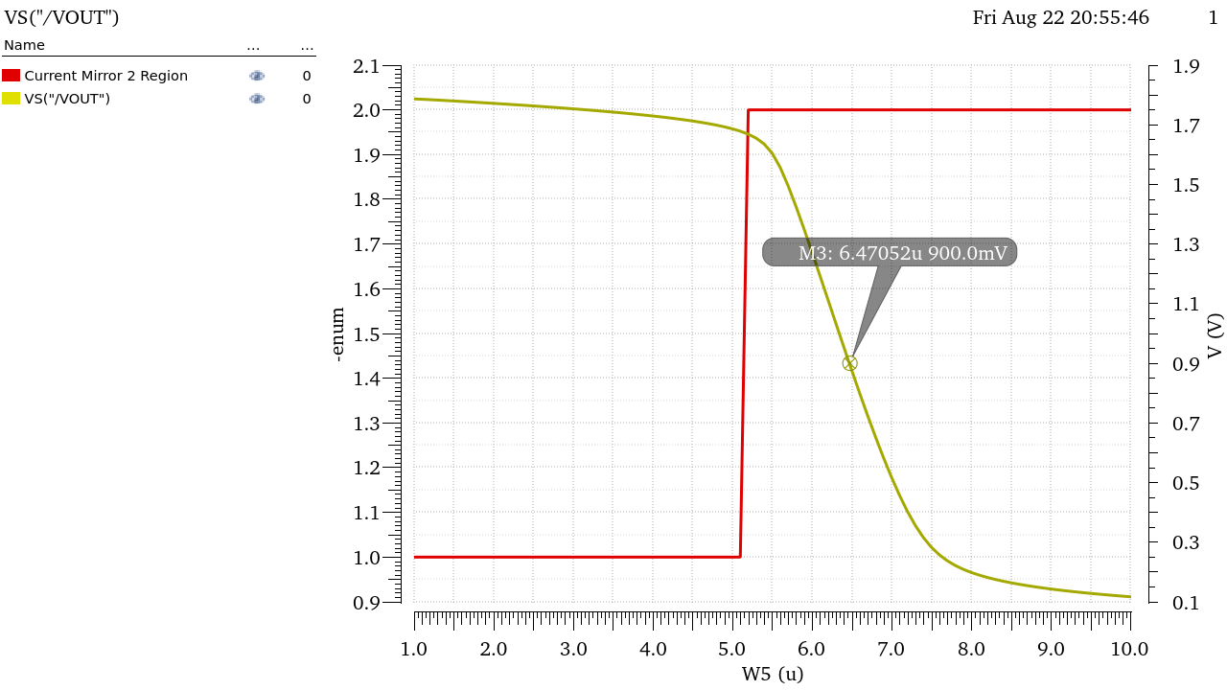
Figure 17 Point at which Vout=0.9V and Current mirror in Sat
$$L=390nm , W=6.47μm$$

Feedforward Zero:
Finally, finding the value of the resistor to cancel the feedforward zero is simple enough:
$$R_{C}=\frac{1}{gm_{6}}≈2.5KΩ$$
Initial Design Point:
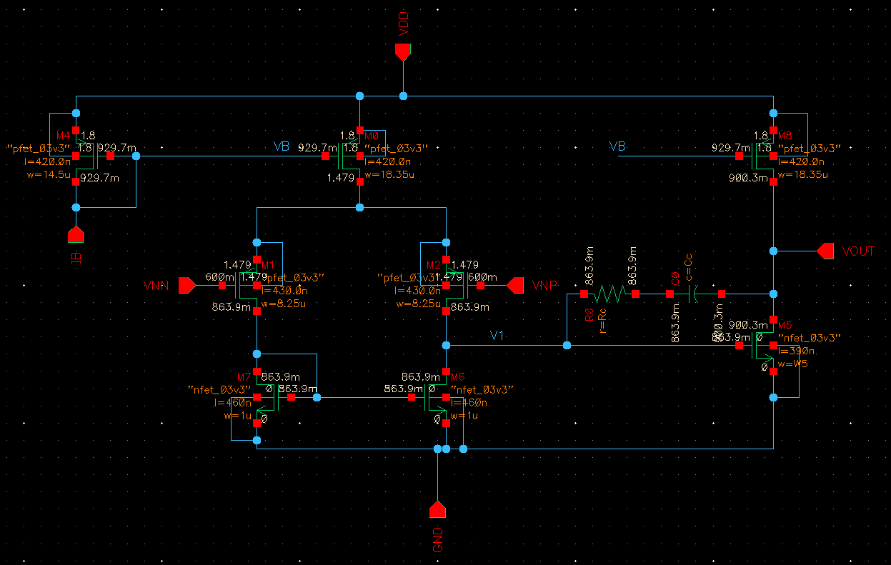
Figure 18 Final Design Schematic
 | M1,2 | M3,4 | M5 | M6 | M7 | M8
W | 8.25um | 1um | 18.35um | 6.47um | 18.35 | 14.5
Multiplier | 1 | 1 | 1 | 1 | 4 | 1
gm | 8E-05 | 5E-05 | 0.0003 | 0.0004 | 0.0006 | 0.0001332
L | 430nm | 460nm | 420nm | 390nm | 420nm | 420nm
ID | 6.25uA | 6.25uA | 12.5uA | 47.5uA | 47.5uA | 10uA
gm/ID | 12.65 | 8.658 | 20.17 | 8.552 | 13.46 | 13.32
VDsat | 134.4mV | 193.6mV | 68.72mV | 189.5mV | 124.5mV | 125.6mV
Vov | 100.1mV | 168.4mV | 46.76mV | 165.8mV | 84.94mV | 86.54mV
Vstar | 158.1mV | 231mV | 99.16mV | 233.9mV | 148.6mV | 150.1mV

M1,2: Input Transistors (PMOS)
M3,4: NMOS Current Mirror Load (NMOS)
M5: Tail Current Source of First Stage (PMOS)
M6: Input Transistor of Second Stage (NMOS)
M7: Tail Current Source of Second Stage (PMOS)
M8: Current Mirror (PMOS)
Simulation and Design Iteration:
Of Course, this design wouldn’t satisfy all the specs exactly from the first run, thus I’ll change them as we go through the requirements and tweak slightly till all specs are met

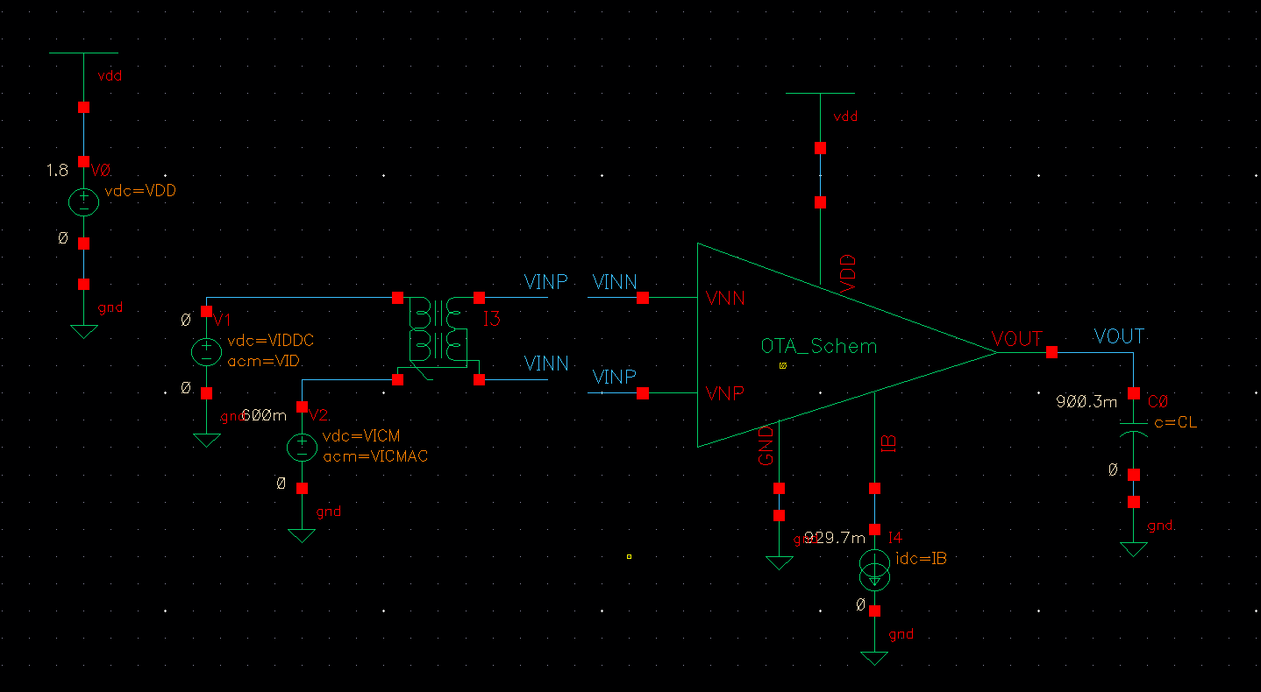
Figure 19 Testbench Schematic

Part 3: Open Loop Simulation:
OP Analysis:
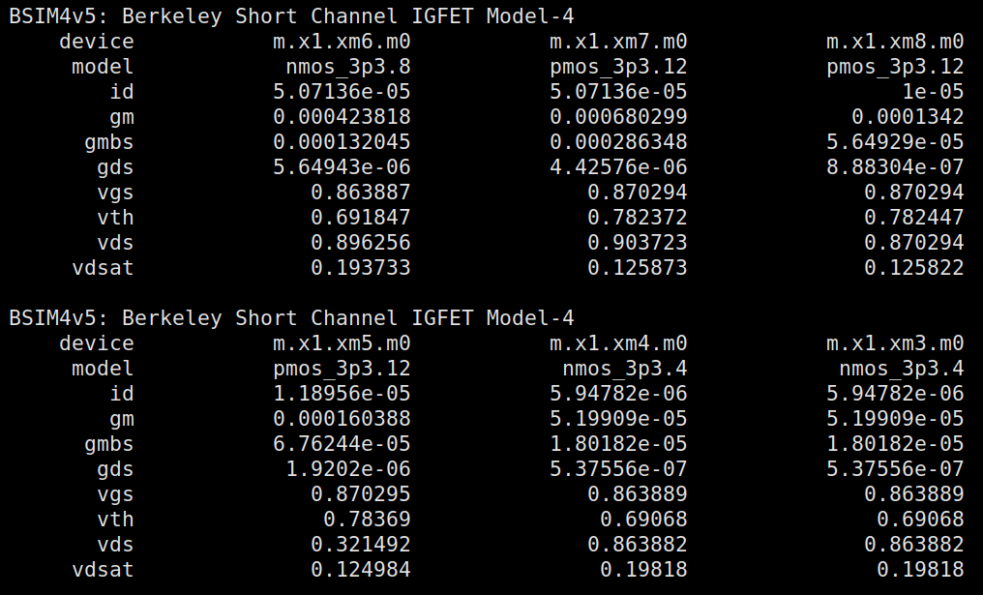
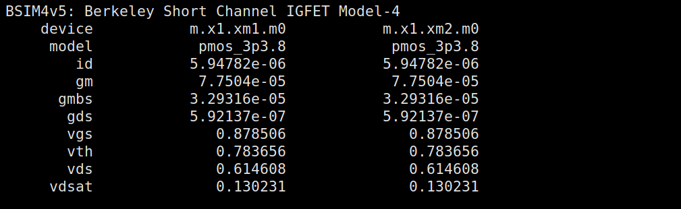
Figure 20 OP Point from Xschem
I used xschem and ngspice to get the operating point as it displays in a much better way than cadence, the values are largely almost identical though.
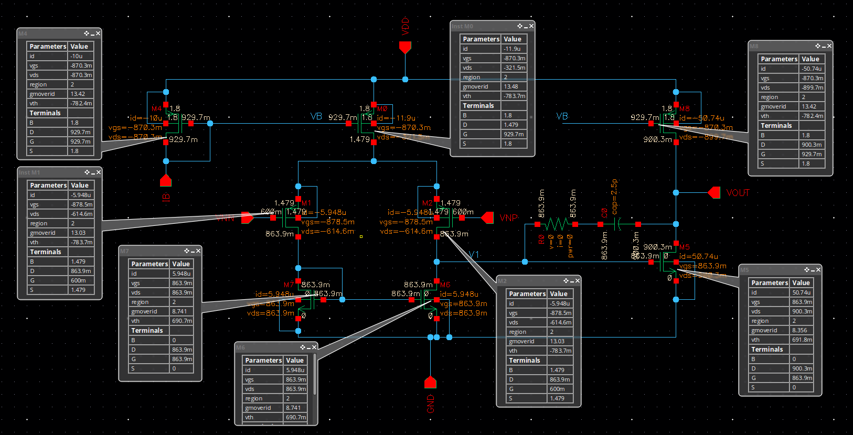
Figure 21 OTA Schematic with OP Point and DC Voltages Annotated
• Is the current (and gm) in the input pair exactly equal?
Yes, the current is exactly equal in both transistors of the input pair.

• What is DC voltage of the first stage? Why?
$$V_{out}=863.9mV$$
$$V_{out}=V_{DD}-V_{DS1,2}-V_{DS5}=1.8-0.6146-0.321=0.864V$$

• What is DC voltage of the second stage? Why?
$$V_{out}=0.9V$$
$$V_{out}=V_{DD}-V_{DS7}=1.8-0.9=0.9V$$

Systematic mismatch is pretty low as seen here between the vout of both stages.
Differential Small Signal:
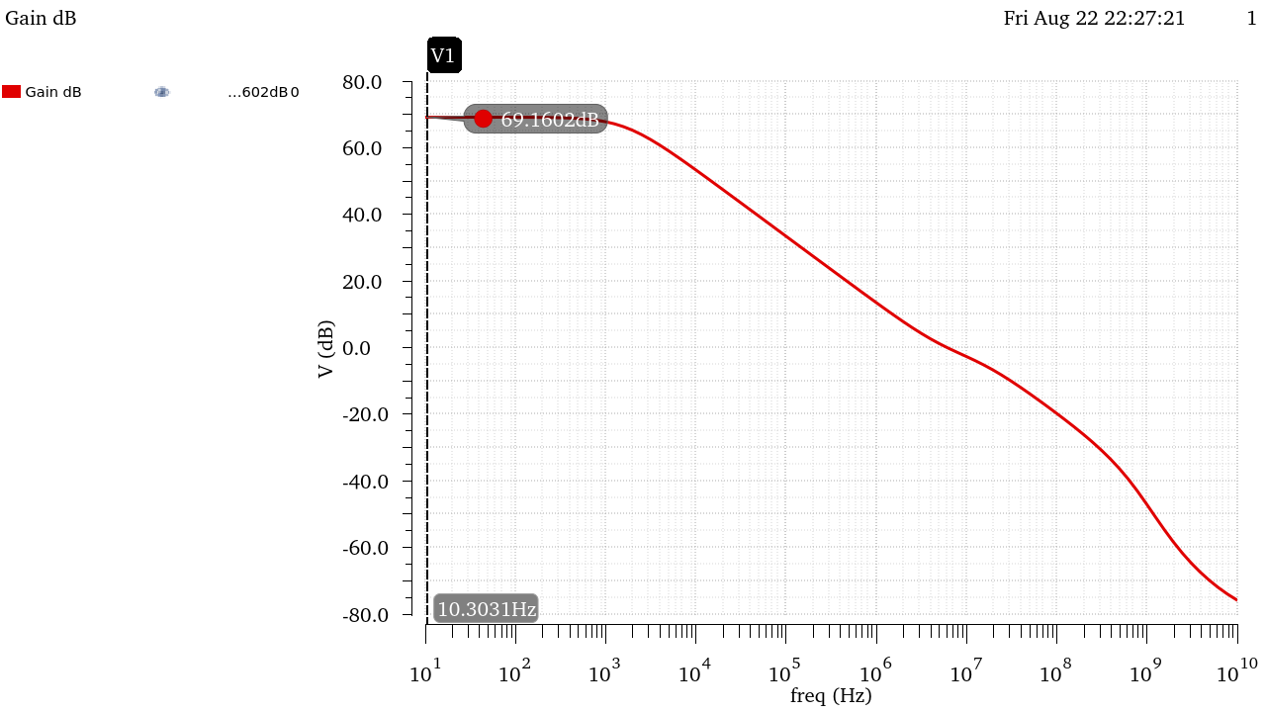
Figure 22 Diff Gain (dB) Open Loop Gain vs Frequency
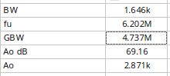
Figure 23 Diff Small Signal Outputs
Hand Analysis:
Using Values from OP Analysis:
$$First Stage Gain: \left|A_{vd}\right|=gm_{1,2}\left(ro_{1,2 }//ro_{3,4}\right)=68.644→36.732 dB$$
$$Second Stage Gain:A_{v}=gm_{6}\left(ro_{6}//ro_{7}\right)=42.06→32.5dB$$
$$Overall Gain:A_{v}=36.732+32.5=69.21→2887.31$$
$$GBW=\frac{gm_{1}}{2πC_{c}}=4.9338MHz$$

 | Simulation | Hand Analysis
Gain | 2871 | 2887
Gain (dB) | 69.16 | 69.21
GBW | 4.737MHz | 4.9338MHz

AOL Gain exceeds the required spec! and agrees with hand analysis.
GBW In hand analysis is a bit less than simulation and less than the required spec as our analysis did not account for other circuit and MOS capacitances, this can be fixed by simply lowering Cc a little bit.

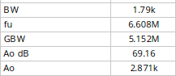
Figure 24 Simulation Results after Lowering Cc to 2.3pF
Lowering Cc results in giving us the required GBW from the spec, but it might affect our phase margin, this will be fine-tuned further in Part 4.

CM Small Signal:
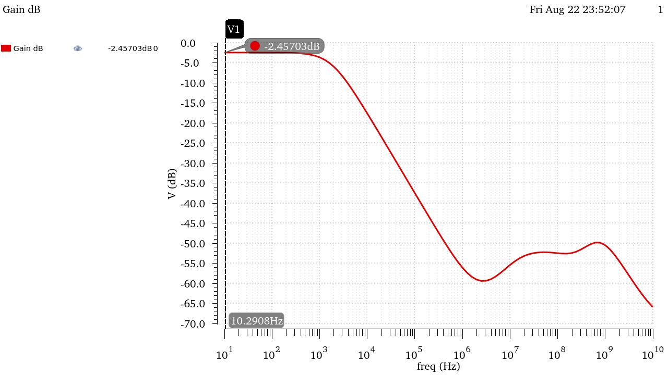
Figure 25 CM Gain (dB) vs Frequency
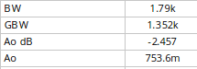
Figure 26 CM Gain Values
Hand Analysis:
Using Values from OP Analysis:
$$\left|A_{vCM}\right|=\frac{1}{2gm_{3,4}{ro}_{5}}*{gm}_{6}\left({ro}_{6}//{ro}_{7}\right)=776.65×10^{-3}→-2.195 dB$$

 | Simulation | Hand Analysis
Gain | 753.6e-3 | 775.65e-06
Gain (dB) | -2.457 | -2.195

Hand analysis and simulation results agree with each other.

CMRR (XF Simulation):
$$CMRR=A_{d}-A_{cm}≈71.405dB$$
CMRR is slightly less than the spec, this can be fixed by slightly increasing the CM Gain which could be achieved by increasing the length of the tail current sources slightly.
I’ll fine tune this using XF simulation.
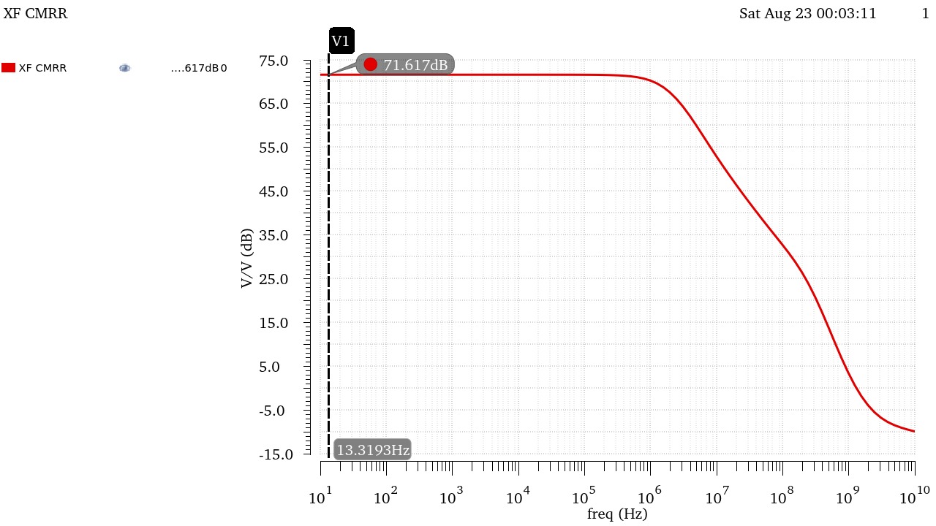
Figure 27 CMRR From XF Simulation
Figure 28 CMRR Value from Simulation
 | Simulation | Hand Analysis
CMRR (dB) | 71.62 | 71.405

As expected, CMRR was a little less than the required spec, I’ll fixed this by slightly increasing the Lengths of the tail current sources, increasing their seen resistance and increasing CM Gain.

After Fine Tuning:
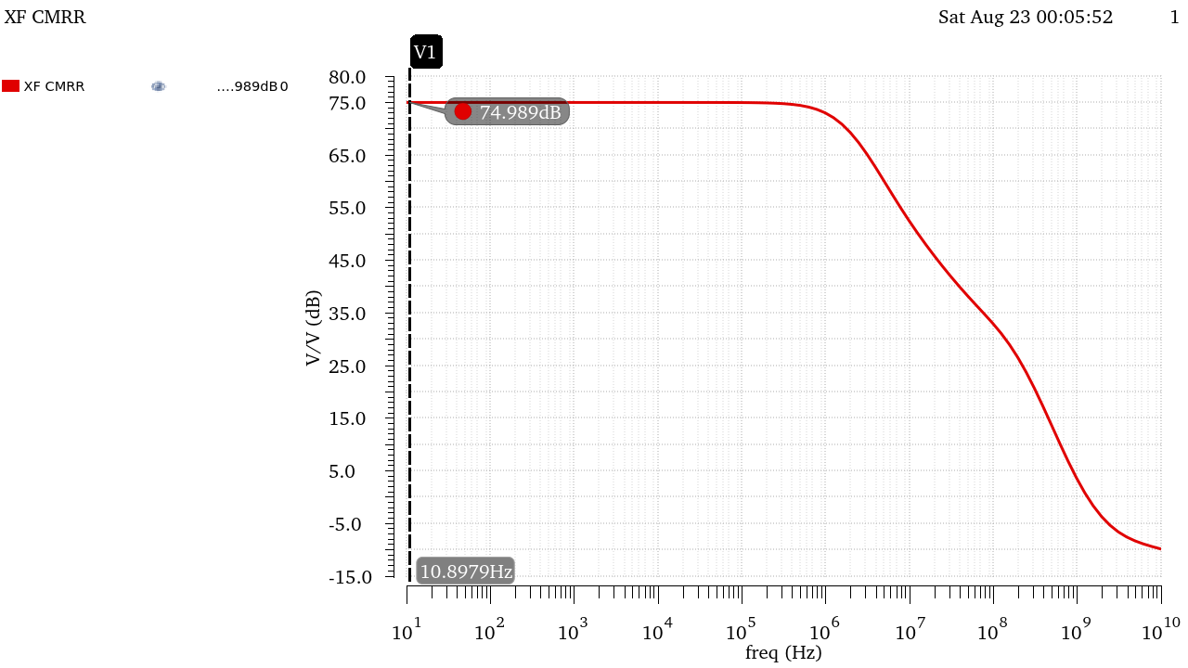
Figure 29 CMRR After Fine Tuning
Figure 30 CMRR Value after Tuning
$$using L_{5,7,8}=600nm instead of 420nm$$
This changed the current slightly in the CS Stage, thus we’ll have to resize W6 to ensure Vout is @ 0.9V
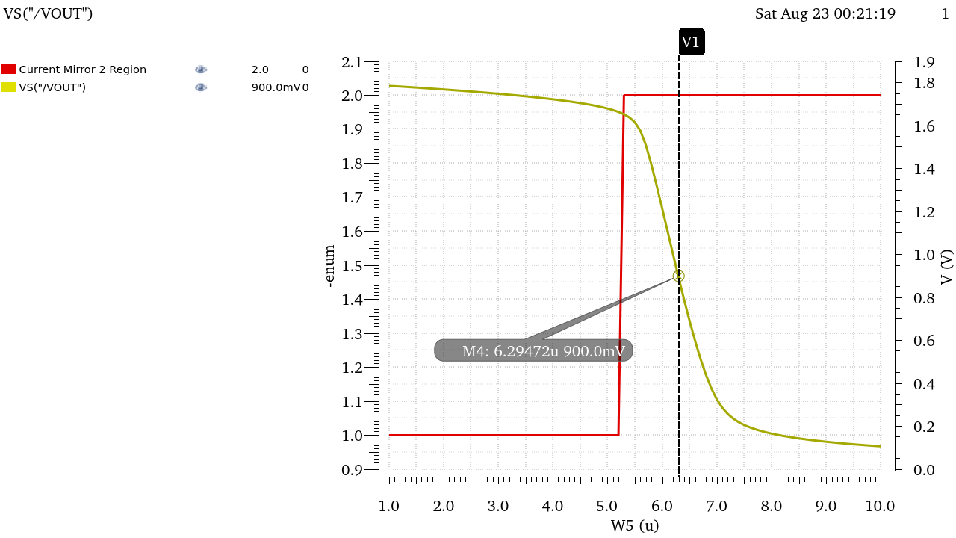
$$W_{6new}=2.295μm$$
All other design points stay mostly the same!
Diff Large Signal:
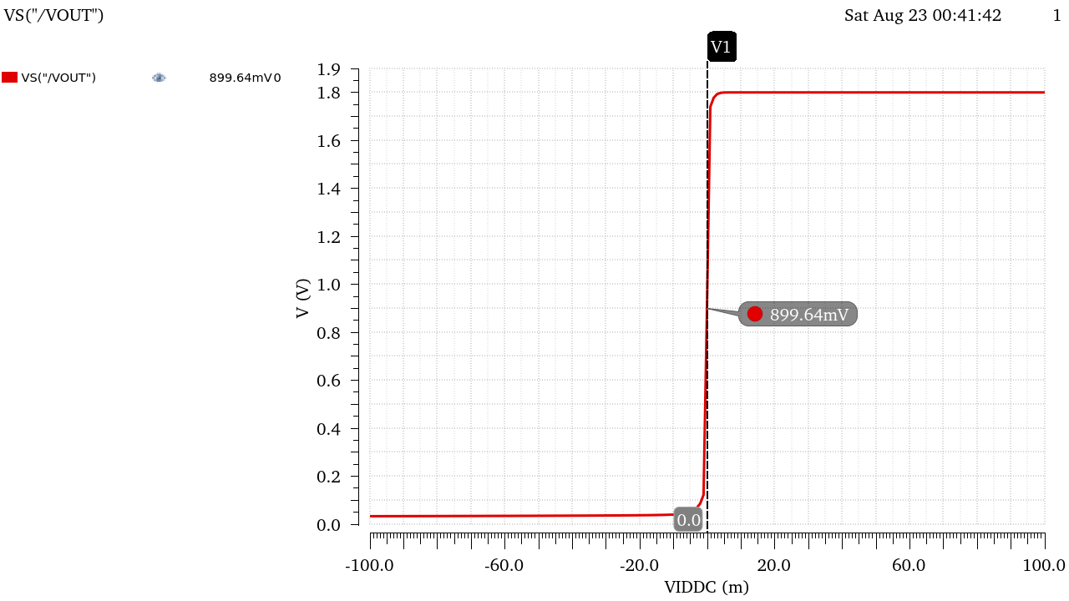
Figure 31 VOUT vs Vid
What is the value of Vout at VID = 0? Why?
$Vout_{@Vid=0}=0.9V$, Same Value as Vout calculated During OP Analysis, This is the Quiescent point of the amplifier on which we biased our transistor for the maximum output swing

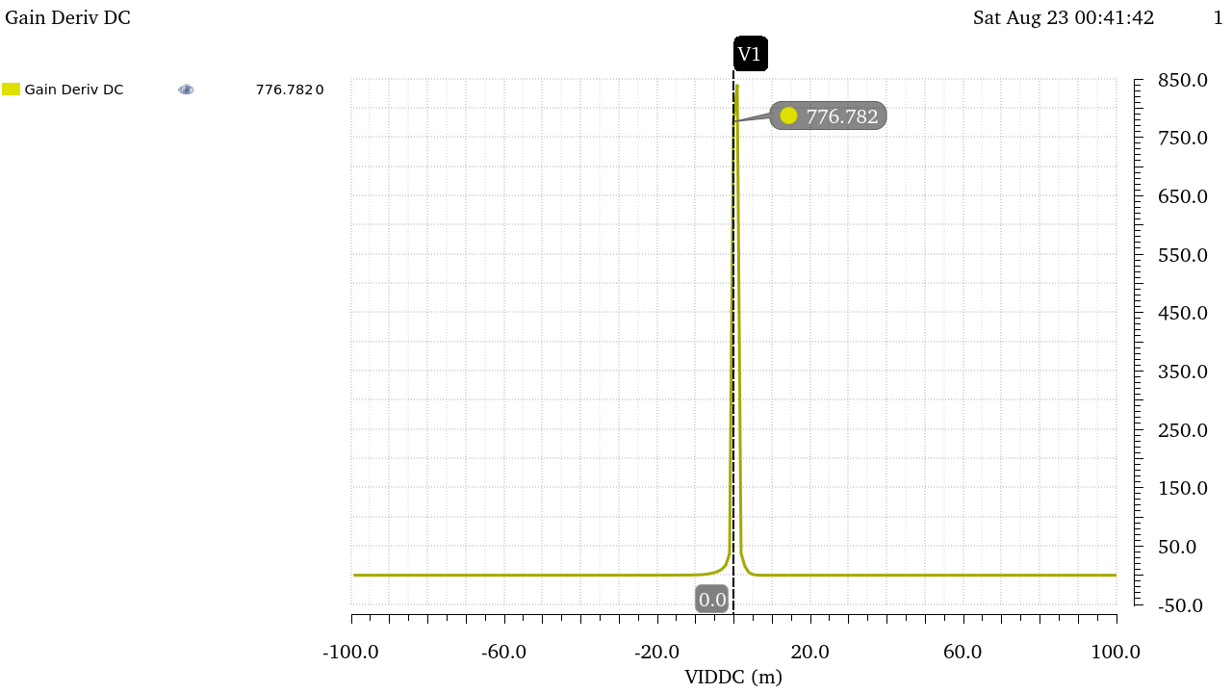
Figure 32 Derivates of Vout vs Vid
Figure 33 Value at the Peak
- Is the peak less than the value of Avd obtained from ac analysis? Why?
The Value of the derivative of Vout vs Vid is the DC Gain, the value at the peak=840.5 is observed to be way lower than Avd=2871

This is due to the very high gain of the amplifier such that the linear region in which the derivative is meaningful is very small, the 1mV step required in the question is just not enough to measure the fine details and values to get the actual gain, This can be fixed by using a lower step size but at the cost of higher processing power and longer simulation time.
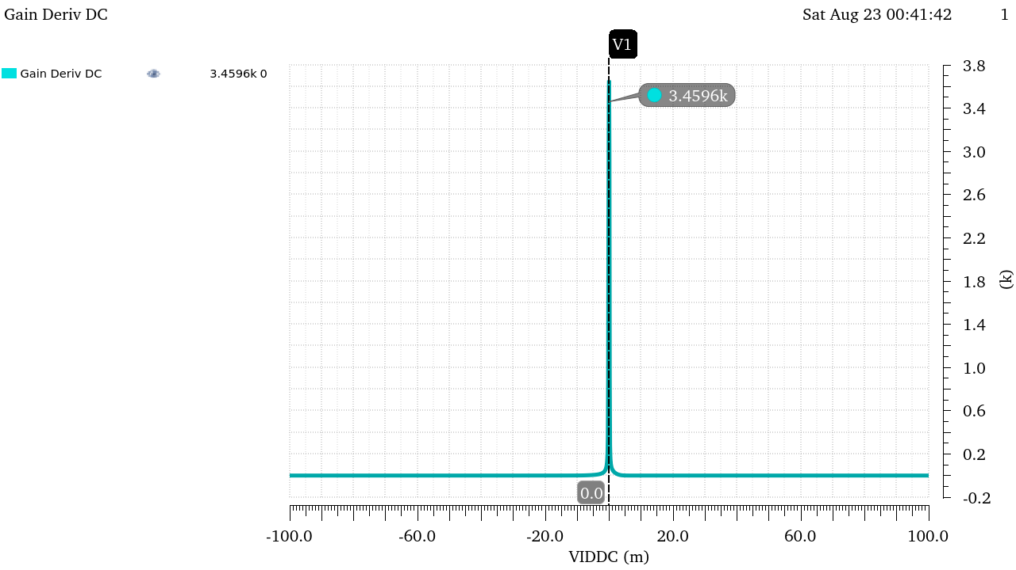
Figure 34 Derivative of Vout vs VID with a step of 0.1mV instead of 1mV
Figure 35 New Value at the Peak after using finer step
Using a finer step resulted in a much better comparable value to the Gain obtained from AC Analysis!
Notice the gain is also slightly higher than what was calculated earlier, this is due to the increase of RSS after changing the lengths of the current sources to achieve the required CMRR.

CM Large Signal:
Region vs VICM:
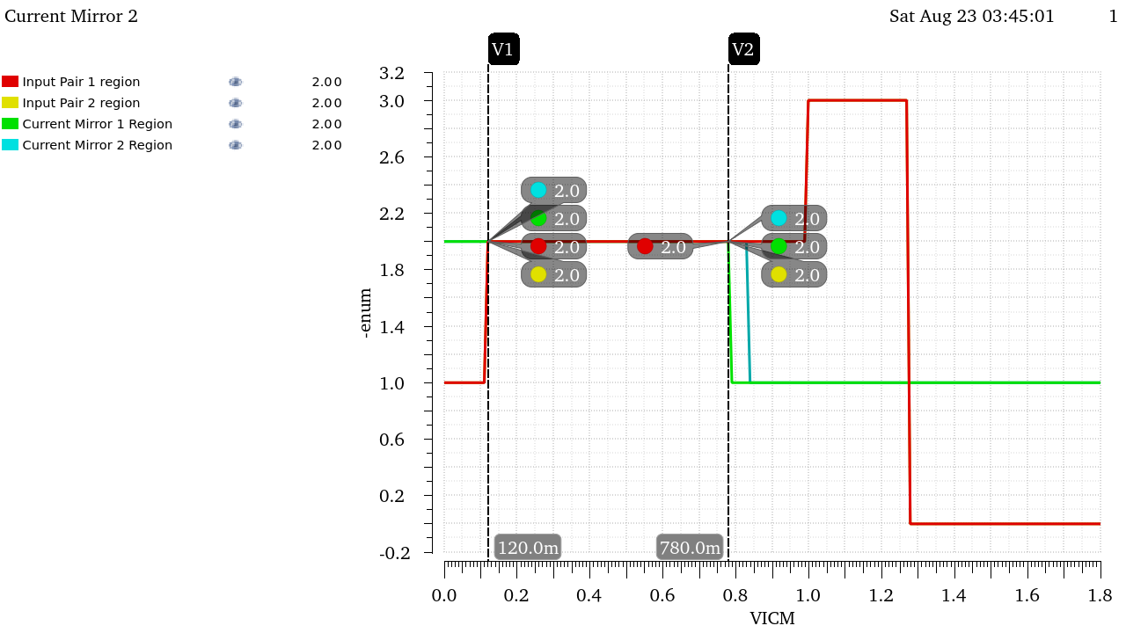
Figure 36 Region vs VICM
$$VICM_{LOW}=120mV , VICM_{HIGH}=780mV$$
We can observe that the Lower CMIR is met but the Higher Range is close but not met exactly,
Fine Tuning:
This can be remedied by increasing the Widths of the tails current sources slightly or increasing the Widths of the input stages, I will also decrease the widths of the Current Mirror transistors to reduce current as I’m currently a little bit over the power consumption spec.
While I’m fine tuning those, I’ll keep an eye on VOUT to make the necessary changes for W6 to keep it at 0.9V as well as the other design parameters to ensure they are within spec.

Final Values after fine Tuning:
$$W_{1,2}=10.3μm , W_{5, 7}=17.3μm , W_{6}=6.26μm$$
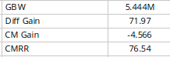
Figure 37 Design Specs after change
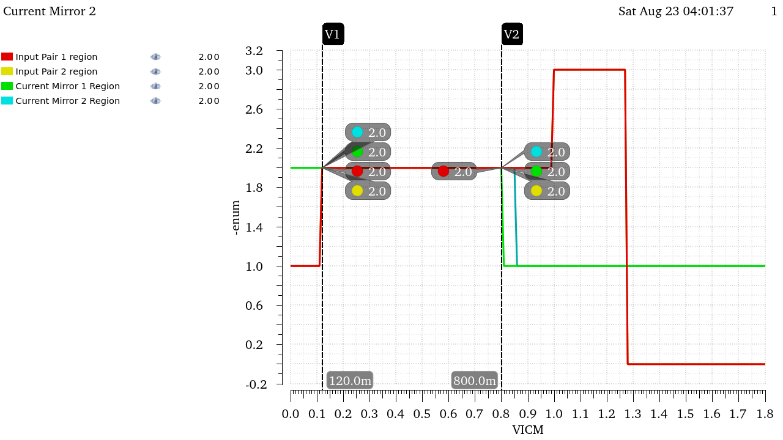
Figure 38 Regions vs VICM After Fine Tuning
$$VICM_{LOW}=120mV , VICM_{HIGH}=800mV$$
As we can see the slight increase in width improved other parameters as well.

(GBW vs VICM):
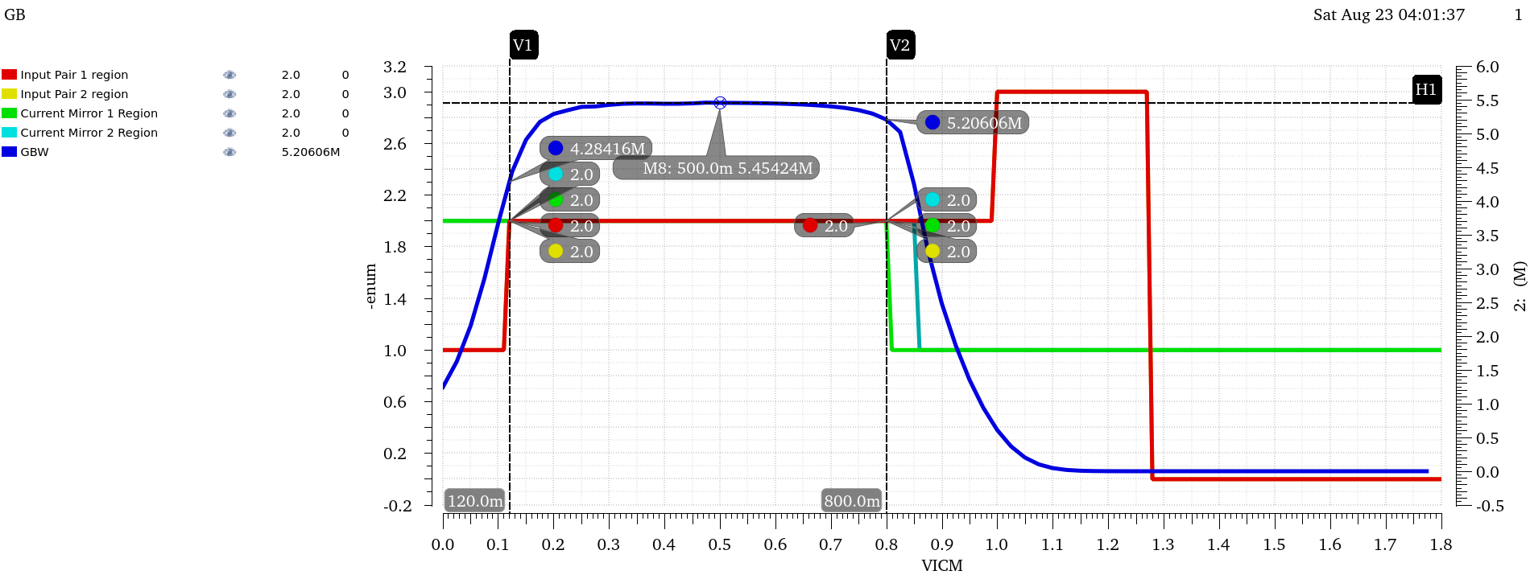
Figure 39 GBW and Regions Annotated and Overlaid
The previous figure shows the CMIR as illustrated by the regions
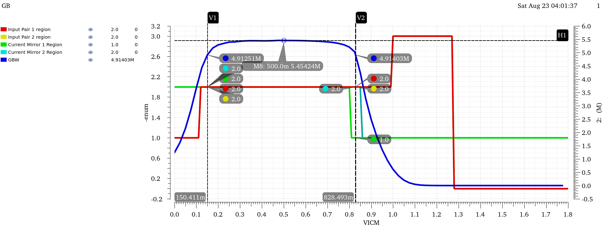
Figure 40 GBW and Region Overlaid and Annotated @ GBW=90% Max
The previous one showcases the CMIR at range where GBW is within 90% if its max value (Also Annotated).
$$VICM_{LOW}=150.411mV , VICM_{HIGH}=828.49mV$$
The design exceeds the required specs.
Hand Analysis:
Calculating the CMIR analytically is quite tricky as some of the device operate in regions where the square law isn’t valid, but we can work around it to get rough estimates.
$$VICM_{LOW}=VGS_{3,4}-V_{TH1,2}≈Vov_{3,4}≈160mV$$
$$VICM_{HIGH}=V_{DD}-V_{GS1,2}-Vov_{5}≈816.6mV$$
 | Simulation | Hand Analysis
CMIR-LOW | 150.411mV | 160mV
CMIR-HIGH | 828.48mV | 816.6mV
The results agree with the hand analysis for the most part.

Final Sizing at the end of Part 3:
Since I’ve fine-tuned the design a lot throughout the procedure, here’s a summary of the new sizing for each transistor:
 | M1,2 | M3,4 | M5 | M6 | M7 | M8
W | 10.3um | 1um | 17.3um | 6.26um | 17.3um | 14.5
Multiplier | 1 | 1 | 1 | 1 | 4 | 1
L | 430nm | 460nm | 600nm | 390nm | 600nm | 600nm
gm | 8.14E-05 | 5.11E-05 | 1.32E-04 | 4.04E-04 | 5.48E-04 | 1.15E-04
ID | 5.77E-06 | 5.77E-06 | 1.15E-05 | 4.76E-05 | 4.76E-05 | 1.00E-05
gm/Id | 1.41E+01 | 8.86E+00 | 1.15E+01 | 8.48E+00 | 1.15E+01 | 1.15E+01
Vstar | 1.42E-01 | 2.26E-01 | 1.74E-01 | 2.36E-01 | 1.74E-01 | 1.74E-01
Vov | 7.61E-02 | 1.70E-01 | 1.25E-01 | 1.69E-01 | 1.25E-01 | 1.25E-01
Vdsat | 1.18E-01 | 1.96E-01 | 1.43E-01 | 1.91E-01 | 1.44E-01 | 1.44E-01

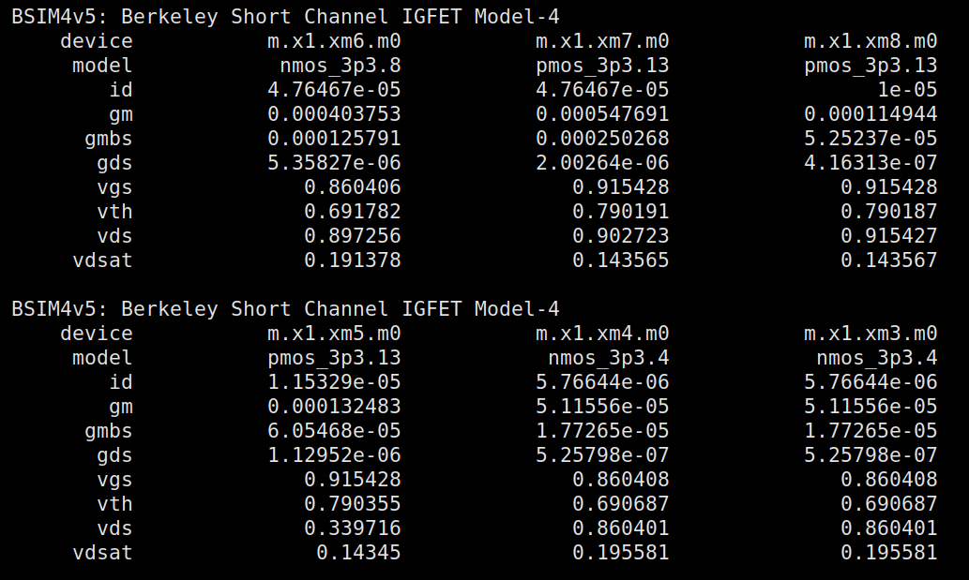
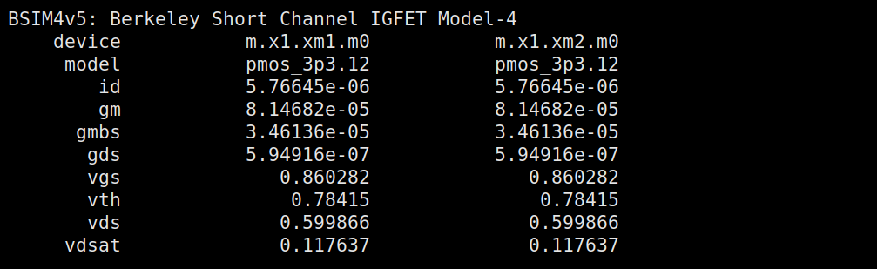
Figure 41 Updated OP Point

Part 4: Closed Loop OTA Simulation:
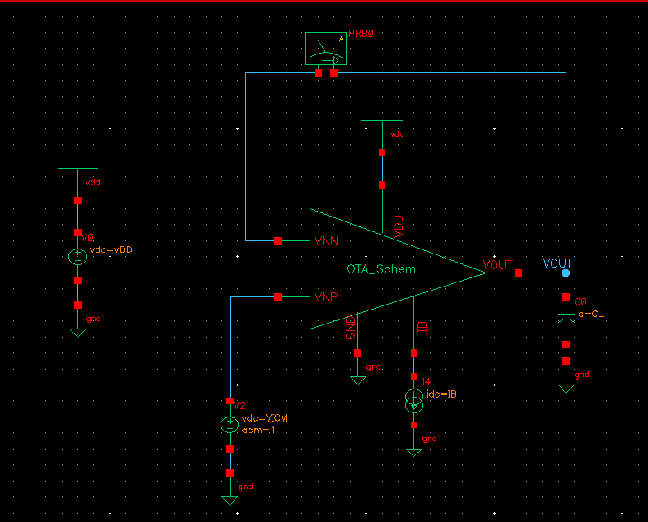
Figure 42 Closed Loop Testbench
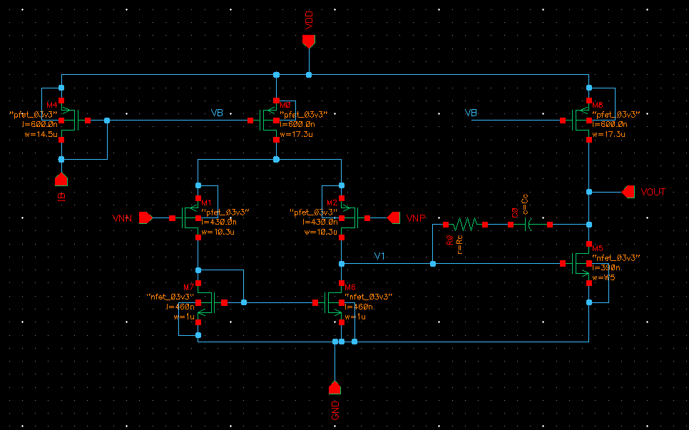
Figure 43 OTA Schematic
Op Analysis:
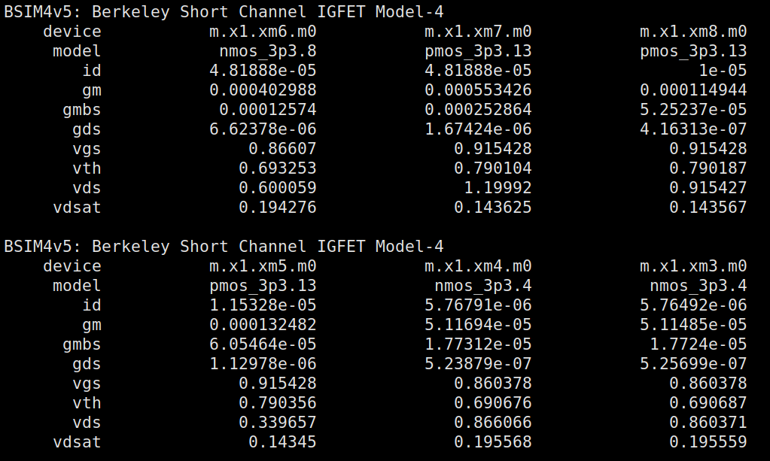
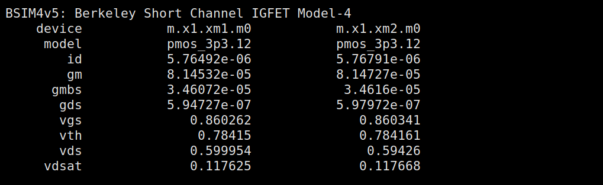
Figure 44 OP Point from Xschem and Ngspice

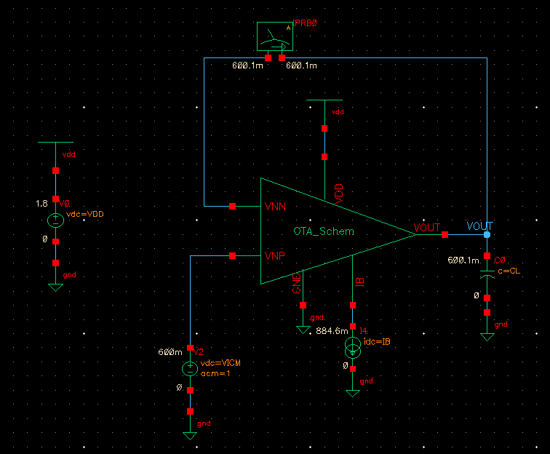
Figure 45 DC Voltages Annotated in TB Schematic
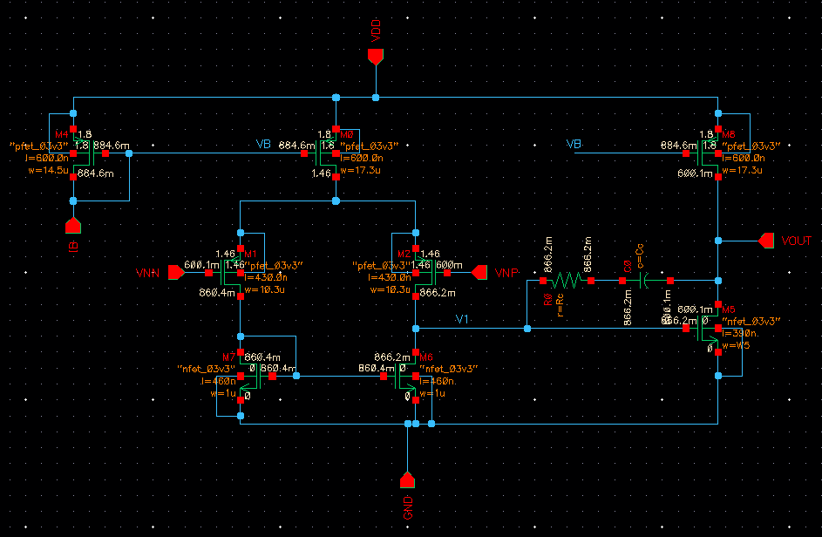
Figure 46 Dc Voltages Annotated in OTA
• Are the DC voltages at the input terminals of the op-amp exactly equal? Why?
There is only a 0.1mV difference between them so approximately equal this is due to the very high gain of the amplifier minimizing Verror.

• Is the DC voltage at the output of the first stage exactly equal to the value in the open-loop simulation? Why?
Its value is 866mV now as opposed to 864mV during the open loop simulation, very small difference between the two due to the high open loop gain

• Is the current (and gm) in the input pair exactly equal? Why?
There is a very small difference that is almost negligible between them, this is due to the very high gain of the amplifier making the input and output nodes follow each other and reduces the deviation caused significantly thus all the values are almost equal to each other.

Loop Gain:
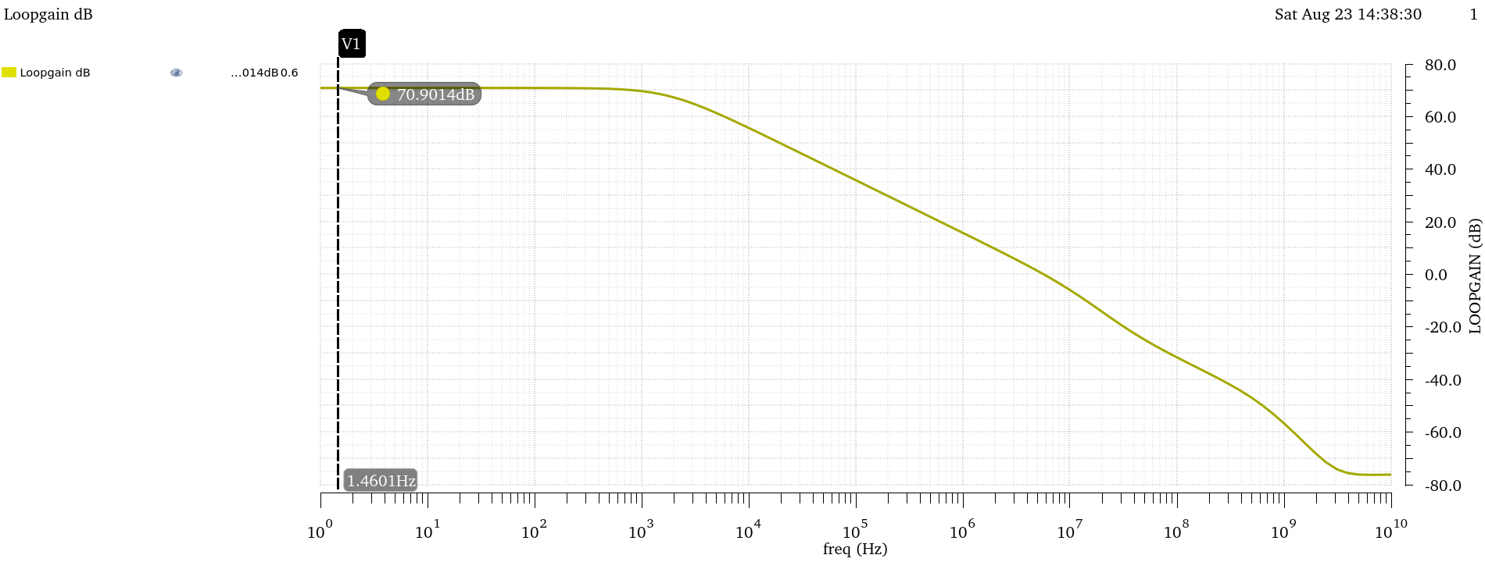
Figure 47 Loop Gain vs Frequency (dB)
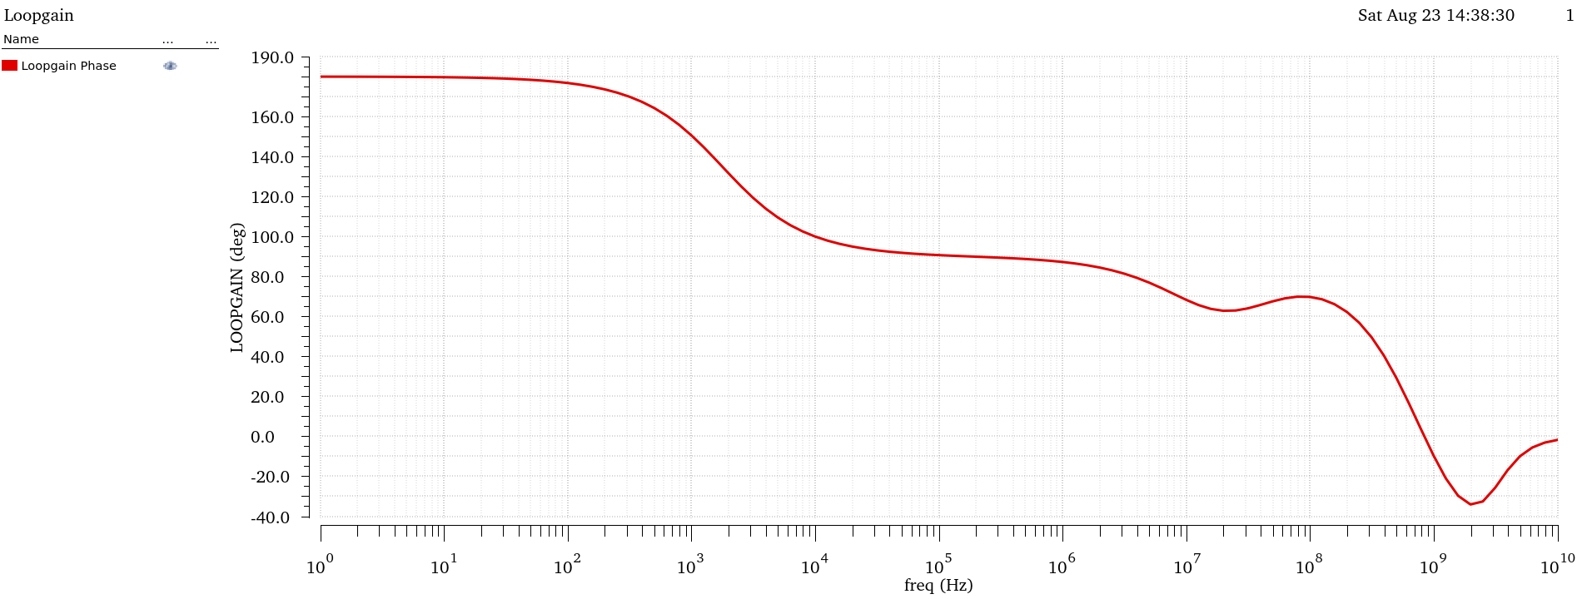
Figure 48 Loop Gain Phase vs Frequency

Compare DC gain, fu, and GBW with those obtained from open-loop simulation. Comment
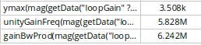
Figure 49 DC LG Gain, UGF and GBW
All Values are comparable to the Open Loop Simulation values at beta = 1 !
As Loop Gain follows the open loop behaviour.

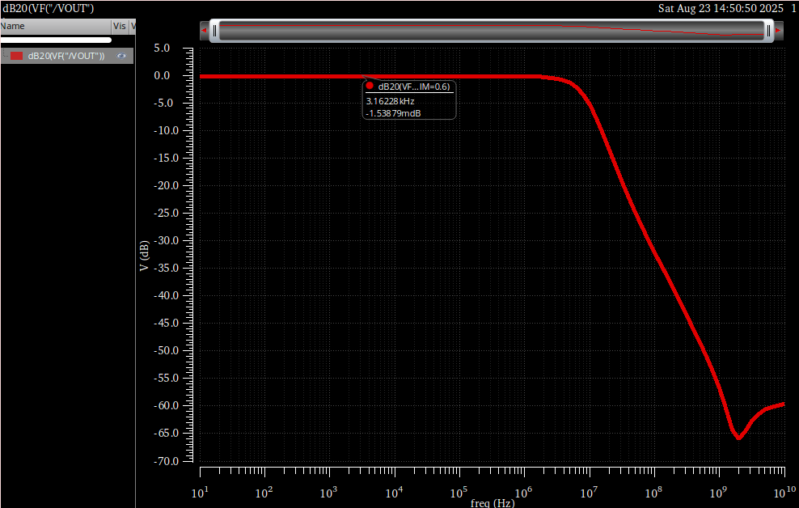
Figure 50 Closed Loop Bandwidth
$$BW_{CL}≈7.447MHz$$

Hand Analysis:
$$β=1 , { A}_{OL}=3.5K \left(From Open Loop Simulation\right)$$
$$Loop Gain=βA_{OL}=3.5K→70.88 dB$$
$$A_{CL}=\frac{A_{OL}}{1+βA_{OL}}=0.99971→-2.48*10^{-3} dB$$

 | Simulation | Hand Analysis
Beta | 1 | 1
Loop Gain | 3.508k | 3.5k
Loop Gain (dB) | 3.508k | 3.5k
Closed Loop Gain | 0.9998 | 0.9997

Analytic Results agree with Hand Analysis for the most part.

Phase Margin:
I had to fine tune the values of Rz and Cc further to get better slew rate and phase margin
Figure 51 Phase margin from simulation
$$R_{z}=5KΩ , C_{C}=2pF$$
Hand Analysis:
$$PM=\tan^{-1}\left(\frac{ω_{p2}}{ω_{gc}}\right)≈\tan^{-1}\left(\frac{gm_{2}C_{C}}{gm_{1}C_{L}}\right)≈{70}^{o}$$
 | Simulation | Hand Analysis
PM | 75.41 | 70

Hand Analysis isn’t entirely accurate because it doesn’t account for parasitic and MOSFET capacitances in the circuit.
Slew Rate:
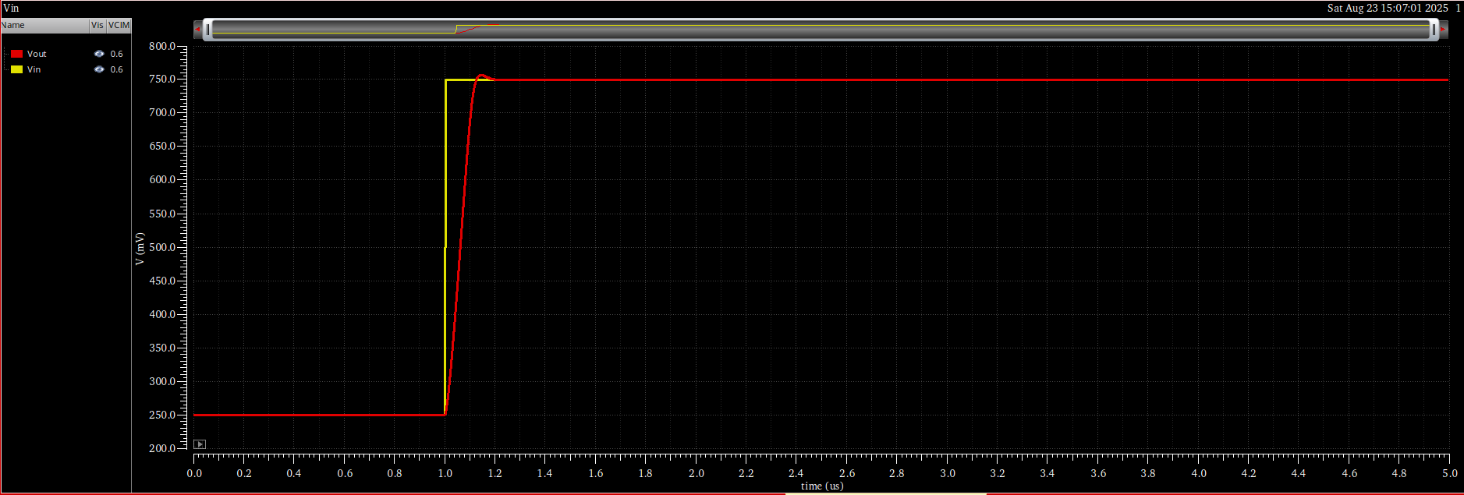
Figure 52 VIn and Vout overlaid
Figure 53 Slew Rate from simulation
Hand Analysis:
$$SR=\frac{I_{B1}}{C_{C}}=\frac{11.53μ}{2p}=5.765M$$
 | Simulation | Hand Analysis
SR | 5.138M | 5.765M

Hand Analysis is slightly larger because it doesn’t account for extra mosfet and parasitic capacitances in the circuit.

But both are comparable and meet the required spec.

Settling Time:
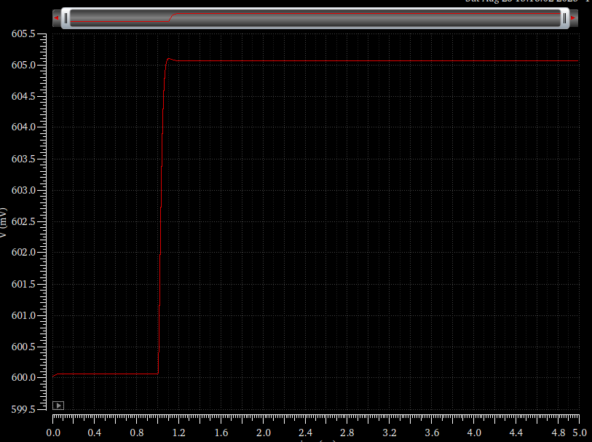
Figure 54 VOUT
Figure 55 Simulation Rise Time
Hand Analysis:
$$Rise Time=\frac{2.2}{ω_{u}}≈37.9n$$
 | Simulation | Hand Analysis
SR | 44.44n | 37.9n

both are comparable and meet the required spec.

There is some ringing observed in the output, due to PM being less than 76.3º

