Lab 10
Noise

PART 1: LPF AC Noise Analysis
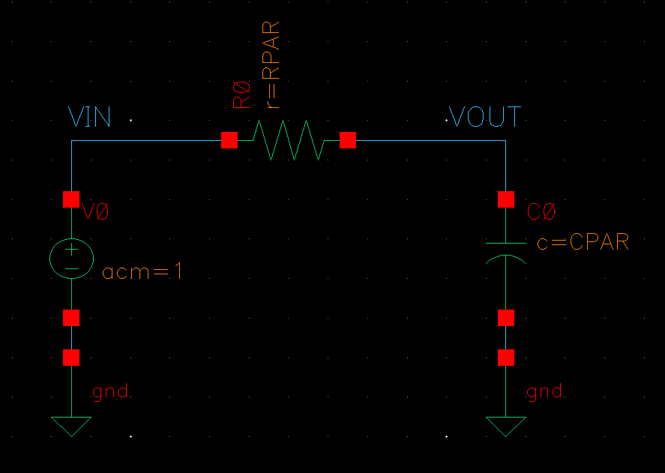
Figure 1 RC LPF Filter
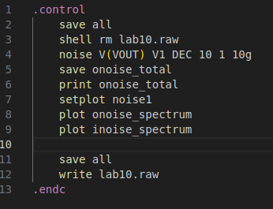
Figure 2 Noise Analysis Code

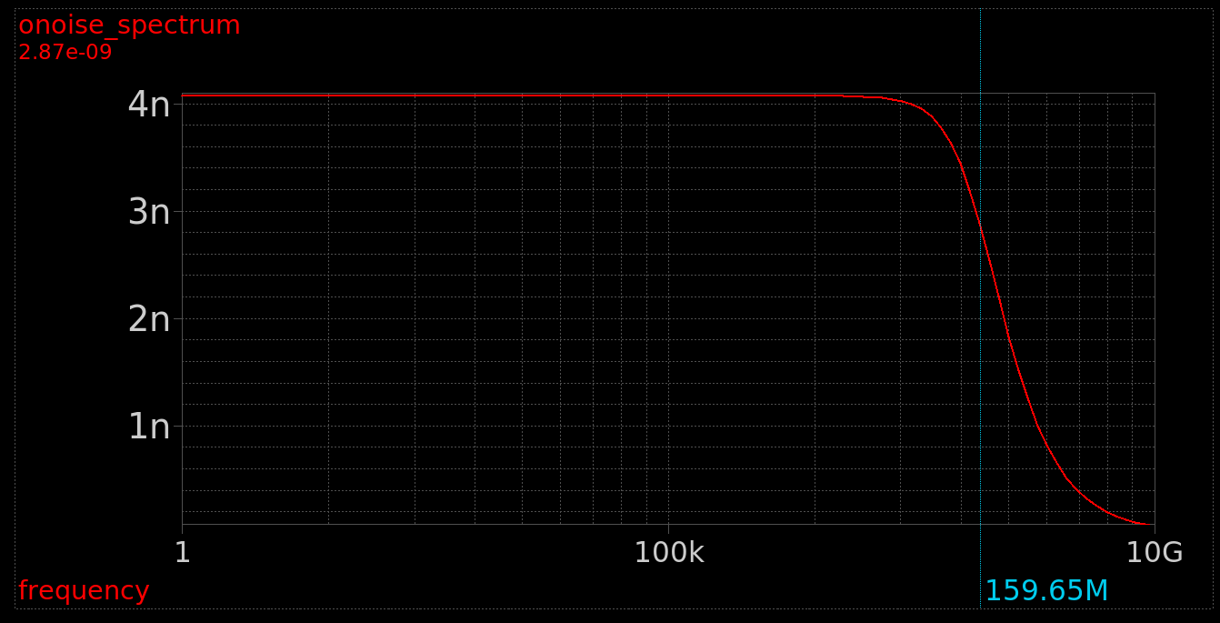
Figure 3 Noise Spectrum BW Annotated
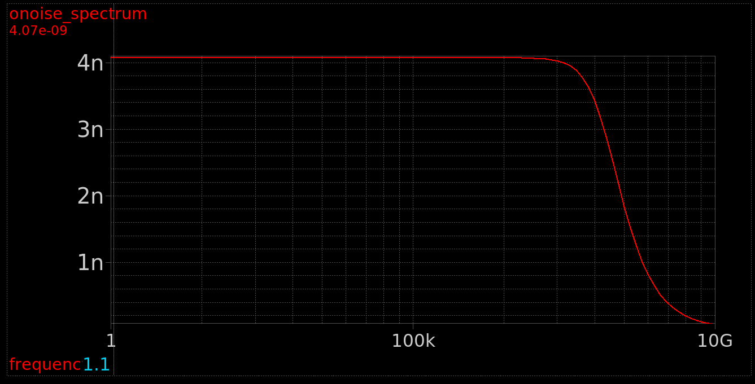
Figure 4 Output Noise Annotated
Figure 5 Total Output Noise RMS Value from xschem

Hand Analysis:
$$V_{n}=\sqrt{4kTR}=\frac{4.07nV}{\sqrt{Hz}}$$
$$BW=\frac{1}{2πRC}=159.155MHz$$
$$V_{noutrms}≈\sqrt{\frac{1p}{C}}*64μ=64μ$$
 | Simulation | Hand Analysis
Vn | 4.071n | 4.07n
BW | 159.65MHz | 159.155MHz
Vnoutrms | 63.97u | 64u

Simulation and Hand Analysis Results agree with each other

- Run parametric sweep for RPAR = 1k, 10k, 100k, 1000k
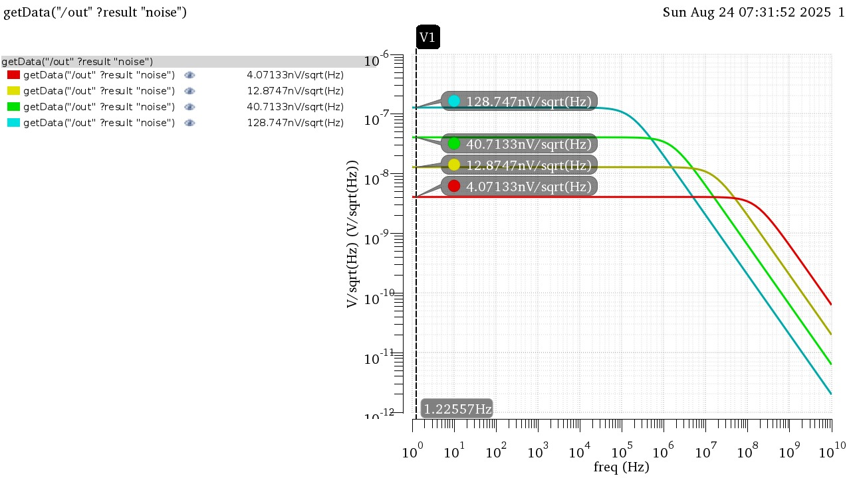
Figure 6 Output Noise results Overlaid
As we increase the Value of RPAR the bandwidth decreases by a factor of 10 and noise increases by a factor of root10

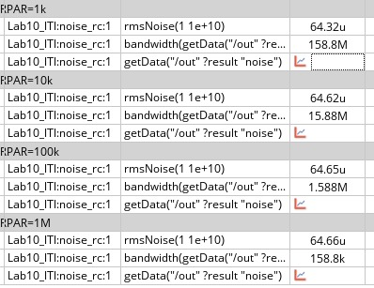
Figure 7 RMS and Bandwidth values for each run
The RMS value of Noise is constant as it doesn’t depend on the value of R
PART 2: LPF Transient Noise Analysis
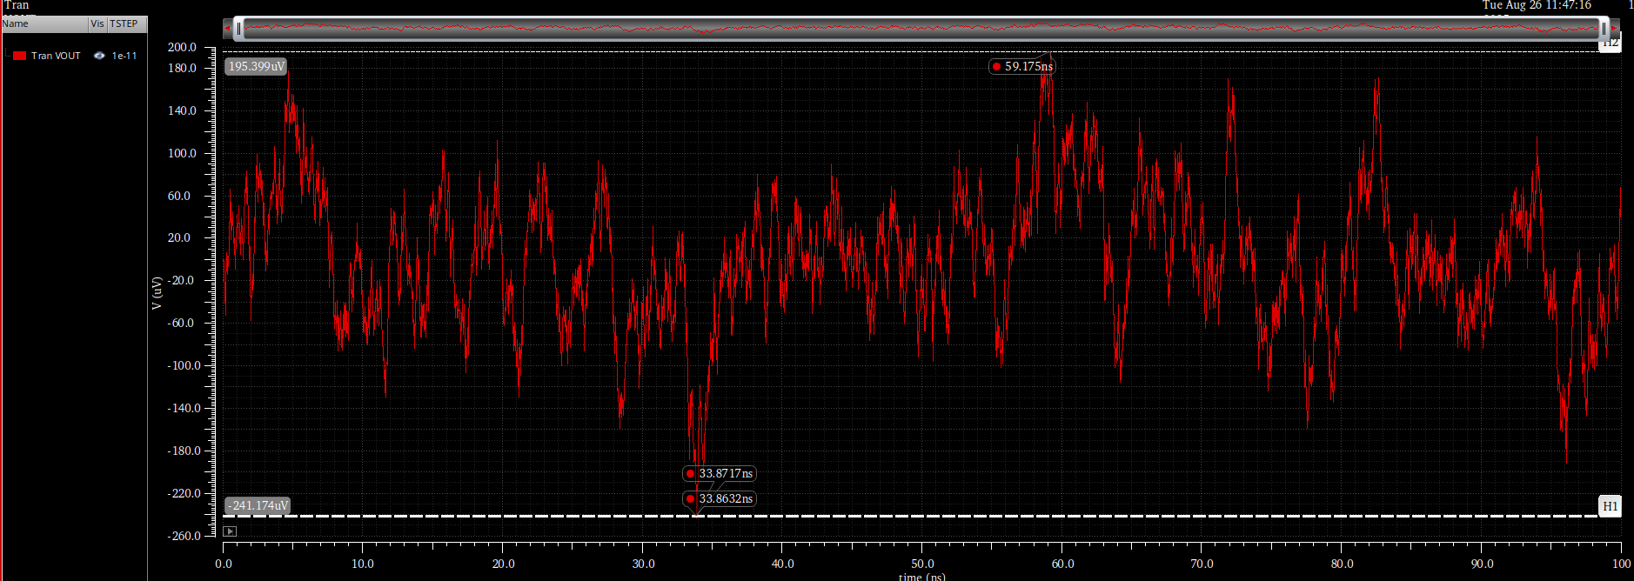
Figure 8 Noise output with min and max annotated
Figure 9 RMS Value of Noise
The RMS Value of noise is close the one calculated in the previous part.

Repeating simulation with Tstep = TAU/10
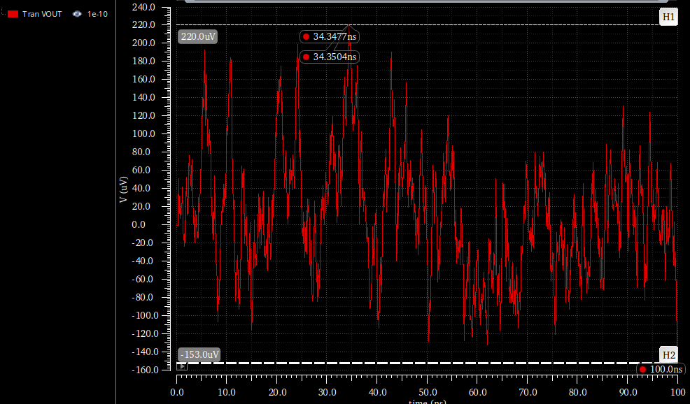
Figure 10 Output Noise annotated
Figure 11 RMS Value of Noise
Output Noise RMS Increased Slightly as Fmax increased so the area integrated is bigger.

Running 20 Runs:
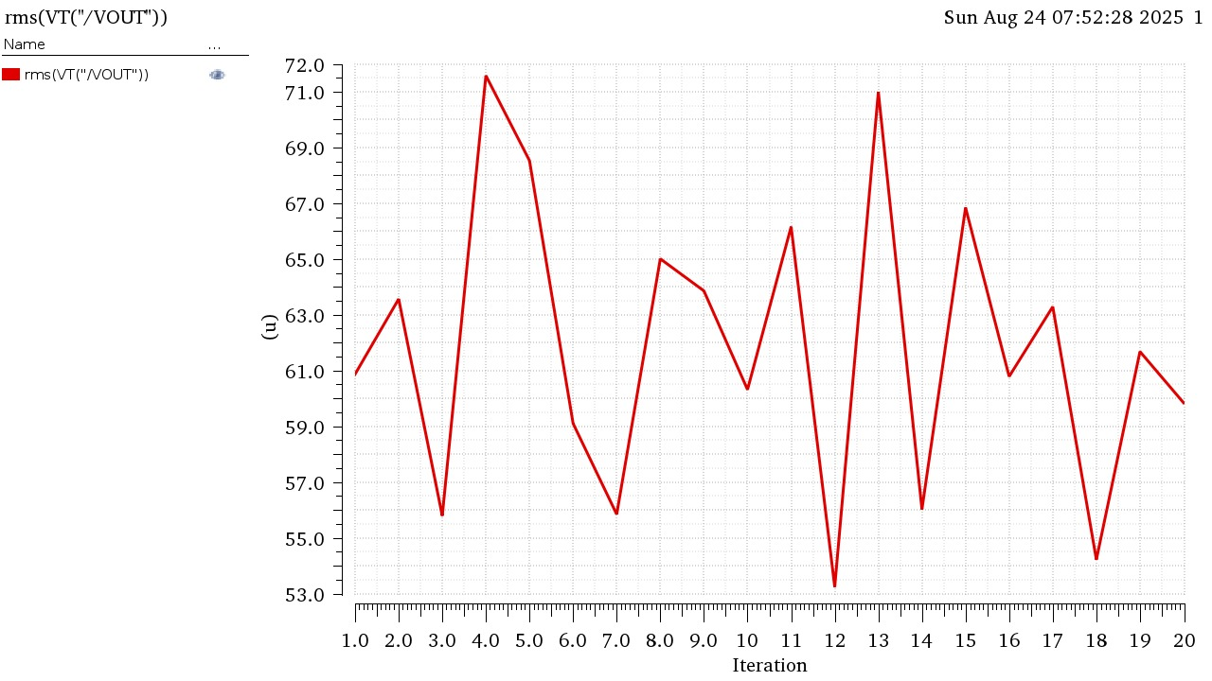
Figure 12 RMS Noise vs Iterations
Figure 13 Average Noise RMS Value
The value is slightly smaller due to the different extremes from each iteration but still comparable to what was calculated in parts 1 and 2.

PART 3: 5T OTA AC Noise Analysis
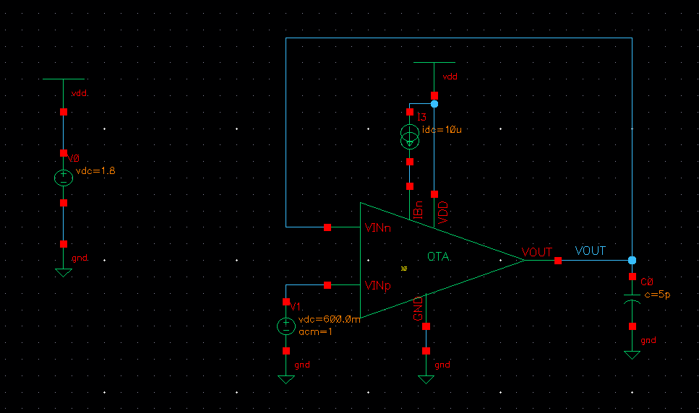
Figure 14 OTA Unity Buffer Schematic
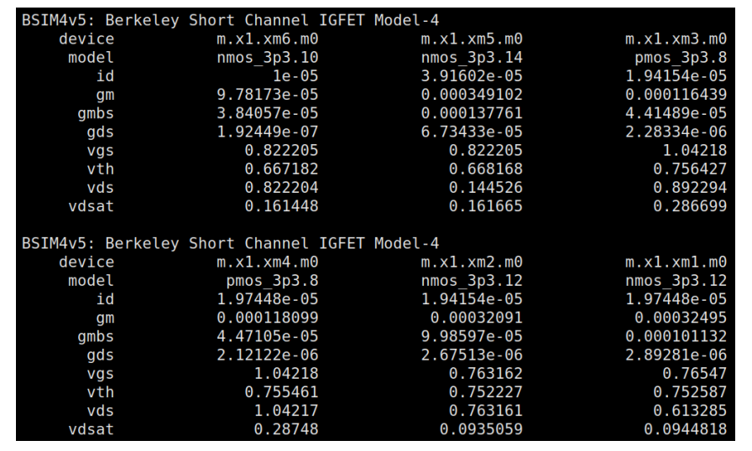
Figure 15 OTA OP Point in buffer config for Hand Analysis

Thermal Noise Calculations:
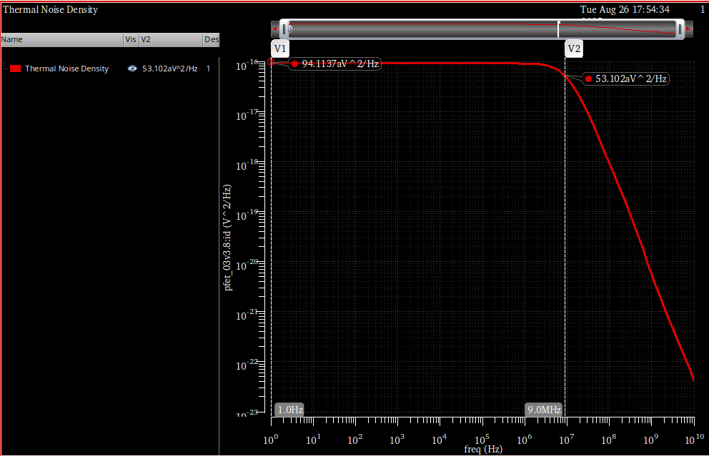
Figure 16 Thermal Noise Output Density
$$V_{nout}^{2}=\frac{94.1aV^{2}}{Hz}$$
Hand Analysis:

$$V_{n}^{2}=\frac{8kTγ}{gm_{1,2}}\left(1+\frac{gm_{3,4}}{gm_{1,2}}\right)≈\frac{90.825aV^{2}}{Hz}$$

RMS Value of Thermal Noise:
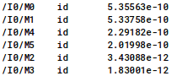
Figure 17 Thermal Noise of Each Transistor from Noise Summary
$${V_{n}^{2}}_{thermal rms}≈\frac{1.4993nV^{2}}{Hz}$$
Noise Bandwidth:
Figure 18 Amplifier Noise BW
Hand Analysis:
$$BW_{nois}=BW_{amp}=10MHz$$
$${V_{n}^{2}}_{thermal rms}=V_{n}^{2}*B_{n}=90.825a*\frac{π}{2}10M=\frac{1.4266nV^{2}}{Hz}$$
 | Simulation | Hand Analysis
V²_{n} Thermal | 94.1a | 90.825a
V²_{n} Thermal RMS | 1.499n | 1.4266n
BW | 10.19MHz | 10MHz

Hand Analysis and simulation results agree with each other.

Total Output Noise and Noise Corner:
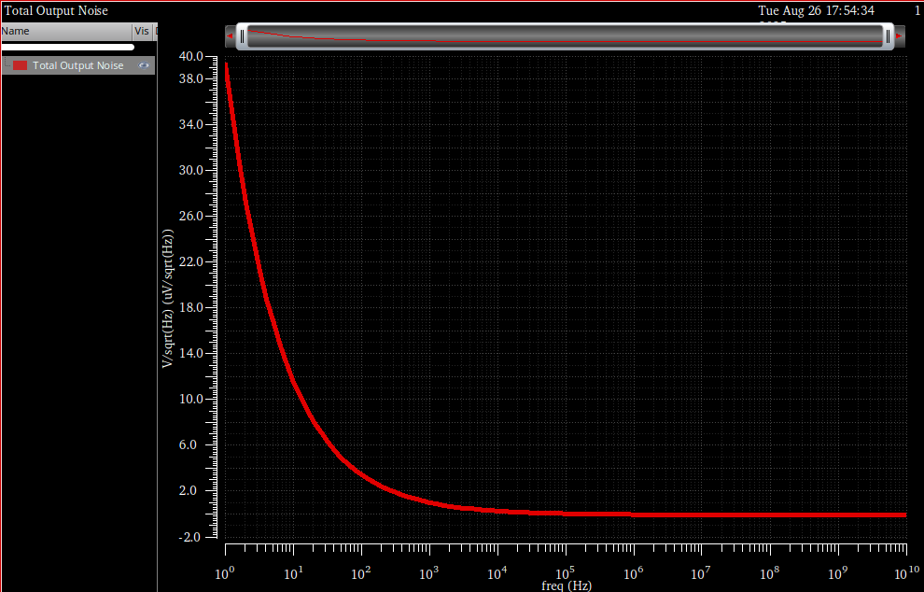
Figure 19 Total Output Noise Density
Estimating Noise Corner:
To estimate the noise corner I plotted both the total Thermal noise and Flicker noise spectrums and estimated where they both cross paths.
I changed the yscale to dB to better visualize it
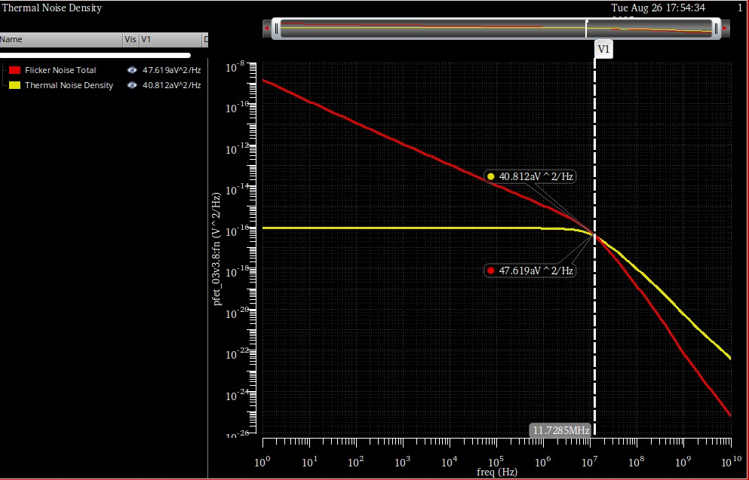
Figure 20 Estimate of Noise Corner
$$Noise Corner≈11.728MHz$$

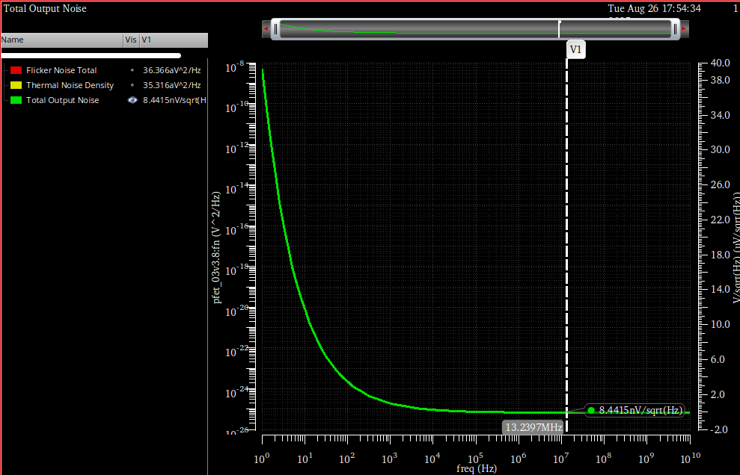
Figure 21 Noise Corner annotated for in total Noise spectrum

PART 4: 5T OTA Transient Noise Analysis
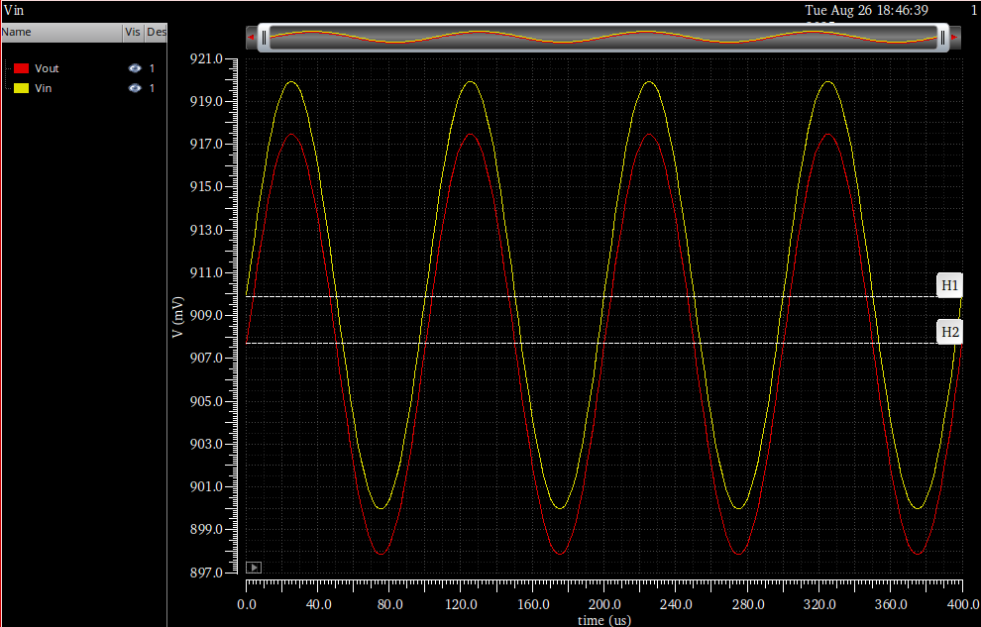
Figure 22 Vin and Vout Overlaid
Both Vin and Vout match pretty well with just a slight difference in the DC Level due to the lower gain of the amplifier resulting in higher verr thus a bigger difference between the output and input voltages.

Noisy Transient Simulation:
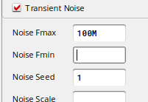
Figure 23 Upper Noise frequency at 10 times the amp GBW
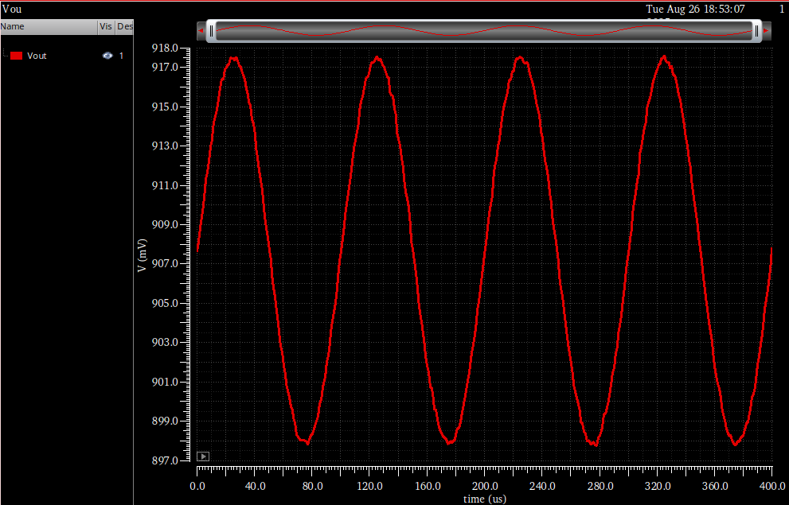
Figure 24 Noisy Output

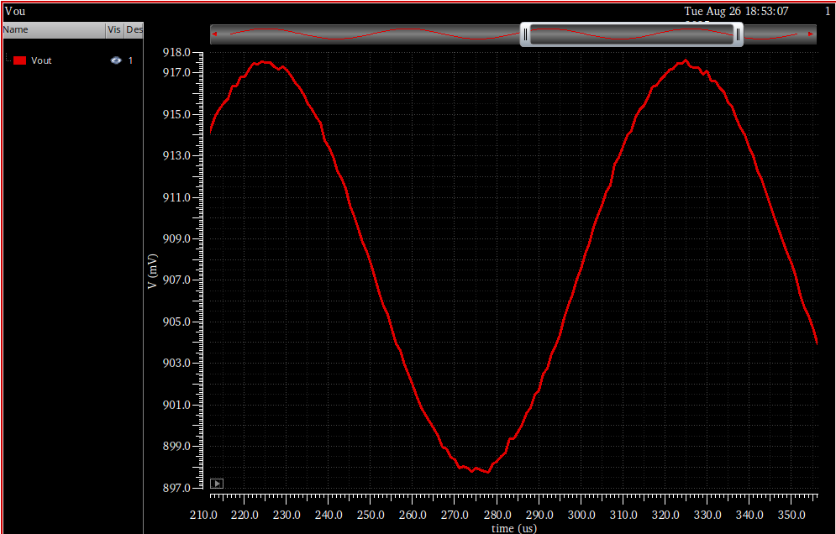
Figure 25 Noise Up close

20 Noise Iterations:
To Isolate the noise from the output I used this expression to use the clean run and subtract the signal from the noise:
Figure 26 Output Setup for output noise RMS
rms((v("/VOUT" ?result "tran") - value(v("/VOUT" ?result "tran" ?resultsDir "/home/centos/simulation/Lab10_ITI/noise_mos/adexl/results/data/Clean_Tran/psf/Lab10_ITI:noise_mos:1/psf") "Design_Point" 1)))

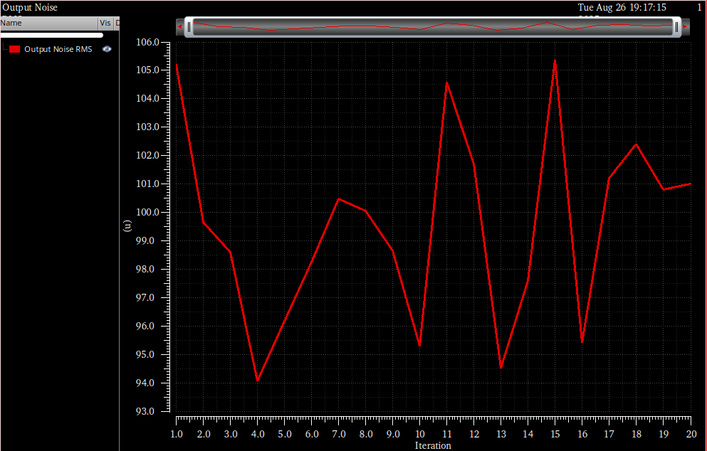
Figure 27 Output Noise vs Iterations
Figure 28 Average Noise RMS
Compared to Previous part:
The value is different as the value from the previous part calculated the average RMS for the squared voltage, but here it is non squared.
Furthermore, it would be slightly higher than the previous part because this simulation takes into consideration the flicker noise which we ignored in hand analysis for simplification.

