|  |  |  |  |
| --- | --- | --- | --- |
| BN | Section | Student ID | اسم الطالب |
| **600** | **5** | **33789** | **أحمد محمد أبوالمفهومية** |
|  |  |  | **سمير محمد أبوالمفهومية** |

**Important Note: Maximum document length is 5 pages.**

# System Design

Here provide overview of your project design. List the main structures and operation supported. Use a graph showing the design of the structures. Also show the flow of the main operations and how they affect the structures. Some example message sequence chart is depicted. Below. You may use psedu-code or capture parts of your code with good comments. Be creative.

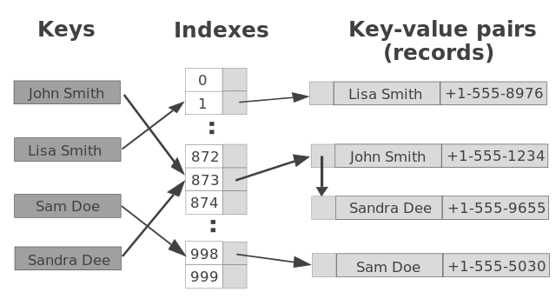

Figure 1: Example Data Structure Design

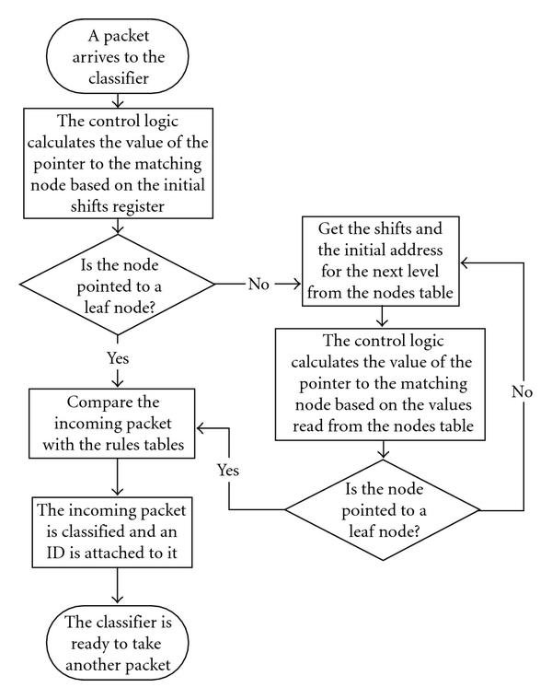

Figure 2: Message Sequence showing object interaction

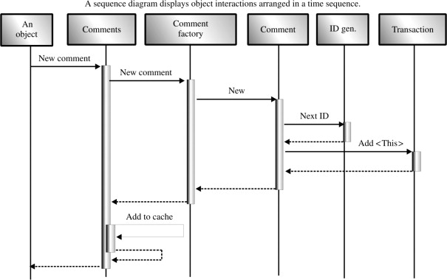

Figure 3: Message Sequence showing object interaction

# Results and Discussion

Table 1: CQI Index and Corresponding MCS

| CQI | Modulation | Effective Code Rate | ECRx1024 |
| --- | --- | --- | --- |
| 0 | No transmission | | |
| 1 | 4QAM | 0.0762 | 78 |
| 2 | 4QAM | 0.1172 | 120 |
| 3 | 4QAM | 0.1885 | 193 |
| 4 | 4QAM | 0.3008 | 308 |
| 5 | 4QAM | 0.4385 | 449 |
| 6 | 4QAM | 0.5879 | 602 |
| 7 | 16QAM | 0.3691 | 378 |
| 8 | 16QAM | 0.4785 | 490 |
| 9 | 16QAM | 0.6016 | 616 |
| 10 | 64QAM | 0.4551 | 466 |
| 11 | 64QAM | 0.5537 | 567 |
| 12 | 64QAM | 0.6504 | 666 |
| 13 | 64QAM | 0.7539 | 772 |
| 14 | 64QAM | 0.8525 | 873 |
| 15 | 64QAM | 0.9258 | 948 |

Figure Example below (format as Figure).

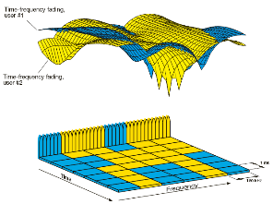

Figure 4: Example Figure

# Any Other Relevant Information (change title to reflect what you want to add)

Anything else you need to add

References

Format references as follows

1. B. Rengarajan, A.L. Stolyar, and H. Viswanathan, "Self-organizing Dynamic Fractional Frequency Reuse on the uplink of OFDMA systems",  in Proc. CISS, 2010, pp.1-6.
2. Harri Holma and Antti Toskala, "LTE for UMTS: Evolution to LTE-Advanced", John Wiley and Sons, 2011.

# Example for Usage of Template (Not to exist in your report, this is just a demo section)

This section just shows you how to format your document and use the template.

## Use of Pre-defined Styles in This Document

When writing a document, pre-defined styles shall be used in order to maintain consistency. This will automatically adjust font sizes, line spaces and paragraphs spacing.

Use "Normal" style for all regular text.

Use styles "Heading 1", "Heading 2", "Heading 3", and "Heading 4" for the subsection of different levels. (More levels are discouraged but if needed, one can then use Heading 5, Heading 6, etc).

## Tables and Figures

For tables use following as example of formatting. Table and figure captions are formatted using the style "Captions". Table entries are formatted with "Table" style.

## Code Snippets

Here are code snippets (format as ProgCode)

int main(int argc, char *argv[])

{

int i, j, k;

function_exit:

return (1);

}