Module: SET08101 (Web Tech)

# Introduction

The assignment Web Tech (SET08101) was to develop a website where the user can encode and decode text messages with two different classical cyphers/encoding schemes.

Classical algorithms are those which were invented before computers till 1950. There are several classical cyphers of which I picked **Caesar** and **Simple Substitution** as two encoding schemes to implement in this assignment.

This is supposed to be a single page website using HTML, css and javascript.

# Software design

For this application, my presentation layer will be html and functional programming will be with javascript. I will use css to beautify the UI. I wish to avoid using much images to keep it simple.

As a standard web development practice, let’s keep the assets (js, css, images) separated in their own directories for better management. So, the files structure should be something like:

Project Root

-- index.html

-- js

---- index.js

-- css

---- style.css

This should be a clean and aesthetically good looking web page. It should also be intuitive and easy to use for the user.

So, let’s plan the UI/UX of the page. Let’s draw a rough sketch of this on paper.

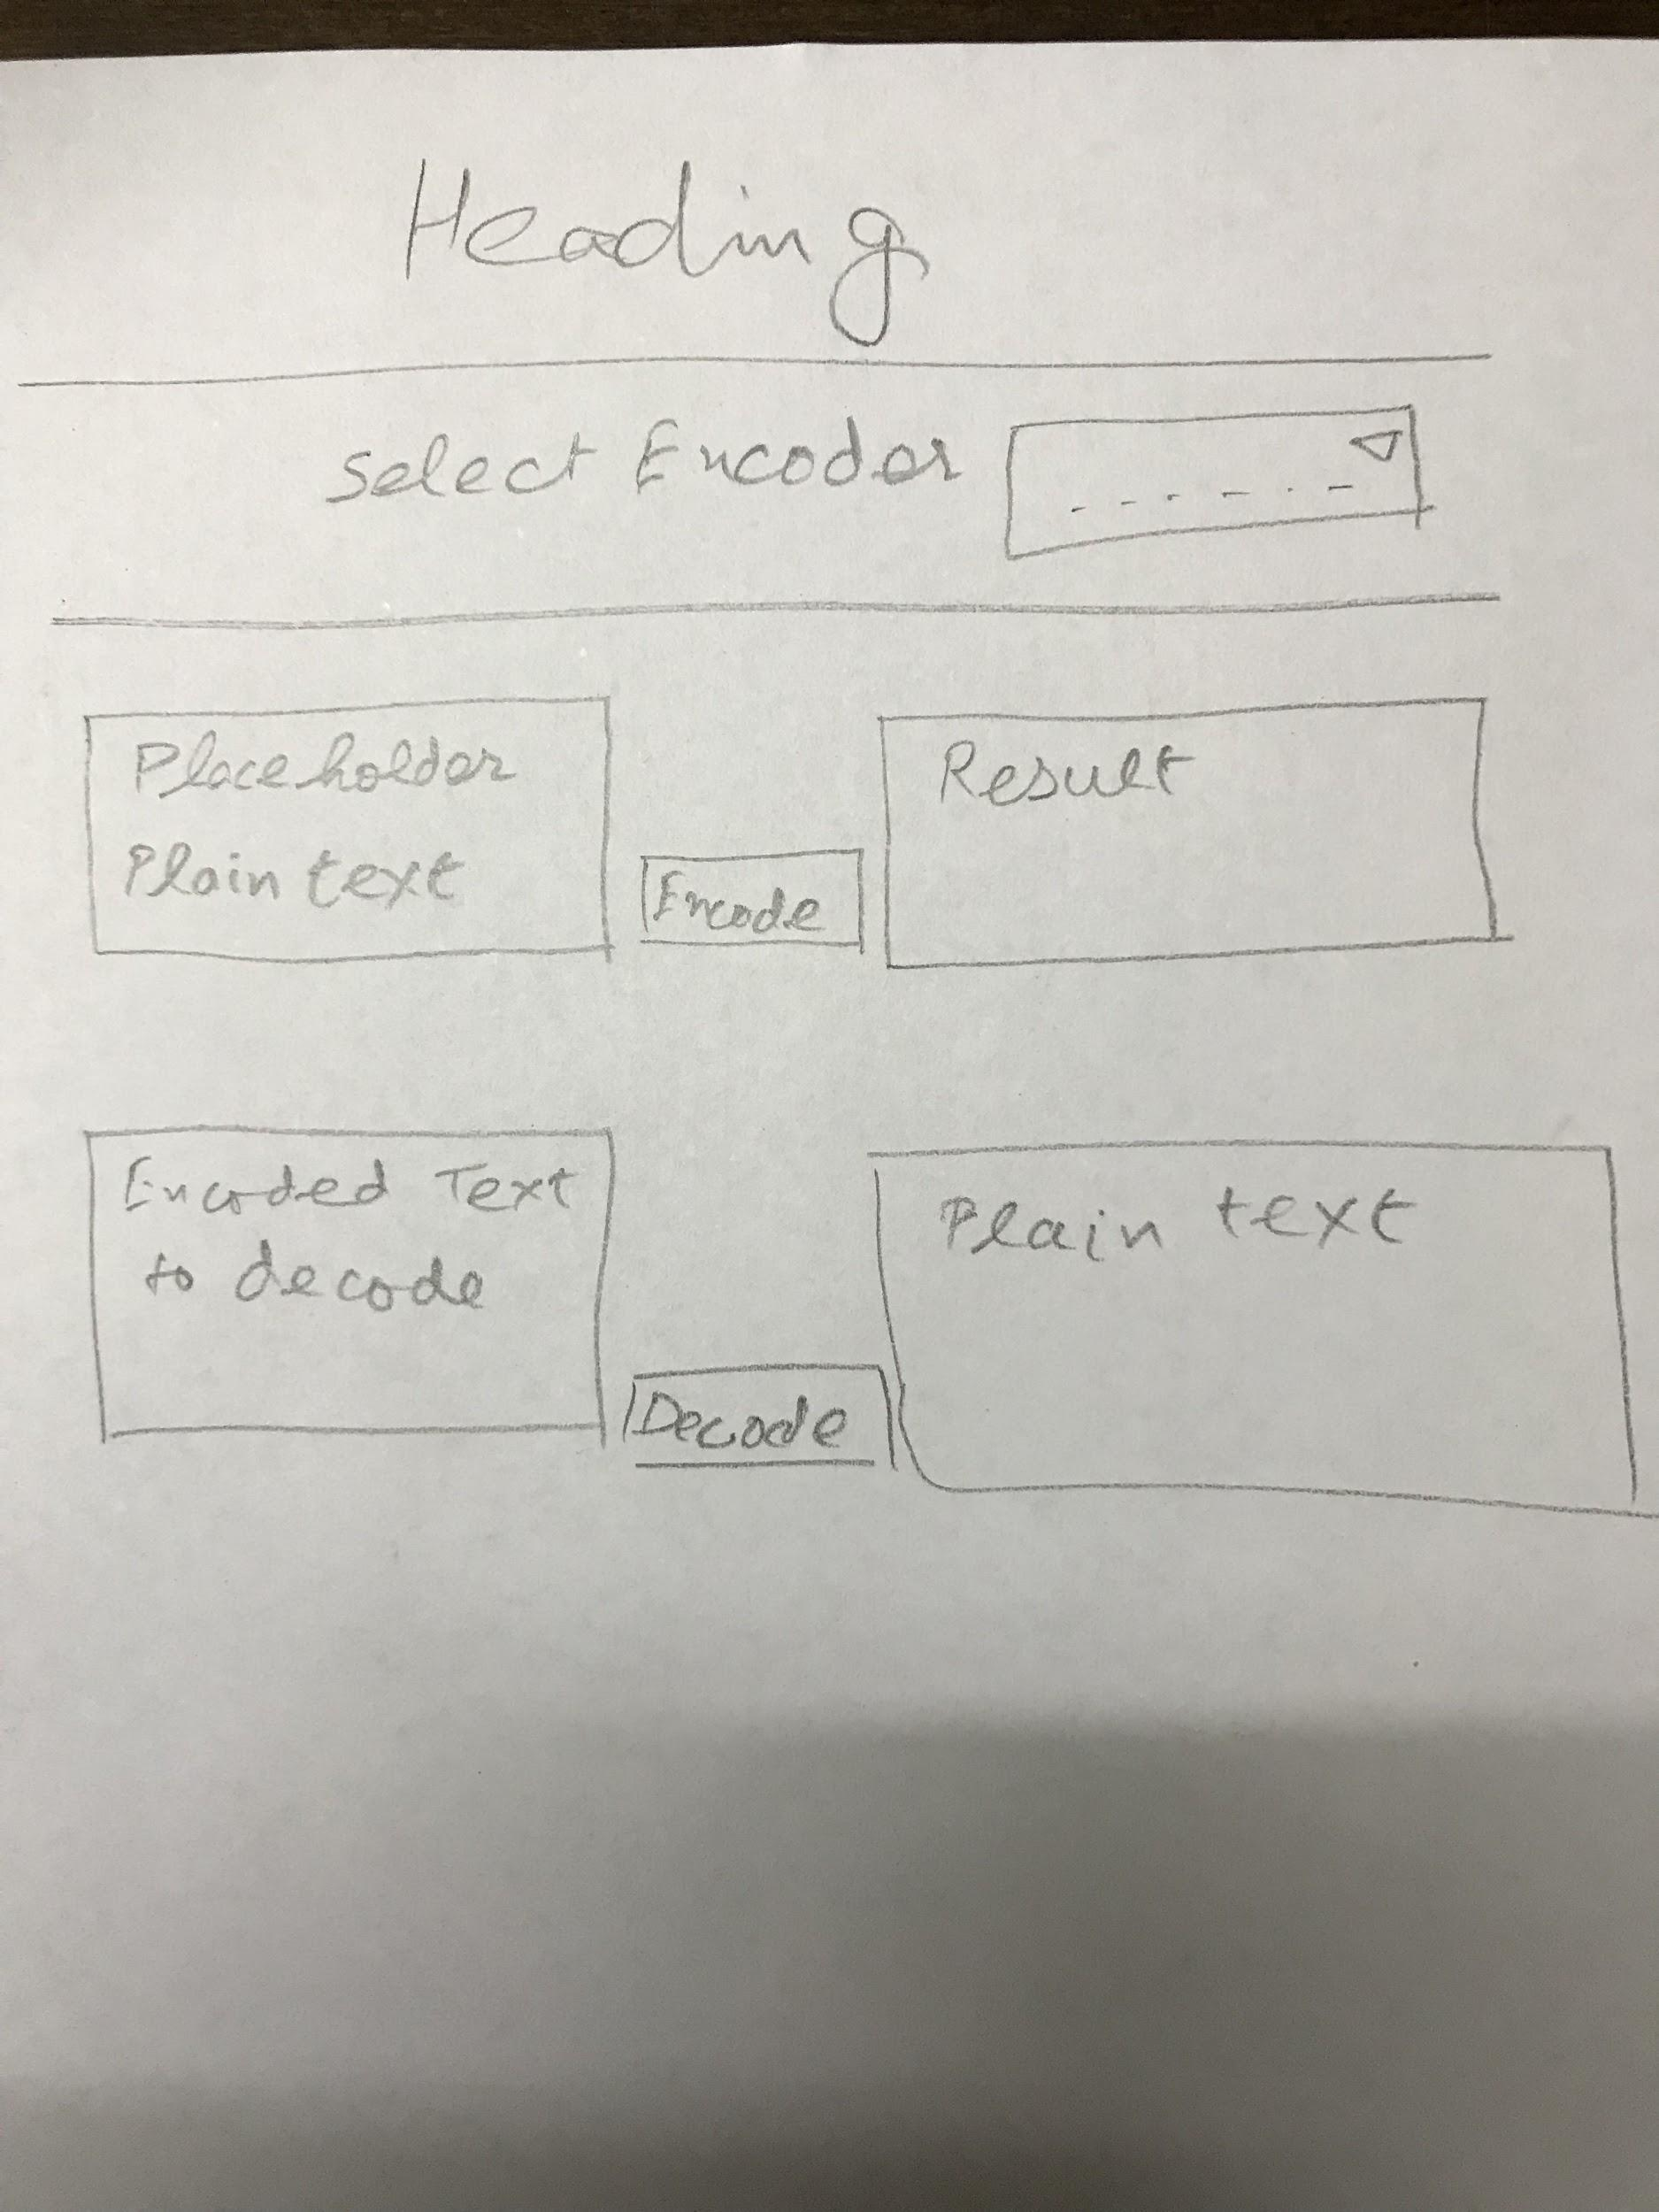

# Implementation

Let’s lay it out in html as per the planned design.

Use “id” attribute with all the 4 textareas to refer those easily in javascript.

Bind the “Encode” button to call a javascript function with encodes the plaintext to respective encoded text using onclick attribute of html element. And same to be done for “Decode” button.

Keeping **scalability** in mind. We may plan to add more encoding algorithms to this page later. So, create separate functions for encoding and decoding with with algorithms. Inside common encode and decode functions, check the algorithm selected and call respective functions based on it.

Default UI of form fields is aesthetically good so put some efforts to make it look beautiful and uniform across the browsers and operating systems.

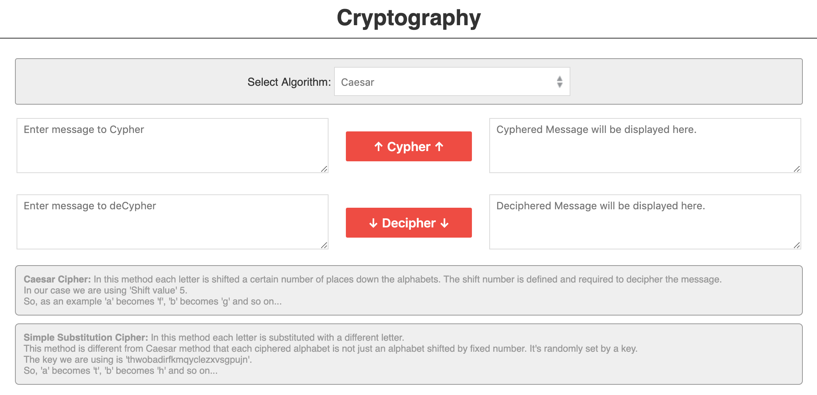

# Critical Evaluation

Caesar algorithm needs a “shift” value to encode and decode and Simple Substitution uses a 26 letter key. For the cases the values of shift and key are defined in the javascript file and hence the website encodes and decodes only with programmer defined keys.

An option to enter shift and key can be added to the web page so that these values can be set by user.

These are defined in js file to keep the page simple.

One small image used is put in css directory. It should be moved to image directory for better asset management.

# Personal evaluation

Learned more about the classical cyphers. Analyzed and tried good UI/UX practices.

# References

For Caesar Cypher: <https://en.wikipedia.org/wiki/Caesar_cipher>

For Simple Substitution: <https://en.wikipedia.org/wiki/Substitution_cipher#Simple_substitution>