ChronoLux — Luxury Watch Store
E-Commerce Website Project

Web Development Assignment

Submitted By: Ameer Ahmad
Roll Number: 24011519-143
Email: ameerr.ahmad2005@gmail.com
Repository: github.com/ameerrahmad/E-Commerce---Watch-Store
Date: May 2026

Table of Contents
1. Project Description
2. Technologies Used
3. Project Structure
4. How the Website Was Created
5. CSS Design System
6. Key Code Samples
7. JavaScript Functionality
8. Screenshots & Outputs
9. Conclusion

1. Project Description
ChronoLux is a fully responsive, multi-page luxury watch e-commerce website built using HTML, CSS, and JavaScript. The project simulates a real-world online store for premium Swiss watches, featuring a dark luxury aesthetic with gold accent colors.
The website consists of 10 pages including a homepage with hero section and featured products, a full product collection page with filters, individual product detail pages, a shopping cart with order summary, contact page with form validation, services page, about/story page with a company timeline, user dashboard with order history, and login/signup authentication pages.

Key Features
- Responsive design that works on desktop, tablet, and mobile devices
- Dark luxury theme with gold accent color scheme (#C9A84C)
- Shopping cart with add/remove/quantity management using localStorage
- Form validation for contact, login, and signup forms
- Dark mode toggle functionality
- Dropdown navigation with mobile hamburger menu
- Product filtering by category, price range, and sort order
- Order status tracking with color-coded badges
- Newsletter subscription with toast notifications
- Clean CSS architecture — no inline styles (CSS classes only)

2. Technologies Used
HTML5: Semantic markup structure for all 10 pages
CSS3: Complete design system with custom properties (CSS variables), flexbox layouts, media queries, and 80+ utility/component classes
JavaScript (ES6): Cart management, form validation, dark mode toggle, toast notifications, and mobile menu
Google Fonts: Cormorant Garamond (headings) and Inter (body text)
Git & GitHub: Version control and remote repository hosting

3. Project Structure
E-Commerce---Watch-Store/
├── index.html (Home page)
├── cssFile/
│ └── globalStyles.css (Complete design system - 1400+ lines)
├── jsFile/
│ └── jsFunctions.js (Cart, validation, dark mode, menu)
├── pages/
│ ├── about.html (Company story & timeline)
│ ├── cart.html (Shopping cart & checkout)
│ ├── contact.html (Contact form & info)
│ ├── dashboard.html (User account dashboard)
│ ├── login.html (Sign in page)
│ ├── signup.html (Registration page)
│ ├── product-detail.html (Single product view)
│ ├── products.html (Full collection with filters)
│ └── services.html (Watch services & pricing)
└── sources/
└── (image assets)

4. How the Website Was Created

Step 1: Design System (CSS)
The first step was creating a comprehensive CSS design system in globalStyles.css. This includes CSS custom properties (variables) for colors, typography, spacing, and borders. A dark/light mode system was implemented using the [data-theme] attribute selector.

Step 2: Component Classes
Over 80 reusable CSS classes were created covering: navigation bar, card system, form system, table system, button variants (lg, sm, tiny, border), hero section, footer, and page-specific layouts like product gallery, cart summary, timeline, and dashboard stats.

Step 3: HTML Pages
Each of the 10 HTML pages was built using semantic HTML5 elements and the CSS class system. No inline CSS styles were used (the only exception being table min-width/max-width for responsive table scrolling). All styling is controlled through classes in globalStyles.css.

Step 4: JavaScript Functionality
A single JavaScript file (jsFunctions.js) handles all interactivity: shopping cart operations using localStorage, form validation, dark mode persistence, hamburger menu toggle, dropdown navigation, and toast notification system.

Step 5: Responsive Design
Media queries at 1024px (tablet), 768px (small tablet), and 600px (mobile) breakpoints ensure the website adapts seamlessly to all screen sizes. The navigation collapses into a hamburger menu on mobile, and flexbox layouts reflow into single columns.

5. CSS Design System
The color system uses CSS custom properties for easy theming:
:root {
--brand-primary-color: #0B0F1A;
--brand-secondary-color: #1A2035;
--brand-third-color: #C9A84C;
--brand-accent-color: #E8C96A;
--bg-main: #07090F;
--bg-card: #111827;
--text-primary-color: #F5F0E8;
--text-secondary-color: #C0B89A;
--text-muted-color: #7A7060;
--radius-sm: 6px;
--radius-md: 10px;
--transition: 0.3s ease;
}

Key CSS classes include card system, button variants, and layout utilities:
.card {
display: flex;
flex-direction: column;
background: var(--bg-card);
border: 1px solid var(--border-primary-color);
border-radius: var(--radius-md);
overflow: hidden;
width: 280px;
transition: all var(--transition);
}
.card:hover {
border-color: var(--border-secondary-color);
transform: translateY(-6px);
box-shadow: 0 16px 40px rgba(201,168,76,0.18);
}
button {
display: inline-flex;
align-items: center;
justify-content: center;
padding: 12px 28px;
font-weight: 600;
letter-spacing: 0.1em;
text-transform: uppercase;
border: 1px solid var(--brand-third-color);
background: var(--brand-third-color);
color: var(--brand-primary-color);
transition: all var(--transition);
}

6. Key Code Samples

Homepage Hero Section (HTML)
<section class="hero">
<div class="hero-bg"
style="background-image:url('sources/image1.png');">
</div>
<div class="hero-content">
<h4>Swiss Precision Since 1889</h4>
<h1>Time Is Your
<span class="accent-text">Masterpiece</span>
</h1>
<p class="hero-subtitle">
Handcrafted mechanical watches that transcend
generations. Where art meets engineering.
</p>
<div class="hero-actions">
<a href="pages/products.html">
<button class="lg-button">Explore Collection</button>
</a>
<a href="pages/about.html">
<button class="lg-button border-button">Our Story</button>
</a>
</div>
</div>
</section>

Product Card (HTML)
<div class="card">
<img src="sources/image3.png" alt="Chronograph Pro" />
<div class="card-body">
<h4>Chronograph Pro</h4>
<h3>The Racing Edition</h3>
<p>Triple sub-dial precision chronograph.</p>
<p class="card-price">$2,850</p>
<div class="card-actions">
<a href="pages/product-detail.html">
<button class="sm-button flex-1">View Details</button>
</a>
<button class="sm-button border-button"
onclick="addToCart('prod-1','Chronograph Pro',
2850,'sources/image3.png')">
Add to Cart
</button>
</div>
</div>
</div>

7. JavaScript Functionality
The cart system uses localStorage for persistence across pages:
// Cart Management
function getCart() {
return JSON.parse(localStorage.getItem('cart') || '[]');
}
function addToCart(id, name, price, image) {
const cart = getCart();
const existing = cart.find(item => item.id === id);
if (existing) {
existing.qty = (existing.qty || 1) + 1;
} else {
cart.push({ id, name, price, image, qty: 1 });
}
localStorage.setItem('cart', JSON.stringify(cart));
updateCartBadge();
showToast(name + ' added to cart!');
}
// Toast Notification System
function showToast(message) {
const toast = document.createElement('div');
toast.className = 'toast';
toast.textContent = message;
document.body.appendChild(toast);
setTimeout(() => toast.remove(), 3000);
}

8. Screenshots & Outputs
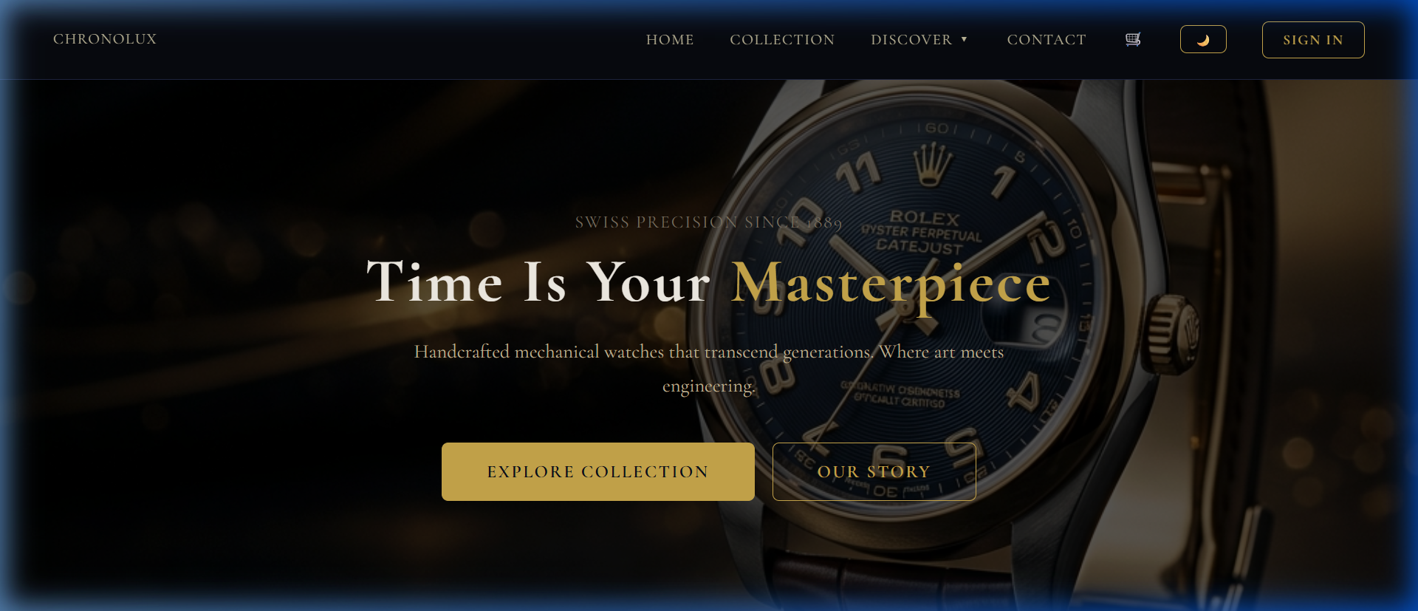
Homepage — Hero Section with luxury branding and call-to-action buttons

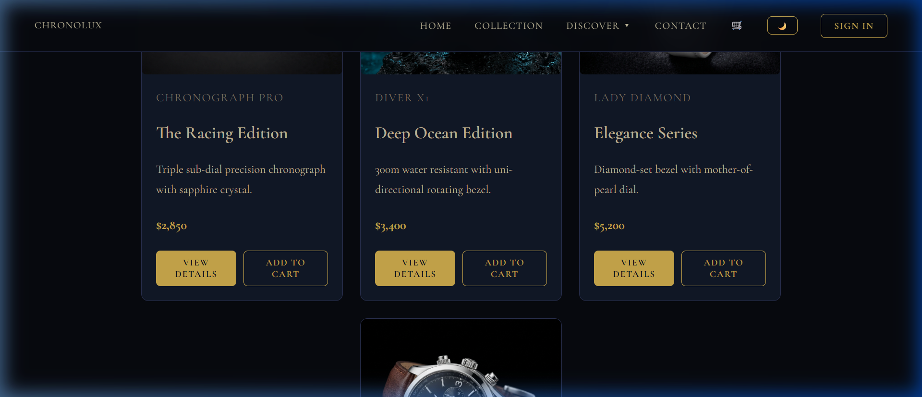
Homepage — Featured Timepieces product cards

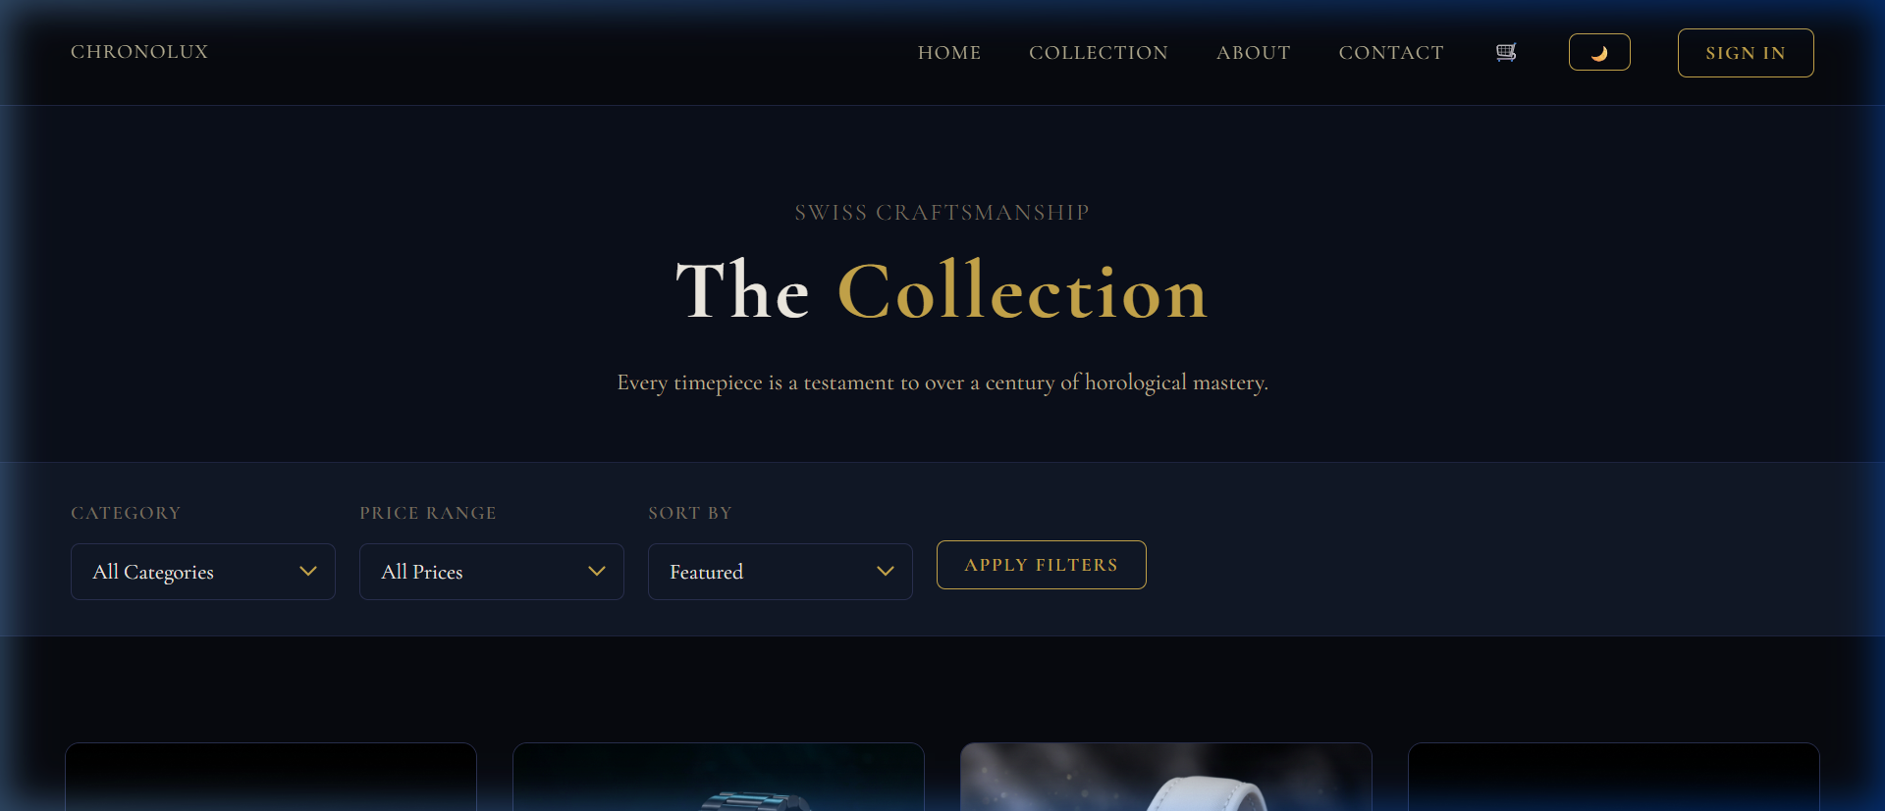
Products Page — Full collection with category/price/sort filters

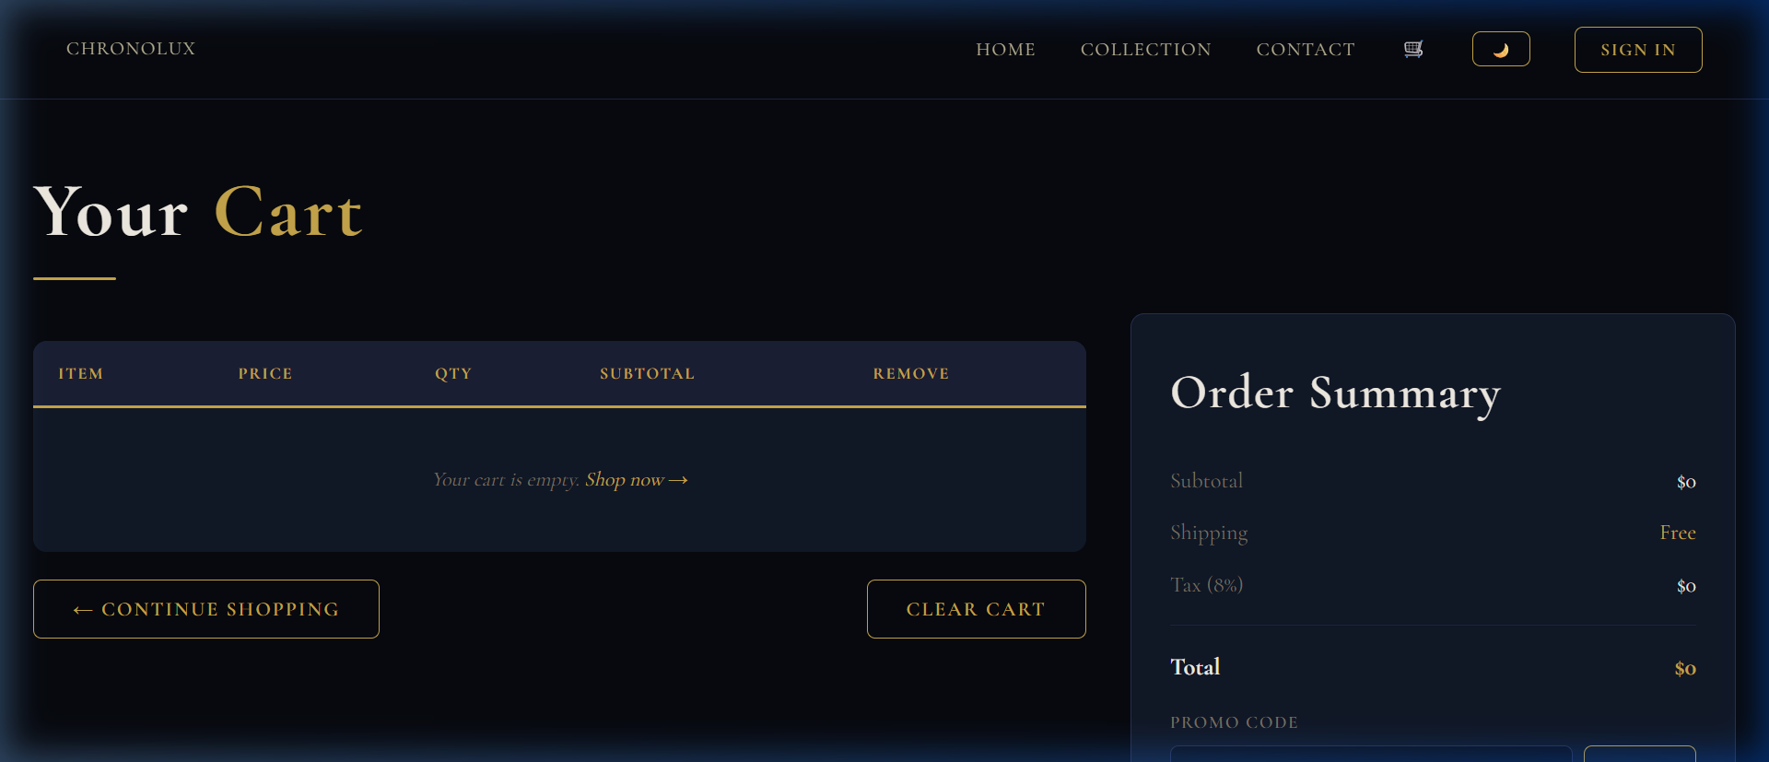
Shopping Cart Page — Empty cart state with order summary panel

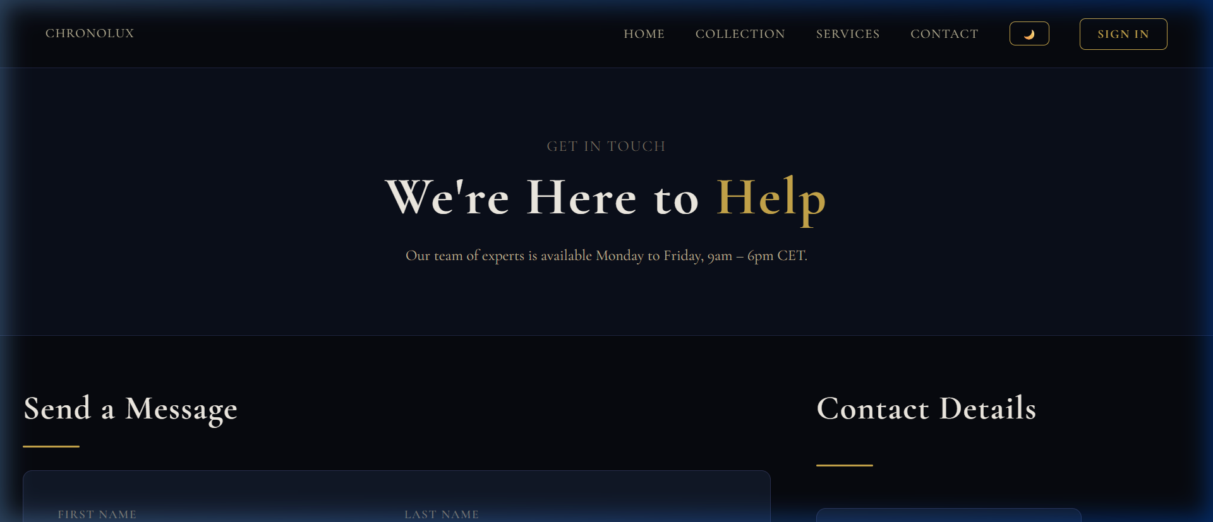
Contact Page — Form with validation and contact info cards

9. Conclusion
The ChronoLux E-Commerce Watch Store project demonstrates a complete, production-ready multi-page website built with core web technologies (HTML, CSS, JavaScript). The project follows modern best practices including:
- Semantic HTML5 structure for accessibility and SEO
- CSS-only styling with no inline styles — all presentation handled through 80+ reusable CSS classes
- CSS custom properties for consistent theming and easy dark mode implementation
- Flexbox-based responsive layouts without CSS Grid
- localStorage-based cart persistence across page navigations
- Client-side form validation with user-friendly error messaging
- Mobile-first responsive design with three breakpoint tiers
- Clean project organization with separated concerns (HTML/CSS/JS)
- Version control with Git and GitHub for collaboration and deployment

The website successfully achieves a premium, luxury aesthetic while maintaining full functionality across all device sizes. The clean separation of HTML structure and CSS presentation ensures maintainability and scalability for future enhancements.

