Assignment_1 – Ameer Abdlrasul

2023-09-11

# <https://www.kaggle.com/datasets/joebeachcapital/nba-player-statistics>

# Import the dataset into R

dataset <- read.csv(“~/Downloads/nba_data_processed.csv”, header=FALSE) head(dataset)

# Print out descriptive statistics for a selection of quantitative and categorical variables.

# Quantitative variables

quant_vars <- c(“Tm”, “Age”) cat_vars <- c(“POS”, “PTS”)

# Frequency table for categorical variables

for (PTS in cat_vars) { cat_freq <- table(dataset[[PTS]]) print(paste(“Frequency table for”, PTS)) print(cat_freq) }

# Transform a variable

dataset $Age<-as.integer(dataset$ Age) dataset $LogAge<-log(dataset$ Age)

# Histogram for 3P

dataset <- as.integer(dataset$3P)

## Warning: NAs introduced by coercion

hist(dataset$3P, main=“3P”, xlab=“3P%”)

# Scatterplot for Team vs. Age

dataset $Tm<-as.numeric(dataset$ Tm) dataset $Age<-as.numeric(dataset$ Age) plot(dataset $Tm,dataset$ Age, main=“Scatterplot: Tm vs. Age”, xlab=“Tm”, ylab=“Age”)

## R Markdown

This is an R Markdown document. Markdown is a simple formatting syntax for authoring HTML, PDF, and MS Word documents. For more details on using R Markdown see <http://rmarkdown.rstudio.com>.

When you click the **Knit** button a document will be generated that includes both content as well as the output of any embedded R code chunks within the document. You can embed an R code chunk like this:

summary(cars)

## speed dist   
## Min. : 4.0 Min. : 2.00   
## 1st Qu.:12.0 1st Qu.: 26.00   
## Median :15.0 Median : 36.00   
## Mean :15.4 Mean : 42.98   
## 3rd Qu.:19.0 3rd Qu.: 56.00   
## Max. :25.0 Max. :120.00

## Including Plots

You can also embed plots, for example:

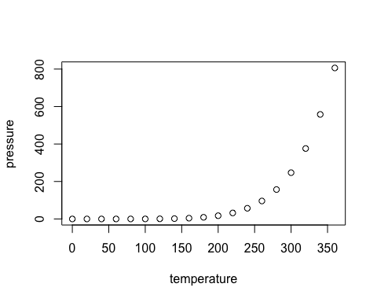

Note that the echo = FALSE parameter was added to the code chunk to prevent printing of the R code that generated the plot.