Assignment 4

Ameer Abdlrasul

2023-10-29

library(tidyverse)

## ── Attaching core tidyverse packages ──────────────────────── tidyverse 2.0.0 ──  
## ✔ dplyr 1.1.3 ✔ readr 2.1.4  
## ✔ forcats 1.0.0 ✔ stringr 1.5.0  
## ✔ ggplot2 3.4.4 ✔ tibble 3.2.1  
## ✔ lubridate 1.9.3 ✔ tidyr 1.3.0  
## ✔ purrr 1.0.2   
## ── Conflicts ────────────────────────────────────────── tidyverse_conflicts() ──  
## ✖ dplyr::filter() masks stats::filter()  
## ✖ dplyr::lag() masks stats::lag()  
## ℹ Use the conflicted package (<http://conflicted.r-lib.org/>) to force all conflicts to become errors

library(factoextra)

## Welcome! Want to learn more? See two factoextra-related books at https://goo.gl/ve3WBa

pharmaceutical_0data<-read.csv("~/Downloads/Pharmaceuticals.csv")  
pharmaceutical_data<-na.omit(pharmaceutical_0data)

Using the numerical variables (1 to 9) to cluster the 21 firms.

row.names(pharmaceutical_0data)<-pharmaceutical_0data[,1]  
Clustering_data<-pharmaceutical_0data[,3:11]

Scaling the data according to requirement

set.seed(143)  
ScaledData<-scale(Clustering_data)

k_wss<-fviz_nbclust(ScaledData,kmeans,method="wss")  
k_silhouette<-fviz_nbclust(ScaledData,kmeans,method="silhouette")  
k_wss

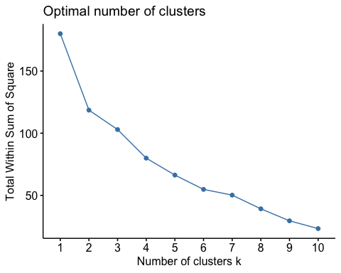

k_silhouette

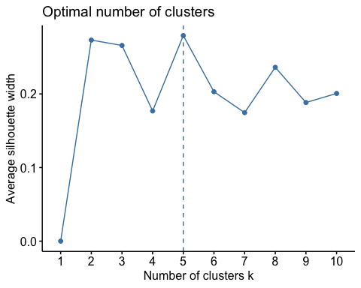

distance<-dist(ScaledData,metho='euclidean')  
fviz_dist(distance)

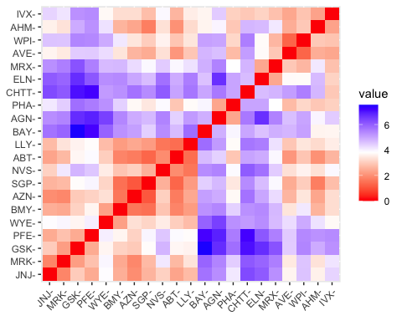

We will be choose silhouette k value of 5 because this will ensure that the sum of squares is low along with proper separation within the clusters.

set.seed(143)  
kmeans_5<-kmeans(ScaledData,centers = 5, nstart = 10)  
kmeans_5

## K-means clustering with 5 clusters of sizes 8, 3, 4, 2, 4  
##   
## Cluster means:  
## Market_Cap Beta PE_Ratio ROE ROA Asset_Turnover  
## 1 -0.03142211 -0.4360989 -0.31724852 0.1950459 0.4083915 0.1729746  
## 2 -0.87051511 1.3409869 -0.05284434 -0.6184015 -1.1928478 -0.4612656  
## 3 -0.76022489 0.2796041 -0.47742380 -0.7438022 -0.8107428 -1.2684804  
## 4 -0.43925134 -0.4701800 2.70002464 -0.8349525 -0.9234951 0.2306328  
## 5 1.69558112 -0.1780563 -0.19845823 1.2349879 1.3503431 1.1531640  
## Leverage Rev_Growth Net_Profit_Margin  
## 1 -0.27449312 -0.7041516 0.556954446  
## 2 1.36644699 -0.6912914 -1.320000179  
## 3 0.06308085 1.5180158 -0.006893899  
## 4 -0.14170336 -0.1168459 -1.416514761  
## 5 -0.46807818 0.4671788 0.591242521  
##   
## Clustering vector:  
## ABT AGN AHM AZN AVE BAY BMY CHTT ELN LLY GSK IVX JNJ MRX MRK NVS   
## 1 4 1 1 3 2 1 2 3 1 5 2 5 3 5 1   
## PFE PHA SGP WPI WYE   
## 5 4 1 3 1   
##   
## Within cluster sum of squares by cluster:  
## [1] 21.879320 15.595925 12.791257 2.803505 9.284424  
## (between_SS / total_SS = 65.4 %)  
##   
## Available components:  
##   
## [1] "cluster" "centers" "totss" "withinss" "tot.withinss"  
## [6] "betweenss" "size" "iter" "ifault"

plot_kmeans_5<-fviz_cluster(kmeans_5,data = ScaledData) + ggtitle("K=5")  
plot_kmeans_5

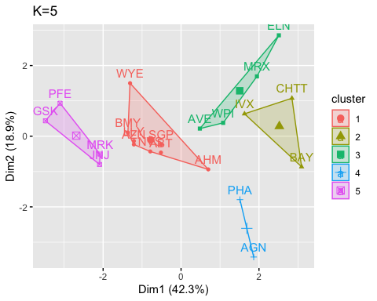

Clustering_data_1<-Clustering_data%>%  
 mutate(Cluster_no=kmeans_5$cluster)%>%  
 group_by(Cluster_no)%>%summarise_all('mean')  
Clustering_data_1

## # A tibble: 5 × 10  
## Cluster_no Market_Cap Beta PE_Ratio ROE ROA Asset_Turnover Leverage  
## <int> <dbl> <dbl> <dbl> <dbl> <dbl> <dbl> <dbl>  
## 1 1 55.8 0.414 20.3 28.7 12.7 0.738 0.371  
## 2 2 6.64 0.87 24.6 16.5 4.17 0.6 1.65   
## 3 3 13.1 0.598 17.7 14.6 6.2 0.425 0.635  
## 4 4 31.9 0.405 69.5 13.2 5.6 0.75 0.475  
## 5 5 157. 0.48 22.2 44.4 17.7 0.95 0.22   
## # ℹ 2 more variables: Rev_Growth <dbl>, Net_Profit_Margin <dbl>

Companies are grouped into following clusters: Cluster_1= ABT,AHM,AZN,BMY,LLY,NVS,SGP,WYE Cluster_2= BAY,CHTT,IVX Cluster_3=AVE,ELN,MRX,WPI Cluster_4=AGN,PHA Cluster_5=GSK,JNJ,MRK,PFE From the above clusters 1.Cluster_1 Companies with moderate returns on equity and investment 2.Cluster_2 Companies with Poor returns on Assets(ROA), Return on Equity (ROE), Low market Capitalization, and weak Asset turnover which implies that these companies are Highly Risky 3.Cluster_3 Companies Similar to those in cluster 2 but with slightly lower levels of risk 4.Cluster_4 Companies with very high price to earnings (P/E) ratios but poor ROA and ROE, making them more risky than those in cluster 2 5.Cluster_5 Companies with high market capitalization, ROE and ROA

Clustering_data_2<- pharmaceutical_data[,12:14] %>% mutate(Clusters=kmeans_5$cluster)  
ggplot(Clustering_data_2, mapping = aes(factor(Clusters), fill =Median_Recommendation))+geom_bar(position='dodge')+labs(x ='Clusters')

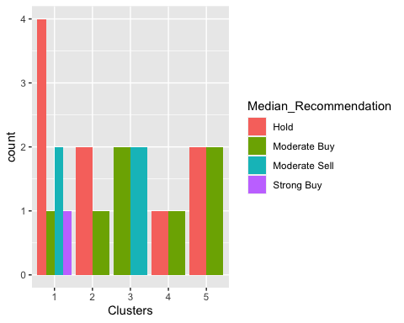

ggplot(Clustering_data_2, mapping = aes(factor(Clusters),fill = Location))+geom_bar(position = 'dodge')+labs(x ='Clusters')

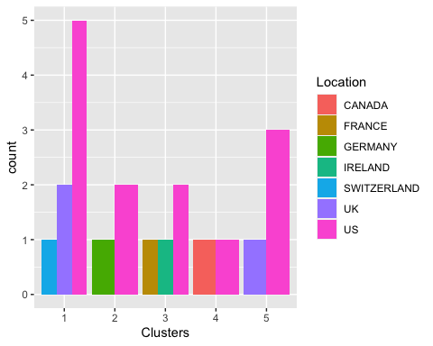

ggplot(Clustering_data_2, mapping = aes(factor(Clusters),fill = Exchange))+geom_bar(position = 'dodge')+labs(x ='Clusters')

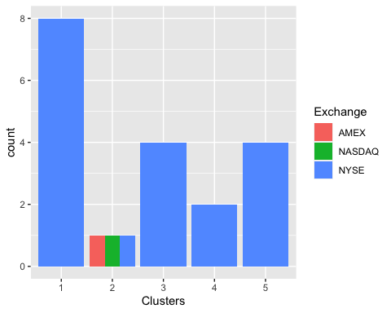

By examining the data, a distinct pattern becomes apparent concerning the connection between the clusters and the ‘Median Recommendation’ variable. Cluster 2 predominantly indicates recommendations spanning from ‘hold’ to ‘moderate buy,’ while Cluster 3 tends to favor recommendations from ‘moderate buy’ to ’moderate sell.’Upon closer inspection of the geographical distribution, it becomes evident that a substantial percentage of pharmaceutical companies are headquartered in the United States, and there is no conspicuous spatial arrangement. Nevertheless, there is no apparent association between clusters and the stock exchange, aside from the observation that the majority of these companies are publicly listed on the New York Stock Exchange (NYSE).

Naming clusters:

**Cluster 1 = Investment Cluster.**

**Cluster 2 = Tight Cluster.**

**Cluster 3 = Low Profit Cluster.**

**Cluster 4 = Risky Cluster.**

**Cluster 5 = Large Purchase Cluster.**