Processor Performance Analysis Using the SimpleScalar Simulator

1. Introduction
This report documents the work carried out for the COA/CA project, which required using the SimpleScalar architectural simulator to study how cache configuration, branch prediction, branch target buffering, and pipeline-width parameters affect processor performance, and to conclude with the design of a constrained "optimum" processor.
All simulations were run using the sim-outorder simulator on Ubuntu (via an Oracle VM). Three SPEC95 benchmarks were used across the four parts of the project: go.ss and gcc95.ss (Part I), and ijpeg.ss with the large.ppm input (Parts II–IV).

1.1 Project Workflow
The general workflow followed for every experiment in this project was:
- Modify the relevant processor, cache, or branch-predictor parameters for the configuration under test.
- Run sim-outorder with those parameters against the chosen benchmark.
- Redirect the simulator output to a text file.
- Extract the required statistics from that file using grep (e.g. grep sim_cycle, grep sim_CPI).
- Tabulate the extracted values and plot them for comparison across configurations.

2. Part I — Cache Configuration Analysis (20 Marks)

2.1 Methodology
Two benchmarks — go.ss and gcc95.ss — were selected for this part. Four memory-system configurations of increasing size (Small, Medium, Large, Excessive) were evaluated, built using the -cache:il1, -cache:dl1, -cache:dl2, and -cache:il2 options of sim-outorder. For each configuration, sim_cycle (execution time) and sim_CPI were recorded.
The four configurations, as specified in the project brief, are summarized below:
Configuration | Cache Parameters (summary)
Small | L1 Unified: 4kB, 2-way, 32B block, random replacement, 1-cycle
Medium | L1I: 8kB direct-mapped, 64B; L1D: 8kB 2-way, 32B; L2 Unified: 64kB 4-way, 64B, LRU, 6-cycle
Large | L1I: 16kB direct-mapped, 128B; L1D: 16kB 2-way, 64B, LRU; L2 Unified: 256kB 2-way, 128B, LRU, 6-cycle
Excessive | L1I: 32kB 2-way, 128B; L1D: 64kB 2-way, 64B, LRU; L2I: 256kB 4-way, 256B, LRU, 4-cyc; L2D: 512kB 8-way, 128B, LRU, 6-cyc

2.2 Results
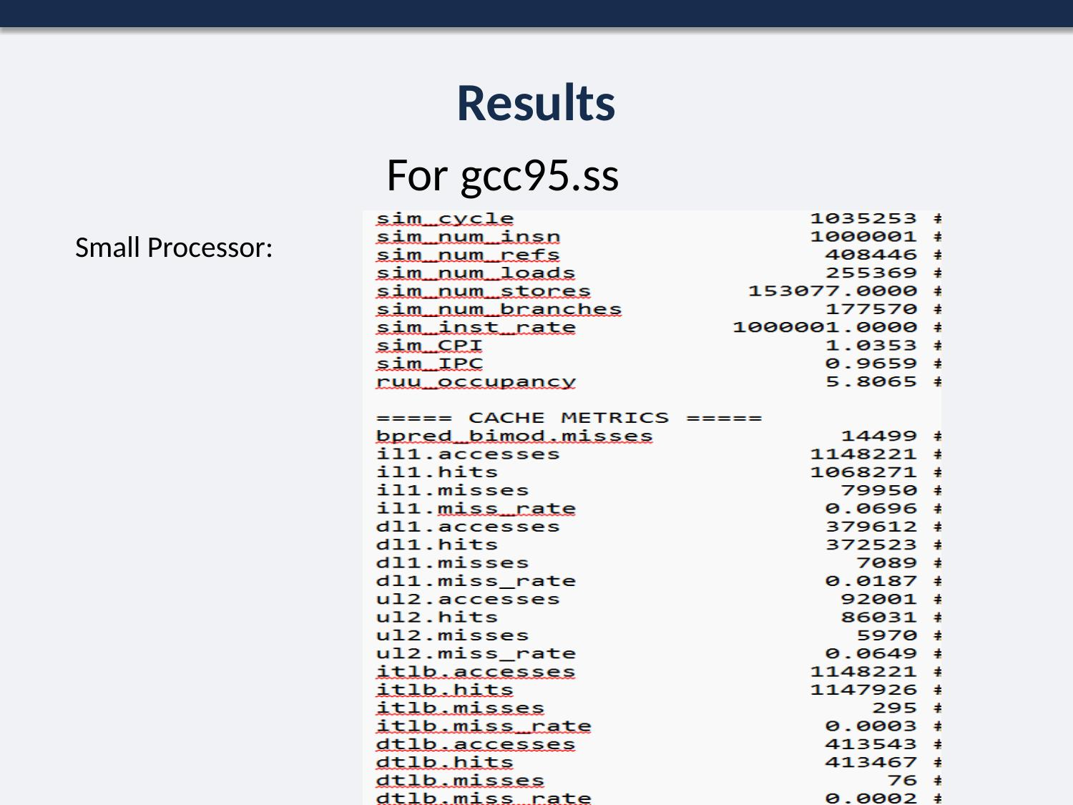
Figure 1. Extracted sim_cycle / sim_CPI output for the Small cache configuration.
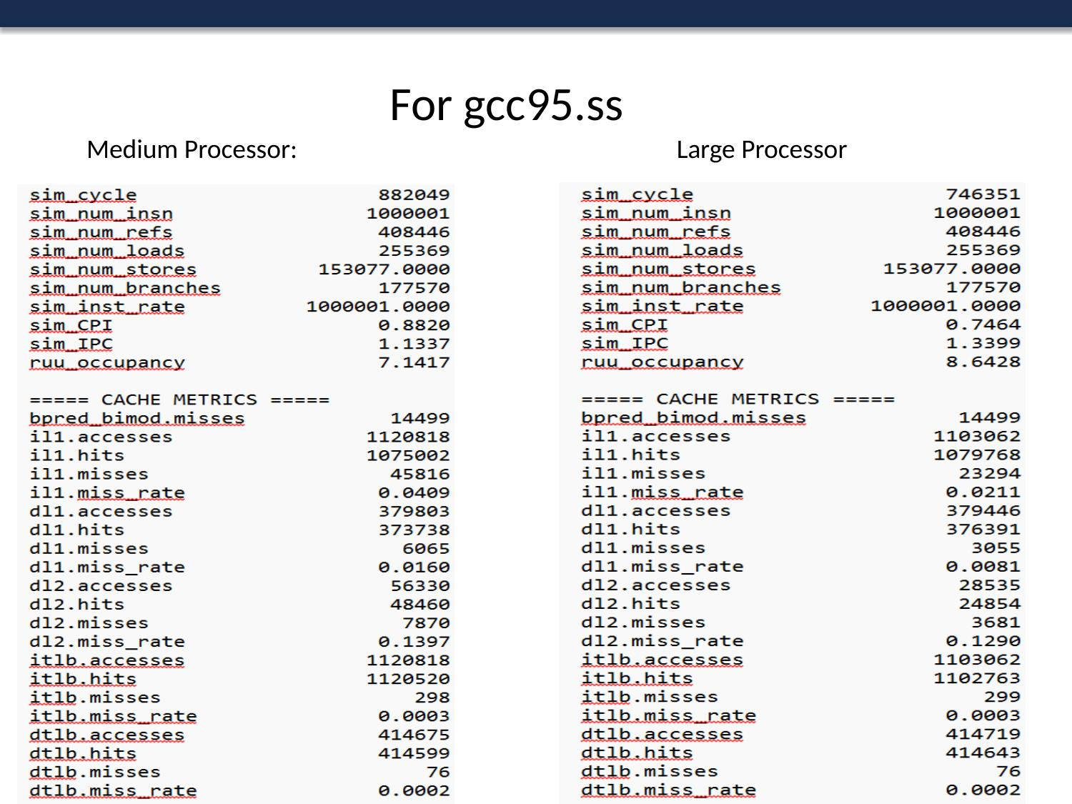
Figure 2. Extracted output for the Medium and Large cache configurations.
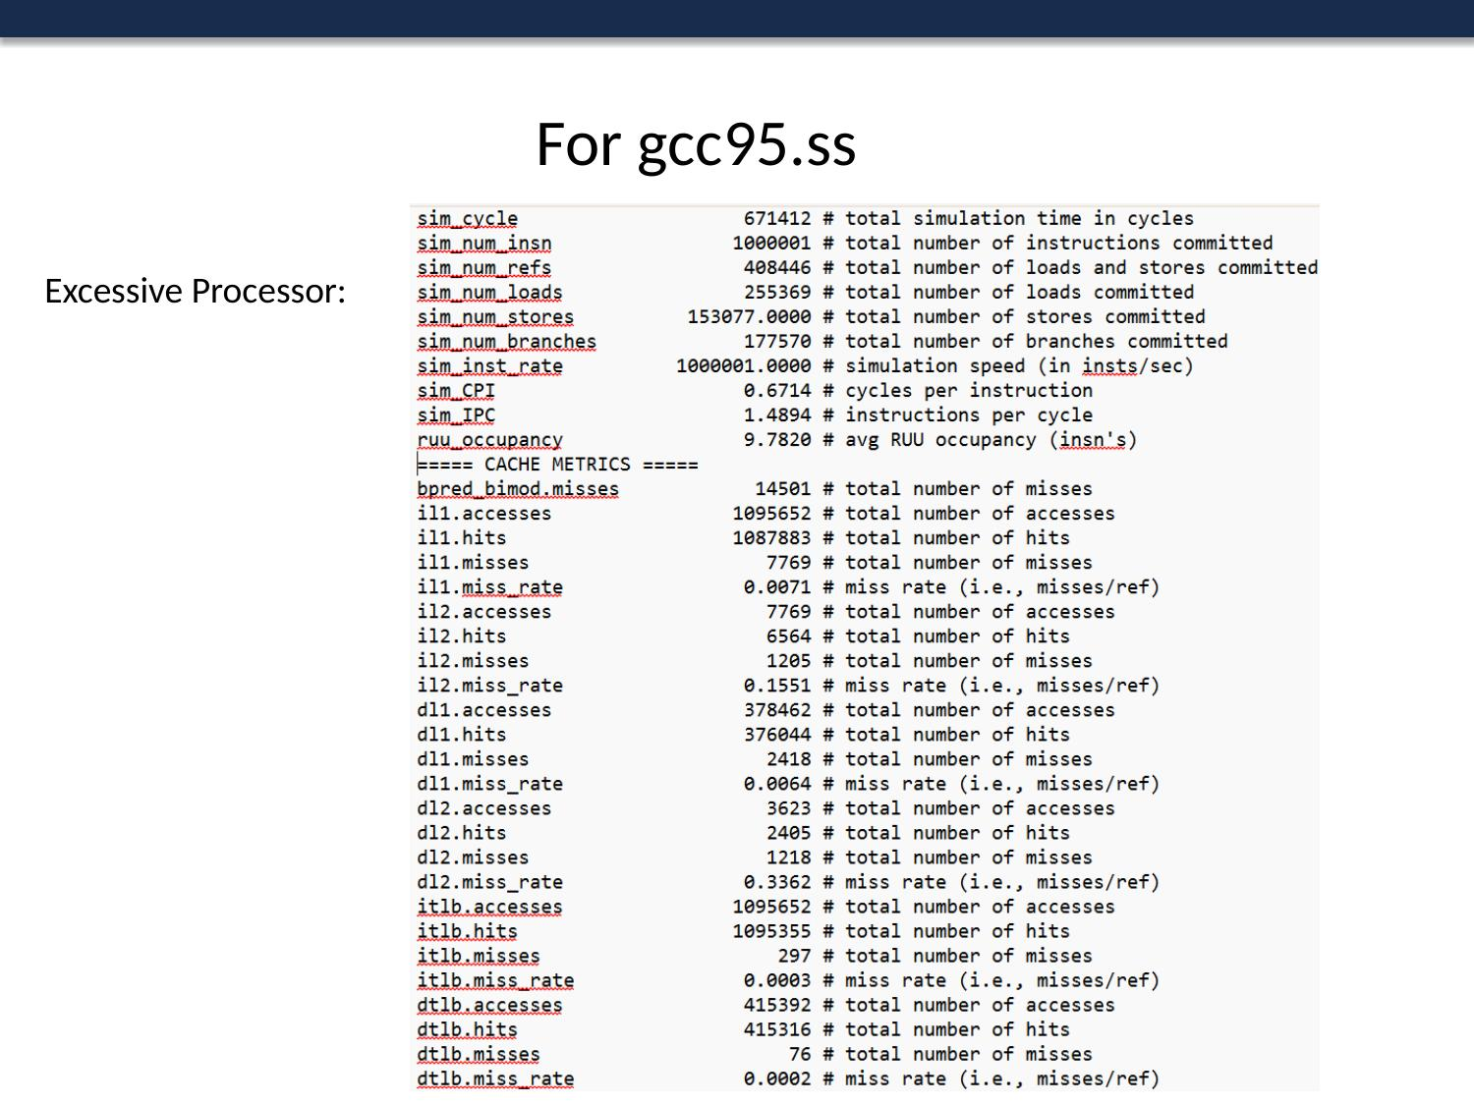
Figure 3. Extracted output for the Excessive cache configuration.
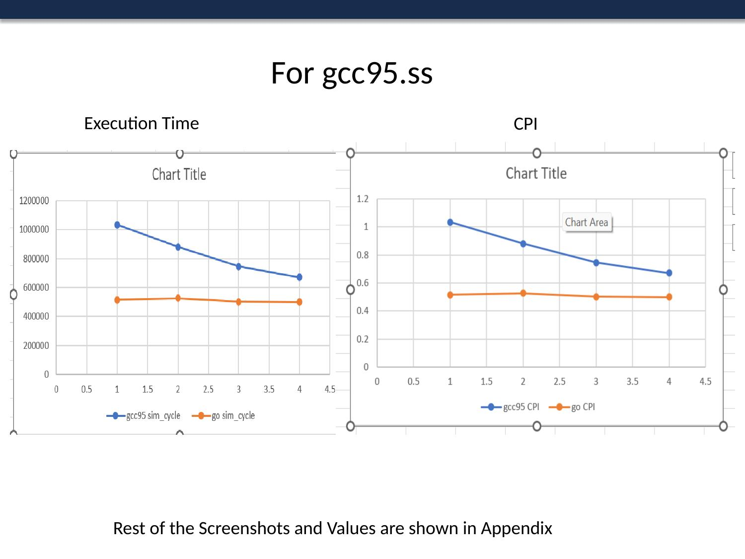
Figure 4. Execution time (sim_cycle) and CPI comparison across the four configurations.

3. Part II(a) — Branch Predictor Analysis (Part of 40 Marks)

3.1 Methodology
Branch predictor performance was compared using ijpeg.ss with the large.ppm input, over a fixed default memory configuration (2KB L1I/L1D, 512KB unified L2). Three predictor families were evaluated:
- Bimodal predictor at table sizes 512, 1024, and 2048.
- 2-level predictor, varying the history/shift-register width (4, 6, 8, 10 bits) and the number of 2nd-level table entries (64, 256, 1024).
- Combination predictor, integrating Bimodal and 2-level schemes at several size pairings.
For each run, the bpred.dir_hits and bpred.misses statistics were extracted with grep (grep bpred_bimod, bpred_2lev, bpred_comb) and compiled into comparison tables and graphs.

3.2 Results
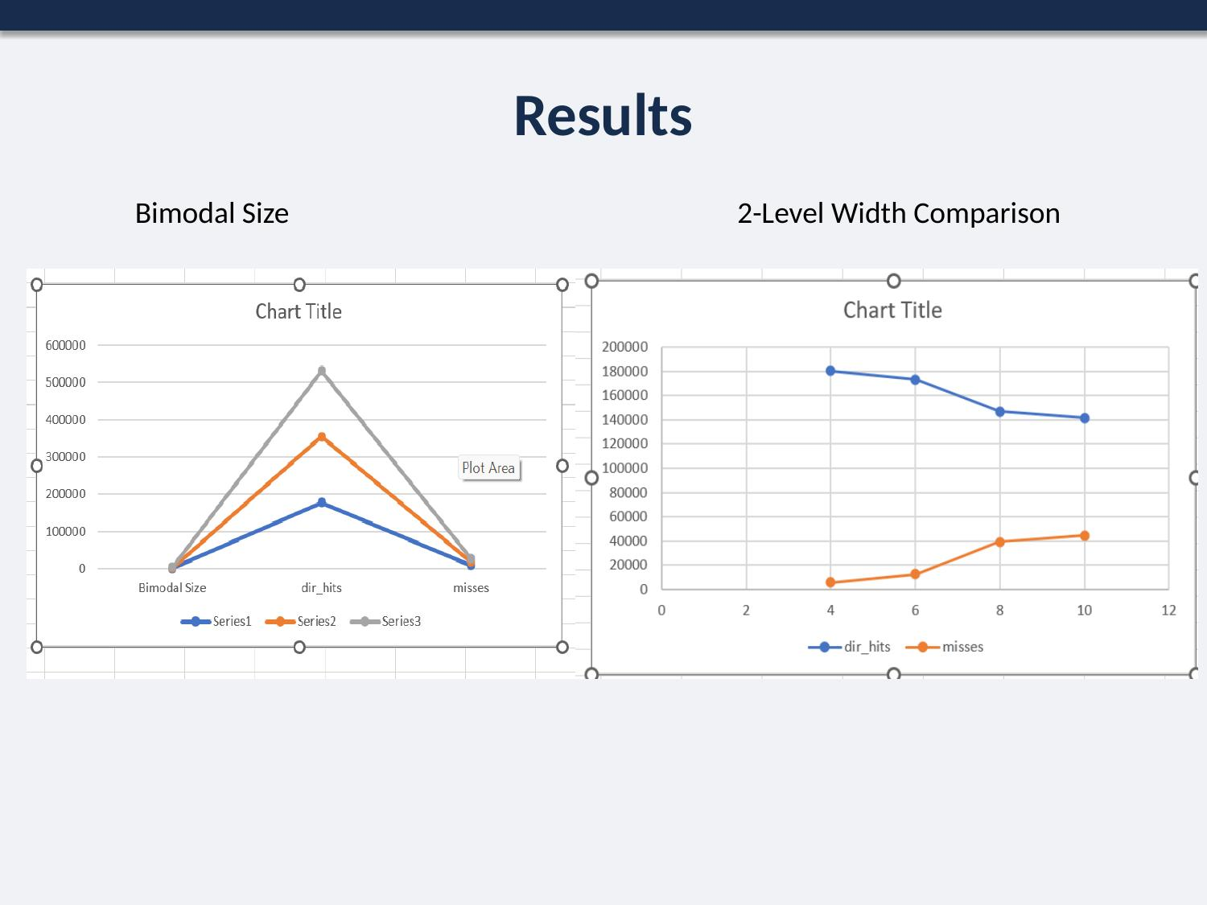
Figure 5. Bimodal predictor size comparison and 2-level predictor width comparison.
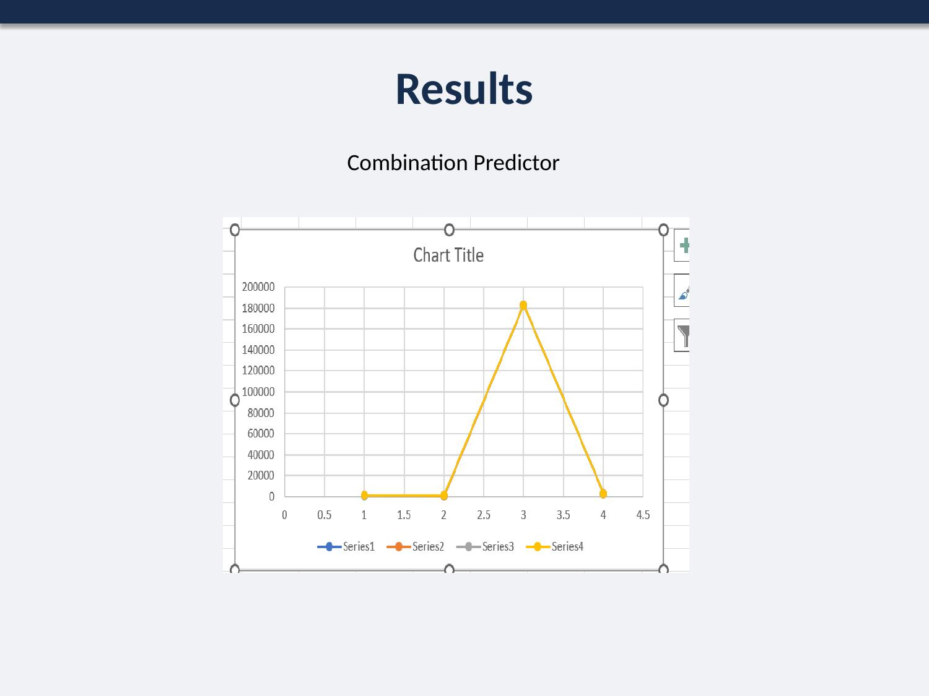
Figure 6. Combination predictor comparison.

4. Part II(b) — Branch Target Buffer (BTB) Analysis

4.1 Methodology
BTB performance was compared using the addr_hits statistic, again on ijpeg.ss with the default memory configuration. Three sub-experiments were run: varying the number of BTB sets (16, 32, 64) at fixed associativity, varying associativity (1, 2, 4) at a fixed set count, and comparing configurations that hold the total BTB size fixed (64×4, 128×2, 256×1).

4.2 Results
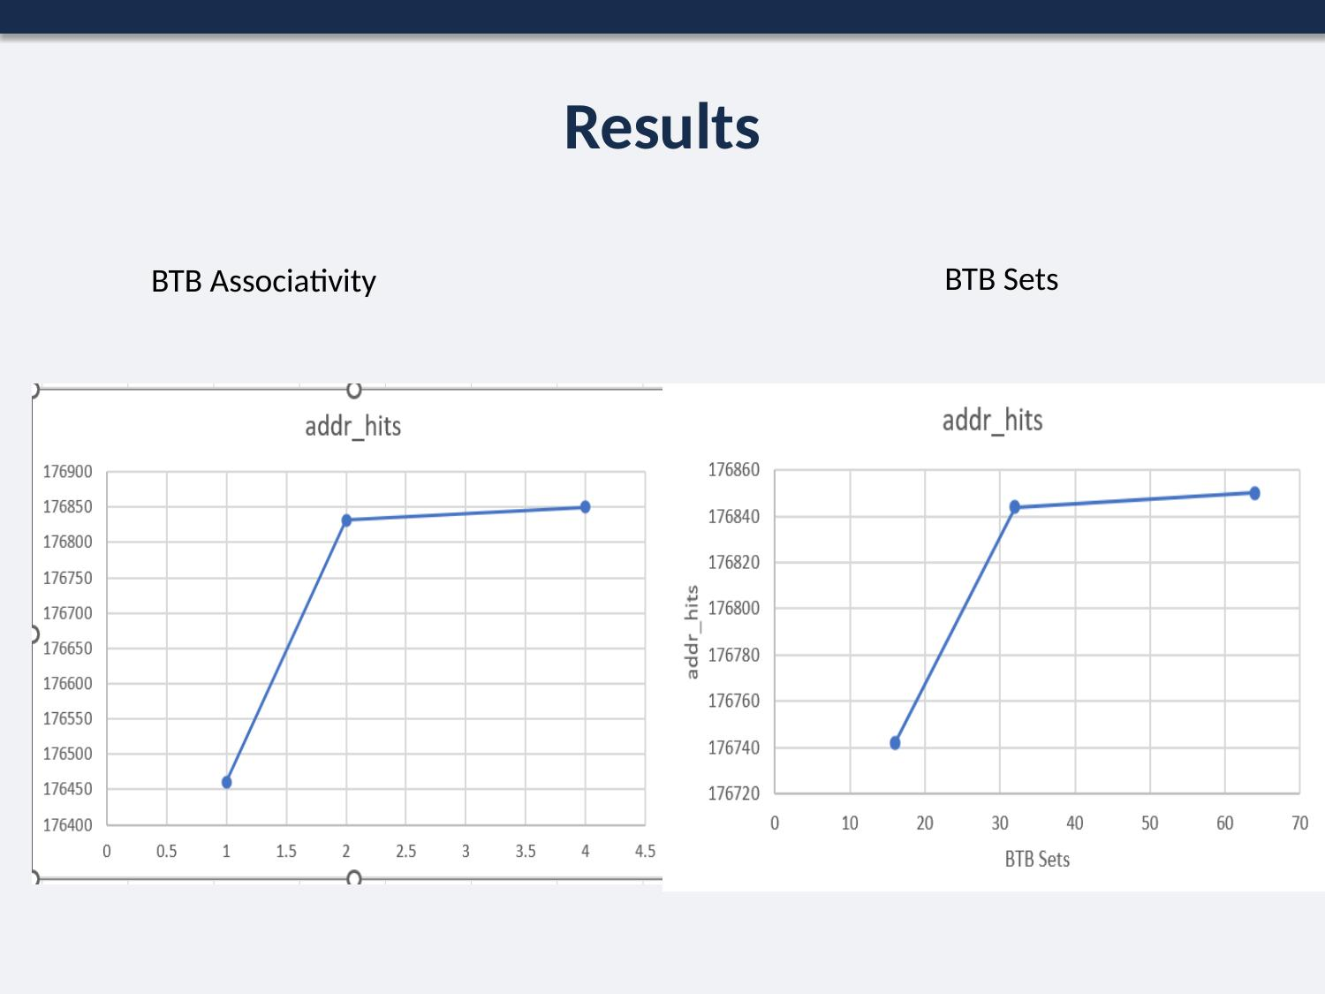
Figure 7. BTB performance vs. associativity, and vs. number of sets.
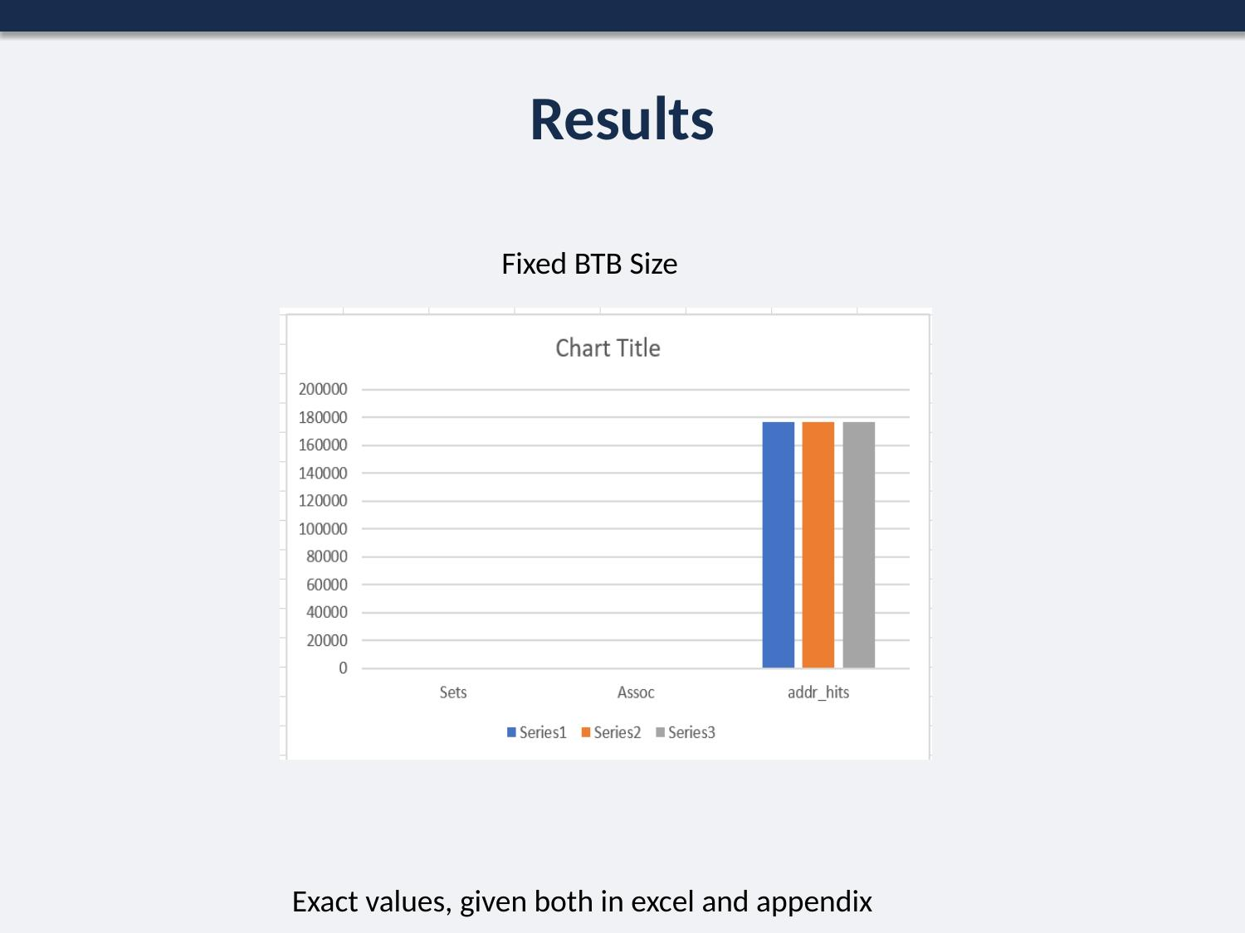
Figure 8. BTB performance with total BTB size held fixed. (Full numeric values are noted in the source slide as provided separately in Excel/Appendix form.)

5. Part III — Detailed Architectural Analysis (20 Marks)

5.1 Methodology
ijpeg.ss was used as the single benchmark for this part. The following were evaluated: branch predictor comparison (bimod, taken, not-taken, 2-level), instruction-fetch-queue (IFQ) size vs. IPC, decode width vs. execution cycles, issue width vs. execution cycles, in-order vs. out-of-order issue, and L1 data/instruction cache hit rate as a function of nsets, block size (bsize), and associativity.

5.2 Results
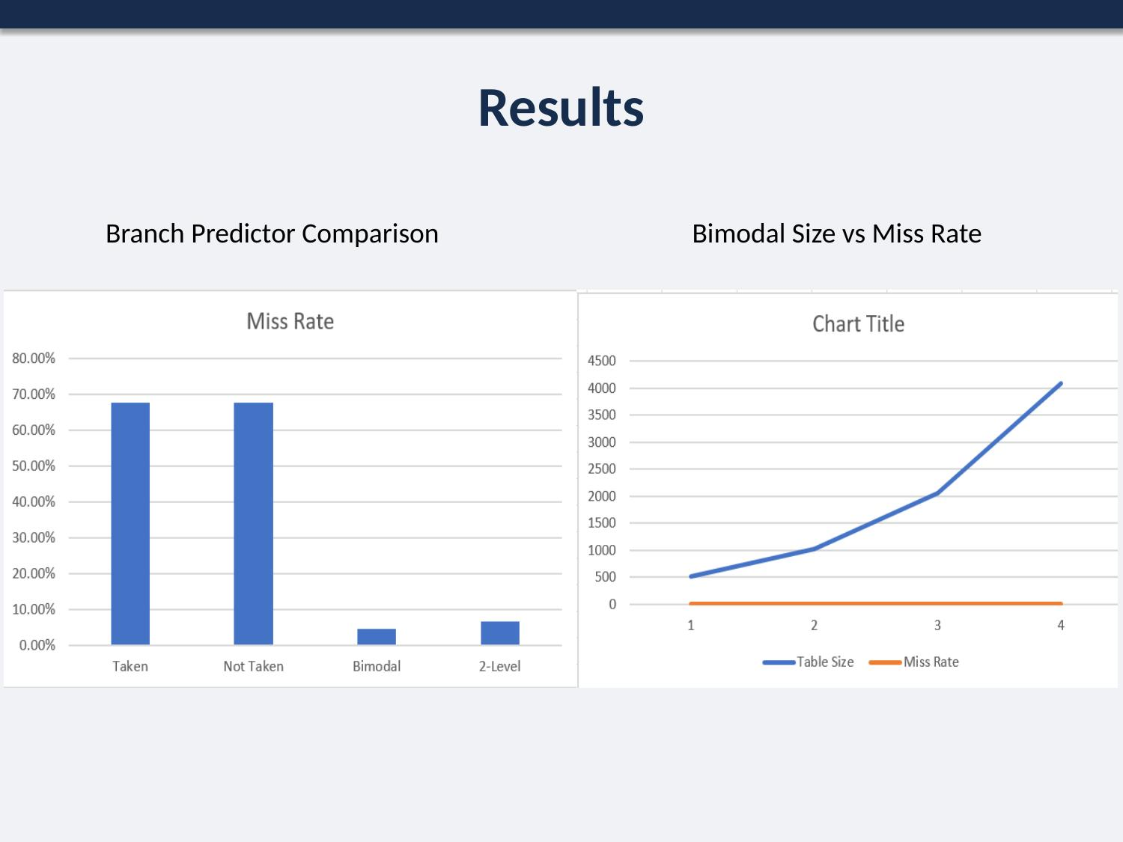
Figure 9. Branch predictor comparison and bimodal table size vs. miss rate.
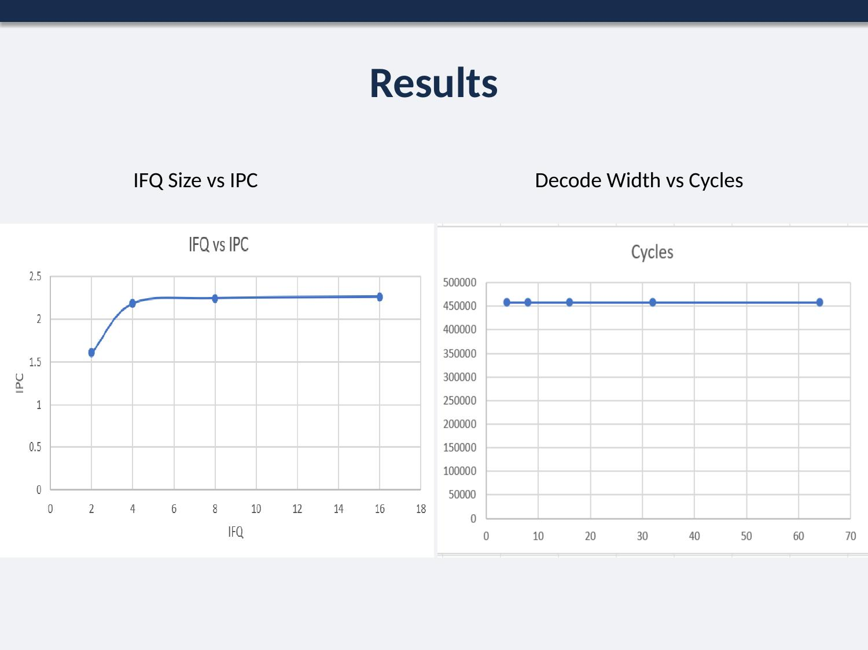
Figure 10. IFQ size vs. IPC, and decode width vs. execution cycles.
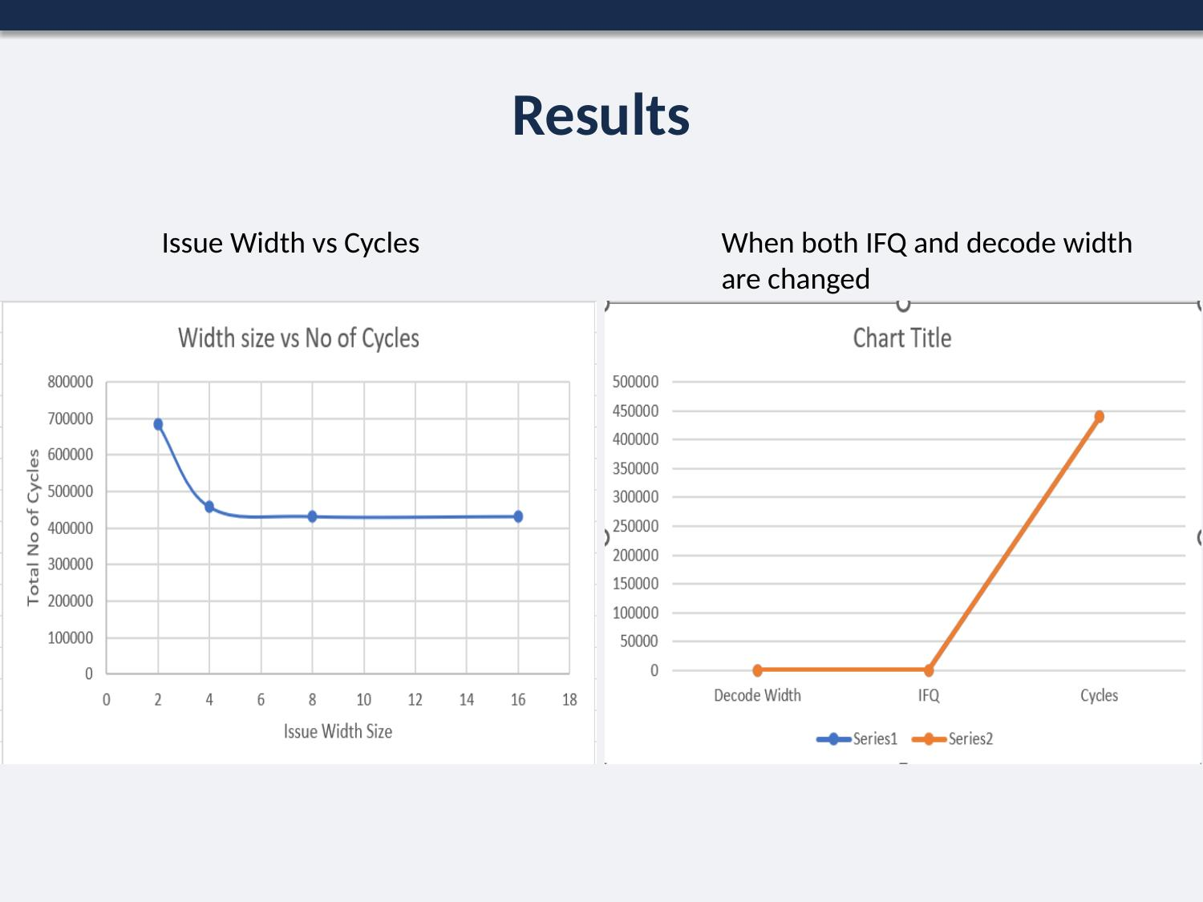
Figure 11. Issue width vs. execution cycles, including the combined IFQ/decode-width sweep.
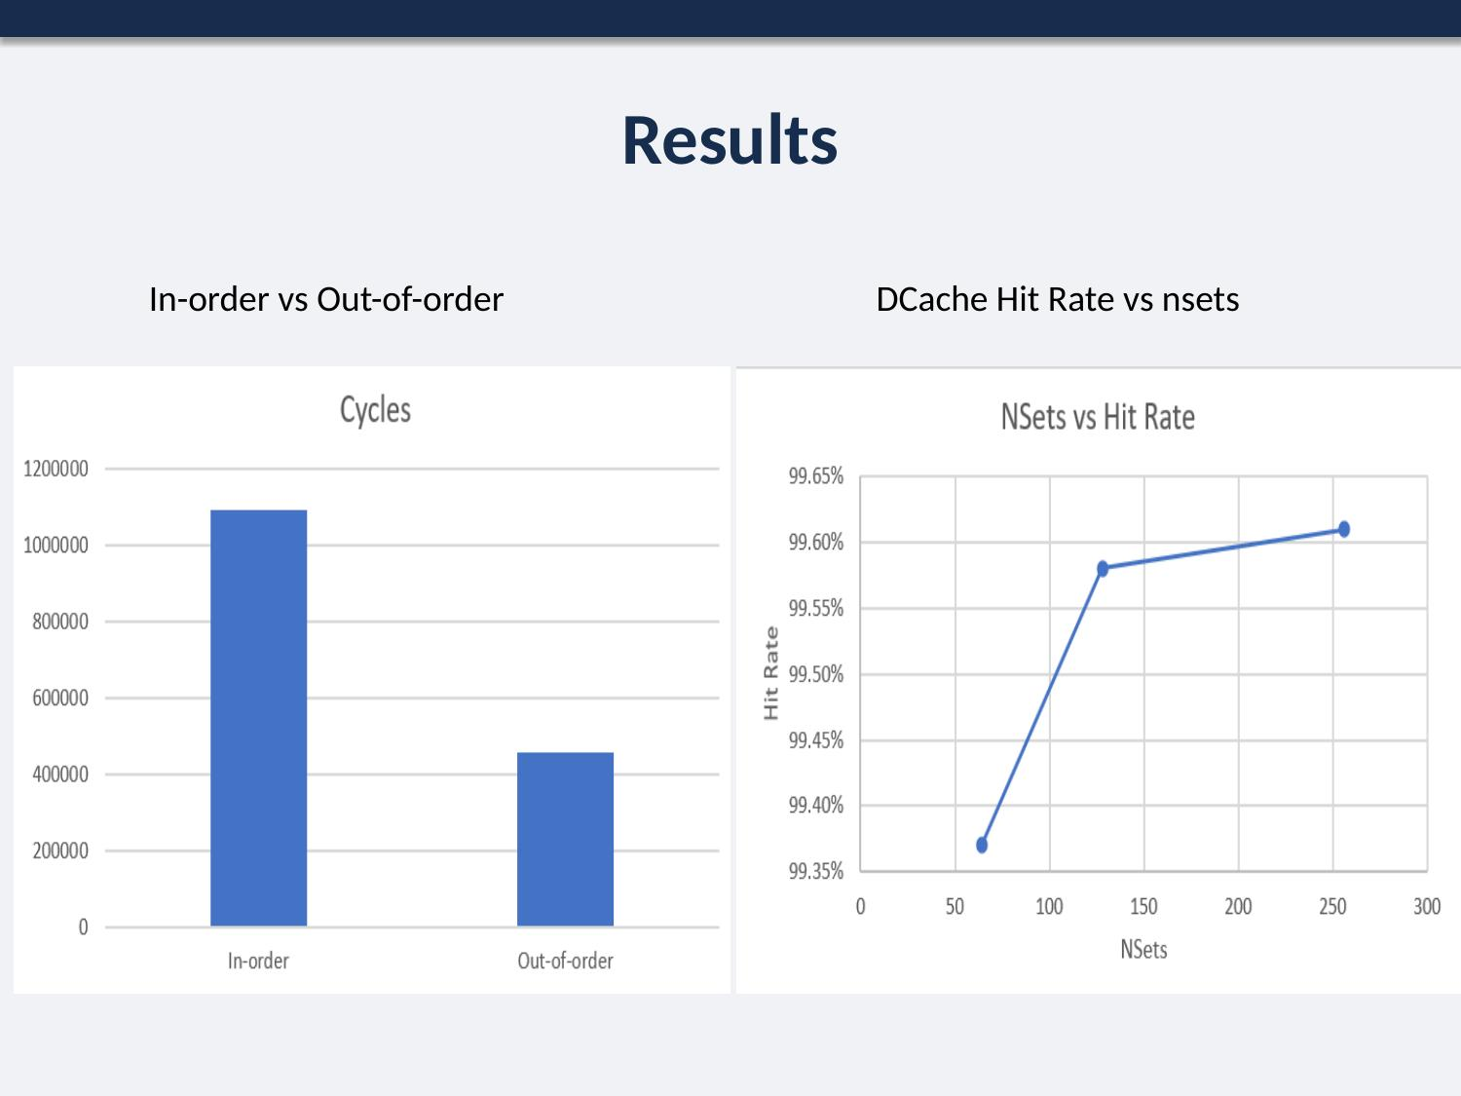
Figure 12. In-order vs. out-of-order execution, and data-cache hit rate vs. number of sets.
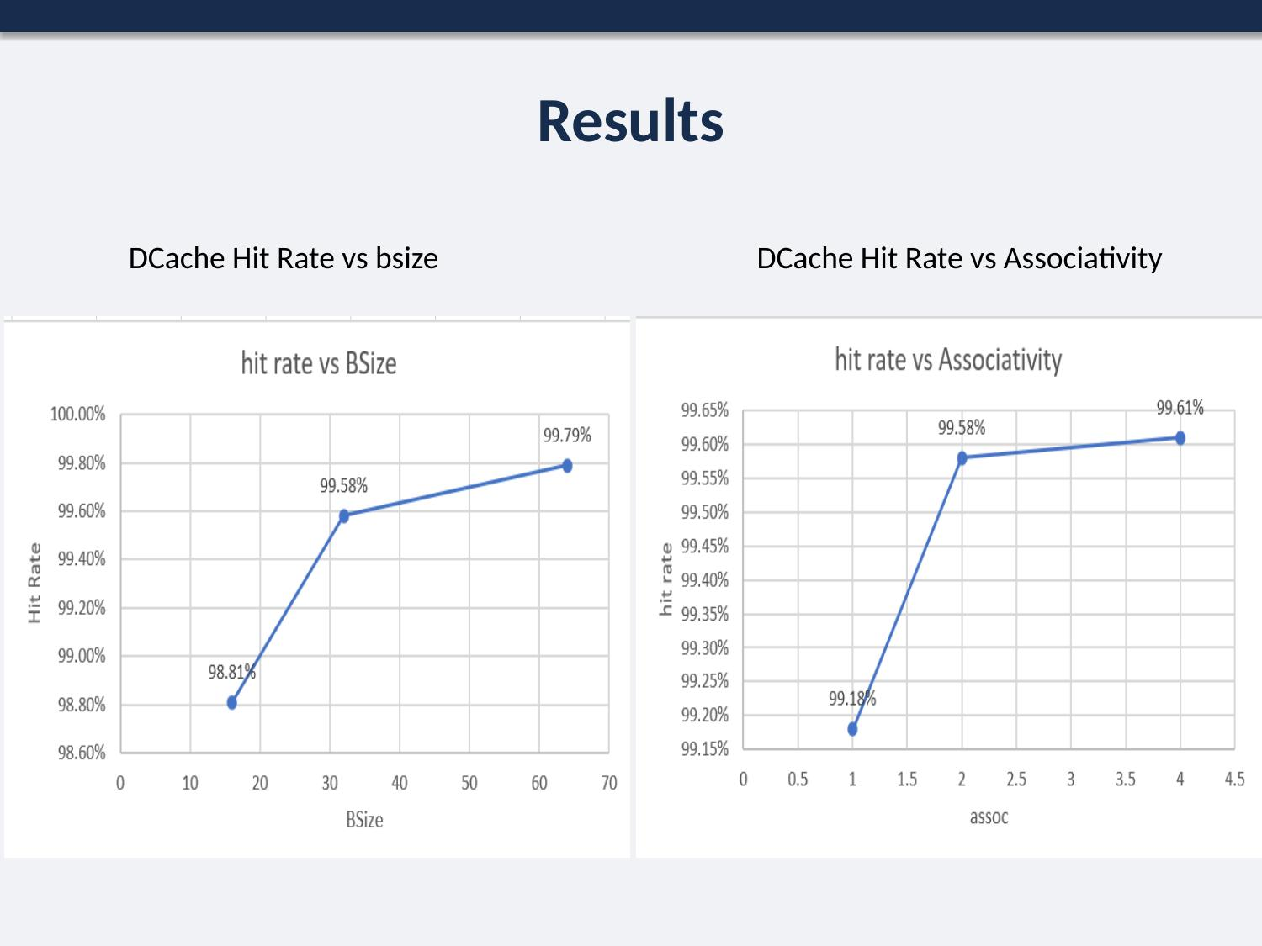
Figure 13. Data-cache hit rate vs. block size and vs. associativity.
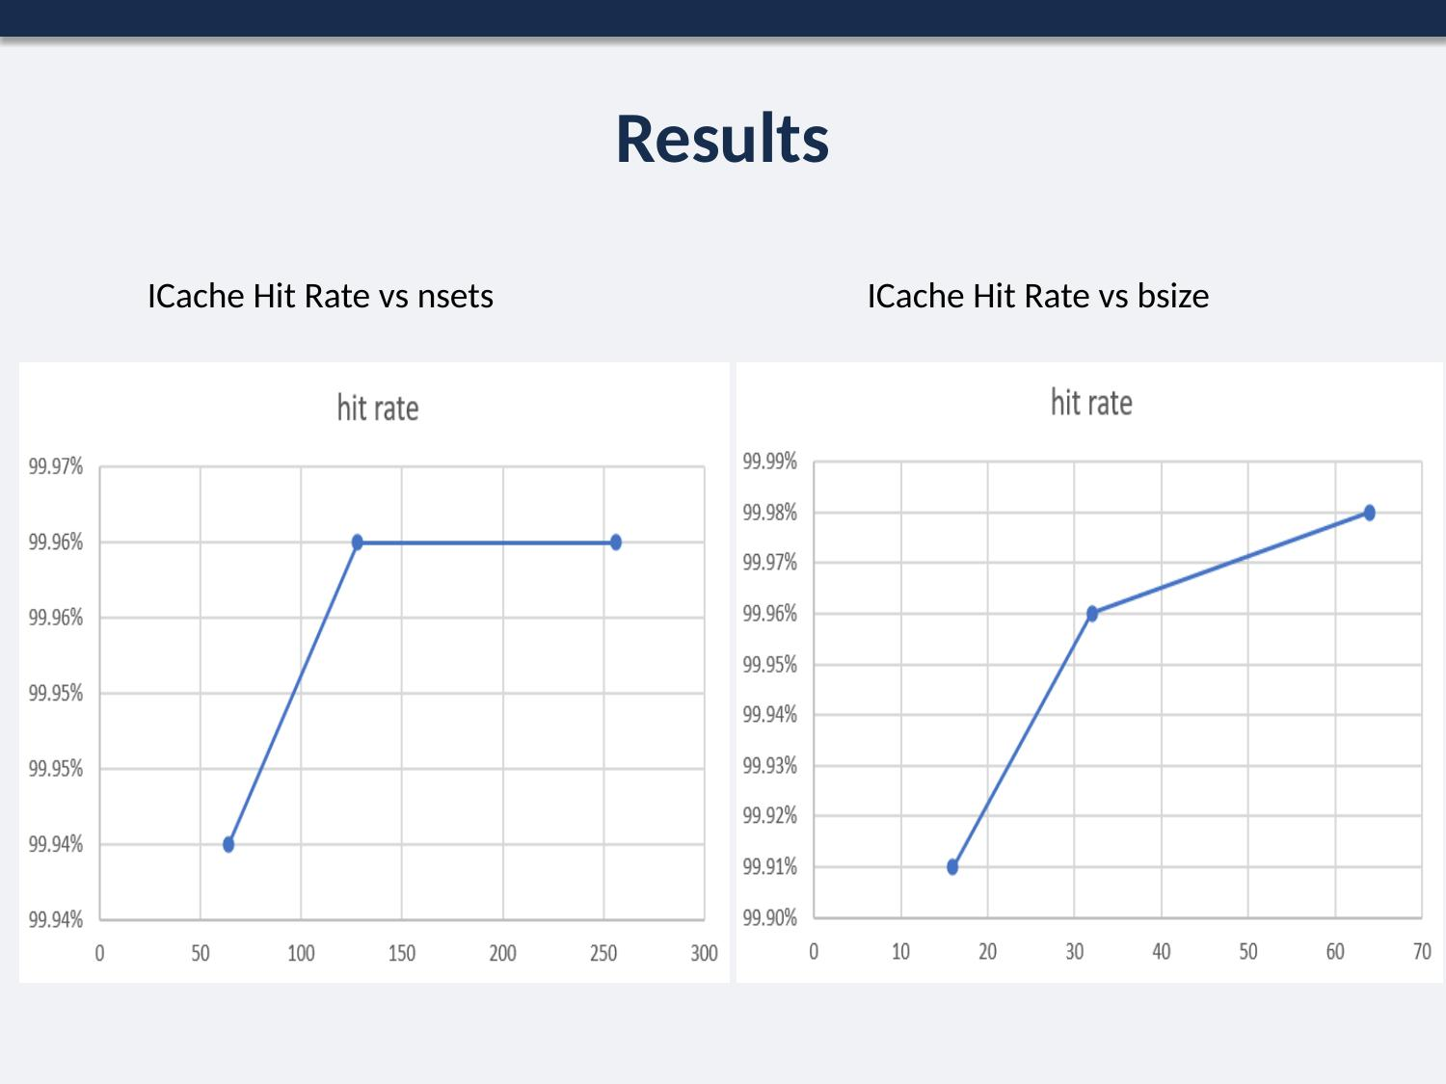
Figure 14. Instruction-cache hit rate vs. number of sets and vs. block size.
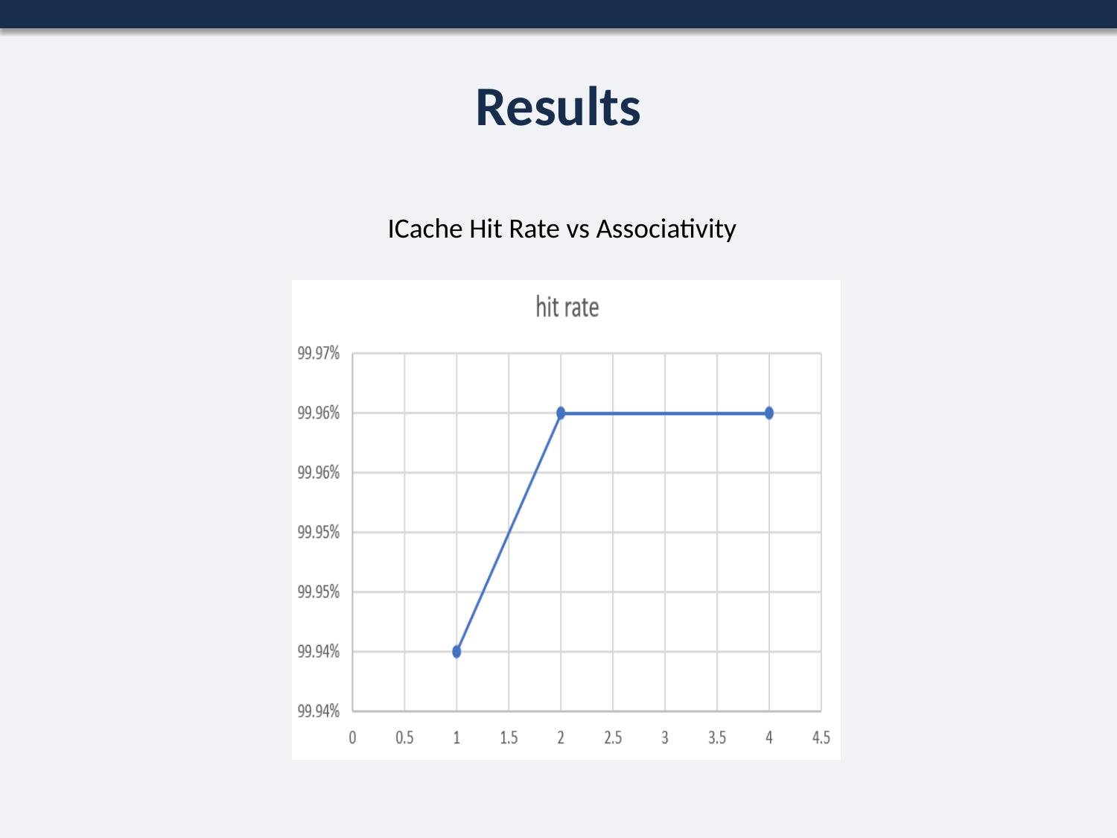
Figure 15. Instruction-cache hit rate vs. associativity.
Note: the project brief also asks for the decode-width sweep to be repeated with the fetch queue fixed at 8 and then at 16 entries, specifically to observe how decode width and fetch-queue size interact. The slides show a single decode-width-vs-cycles result (Figure 10) without that repeated sweep, so it isn't possible to confirm from this deck alone whether that sub-part was completed elsewhere (e.g. appendix) or is still outstanding.

6. Part IV — Optimum Processor Design (20 Marks)

6.1 Design Constraints
An optimum configuration of ijpeg.ss was sought under the following fixed constraints:
- Branch prediction: bimod scheme only.
- Total memory budget: 512 bytes, distributed across the branch-prediction table, Data Cache L1/L2, and Instruction Cache L2 as needed.
- Issue order: in-order only.
- Pipeline width budget: 7 total units to allocate across IFQ size, decode width, and issue width.

6.2 Results and Final Selection
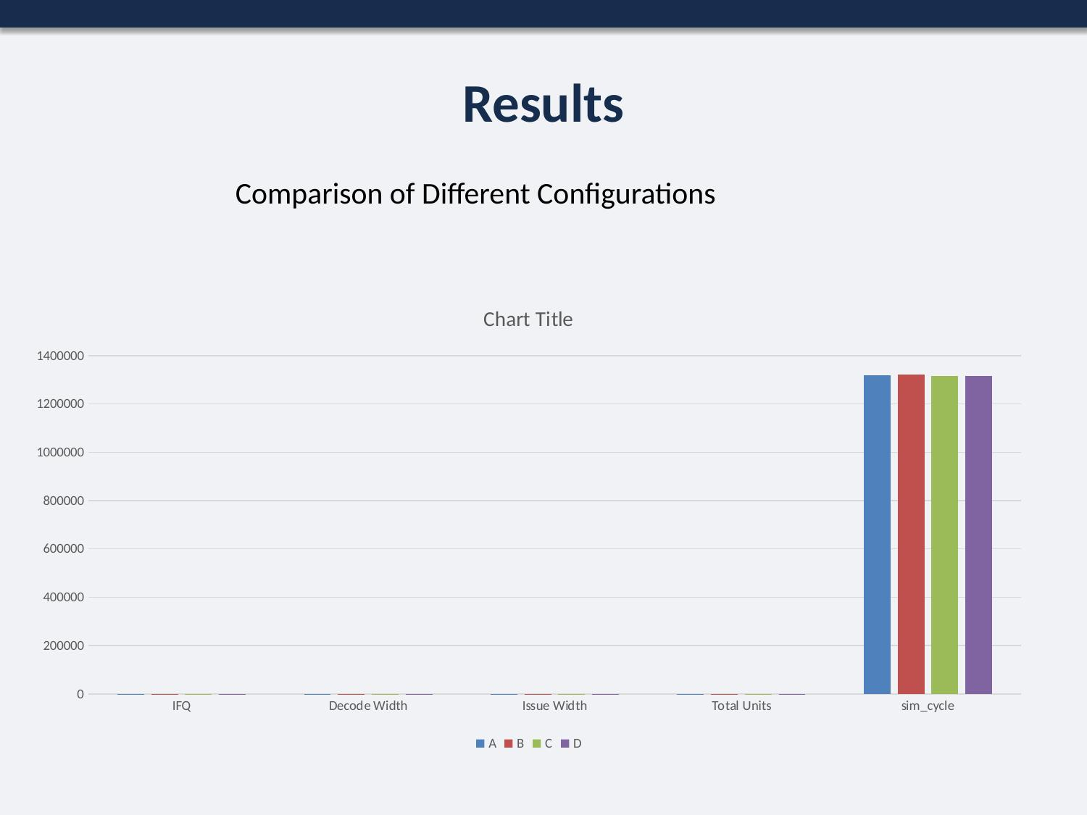
Figure 16. sim_cycle comparison across the evaluated configurations.
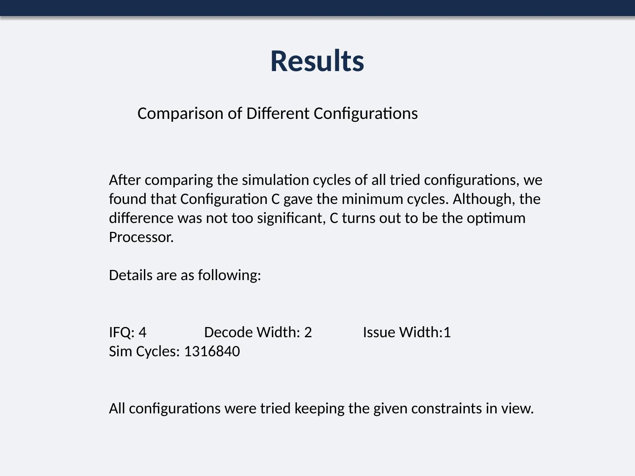
Figure 17. Final configuration comparison and selection rationale.
Across all configurations tried within the given constraints, Configuration C produced the lowest simulation cycle count, though by a narrow margin over the alternatives considered:
Parameter | Value
Instruction Fetch Queue (IFQ) | 4
Decode Width | 2
Issue Width | 1
Total width units used | 7 (of 7 allowed)
Resulting sim_cycle | 1,316,840

7. Conclusion
The project exercised the full sim-outorder workflow — configuring caches, branch predictors, BTBs, and pipeline widths; running SimpleScalar; extracting statistics with grep; and building comparative tables and graphs — across four parts of increasing architectural scope, ending in a constrained design exercise that selected Configuration C (IFQ 4 / Decode 2 / Issue 1) as the lowest-cycle option for ijpeg.ss under the given 7-unit, 512-byte, in-order/bimod constraints.
Two gaps are worth resolving before this is treated as a finished submission: the missing go.ss comparison in Part I (Section 2.2), and confirmation of whether the Part III decode-width/fetch-queue interaction sweep (Section 5.2) was completed. Both are flagged above rather than assumed complete.

