**Chatbot Deployment with IBM Cloud Watson Assistant**

**Challenge:**

In the healthcare sector, there's a growing need for efficient communication and support tools. Patients may face challenges such as long waiting times, difficulty in accessing information, and the need for constant health monitoring. Developing a **healthcare chatbot** can address these issues by providing instant assistance, information dissemination, and personalized health management.

**ARCHITECTUR:**

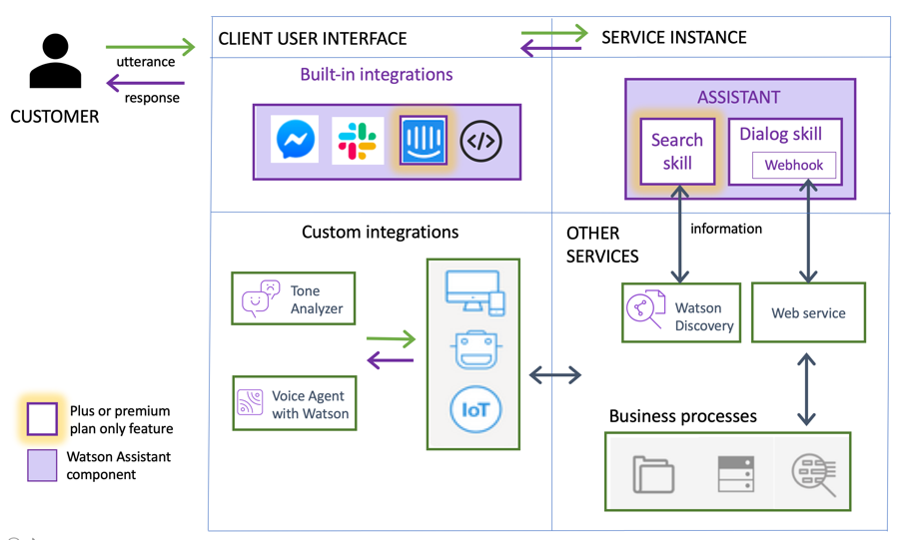

**Innovative Ideas:**

**1.Personal Health Assistant:**

Idea: Develop a chatbot that acts as a personal health assistant. It can help users track medication schedules, provide health tips, and offer personalized advice based on the user's health history.

**2.Appointment Scheduler and Reminders:**

Create a chatbot that allows users to schedule appointments, receive reminders, and even assist in rescheduling

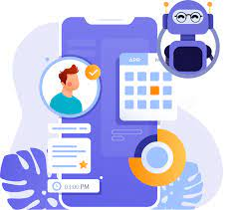

**3.Symptom Checker and Triage:**

Implement a symptom-checking chatbot that helps users assess their symptoms. The chatbot can provide initial recommendations and, if necessary, guide users to seek urgent medical attention.

**4.Medication Adherence Support:**

Idea: Develop a chatbot that supports medication adherence. It can send timely reminders, offer information about medications, and address common concerns or side effects.

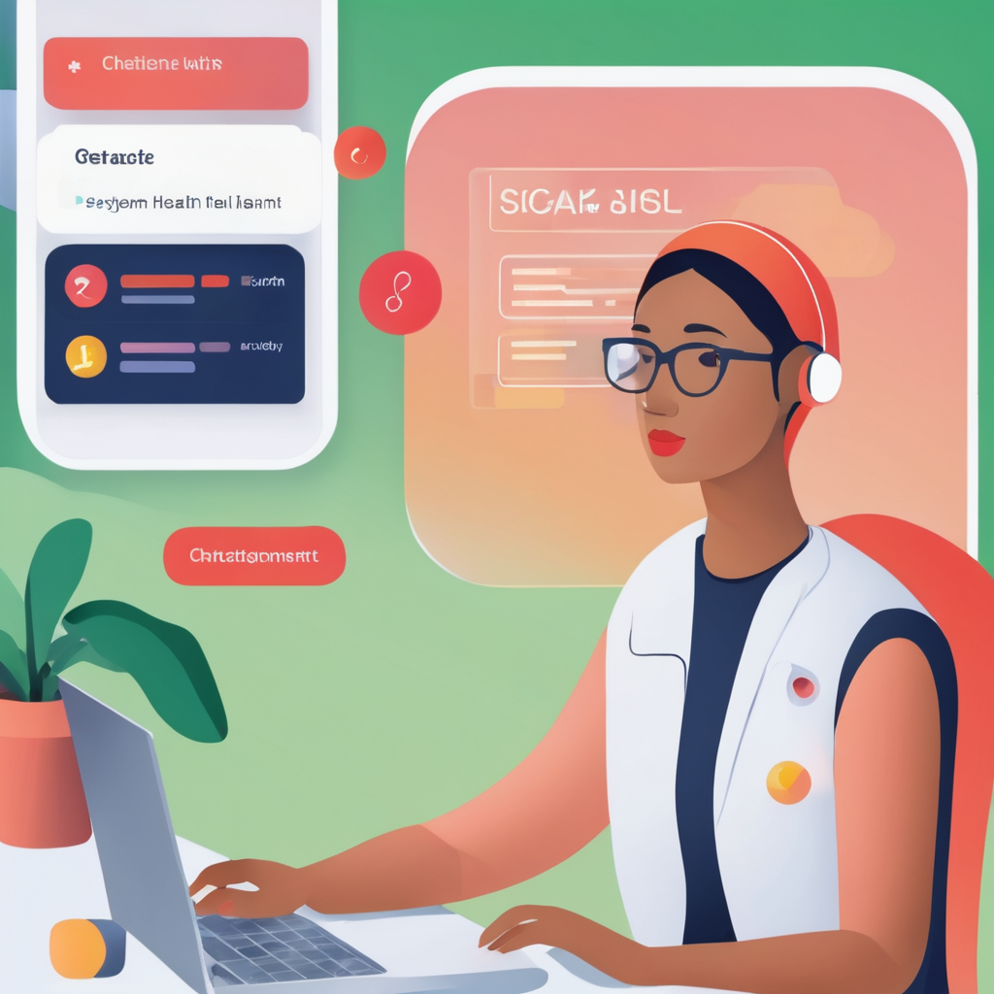

**5.Health Information Resource:**

Idea: Build a comprehensive health information chatbot. Users can ask questions about medical conditions, treatment options, or general health advice. Ensure the information is sourced from reputable medical databases.

**Mental Health Support Bot:**

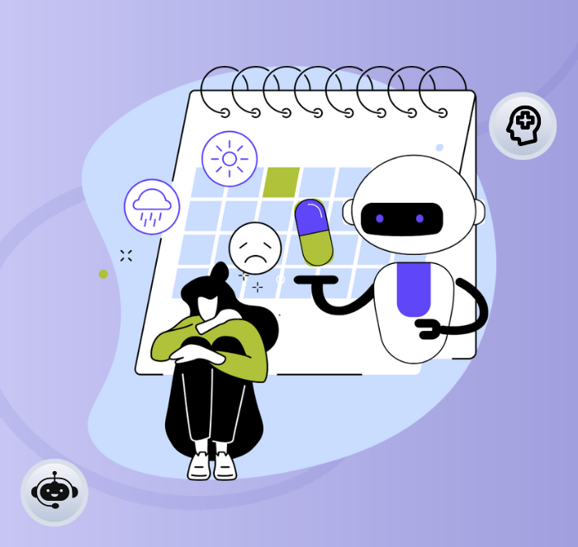

Develop a chatbot focused on mental health support. It can provide resources for stress management, offer coping strategies, and even facilitate mood tracking.

**6.Post-Discharge Follow-up:**

* Implement a chatbot that follows up with patients after hospital discharge. It can check on recovery progress, provide post-discharge instructions, and address any concerns.

**7.Nutrition and Diet Guidance:**

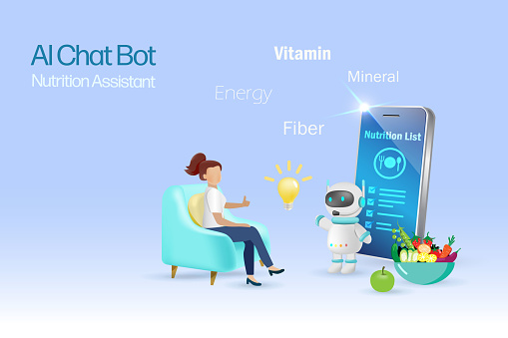

Create a chatbot that offers personalized nutrition advice. Users can input dietary preferences and receive information on healthy eating habits, recipes, and nutritional content.

**8.Emergency First Aid Assistance:**

Idea: Develop a chatbot that provides basic first aid information in emergency situations. It can guide users through essential first aid steps and connect with emergency services if needed.

