**phase 3**

**Chatbot Name: HealthBot Assist**

**Chatbot Persona:**

**Personality Traits:**

**Empathetic**: HealthBot Assist is designed to be understanding and supportive, especially when users express health-related concerns.

**Informative**: The chatbot is knowledgeable about healthcare topics, insurance, and general medical information.

**Professiona**l: Maintains a professional tone to instill confidence in users seeking healthcare assistance.

**Conversation Flow:**

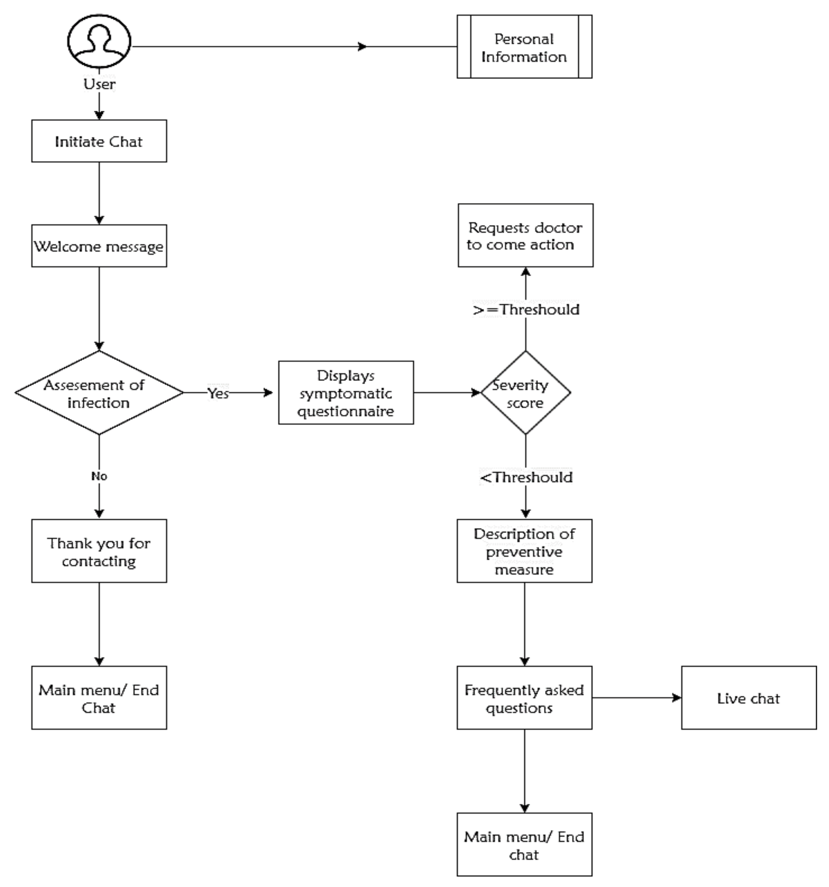

**Welcome and Introduction:**

Greet the user warmly.

Introduce HealthBot Assist and its purpose.

Example: "Hello! I'm HealthBot Assist, here to help with your healthcare inquiries. How can I assist you today?"

**User Inquiry:**

Identify the user's intent based on their input.

Example: User says, "I'm not feeling well."

**Intent Recognition:**

Recognize the user's intent, e.g., #GeneralInquiry.

Extract relevant entities (e.g., symptoms).

Example: "I'm sorry to hear that. Could you please share more details about your symptoms?"

**User Response:**

User provides more information.

Example: "I have a headache and feel nauseous."

Condition-Based Responses:

Respond based on the recognized intent and entities.

Example: "I'm not a doctor, but a headache and nausea could be related to various causes. It's recommended to consult with a healthcare professional. In the meantime, staying hydrated and resting might help."

**Intents:**

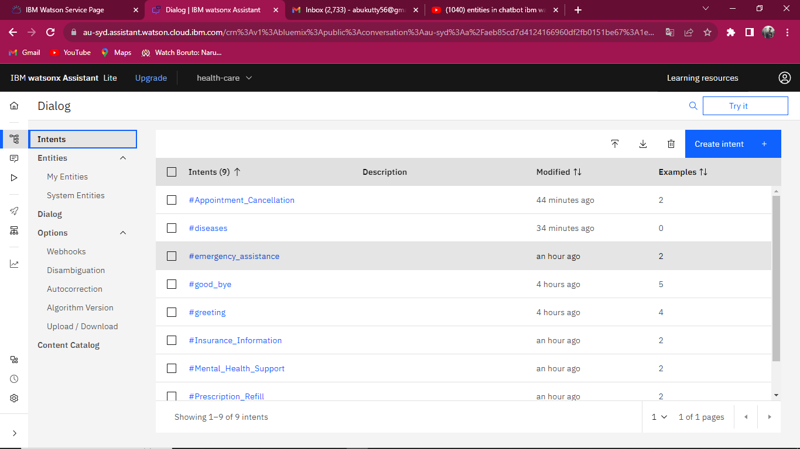

**Emergency Assistance:**

Purpose: Recognizing when the user is in need of immediate medical attention.

Examples: "Emergency! I need help right away," "Urgent situation. Please connect me to emergency services."

**Insurance Information:**

Purpose: Handling queries related to health insurance information.

Examples: "Can you tell me about my insurance coverage?" "I need details about my health insurance policy."

**Prescription Refill:**

Purpose: Recognizing requests for prescription refills and facilitating the process.

Examples: "I'd like to refill my prescription for [Medication Name]," "Help me renew my prescription for [Medication Name]."

**Mental Health Support:**

Purpose: Identifying when the user needs mental health support or resources.

Examples: "I'm feeling really anxious and need someone to talk to," "Can you provide resources for mental health support?"

**Appointment Cancellation:**

Purpose: Handling requests to cancel or reschedule medical appointments.

Examples: "I need to cancel my appointment scheduled for [Date and Time]," "Cancel my upcoming visit on [Date]."

**General Inquiry:**

Purpose: Handling general inquiries related to healthcare services.

Examples: "How can I improve my mental health?" "Tell me about common symptoms of [specific condition]."

**Entities:**

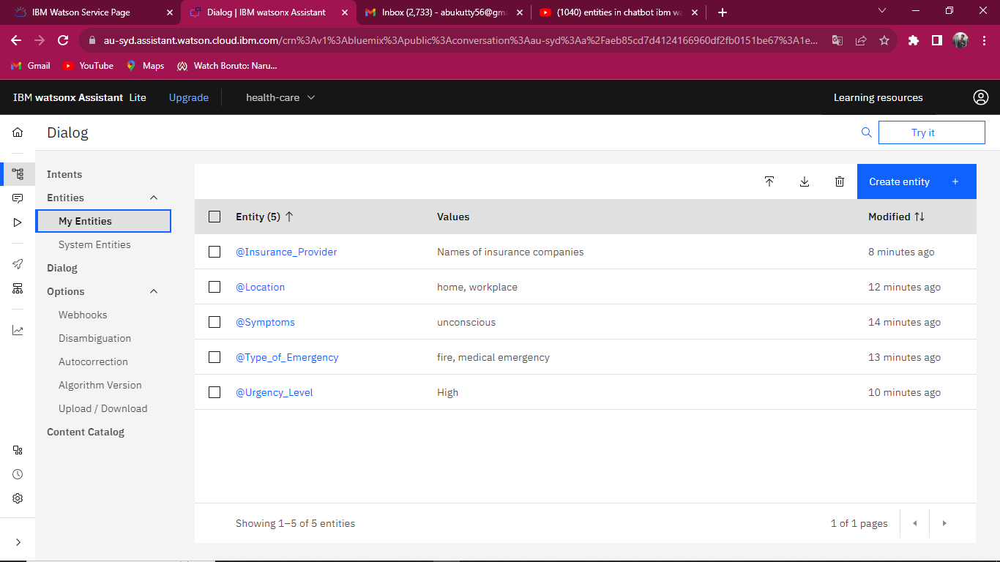

**Urgency Level:**

Values: "High," "Medium," "Low"

Purpose: Categorizing the urgency level of the user's request, especially for emergency-related intents.

Synonyms:

"Critical," "Urgent," "Immediate"

**Insurance Provider:**

Values: Names of insurance companies

Purpose: Extracting the specific insurance provider mentioned by the user.

Synonyms:

"Health insurer," "Coverage provider," "Insurance company"

**Medication Name:**

Values: Names of medications

Purpose: Extracting specific medications mentioned by the user.

Synonyms:

"Prescription drug," "Medicine," "Pharmaceutical"

Appointment Date and Time:

Purpose: Extracting information for scheduling or canceling appointments.

Synonyms:

"Meeting time," "Visit schedule," "Appointment timing"

**Dialog Nodes:**

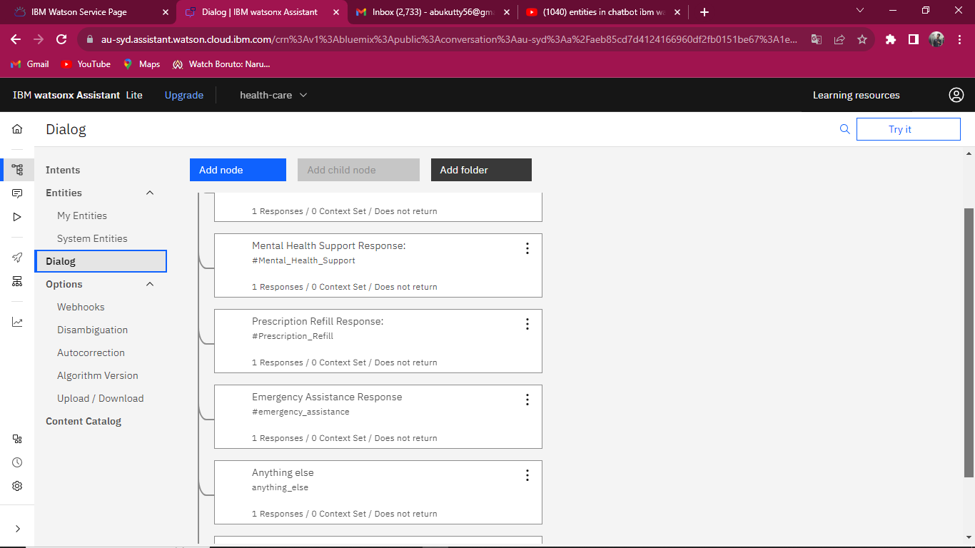

**Emergency Assistance Response:**

Condition: #EmergencyAssistance intent is recognized.

Response:

"I'm sorry to hear that you're in distress. Please provide your current location, and I will connect you to emergency services."

"Urgency level detected: <?entities['UrgencyLevel'][0]['value']?>. I'll help you right away. Could you please share your current location?"

**Insurance Information Response:**

Condition: #InsuranceInformation intent is recognized.

Response:

"Sure, I can help with that. Please provide the name of your insurance provider, and I'll fetch the relevant information for you."

"Got it. To assist you with insurance information, please share the name of your insurance provider."

**Prescription Refill Response:**

Condition: #PrescriptionRefill intent is recognized.

Response:

"Certainly! To process your prescription refill, please provide the name of the medication and the dosage."

"Great! I can help with your prescription refill. Could you please provide the name and dosage of the medication?"

**Mental Health Support Response:**

Condition: #MentalHealthSupport intent is recognized.

Response:

"I'm here to support you. If you need someone to talk to, I can provide resources or connect you with a mental health professional."

"It's important to take care of your mental health. I can provide resources or connect you with a professional. What would you like to discuss?"

**Appointment Cancellation Response:**

Condition: #AppointmentCancellation intent is recognized.

Response:

"I understand. To cancel or reschedule your appointment, please provide your name and the date/time of the appointment."

"Sure, I can assist with that. Please share your name and the details of the appointment you'd like to cancel or reschedule."

**Fallback Response (General):**

Condition: None of the specified intents are recognized.

Response:

"I'm sorry, I didn't quite catch that. Could you please rephrase or provide more details about your healthcare inquiry?"

"I'm here to help with healthcare-related questions. Could you please provide more information or ask in a different way?"

