Business Process Optimization
using Reinforcement Learning

Documentation

Table of Contents
1.0 Data Cleaning / Transformation 3
2.0 Training Process 5
2.1 State Space 5
2.2 Action Space 5
2.3 Environment & Reward Function 6
2.4 Q-Learning Agent 6
2.5 Training Pipeline 6
3.0 Live Inference Pipeline 8
3.1 Request Handling 8
3.2 Parsing 8
3.3 AS-IS Analysis 8
3.4 Redesign Loop 8
3.5 TO-BE Analysis & Response 9
4.0 Project Github Link 10

1.0 Data Cleaning / Transformation
- Downloaded raw dataset from Git repo
Link: - https://github.com/camunda/bpmn-for-research

- Validation & Train / Evaluation Split
All .bpmn files were passed through a validity check in which .bpmn files with following issues were removed.

- No start event, or no end event
- No sequence flows at all
- A flow referencing a task/gateway/event id that doesn’t exists (orphan flow reference)
- Any node unreachable from the start event (disconnected nodes)
- No end event reachable from the start event at all.

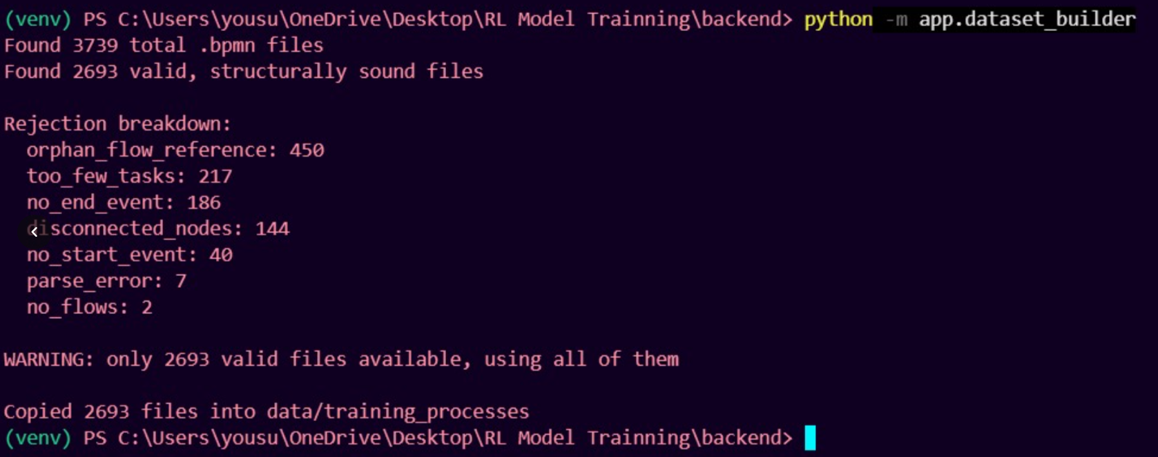

File - app/dataCleaning/dataset_builder.py

- The were different languages used in files. So, all were standardized to English language. Using following python packages

- Google Translate API
- Argostranslate
File - app/dataCleaning/translator.py
- The raw dataset carries process topology only, there were no durations, costs, or branch probabilities.
- Resource was assigned randomly from a fixed pool (Officer, Clerk, Manager, Analyst, or System) each with its own hourly rate and unit currency.
- Duration drawn from a random range depending upon resource type. 0.1 to 1hrs for systems handled task and 1 to 8hrs for human handled task.
- Cost was computed as duration x per hourly rate
- Branch probabilities normalized to sum to 1.0.
File - app/dataCleaning/synthetic_metrics.py
- Converted to our target schema, that is (CMS) JSON.
File - convert_to_target_schema.py
- Build final dataset Train (2393) / Eval Split (300)
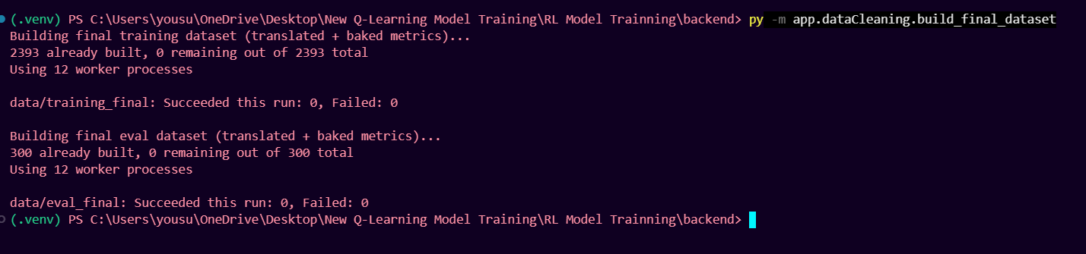
File - app/dataCleaning/build_final_dataset.py

2.0 Training Process

2.1 State Space
A process's state is encoded as a tuple: (time_bucket, cost_bucket, elig 1 , elig2 , ..., elig10).
- time_bucket / cost_bucket ∈ {low, medium, high} — the process's current total time/cost bucketed against configurable cutoffs
- Ten binary eligibility bits, one per heuristic — whether that heuristic's detector currently finds at least one applicable candidate on this process
That gives up to 3 × 3 × 210 = 9,216 possible states, though only a fraction are ever actually reached during training or inference.
File - app/rl/state_builder.py

2.2 Action Space
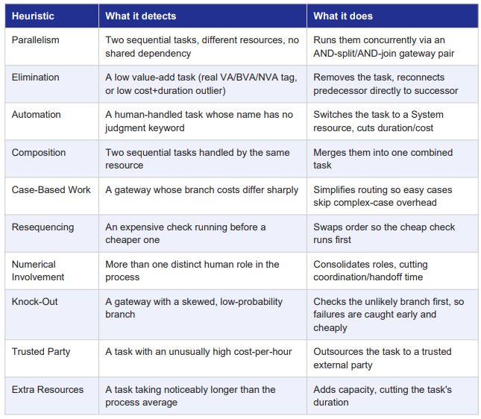
File - app/heuristics/registry.py

2.3 Environment & Reward Function
ProcessRedesignEnv exposes a standard Gym-style reset()/step(action) interface. Each step:
- Rejects the action outright (reward −1.0) if it isn't currently eligible
- Applies the corresponding heuristic executor; rejects (reward −1.0) if execution fails for a structural reason.
- Computes the reward from the resulting time/cost change.
- Rejects the step (treats it as if it never happened) if the reward is implausibly negative, beyond a small noise tolerance — this catches heuristic/parsing edge cases rather than genuine trade-offs.
- Otherwise commits the new process state. The episode ends once no heuristic remains eligible, or a step limit is reached.
File - app/rl/environment.py

2.4 Q-Learning Agent
Off-policy temporal-difference control, ε-greedy action selection during training:
Q(s,a) ← Q(s,a) + α × (reward + γ × max a' Q(s',a') - Q(s,a)) Hyperparameter Value
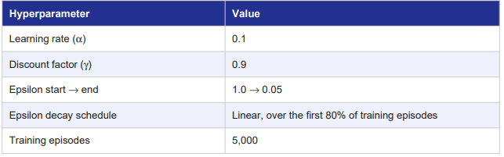
File - app/rl/q_learning_agent.py

2.5 Training Pipeline
Each of the 5,000 episodes:
- Picks one random process file from the training corpus (2,393 JSON files).
- Resets a fresh environment on it and computes its initial state.
- Repeatedly chooses an action via ε-greedy selection, steps the environment, and updates the Q-table with the observed reward — until no heuristic remains eligible.
- Logs a rolling average reward (last 500 episodes) and current Q-table size every 500 episodes, so convergence can be watched as it happens.
The finished Q-table (a plain Python dict, on the order of a few thousand (state, action) entries) is pickled to app/rl/model/trained_q_table_target_schema.pkl — the exact file the live backend loads at startup and never modifies again.
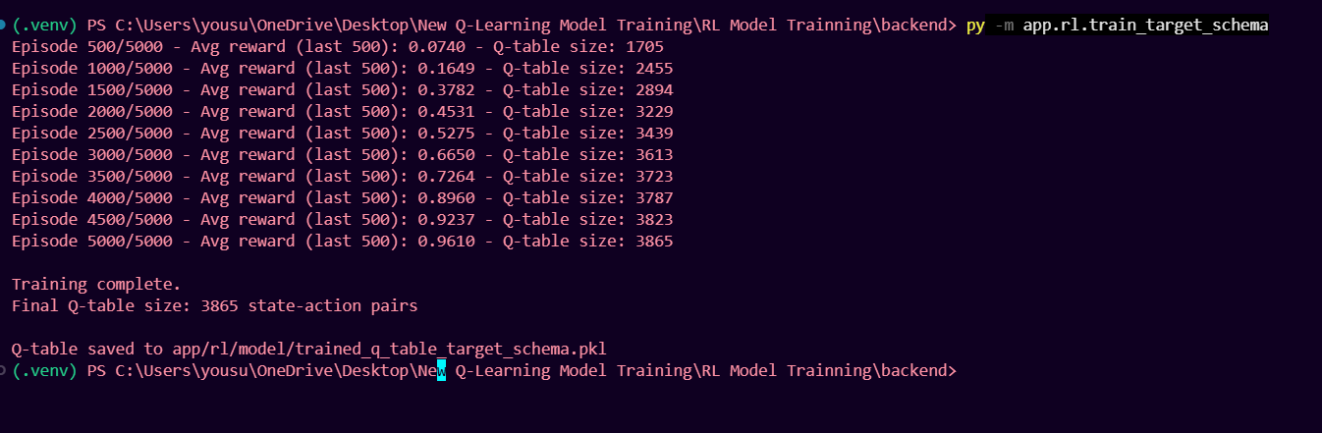

3.0 Live Inference Pipeline

3.1 Request Handling
The endpoint accepts a process in the Digital Twin SaaS's relational JSON schema, in one of two shapes: a bundle ({process, subprocesses}, used by the live frontend, with every referenced subprocess pre-fetched) or a flat shape (the process dict directly, for local testing, falling back to on-disk cached subprocess files).
File – main.py

3.2 Parsing
target_schema_parser.py builds the internal process graph one of two ways: if the SaaS supplied usable BPMN XML, that XML gives the topology and is enriched with the real relational data; otherwise (the XML generator is unreliable server-side) the graph is reconstructed directly from the relational process_task[]/gateways[] data using an order-and-jump heuristic. Subprocess references are resolved recursively and rolled up into a single frozen node.
File - app/target_schema_parser.py

3.3 AS-IS Analysis
Before any redesign happens, a full analysis snapshot is taken: Cycle Time, Theoretical Cycle Time, Cycle Time Efficiency (both from app/utils/metrics_calculator.py), the Critical Path (forward/backward CPM pass, from app/utils/critical_path.py), the RACI matrix, a cost breakdown (process / rework / waiting), and a per-task time/cost table.
File - app/rl/inference.py (_analysis_snapshot)

3.4 Redesign Loop
At each step, every currently eligible heuristic is tried in order of its learned Q-value, highest first. If the best action's actual resulting improvement falls below a minimum threshold, it is rolled back and the next-best action is tried instead — continuing until one clears the threshold or every eligible action has been exhausted for that step. Each applied step is recorded with a plain-language explanation of why it was chosen, the before/after time and cost, and the full ranked list of Q-values the agent considered at that decision point. The loop stops once no remaining action clears the improvement bar, or a step limit is reached
File - app/rl/inference.py (_run_redesign)

3.5 TO-BE Analysis & Response
The same full analysis snapshot is recomputed on the final redesigned process, and the response packages both snapshots, the overall time/cost reduction percentages, the full step-by-step trace, and a descriptive block covering the algorithm, state/action space, reward function, and hyperparameters — everything the frontend's six report tabs (Flow Analysis, Critical Path, RACI Matrix, BPMN Diagram, Redesign Trace, RL Details) render directly from
File - app/rl/inference.py
Screenshots
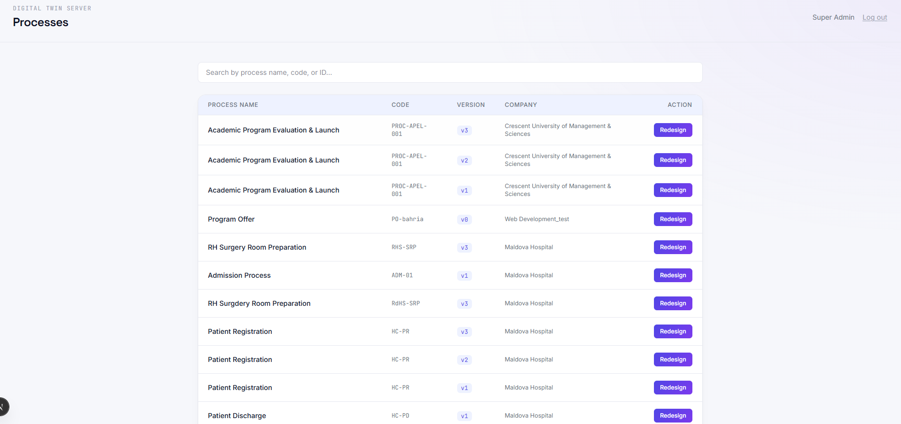

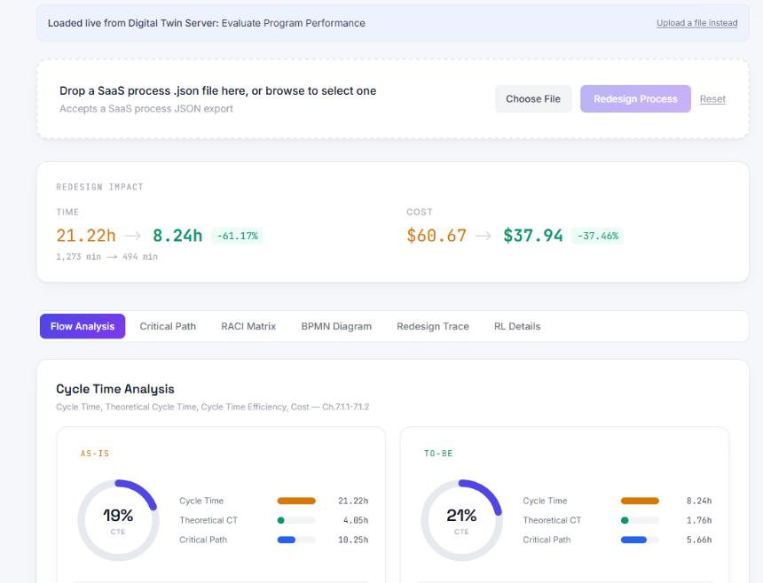

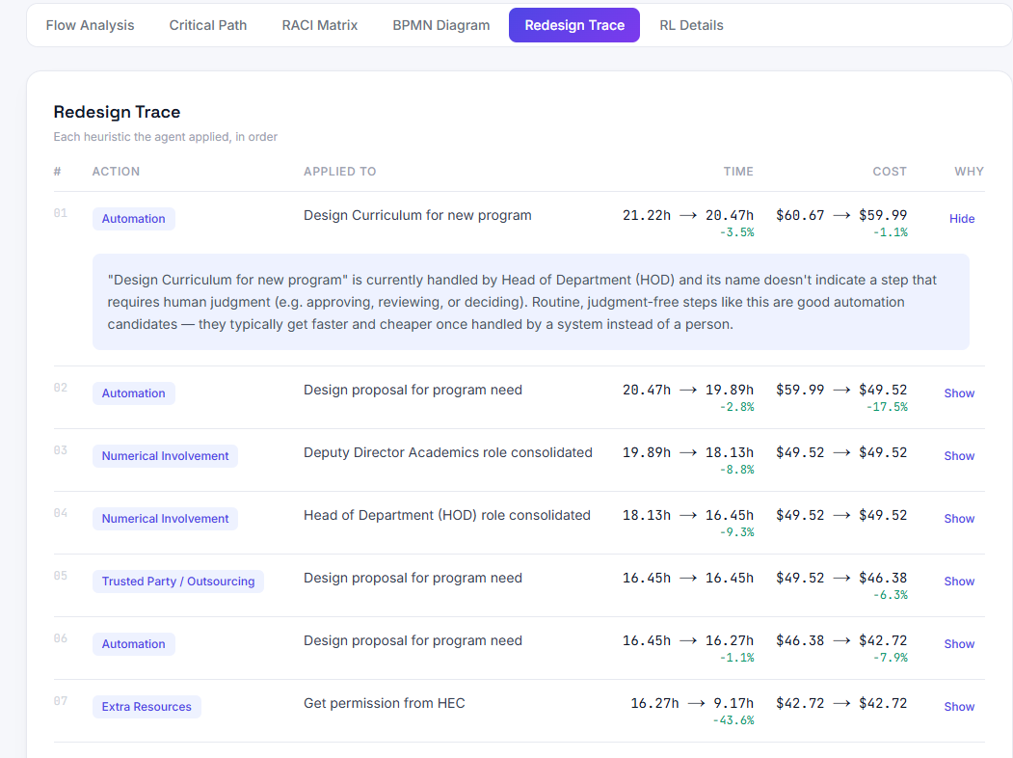

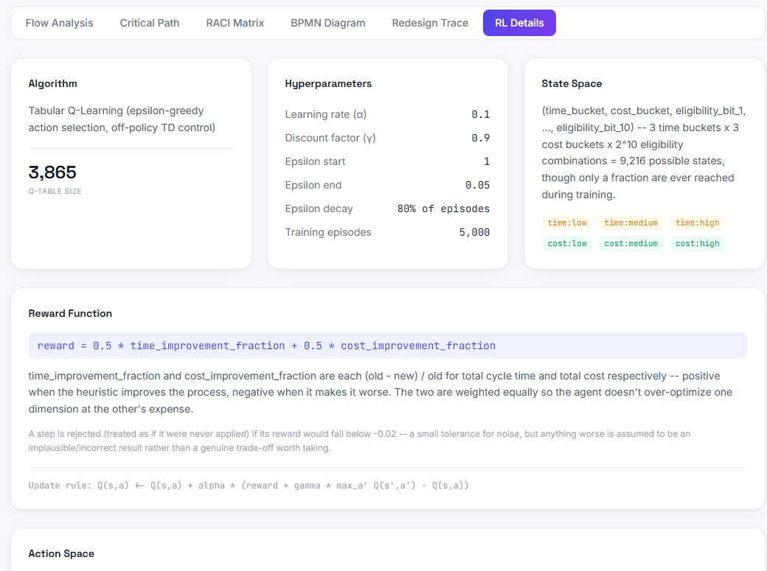

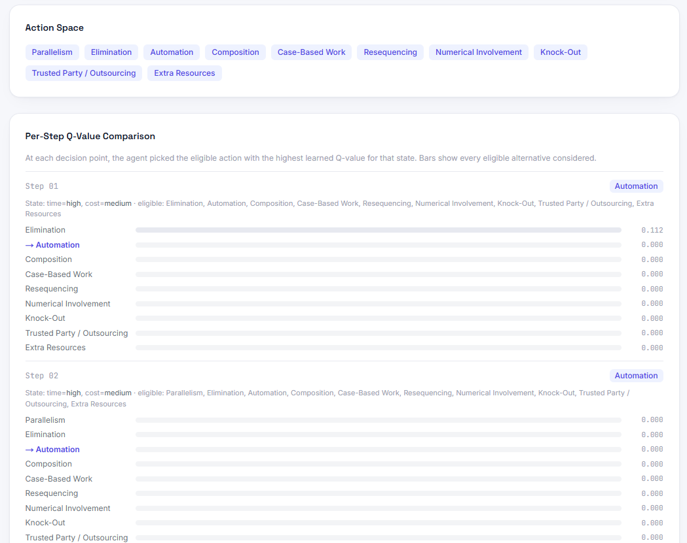

4.0 Project Github Link

Link - https://github.com/ameeryousuf/Business-Process-Redesign---Model-Training-

