ITM University Gwalior
School of Computing and Intelligent Systems
Project-Based Learning (PBL)
Mini Project Report

Course: Data Analytics Using Python
Course Code: CSL0312
Program: B.Tech. CSE (Artificial Intelligence & Machine Learning)
Semester: III Section: F
Academic Session: July–Dec 2026
Project Details
Project Title: Energy Consumption and Sustainability Analytics
Domain (as per Section 6): Data Analytics / Energy Sustainability
Team Leader Name & Roll No.: S.Amee Satsangi – BETN1AI25206
Team Member Name & Roll No.:
Team Member Name & Roll No.:
Faculty Mentor: DR. Sanjay Jain Professor, Dept. of CSA, SOET,
ITM University, Gwalior
Date of Submission: 16-10-2026

Table of Contents
Section No. | Section Title (lecturer’s format)
1 | Introduction & Problem Statement
2 | Dataset Description & Source
3 | Data Cleaning & Preprocessing
4 | Exploratory Data Analysis (EDA)
5 | Data Visualization & Observations
6 | Statistical Analysis (Basic)
7 | Key Insights & Interpretation
8 | Conclusion & Future Scope
9 | References
10 | AI Tool Usage Declaration
11 | Project Links & Deliverables
12 | Report Structure Checklist (Section 8 Compliance)
13 | Declaration by Student(s)
14 | For Faculty Use Only — PBL Final Report Evaluation

1. Introduction & Problem Statement

1.1 Introduction
Electricity is part of nearly every household activity, from lighting and cooking to heating, cooling, and using electronic devices. However, electricity use is not the same at every hour or in every season. Looking at recorded readings over time can help us understand when demand is usually higher, how consumption changes from day to day, and which measurements tend to move together. Data analytics provides a practical way to turn a large collection of readings into summaries that are easier to understand.
This project, Energy Consumption and Sustainability Analytics, studies the Individual Household Electric Power Consumption dataset from the UCI Machine Learning Repository. The source dataset contains measurements recorded at approximately one-minute intervals for a household in Sceaux, France. The notebook focuses on the period from 1 December 2009 to 26 November 2010. It uses Python libraries such as Pandas, NumPy, Matplotlib, and Seaborn to clean the data, calculate summary statistics, group readings by time, and create visualisations. An interactive Streamlit dashboard is also included in the project files.

1.2 Problem Statement
The main problem is that raw minute-level electricity readings are too detailed to interpret easily without preparation and analysis. The project therefore organises the readings and answers practical descriptive questions: What is the average active power? Which hour has the highest average use? How does average use differ by weekday? How do estimated monthly energy totals compare? What do the sub-metering values and correlation heatmap show?

1.3 Objectives and Scope
- Understand the structure and measurement units of the source dataset.
- Prepare date and time fields, handle missing readings, and remove duplicate timestamps where present.
- Explore hourly, daily, weekday, monthly, and sub-metering patterns.
- Summarise the measurements with descriptive statistics and a correlation heatmap.
- Present findings using notebook charts and an interactive dashboard, while stating the limits of the analysis.

1.4 Why the project matters
The project demonstrates how everyday electricity data can be made more useful through cleaning, aggregation, and visual communication. The results may help a reader decide which time periods are worth monitoring, but they do not prove the cause of a peak or show that every household behaves in the same way. The analysis is descriptive rather than a forecasting or appliance-identification system.
The project focuses on understanding observed consumption patterns using the available measurements; it does not infer appliance identities or generalise one household’s results to all homes.

2. Dataset Description & Source

2.1 Dataset source and overview
The project uses the Individual Household Electric Power Consumption dataset. The original public dataset covers December 2006 to November 2010 and records electricity-related measurements for one household in Sceaux, France. The notebook loads a semicolon-separated compressed text file and converts the question mark character (?) into a missing value. The notebook’s initial loaded shape is 2,075,259 records and 9 columns.
Required item | Project detail
Dataset Name | Individual Household Electric Power Consumption
Source / Organization | UCI Machine Learning Repository
Dataset URL | https://archive.ics.uci.edu/dataset/235/individual+household+electric+power+consumption
Dataset type | ☑ Public ☐ Private ☐ Self-Collected
Original records | 2,075,259
Original attributes | 9 columns
Selected period | 1 December 2009 – 26 November 2010
Selected rows | 519,663
Quality requirement | ☑ More than 500 records and 5 attributes; missing readings documented and partially interpolated.

2.2 Description of attributes
Column | Meaning | Unit / note
Date | Date of observation | Day-first date format in source
Time | Time of observation | Time of day
Global_active_power | Active power consumed by the household | kW
Global_reactive_power | Reactive power measurement | kW as labelled in source data
Voltage | Average voltage measurement | V
Global_intensity | Current intensity | A
Sub_metering_1 | First sub-metering channel | Wh per minute reading
Sub_metering_2 | Second sub-metering channel | Wh per minute reading
Sub_metering_3 | Third sub-metering channel | Wh per minute reading

2.3 Initial inspection output
df = pd.read_csv(
'/content/household_power_consumption.txt.zip',
sep=';',
na_values=['?'],
low_memory=False
)
print(df.shape)
Output recorded
The dataset has been loaded successfully!
Number of rows and columns: (2075259, 9)
The dataset has one row for each recorded time point and includes seven measurement columns in addition to Date and Time. The selected period contains close to one year of observations, but it does not include the full month of November 2010. This matters when comparing monthly totals.

3. Data Cleaning & Preprocessing

3.1 Loading and missing-value recognition
The notebook reads the source file with a semicolon separator because the original text data uses semicolons between fields. The `na_values=['?']` option converts question marks into missing values instead of treating them as normal text. This is important because the measurement columns need to be numeric for averages, totals, correlations, and charts.
df = pd.read_csv(
'/content/household_power_consumption.txt.zip',
sep=';',
na_values=['?'],
low_memory=False
)
df.info()
df.isnull().sum()
output summary
Initial loaded shape: (2,075,259, 9)
Missing values in each measurement column: 25,979
Date and Time: no missing values reported in the initial notebook inspection.

3.2 Date conversion and period selection
The Date column is parsed with `dayfirst=True` because the source dates use day/month/year ordering. The project then selects dates from 1 December 2009 up to, but not including, 1 December 2010. Using an exclusive end date includes all available dates in November while keeping the filter easy to understand.
df['Date'] = pd.to_datetime(
df['Date'], dayfirst=True, errors='coerce'
)
df_12months = df[
(df['Date'] >= '2009-12-01') &
(df['Date'] < '2010-12-01')
].copy()
output summary
Data for our selected period is ready!
Number of rows and columns: (519663, 9)
Starting date: 2009-12-01 00:00:00
Ending date: 2010-11-26 00:00:00
Number of months covered: 12

3.3 Numeric columns and timestamp
The measurement columns are converted to numeric values so that missing data and calculations behave consistently. Date and Time are combined into a DateTime field, invalid timestamps are removed, duplicate timestamps are removed if present, and the observations are sorted in time order. The DateTime field is then used as the index for time-based resampling and interpolation.

3. Data Cleaning & Preprocessing (continued)

3.4 Limited time interpolation
The notebook fills only short internal gaps in the numerical time series. It uses time-based interpolation with a limit of five consecutive missing readings and `limit_area='inside'`. In simple terms, the method estimates a missing value from nearby valid observations only when the gap is short and is surrounded by known values. It does not fill long gaps or missing values at the beginning or end of a series.
df_clean = df_12months.set_index('DateTime').copy()
df_clean[numeric_columns] = df_clean[numeric_columns].interpolate(
method='time',
limit=5,
limit_area='inside'
)
Cleaning check | Observed result | Meaning
Selected rows | 519,663 | Rows in the selected period before indexing.
Selected columns after DateTime creation | 10 | The seven measurements plus Date, Time, and DateTime.
Missing values per measurement after selection/cleaning | 17,631 | Missing readings remain after restricting to the chosen period.
Missing values per measurement after interpolation | 17,599 | Interpolation filled 32 missing values per measurement column.
Non-missing count in final summary | 502,064 | Statistics are calculated from available readings.

3.5 What was and was not changed
- Date parsing and timestamp preparation were performed because time-based analysis requires consistent date/time values.
- Duplicate timestamps were checked and removed according to the notebook workflow.
- Short internal gaps were interpolated, but missing readings were not completely eliminated.
- The notebook does not apply a formal outlier-removal rule, category encoding, or feature scaling. These steps are not claimed in this report.
- Summary statistics use available non-missing values, so the remaining missing data should be kept in mind when interpreting the results.
Output recorded
Missing readings after filling short gaps:
17,599 in each of the seven measurement columns.
This approach keeps the preprocessing close to the original project. A possible future improvement would be to compare the results before and after interpolation or to document a separate strategy for long gaps.

4. Exploratory Data Analysis (EDA)

4.1 Purpose of EDA
Exploratory Data Analysis is used to become familiar with the cleaned data before drawing conclusions. In this project, EDA focuses on the level of active power, changes over time, weekday and hourly differences, estimated monthly energy, the three sub-metering channels, and relationships between numerical measurements.

4.2 Main analyses performed
Analysis | Method used | Question answered
Summary statistics | `describe()` and basic calculations | What are typical values and how widely do readings vary?
Hourly trend | Resample active power to hourly means | How does average power change over time?
Daily trend | Resample active power to daily means | How much does the daily average fluctuate?
Weekday comparison | Group by weekday and calculate mean | Which weekday has the highest/lowest average?
Hour-of-day profile | Group by hour from 0 to 23 | Which hour has the highest/lowest average power?
Monthly energy estimate | Sum active-power readings by month and divide by 60 | How do estimated monthly totals compare?
Sub-metering totals | Monthly sum and conversion from Wh to kWh | How do the three measurement groups compare?
Correlation | Pearson correlation matrix and heatmap | Which numerical variables move together linearly?

4.3 Example: hourly and weekday analysis
df_clean['Hour'] = df_clean.index.hour
hourly_pattern = df_clean.groupby('Hour')[
'Global_active_power'
].mean()
peak_hour = hourly_pattern.idxmax()
off_peak_hour = hourly_pattern.idxmin()
output
Peak consumption hour: 20:00
Off-peak consumption hour: 04:00
df_clean['Day'] = df_clean.index.day_name()
weekly_consumption = df_clean.groupby('Day')[
'Global_active_power'
].mean()
output
Monday 1.06 kW | Tuesday 1.06 kW | Wednesday 1.11 kW
Thursday 1.06 kW | Friday 1.04 kW | Saturday 1.18 kW | Sunday 1.12 kW

4.4 EDA interpretation
The EDA shows that active power changes with time and is not evenly distributed across all hours or days. The grouping methods make it easier to compare like with like. These are descriptive patterns: the notebook does not include occupancy information, appliance logs, weather measurements, or a causal test that would explain why a particular period is higher.

5. Data Visualization & Observations

5.1 Hourly active-power time series
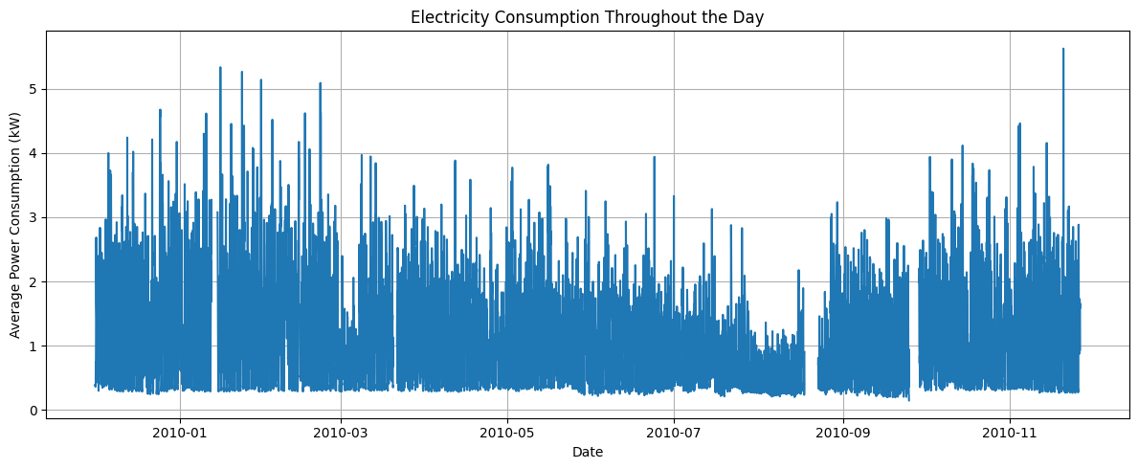
Figure 1. Hourly average active power over the selected period.
Observation: The hourly-resampled line shows changes in active power across the selected dates. The curve contains periods of higher and lower demand rather than a flat pattern. Hourly averaging reduces some minute-to-minute noise while preserving broader changes.

5.2 Daily average active power
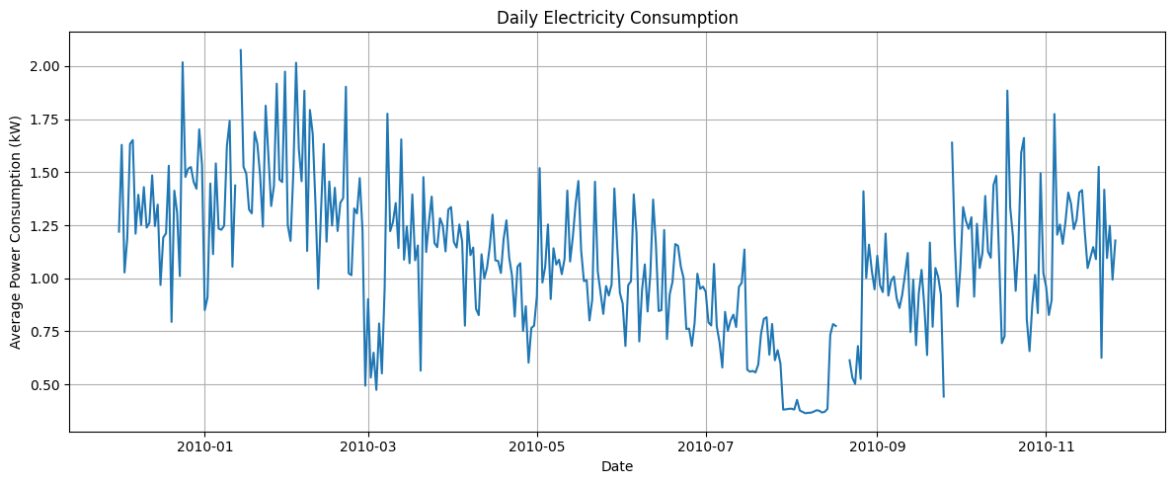
Figure 2. Daily average active power over the selected period.
Observation: The daily average also changes from day to day. This supports looking at a series of days or months rather than assuming one day is representative of the whole period. The chart does not identify the activity behind a rise or fall.

5.3 Average active power by weekday
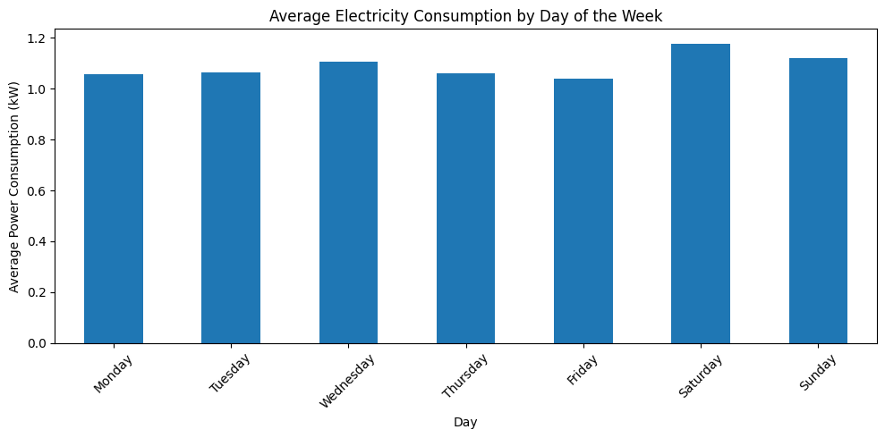
Figure 3. Average active power by weekday.
Weekday group means
Monday 1.06 | Tuesday 1.06 | Wednesday 1.11 | Thursday 1.06
Friday 1.04 | Saturday 1.18 | Sunday 1.12 (kW)
Observation: Saturday has the highest weekday average at 1.18 kW and Friday has the lowest at 1.04 kW. Wednesday and Sunday are between these values. The differences describe this selected household and period; they should not be treated as a universal weekly pattern.

5.4 Average active power by hour
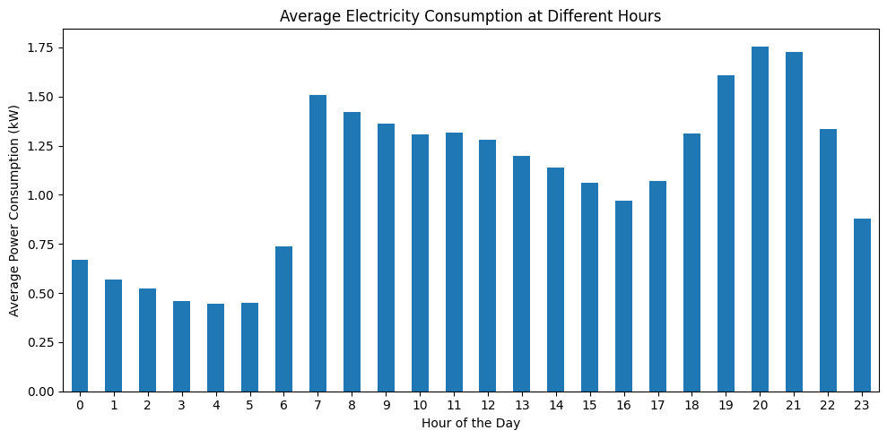
Figure 5. Average active power by hour of day.
output
Peak consumption hour: 20:00
Off-peak consumption hour: 04:00
Observation: The hour profile indicates that the highest average occurs at 8 PM and the lowest at 4 AM. A household could use this information as a starting point for monitoring demand, but the analysis cannot say which device or behaviour causes the peak.

5.5 Estimated monthly energy consumption
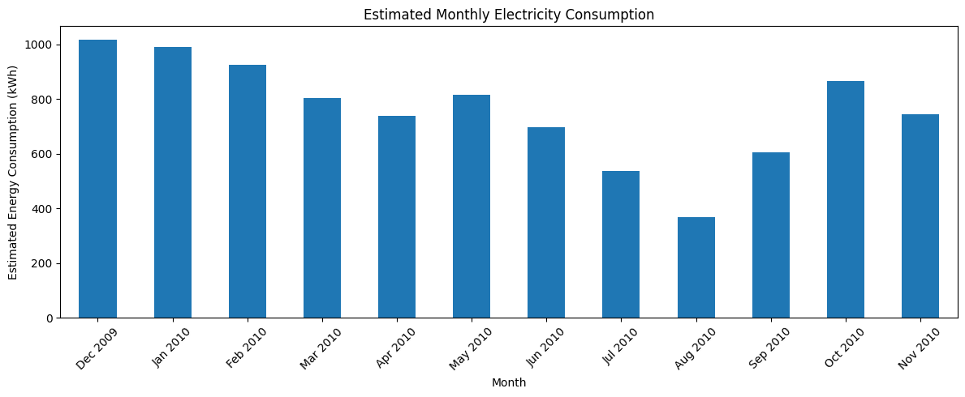
Figure 4. Estimated monthly energy consumption.
Selected monthly totals
December 2009: 1,015.16 kWh
January 2010: 989.90 kWh
February 2010: 924.62 kWh
August 2010: 368.47 kWh (lowest full-month estimate in the notebook)
Observation: The estimated monthly total is highest in December 2009 and lowest in August 2010. The totals are calculated by summing minute-level active-power values and dividing by 60. They are approximate and can be affected by remaining missing readings. November 2010 is incomplete, so its total is not directly comparable with a full month.

5.6 Sub-metering group totals
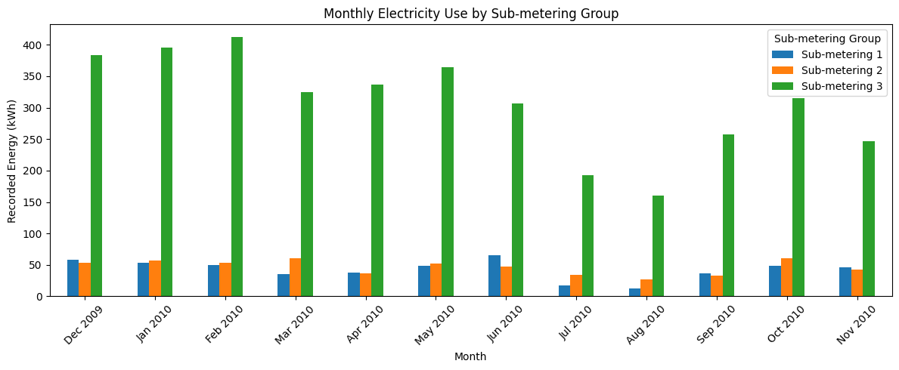
Figure 6. Monthly readings for the three sub-metering groups.
output
Sub-metering 1: 509.54 kWh
Sub-metering 2: 557.45 kWh
Sub-metering 3: 3,697.50 kWh
Observation: Sub-metering 3 has the largest reported total in the notebook, followed by Group 2 and Group 1. The report keeps the neutral group names used in the analysis and does not infer specific appliance usage from these totals.

5.7 Weekday-by-hour heatmap
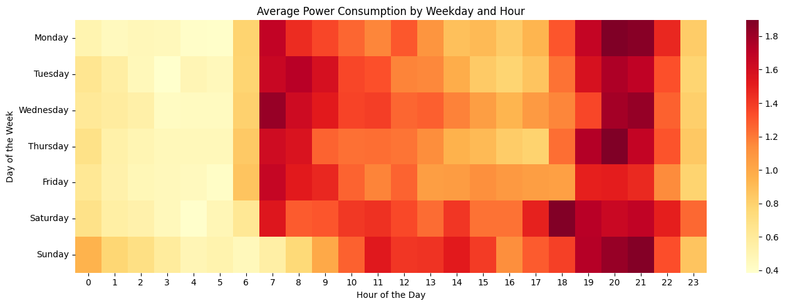
Figure 7. Average active power by weekday and hour.
Observation: The heatmap places weekday on one axis and hour on the other. Each cell represents the average active power for that weekday-hour combination. The colour intensity makes recurring higher and lower periods easier to compare than reading many separate values. Empty or unusual-looking cells should be interpreted with awareness of missing readings.

5.8 Correlation heatmap
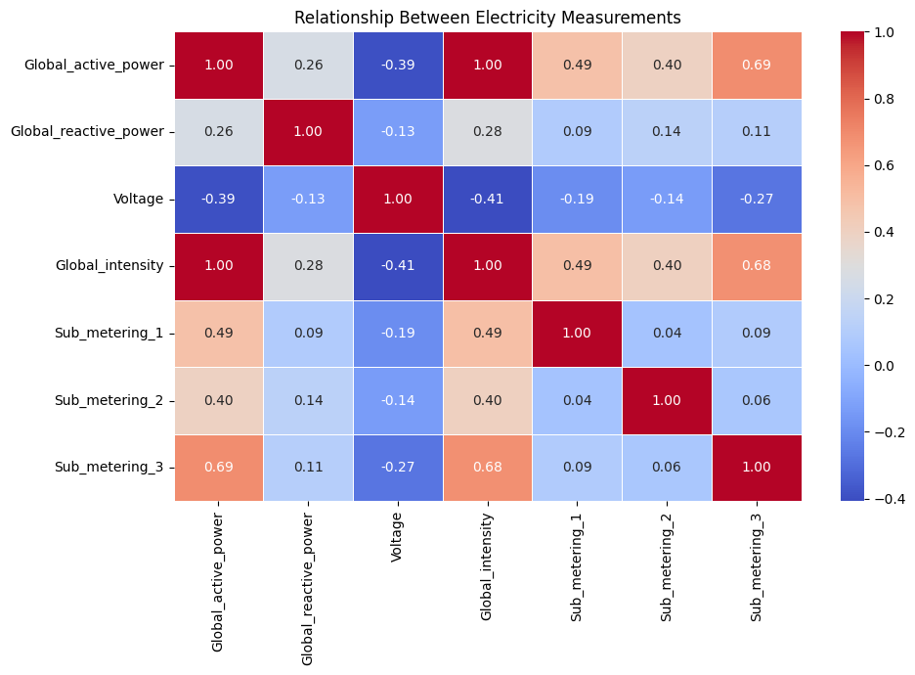
Figure 8. Correlation heatmap of numerical electricity measurements.
Observation: The heatmap displays pairwise Pearson correlations for the seven numerical measurements. Correlation values closer to +1 indicate a stronger positive linear relationship; values closer to −1 indicate a stronger negative linear relationship; values around zero indicate a weaker linear relationship. A correlation does not establish cause and effect.

5. Data Visualization & Observations (summary)

5.9 How the figures support the project
Figure | What it contributes | Care needed when interpreting
1. Hourly time series | Shows broad variation across the selected period. | Hourly averages can hide short spikes.
2. Daily time series | Shows day-to-day movement in average active power. | A daily average may hide within-day peaks.
3. Weekday bar chart | Compares mean active power across weekdays. | The result is specific to this household and period.
4. Monthly energy bar chart | Compares approximate energy estimates by month. | November 2010 is incomplete; missing readings remain.
5. Hour profile | Highlights the 20:00 peak and 04:00 low average hours. | Does not identify the cause of the pattern.
6. Sub-metering chart | Compares the three recorded sub-metering groups. | Do not assign appliance identities without supporting evidence.
7. Weekday-hour heatmap | Shows interactions between weekday and hour. | Cell averages can be affected by uneven/missing observations.
8. Correlation heatmap | Summarises linear associations between measurements. | Correlation is not causation.

5.10 Visualisation tools
The Streamlit application provides a separate interactive way to explore the analysis; the notebook remains the primary evidence for the calculations and chart outputs.
Project implementation
Libraries visible in the notebook: Pandas, NumPy, Matplotlib, Seaborn, Plotly, and Streamlit-related project files.

6. Statistical Analysis (Basic)

6.1 Descriptive statistics
Descriptive statistics summarise the centre and spread of the measurements. The notebook uses Pandas summary functions and prints the mean, minimum, and maximum of Global_active_power. The mean represents the arithmetic average, while the median is the middle value after sorting valid readings. The standard deviation describes how spread out readings are around the mean.
Statistic | Global active power | Plain-language interpretation
Valid count | 502,064 | Number of available values used for this summary.
Mean | 1.09 kW | Average active power across available readings.
Standard deviation | 0.95 kW | Readings show meaningful variation around the average.
Minimum | 0.14 kW | Lowest recorded value in the selected cleaned data.
25th percentile | 0.34 kW | One quarter of valid readings are at or below this value.
Median (50th percentile) | 0.74 kW | Half of valid readings are at or below this value.
75th percentile | 1.53 kW | Three quarters of valid readings are at or below this value.
Maximum | 9.72 kW | Highest recorded value in the selected cleaned data.

6.2 Code and recorded output
print("Average power consumption:",
round(df_clean['Global_active_power'].mean(), 2), "kW")
print("Highest power consumption:",
round(df_clean['Global_active_power'].max(), 2), "kW")
print("Lowest power consumption:",
round(df_clean['Global_active_power'].min(), 2), "kW")
Output recorded
Average power consumption: 1.09 kW
Highest power consumption: 9.72 kW
Lowest power consumption: 0.14 kW

6.3 Interpretation and limitations
The mean is greater than the median, which suggests that some higher readings pull the average upward. The maximum is much higher than the median, showing that the data includes periods of substantially higher power use. This is a useful descriptive signal, but the project does not conduct formal hypothesis tests or claim that a particular factor caused the high readings.

6.4 Sub-metering totals
Measurement group | Total reported (kWh)
Sub-metering 1 | 509.54
Sub-metering 2 | 557.45
Sub-metering 3 | 3,697.50

These are the reported totals after converting the recorded sub-metering values to kWh. They are retained as group totals without assigning specific appliances.

7. Key Insights & Interpretation
The following five insights are based on the outputs. Each insight separates the numerical result from a cautious interpretation.
1. Average active power was 1.09 kW. This gives a useful baseline for the selected household and period. It is based on available non-missing readings, not on a complete record for every minute.
2. The highest average-use hour was 20:00, and the lowest was 04:00. The household’s average active power was highest in the evening and lowest in the early morning. Monitoring these hours could help a household understand its daily pattern, but the analysis does not identify the reason.
3. Saturday had the highest weekday average (1.18 kW), while Friday had the lowest (1.04 kW). Average power differed by weekday. The result is descriptive and should not be generalised to other households without additional data.
4. December 2009 had the highest estimated monthly energy (1,015.16 kWh), and August 2010 had the lowest (368.47 kWh). The variation may be worth exploring alongside weather or household routine data in future work. The present analysis does not isolate a cause, and November 2010 is incomplete.
5. Sub-metering 3 had the largest recorded total (3,697.50 kWh). This group’s total was much larger than Group 2 (557.45 kWh) and Group 1 (509.54 kWh). The report does not claim which appliances account for these values.

How these insights could be used
- Use the evening peak as a time to observe and review high-load activities, rather than assuming a cause.
- Compare complete months when looking for seasonal differences and mark partial months clearly.
- Treat the sub-metering channels as measured groups unless a reliable source confirms appliance mapping.
- Use the dashboard as a communication aid, while returning to the notebook for the underlying calculations.
Consolidated output summary
Main findings : mean 1.09 kW; maximum 9.72 kW; peak average-use hour 20:00; lowest average-use hour 04:00.

8. Conclusion & Future Scope

8.1 Conclusion
This project used Python-based data analytics to make a large set of minute-level electricity readings easier to understand. The data was loaded from a public source, converted into usable date and time values, restricted to the selected period, and prepared for analysis. Short internal gaps were interpolated, but the report also records that missing values remain. The analysis examined hourly and daily trends, weekday averages, monthly energy estimates, sub-metering totals, descriptive statistics, and correlations between numerical measurements.
The results show that average active power was 1.09 kW, the maximum recorded active power was 9.72 kW, and the average-use profile peaked at 20:00 while reaching its low point at 04:00. Saturday had the highest weekday average in the selected period, and the estimated monthly total was highest in December 2009 and lowest in August 2010. The sub-metering totals were also uneven, with Group 3 larger than Groups 1 and 2.
The notebook charts and Streamlit dashboard support presenting these findings in a clear way. However, the project describes only one household in France. Some readings remain missing after limited interpolation, the monthly totals are approximate, and November 2010 is incomplete. These limitations mean that the results should be read as an overview of the selected data, not as a universal rule about household electricity use.

8.2 Practical recommendations
- Review the observed evening peak and look for high-load activities that can reasonably be shifted or reduced.
- Switch off lights and devices when they are not needed and consider efficient alternatives where appropriate.
- Compare full calendar months when reviewing changes in estimated energy use.
- Keep the dashboard and notebook outputs together so that visual summaries can be checked against the analysis.

8.3 Future scope
- Include data from more households to test whether the patterns are consistent across homes.
- Compare alternative missing-data strategies and report how they affect the summary values.
- Add reliable weather or occupancy-related information to explore possible explanations for changes.
- Add dashboard filters for date ranges and measurement groups, with clear notes about missing data and partial months.
- Explore anomaly detection or forecasting as a separate extension, with appropriate validation rather than presenting it as completed work.

9. References
1. Hebrail, G., & Berard, A. (2006). Individual Household Electric Power Consumption [Dataset]. UCI Machine Learning Repository: https://doi.org/10.24432/C58K54
2. UCI Machine Learning Repository. Individual Household Electric Power Consumption: https://archive.ics.uci.edu/dataset/235/individual+household+electric+power+consumption
3. pandas development team. pandas documentation: https://pandas.pydata.org/docs/
4. Matplotlib Development Team. Matplotlib documentation: https://matplotlib.org/stable/
5. Streamlit, Inc. Streamlit documentation. https://docs.streamlit.io/

10. AI Tool Usage Declaration
As required by the PBL guidelines, AI assistance is disclosed clearly. ChatGPT was used to support report organisation, improve wording, explain technical concepts in simple language, and format the project findings into a readable academic report. The saved notebook was used as the primary evidence for the code, charts, and numerical outputs included here.
AI assistance supports the presentation of the work but does not replace the student’s responsibility for understanding the code, checking the analysis, and explaining the findings during evaluation.
AI Tool Used | Purpose | Extent of Use / Section Applied
ChatGPT | Writing support, explanations, and report formatting. | Helped organise report sections, clarify the data-analysis workflow, and present notebook outputs in clear academic language.

☐ No AI tools were used in this project.
☑ AI tools were used, as detailed above.
Student confirmation: I take responsibility for understanding and verifying the work presented in this report.
Name and Signature: ______________________________________________

11. Project Links & Deliverables

GitHub Repository Link: https://github.com/ameesatsangi/energy-consumption-dashboard

Python Notebook (.ipynb) File Name: household_power_consumption_google colab project_txt_zip.ipynb

Deployed Streamlit dashboard: https://energy-consumption-dashboard-crrdzv2qcrhh9puwb68rhg.streamlit.app/

PBL Report File Name: Data_Analytics_Report

☑ GitHub repository includes code, notebook, and a PBL report and README

12. Report Structure Checklist (Section 8 Compliance)
S. No. | Report Section (as per Section 8 format) | Included (✓)
1 | Title Page | ✓
2 | Introduction & Problem Statement | ✓
3 | Dataset Description & Source | ✓
4 | Data Cleaning & Preprocessing | ✓
5 | Exploratory Data Analysis (EDA) | ✓
6 | Data Visualization & Observations | ✓
7 | Statistical Analysis (Basic) | ✓
8 | Key Insights & Interpretation | ✓
9 | Conclusion & Future Scope | ✓
10 | References | ✓

13. Declaration by Student(s)
I/We hereby declare that this Mini Project Report is our own original work, prepared using publicly available/open datasets. All sources of data, references, and AI tool assistance have been duly acknowledged. I/We understand that any instance of plagiarism in code or report will attract strict academic action, as per Section 15 of the PBL guidelines.
Team Leader Signature: _____________________________________________
Team Member Signature(s): _____________________________________________
Date: ____________________________________________________________

14. For Faculty Use Only — PBL Final Report Evaluation
Evaluation Component B — PBL Final Report Submission | Mid-Term (PBL Based): 10 Marks (Section 10 of PBL Guidelines)
Evaluation Criteria | Max Marks | Marks Awarded
Data Cleaning & Preprocessing | 2
Exploratory Data Analysis (EDA) | 2
Visualization & Observations | 2
Statistical Analysis | 2
Insights, Interpretation & Conclusion | 2
Total (out of 10) | 10
Faculty Remarks:

Faculty Mentor Signature: _____________________________________________
Date: ____________________________________________________________

