SALESFORCE PROJECT

***Time Capsule App***

**Phase 3: Data Modeling & Relationships**

**➤ Standard & Custom Objects**

* Standard objects like Users and Accounts are leveraged for authentication and basic data storage.
* Custom objects such as Capsule__c and Media__c are created to store capsule details and associated media files.
* This separation ensures structured storage and scalability for the app.

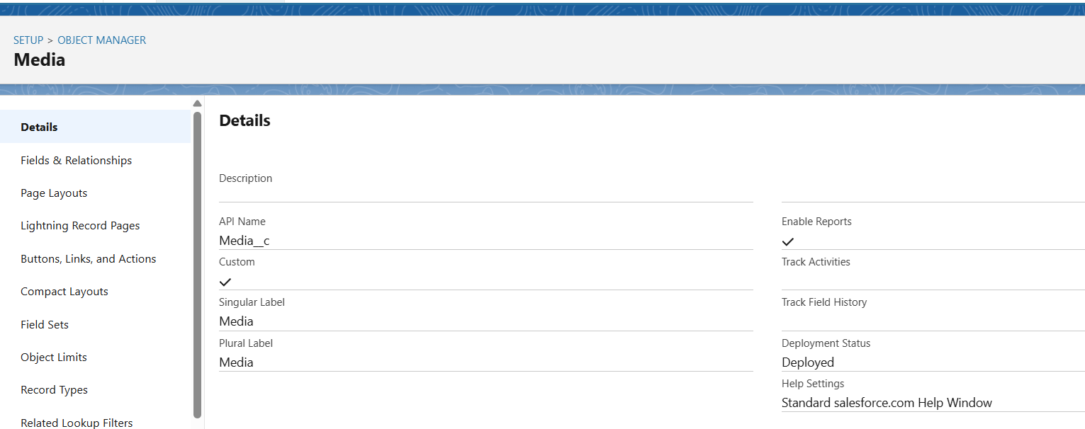

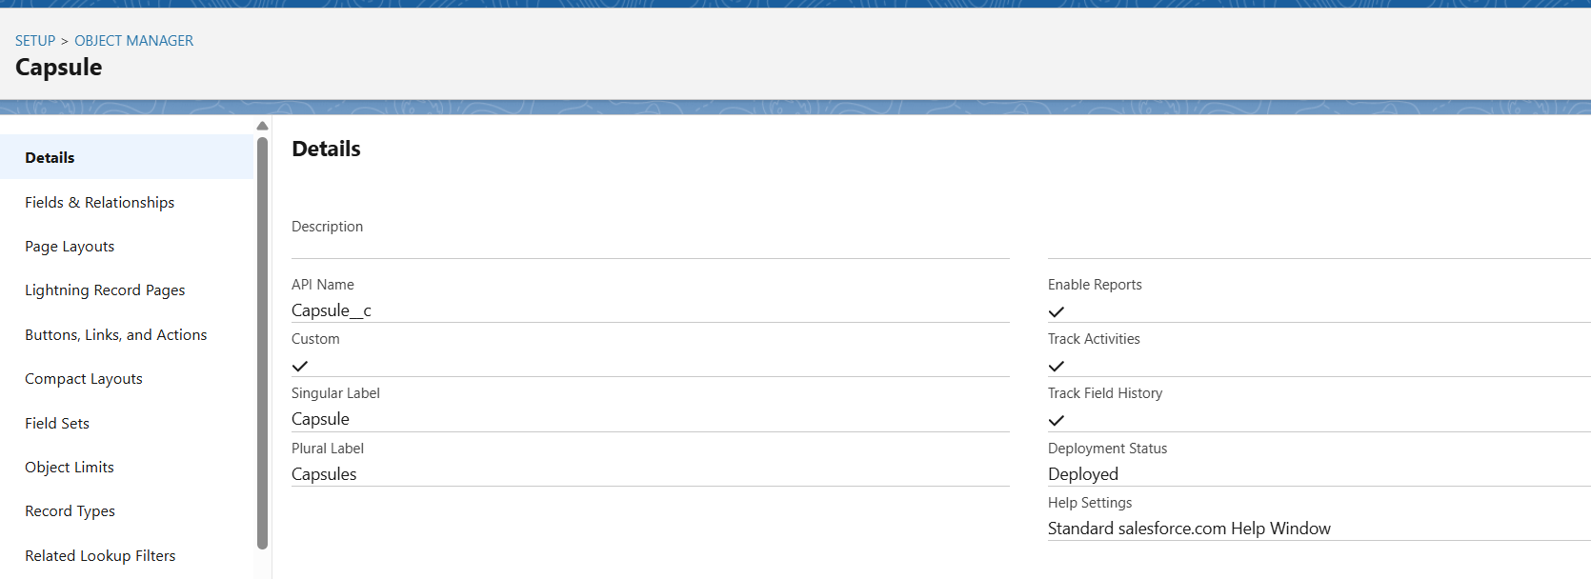

**➤ Fields**

* Capsule__c includes fields like Capsule Name, Description, Unlock Date, and Owner to store key information.
* Media__c includes Media Name, File URL, Media Type, and Linked Capsule to manage media files linked to capsules.
* Proper field types and attributes ensure data integrity and usability.

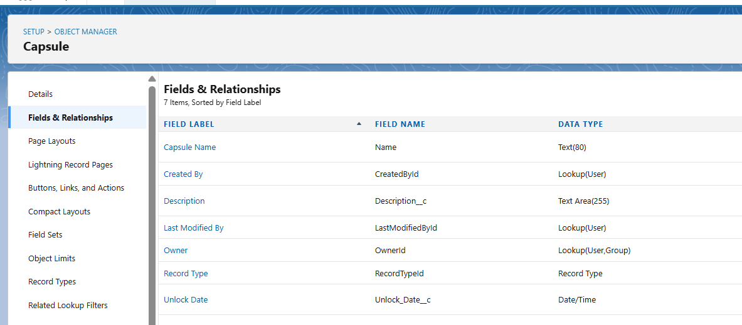

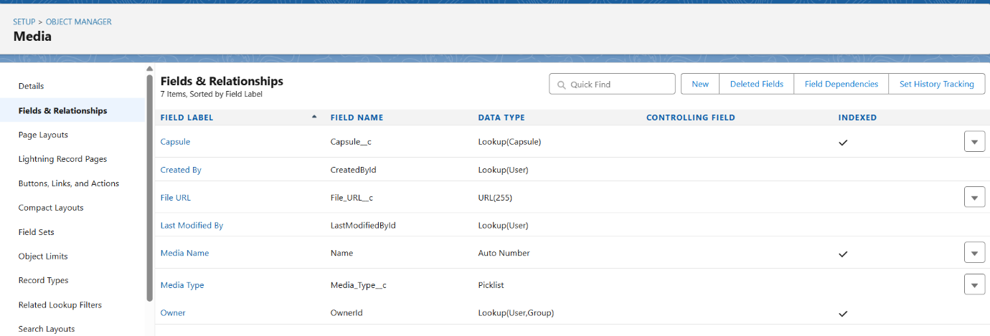

**➤ Record Types**

* Different record types allow categorization of capsules, such as **Personal Capsule** for individual use and **Shared Capsule** for teams or families.
* Record types help control page layouts and processes depending on the type of capsule.
* Profiles are assigned to ensure the correct visibility and access for each type.

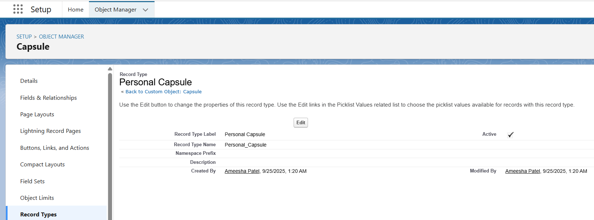

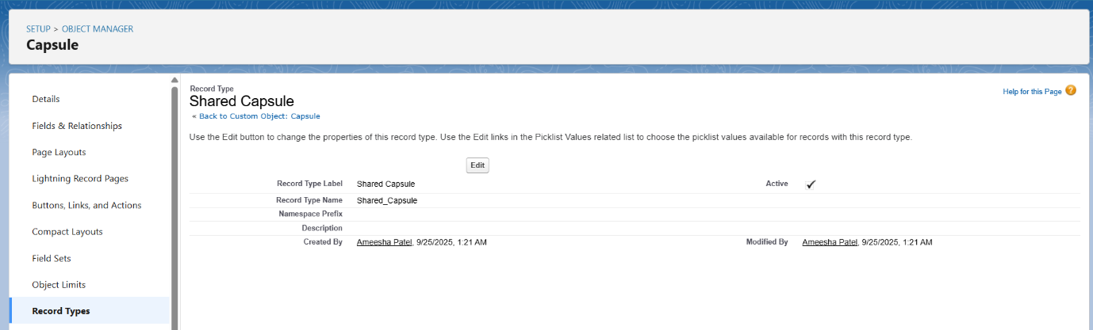

**➤ Page Layouts**

* Layouts determine how fields are displayed to users for each object.
* Capsule__c layout includes fields like **Capsule Name, Unlock Date**, and related Media__c records.
* Media__c layout shows **Media Name, Media Type**, and the attached capsule, making data entry simple and intuitive.

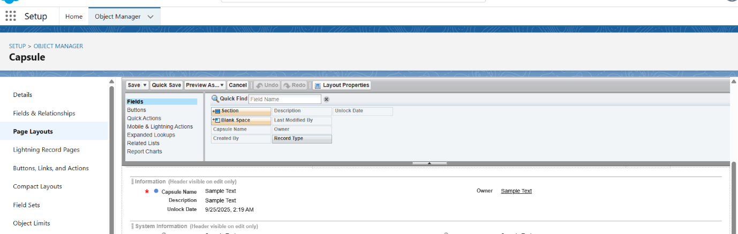

**➤ Compact Layouts**

* Compact layouts provide a quick view of key fields at a glance.
* Capsule__c shows **Capsule Name, Unlock Date, and Status**, while Media__c shows **Media Name and Media Type**.
* This improves usability in mobile and list views.

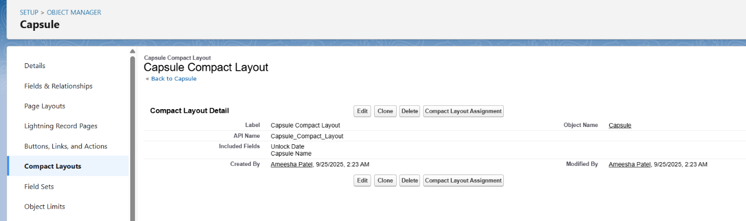

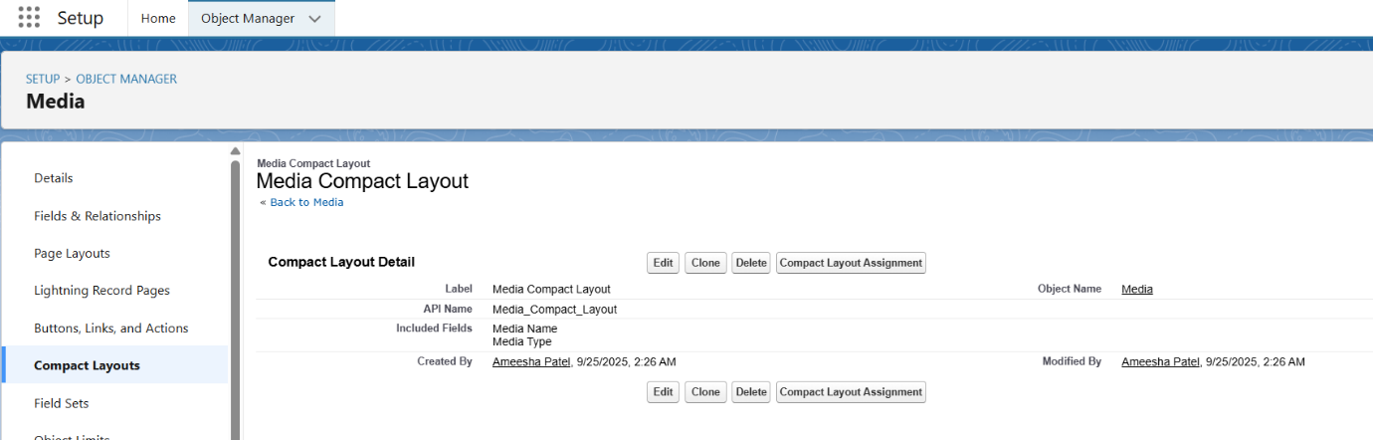

**➤ Schema Builder**

* Visual tool to see and manage objects and their relationships.
* Capsule__c and Media__c relationships are represented, making it easy to understand data connections.
* Allows drag-and-drop to visualize relationships, though existing objects appear automatically.

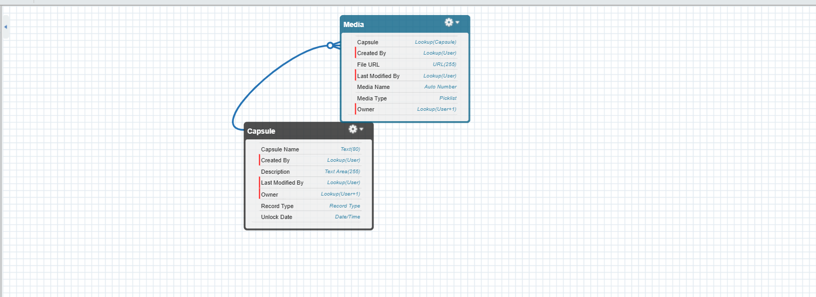

**➤ Lookup vs Master-Detail vs Hierarchical Relationships**

* **Master-Detail:** Capsule__c (Parent) → Media__c (Child), ensures media is deleted if capsule is deleted.
* **Lookup:** Optional links, e.g., Capsules to Users who can access them.
* **Hierarchical:** Mainly for User object (manager-subordinate relationships), not heavily used in this app.

**➤ Junction Objects**

* Enables many-to-many relationships, e.g., one Capsule shared with multiple Users or one Media linked to multiple Capsules.
* Uses two **Master-Detail relationships** to link Capsule__c and Media__c.
* Each CapsuleShare__c record represents a single combination of capsule ↔ user or capsule ↔ media.

