SALESFORCE PROJECT

***Time Capsule App***

**Phase 4: Process Automation (Admin)**

**➤ Validation Rules**

* These rules enforce correct data entry.
* Example: Prevent a capsule from being saved if **Unlock Date < Today’s Date**, ensuring capsules can’t be unlocked before their intended time.

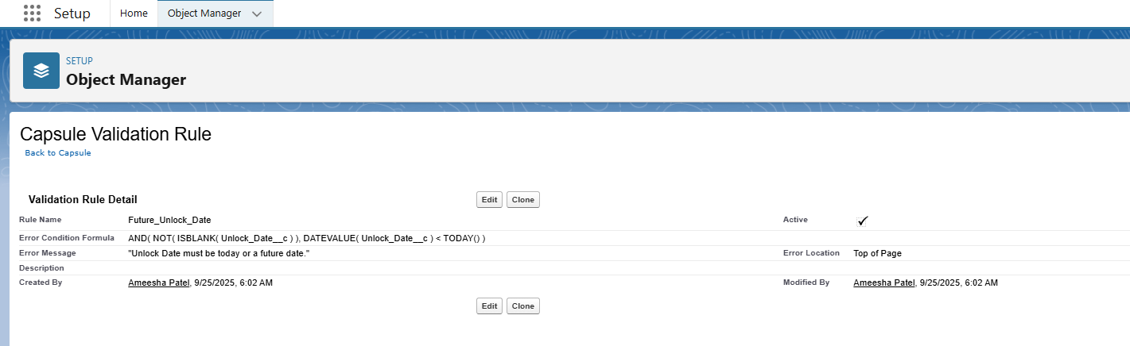

**➤ Workflow Rules**

* Automates simple IF/THEN actions.
* Example: When a capsule is created, send a confirmation email to the owner.

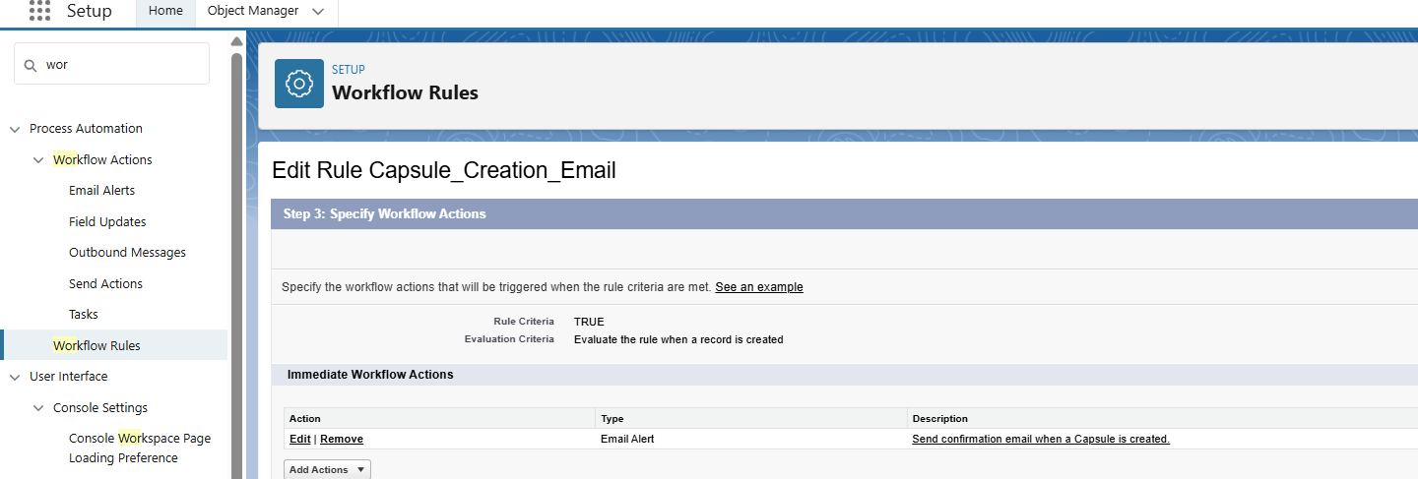

**➤ Process Builder**

* Used for **multi-step automation** across related objects.
* Example: When a capsule’s Unlock Date is reached, automatically update its status to “Ready to Unlock” and notify the owner.

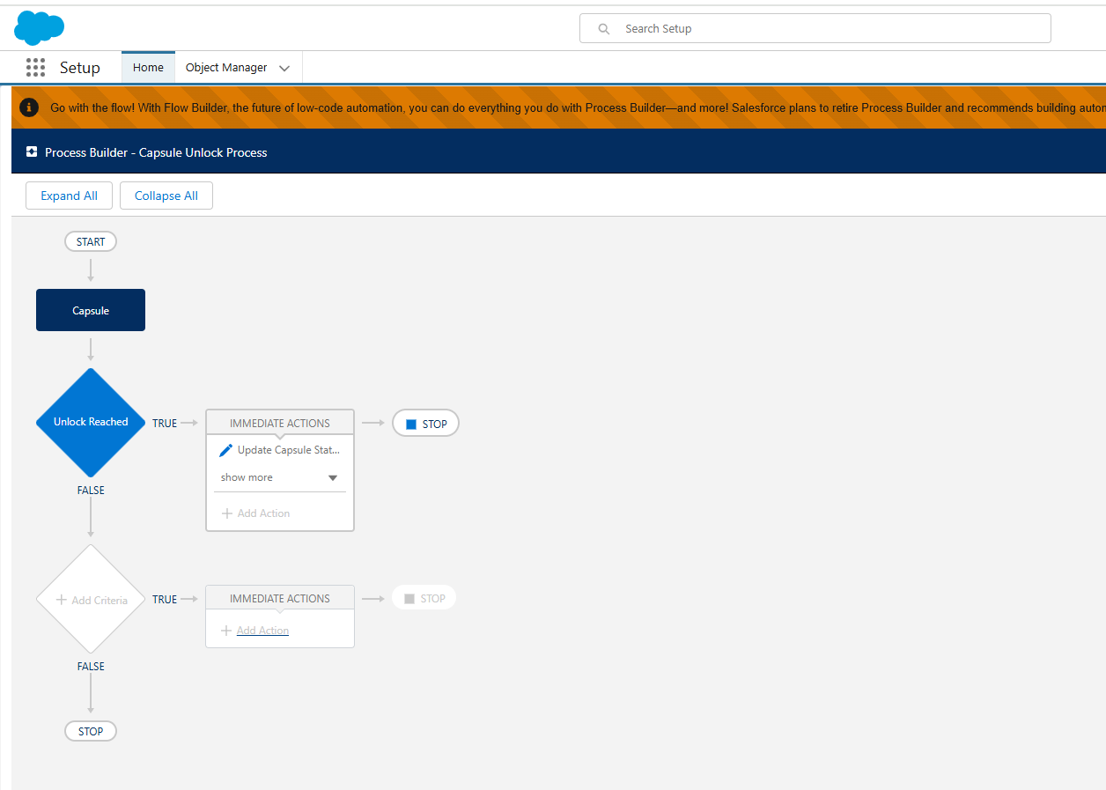

**➤ Approval Process**

* Provides a **formal review system** before actions happen.
* Example: A shared capsule requires approval from all family/group members before being locked.

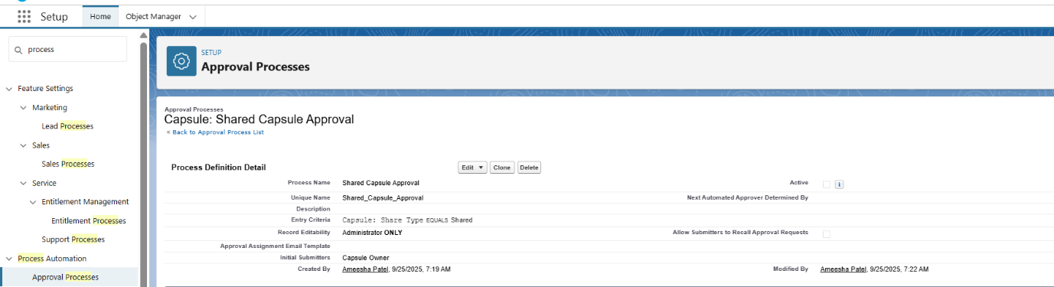

**➤ Email Alerts**

* Sends predefined emails when certain actions occur.
* Example: Notify capsule owner when media is added, or when capsule is unlocked.

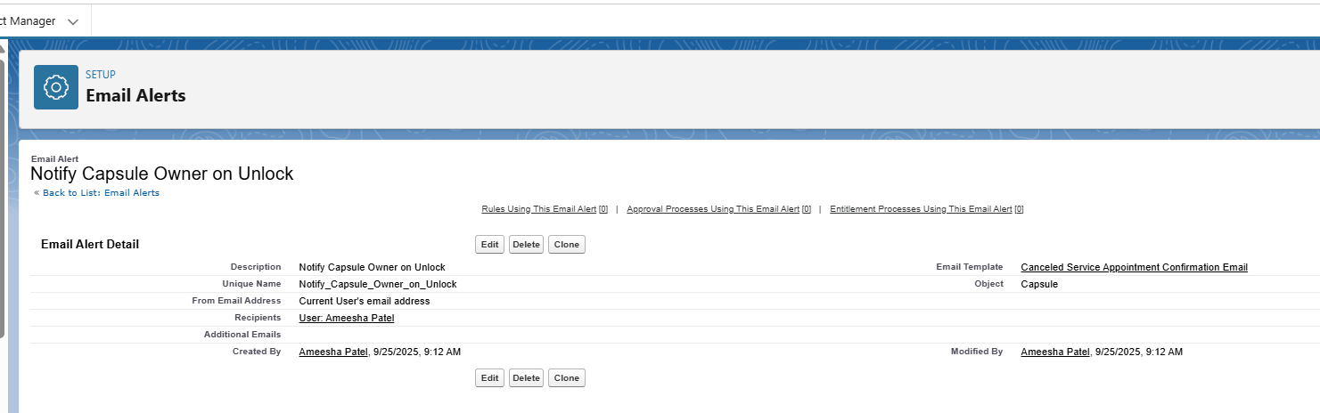

**➤ Field Updates**

* Automatically update field values based on triggers.
* Example: Change capsule status from “Locked” to “Unlocked” when unlock date is reached.

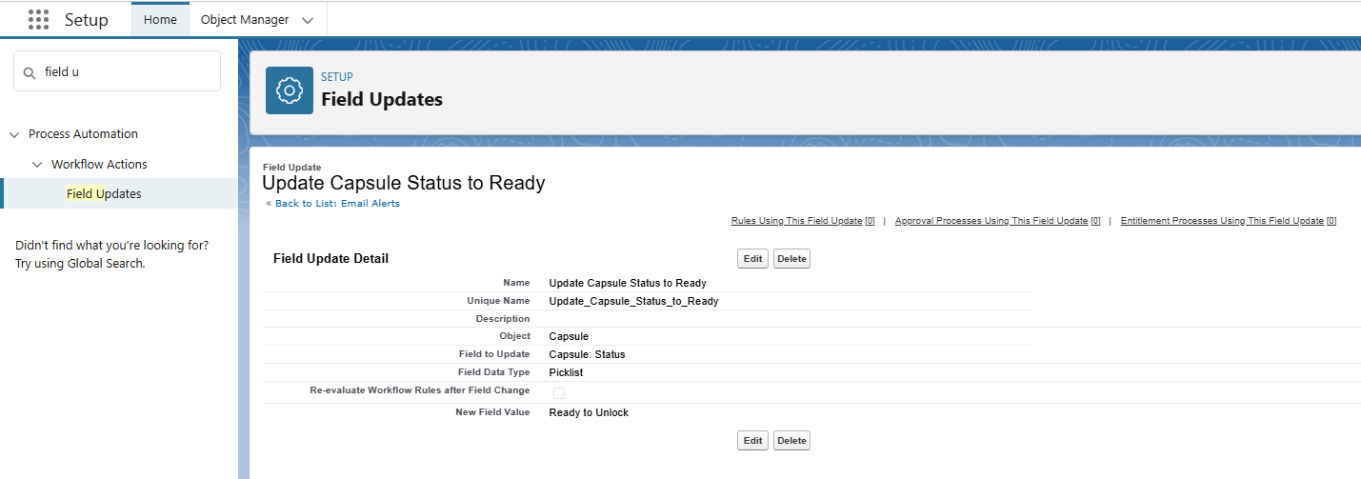

**➤ Tasks**

* Automatically assign tasks to users.
* Example: Assign a task to the owner to review capsule contents before sharing.

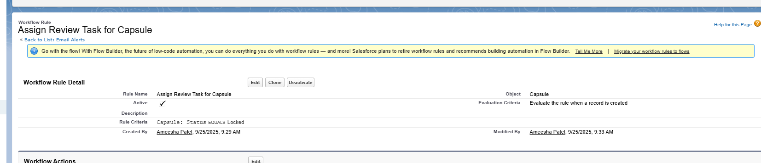

**➤ Custom Notifications**

* Push notifications inside Salesforce or to mobile app.

