SALESFORCE PROJECT

***Time Capsule App***

**Phase 5: Apex Programming (Developer)**

**➤ Classes & Objects**

* Apex classes define the structure and behavior of objects and business logic.
* Example: CapsuleManager class to handle capsule creation, media attachment, and unlock logic.
* Objects: Capsule__c and Media__c can be accessed via Apex to read, update, or create records programmatically.

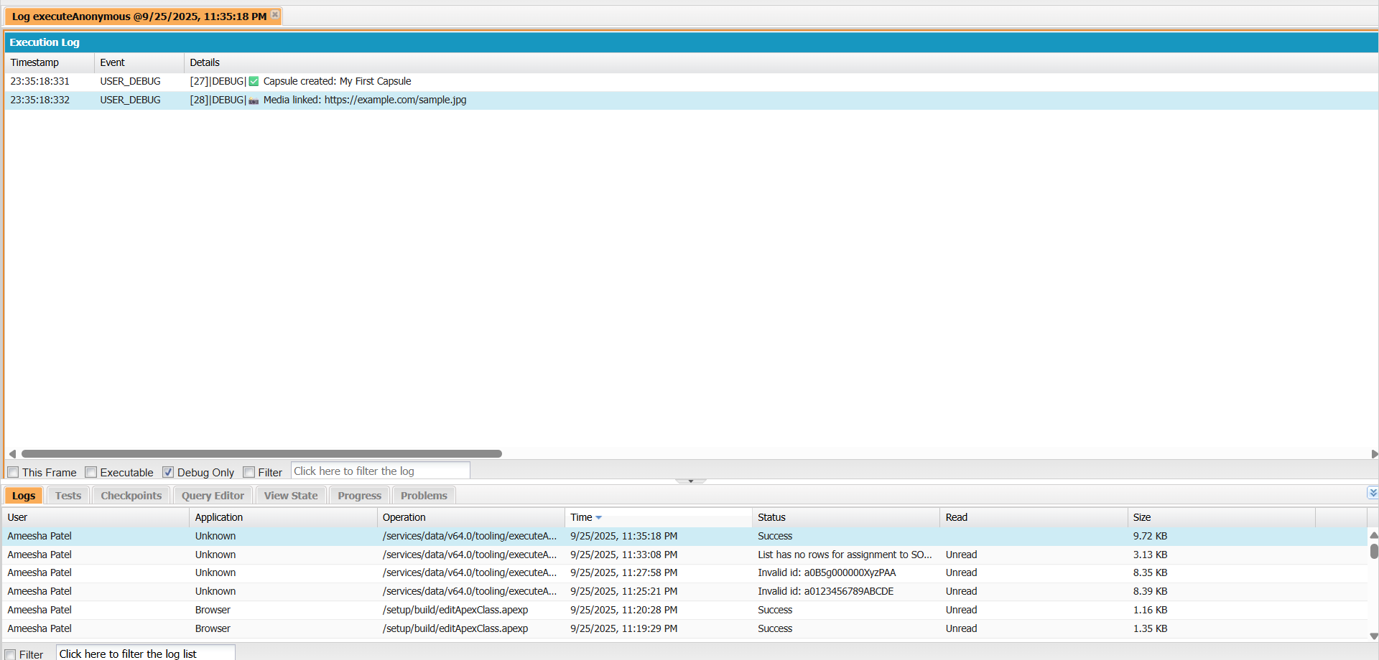

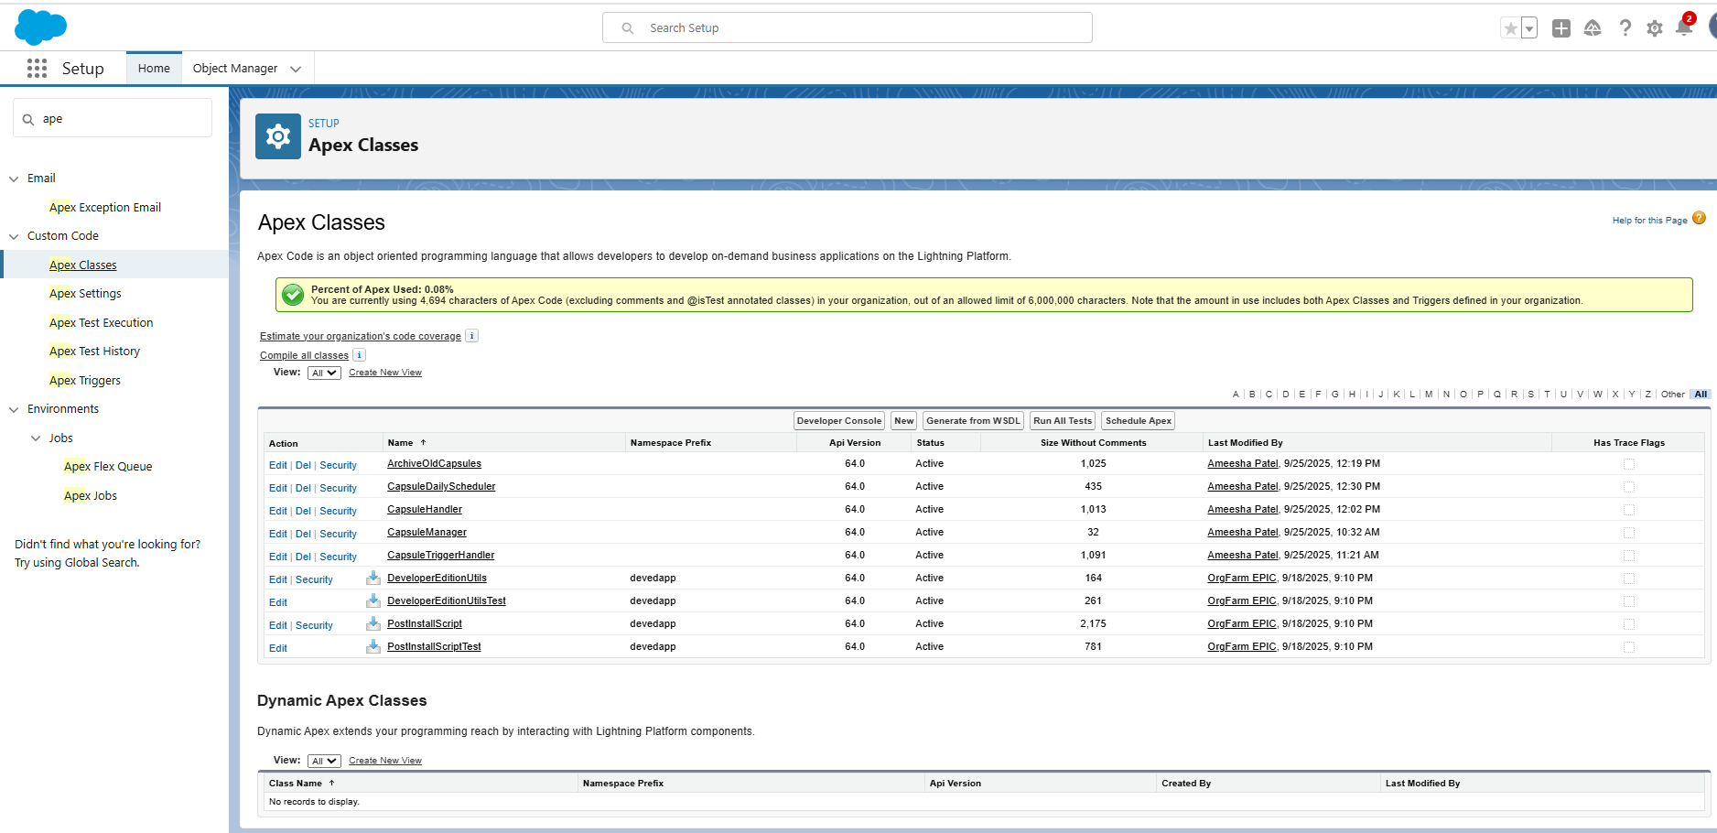

**➤ Apex Triggers (before/after insert/update/delete)**

* Triggers automatically execute Apex code on specific object events.
* Example:
  + Before Insert: Validate Unlock_Date__c before saving a capsule.
  + After Insert: Send notification or create tasks once a capsule is created.

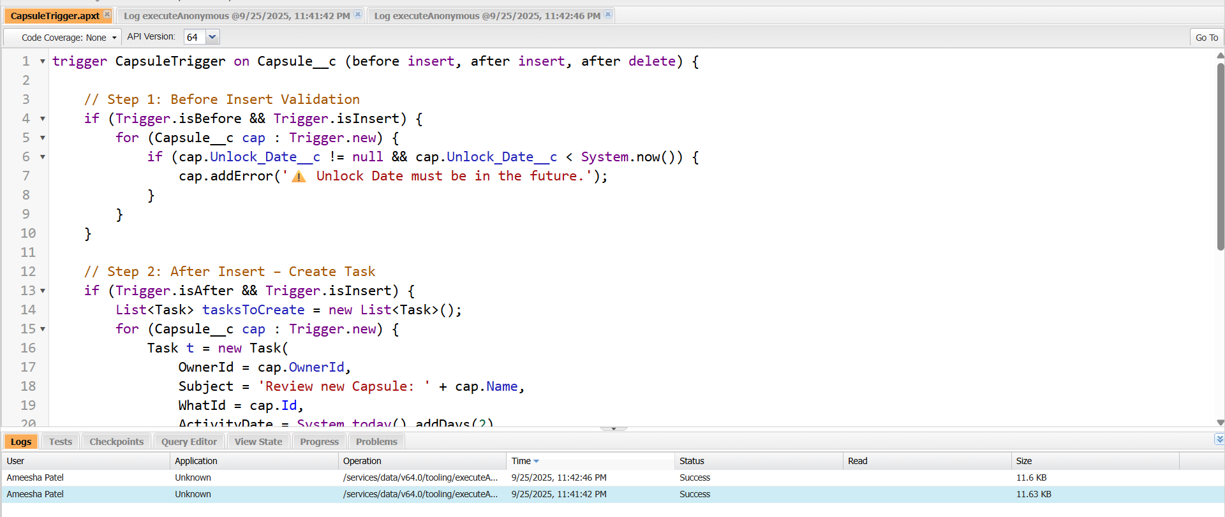

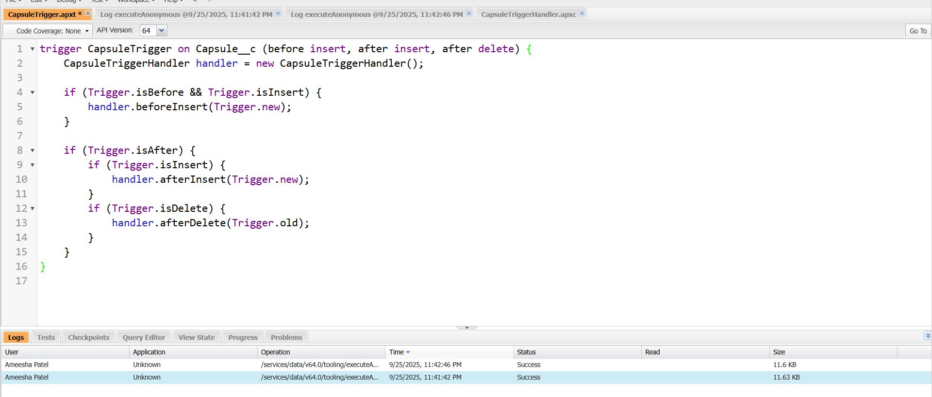

**➤ SOQL & SOSL**

* SOQL (Salesforce Object Query Language): Query specific records.
  + Example: SELECT Id, Capsule_Name__c FROM Capsule__c WHERE Unlock_Date__c = TODAY
* SOSL (Salesforce Object Search Language): Search across multiple objects and fields.
* Example: Search for a keyword in Media__c titles and descriptions. Example: Search for a keyword in Media__c titles and descriptions.

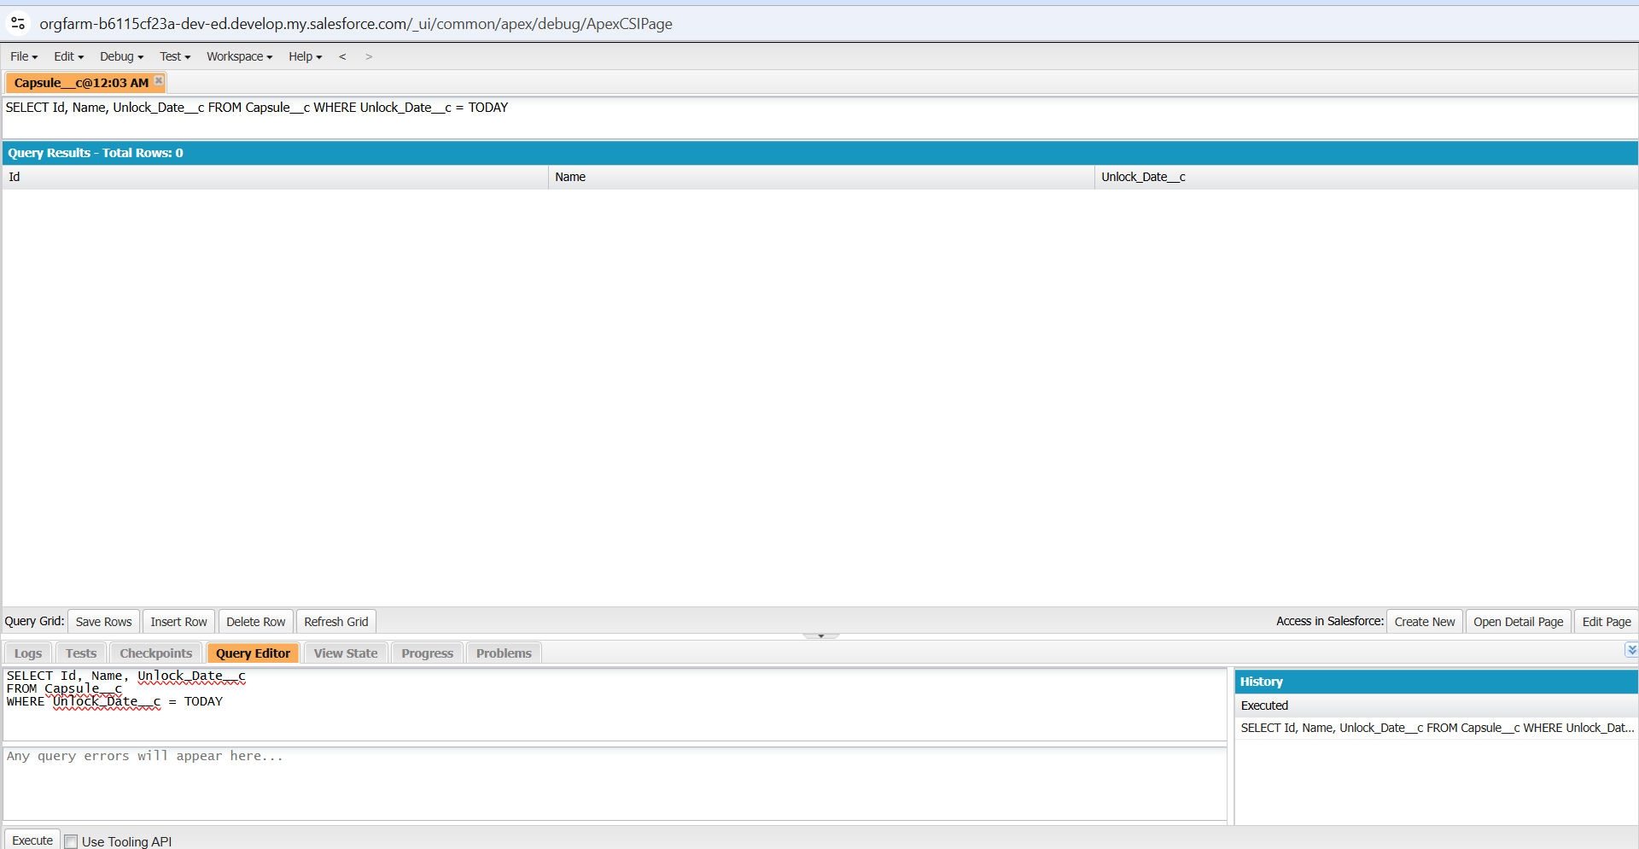

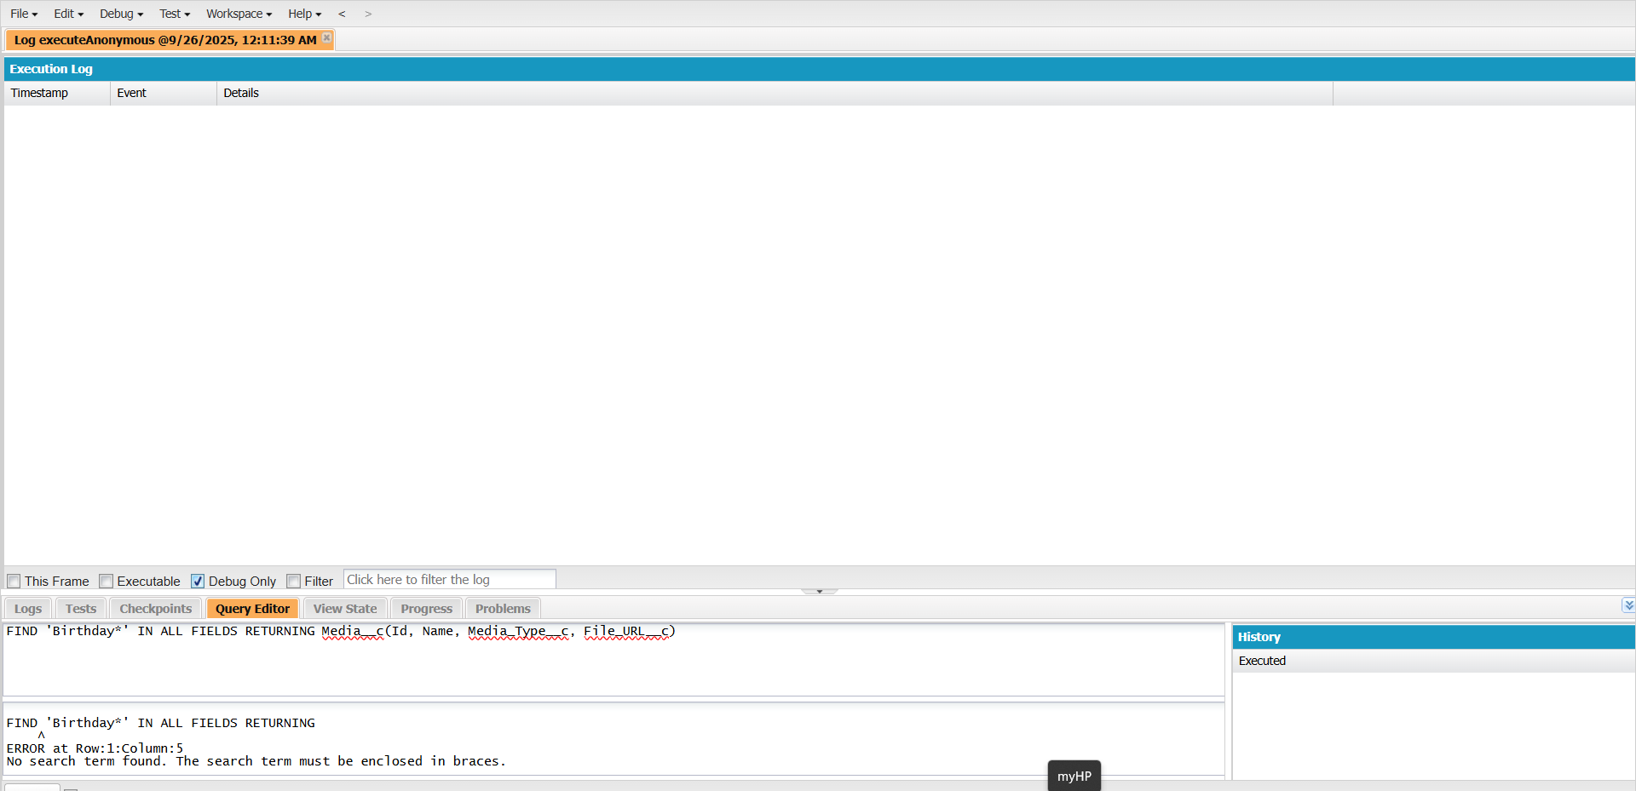

**➤ Collections: List, Set, Map**

* List: Ordered collection of records (e.g., all media linked to a capsule).
* Set: Unique collection, no duplicates (e.g., unique user IDs to notify).
* Map: Key-value pairs (e.g., Capsule Id → List of Media records).

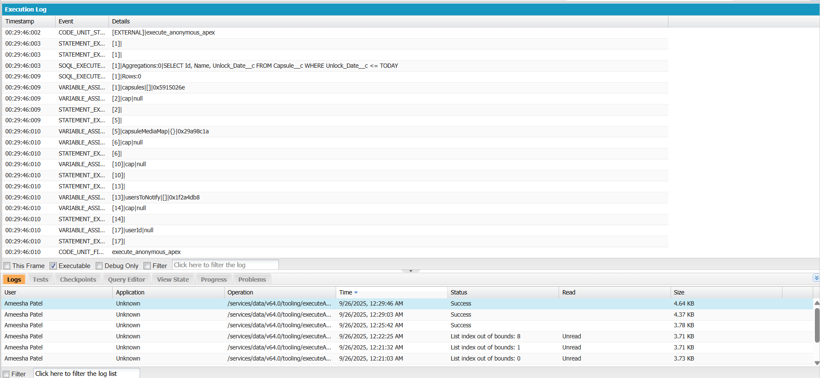

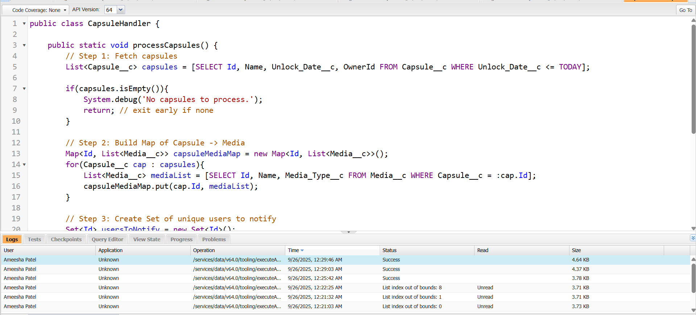

**➤ Control Statements**

* Use if, for, while, switch to manage logic.
* **Example:** Loop through all capsules due for unlock today and send notifications.

// Query capsules whose unlock date is today

List<Capsule__c> todaysCapsules = [SELECT Id, Name, OwnerId FROM Capsule__c WHERE Unlock_Date__c = TODAY];

// Loop through each capsule

for(Capsule__c cap : todaysCapsules) {

// Check if capsule has media linked

if(cap.Name != null) {

System.debug('Capsule ready to unlock: ' + cap.Name);

} else {

System.debug('No capsule found.');

}

}

// Optional: Switch statement example

String capsuleType = 'Personal';

switch on capsuleType {

when 'Personal' {

System.debug('Personal capsule unlock logic');

}

when 'Shared' {

System.debug('Shared capsule unlock logic');

}

when else {

System.debug('Unknown capsule type');

}

}

**➤ Batch Apex**

* Process large data sets asynchronously.
* **Example:** Batch process old capsules to archive media that are past the unlock date.

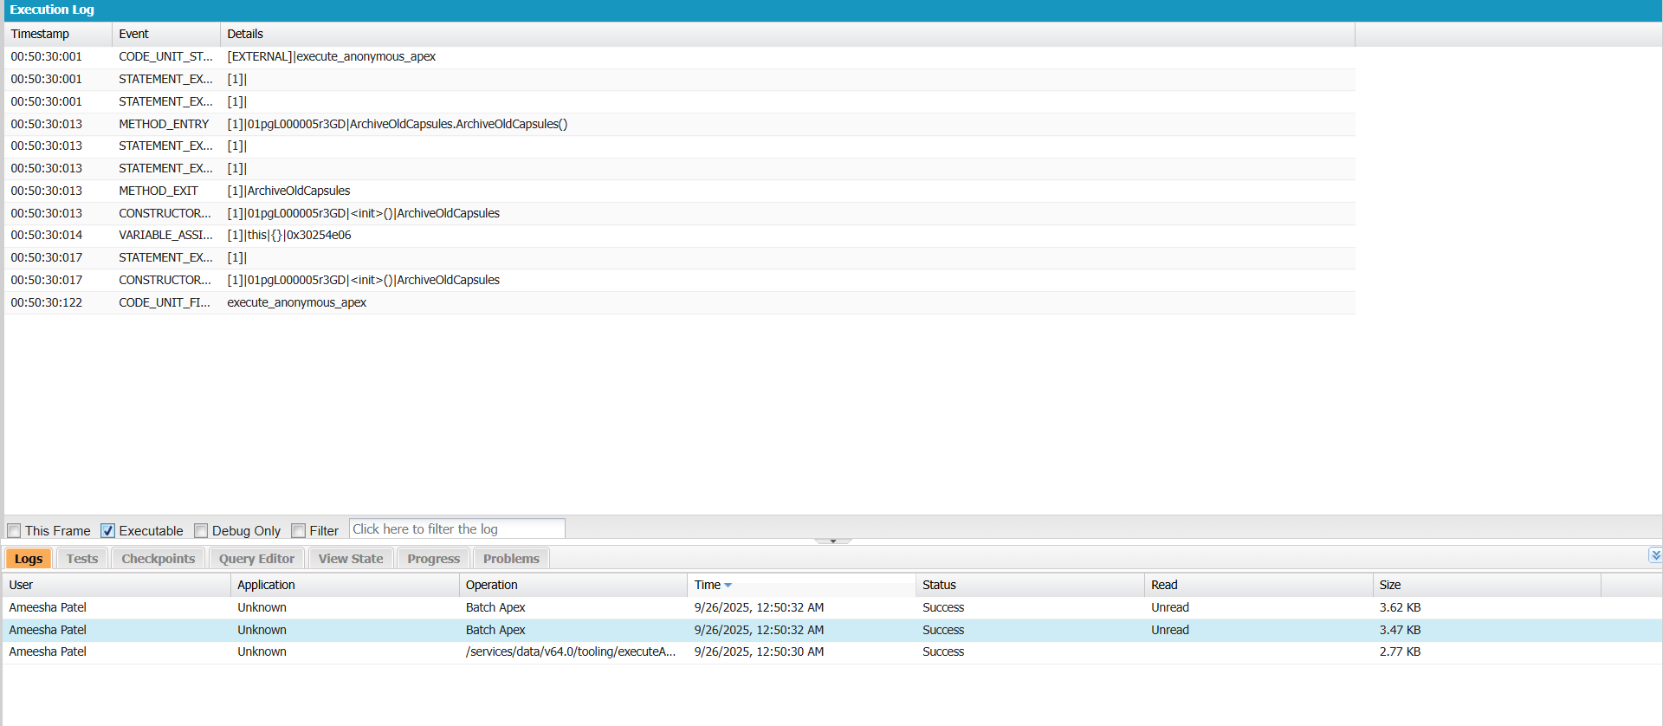

**➤ Scheduled Apex**

* Automate recurring processes.
* **Example:** Schedule a daily job to check capsules whose unlock date is today and update their status.

