SALESFORCE PROJECT

***Time Capsule App***

**➤ Named Credentials**

* Store external system URLs and authentication securely in Salesforce.
* Example: Save the base URL + API key for an external media storage service.

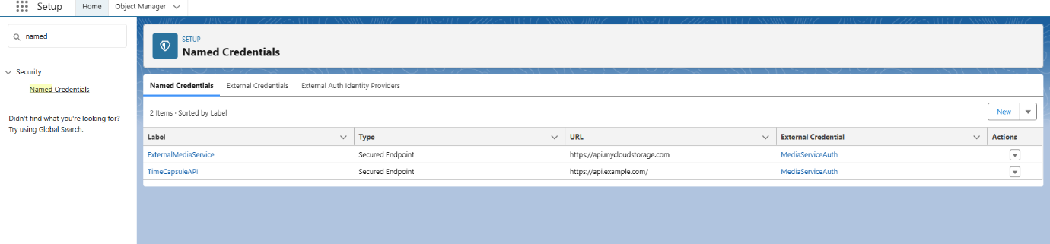

**➤ External Services**

* Allows you to connect Salesforce to REST APIs without writing much Apex.
* Example: Import a schema from an API and auto-generate Apex actions to call it.

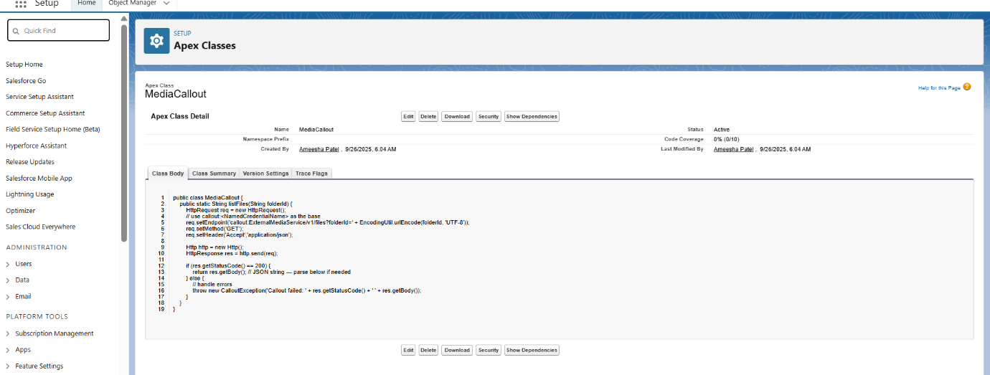

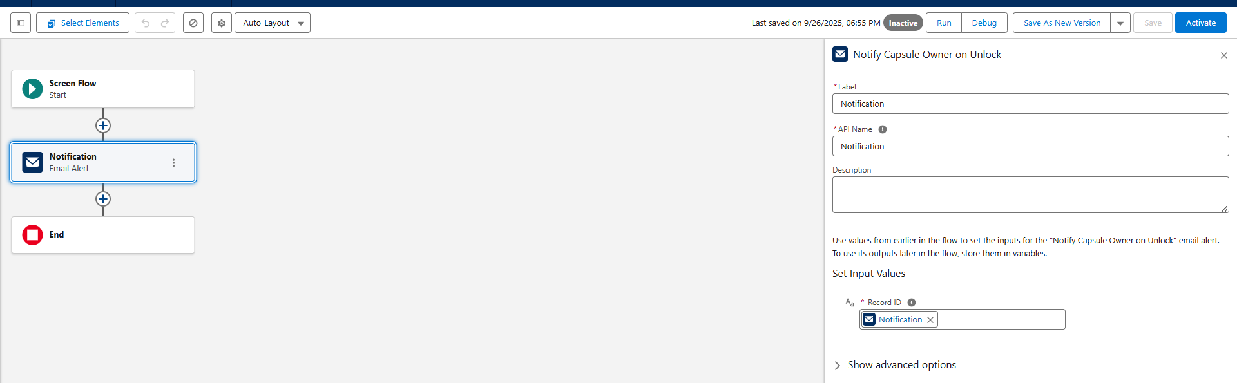

**➤ Web Services (REST/SOAP)**

* Expose Salesforce data as services or consume external ones.
* Example: Provide a REST endpoint for external apps to fetch Capsule details.

