**SALESFORCE PROJECT**

***Time Capsule App***

**Phase 8: Data Management & Deployment**

**➤ Data Import Wizard**Tool to import small to medium amounts of data into Salesforce without writing code.  
You can map CSV columns to Salesforce fields and quickly populate custom objects like Capsule__c and Media__c.

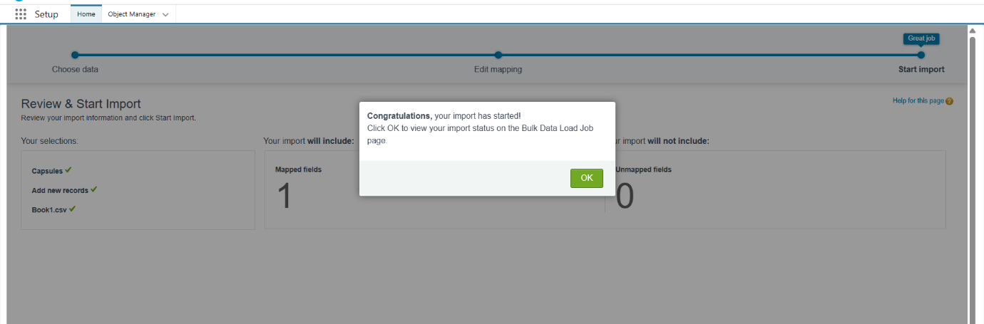

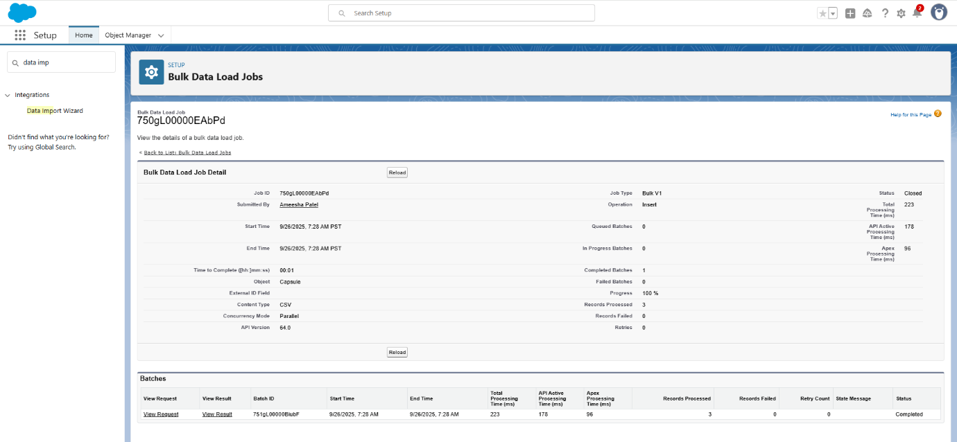

➤ **Duplicate Rules**  
Feature to prevent creation of duplicate records in Salesforce.  
You can define matching criteria and choose actions like blocking duplicates or alerting users.

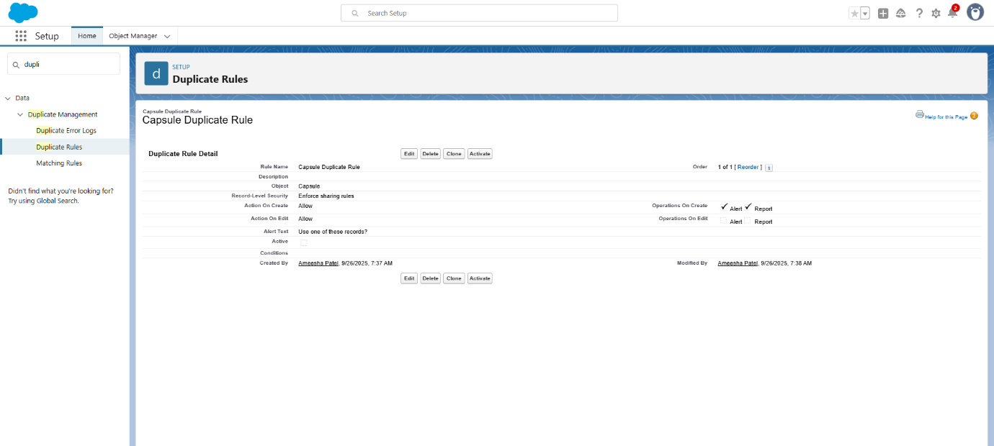

➤ **Data Export & Backup**  
Tool to regularly export Salesforce data for backup and disaster recovery.  
You can schedule exports or run them immediately to get CSV/ZIP files of selected objects.

