**SALESFORCE PROJECT**

***Time Capsule App***

**Phase 9: Reporting, Dashboards & Security Review**

➤ **Reports (Tabular, Summary, Matrix, Joined)**  
Tool to analyze Salesforce data and extract meaningful insights.  
You can create different types of reports to summarize data in various ways:

* **Tabular:** Simple list of records
* **Summary:** Grouped records with subtotals
* **Matrix:** Data grouped by rows and columns
* **Joined:** Combine multiple reports into one view  
  Example: Create a Summary report showing upcoming capsule unlocks by owner.

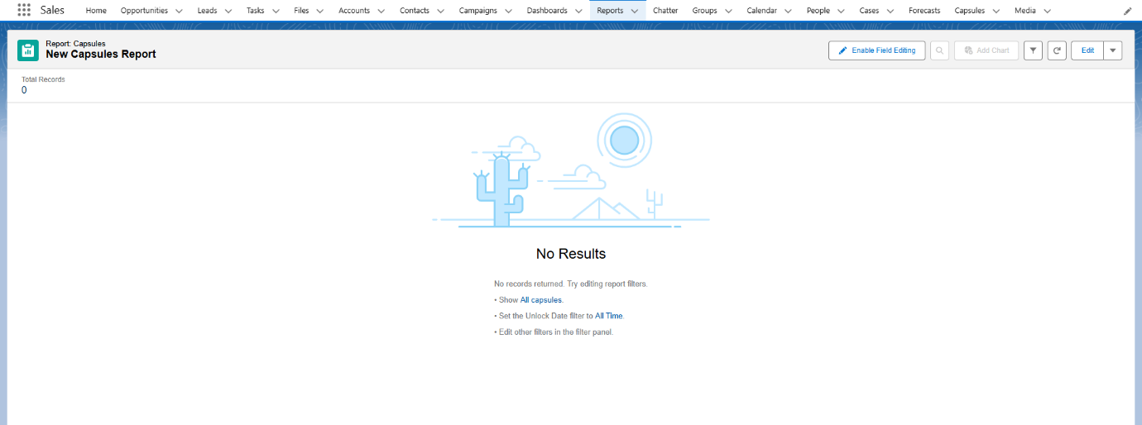

➤ **Report Types**  
Define which objects and fields can be used in reports.  
You can create **custom report types** to combine standard and custom objects for specialized reporting.  
Example: Create a report type linking Capsules and Media objects to report on all media attached to capsules.

