SALESFORCE PROJECT

***Time Capsule App***

**Phase 2: Org Setup & Configuration**

|  |
| --- |
|  |

|  |
| --- |
|  |

**→ Salesforce Editions**

* Selected **Developer Edition** for building and testing the Time Capsule App.

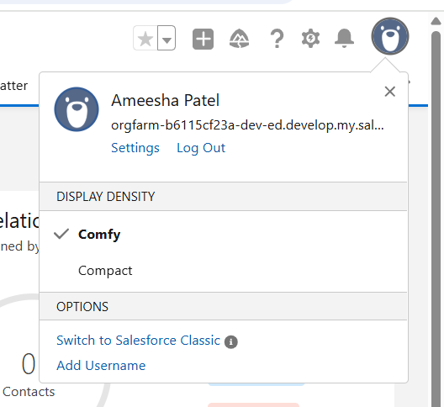

**→ Company Profile Setup**

* Configured company name, project lead as primary contact, default locale (English (United States)), currency (English (United States) - USD), and timezone (GMT-07:00) Pacific Daylight Time (America/Los_Angeles).

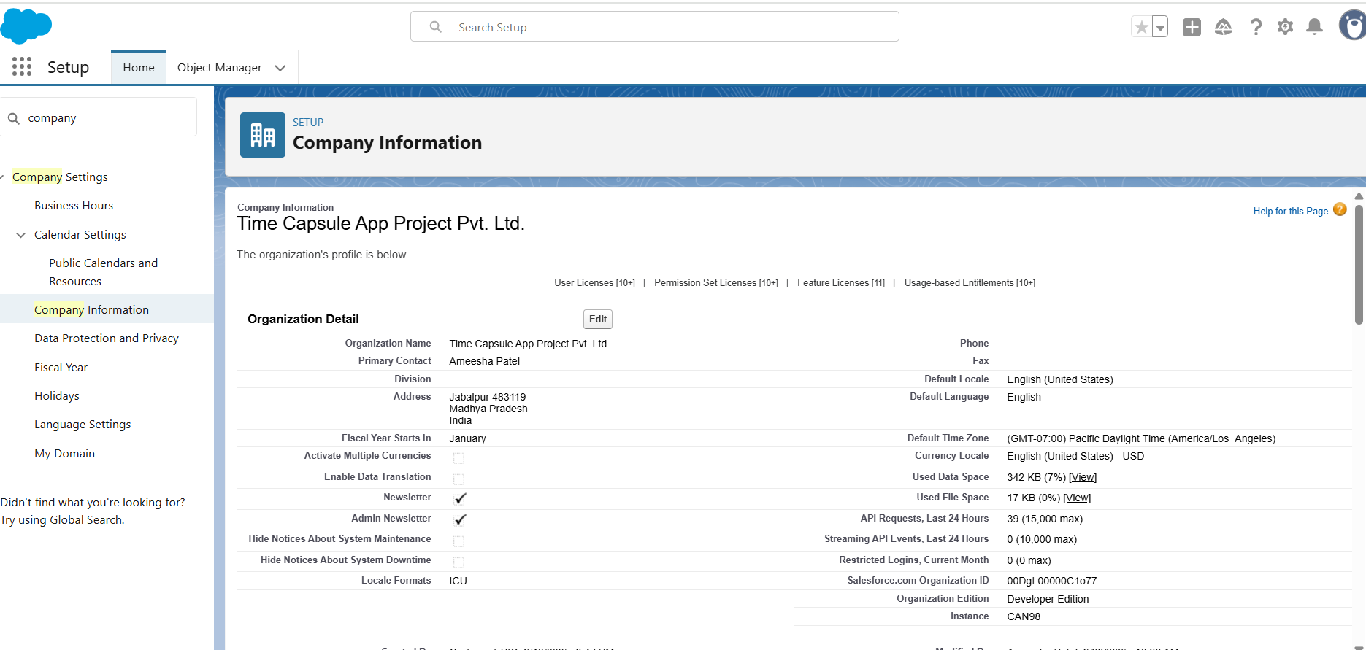

**→ Business Hours & Holidays**

* Defined default support hours (Monday–Friday, 9 AM–6 PM) and added national holidays so reminders and capsule unlocks respect these timings.

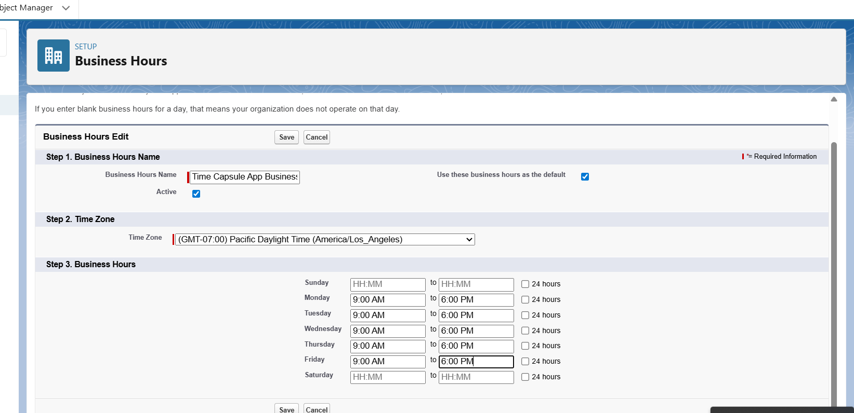

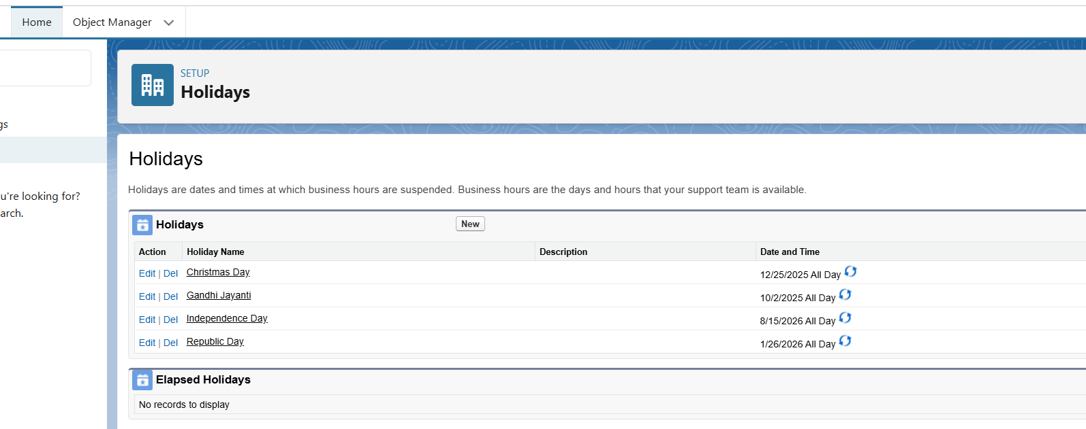

**→ Fiscal Year Settings**:

* We kept the **Standard Fiscal Year** (January - December) as the org's default.

**→ User Setup & Licenses**

* Created System Admin for full configuration and Standard Users for capsule creation/unlocking, assigning Salesforce Platform License.

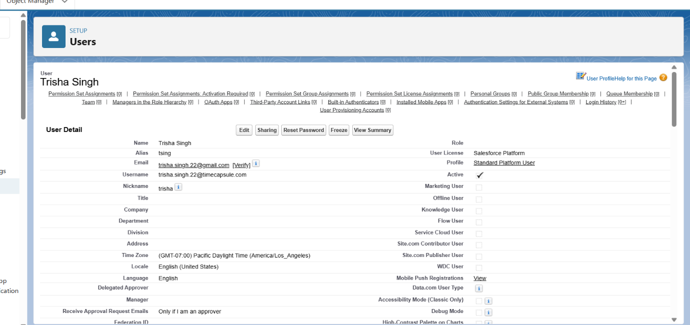

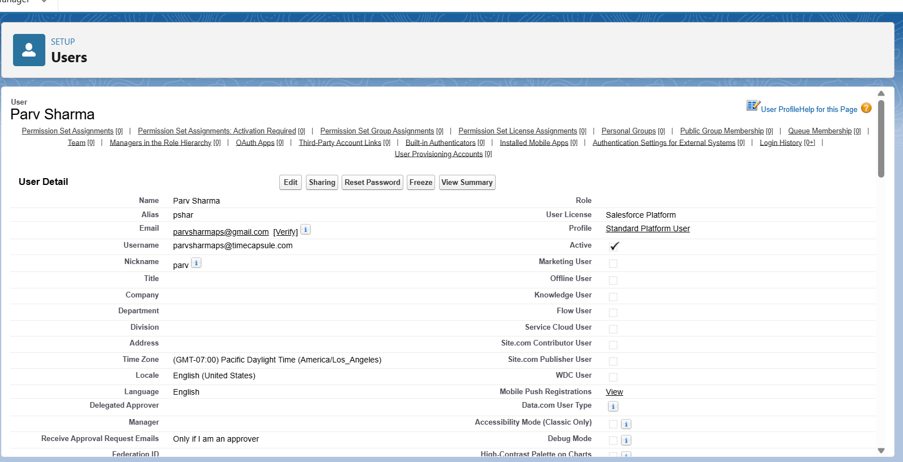

**→ Profiles**

* Defined object and field access for users, ensuring standard users have appropriate visibility without full administrative rights.

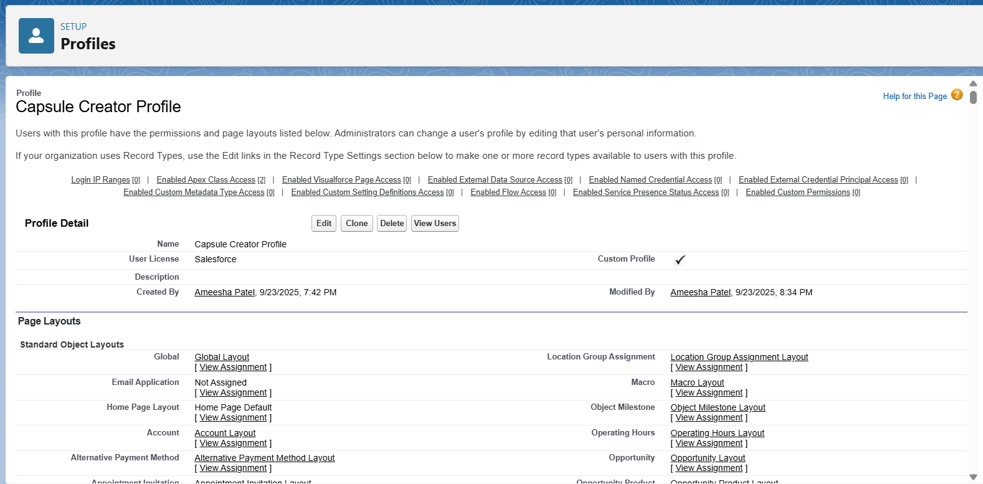

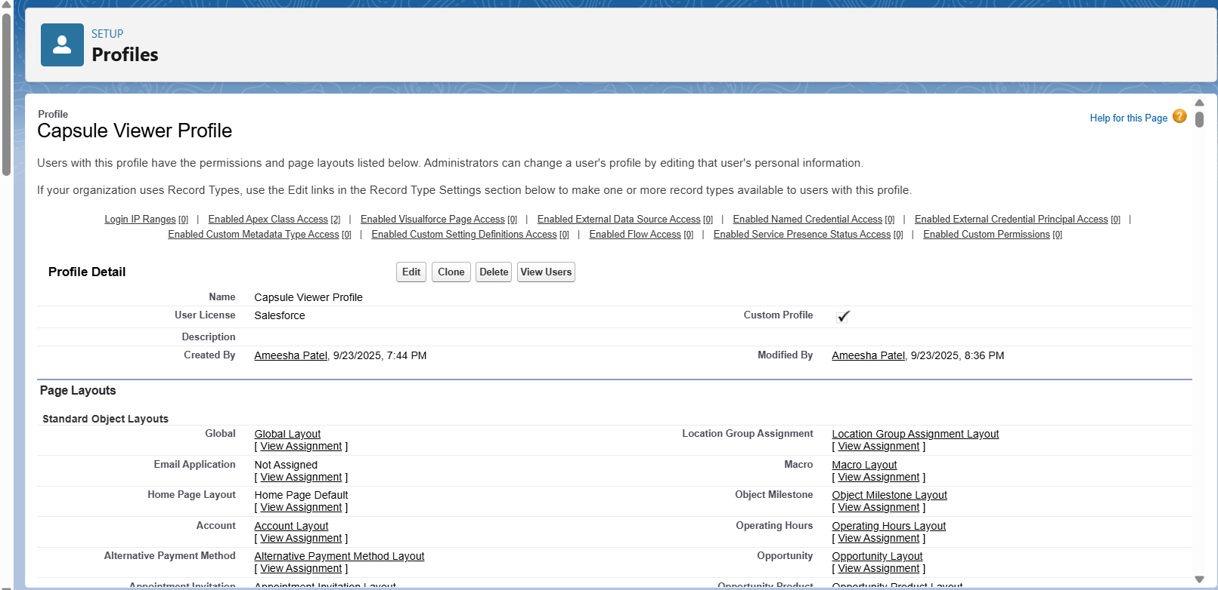

**→ Roles**

* Set up hierarchy for access control so that record visibility is consistent with ownership and team structure.

**→ Permission Sets**

* Created additional permissions (Capsule Creation) for select users without changing their base profile.

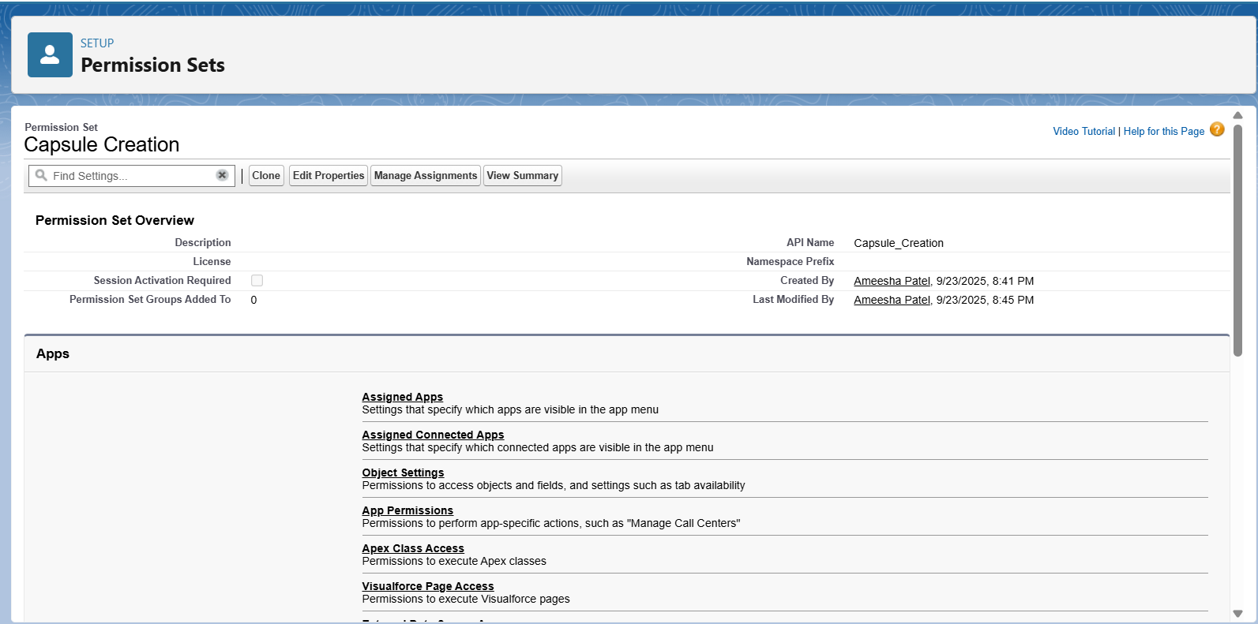

**→ Organization-Wide Defaults (OWD)**

* Capsule__c set to **Private**, User Messages set to **Private**, maintaining data confidentiality.

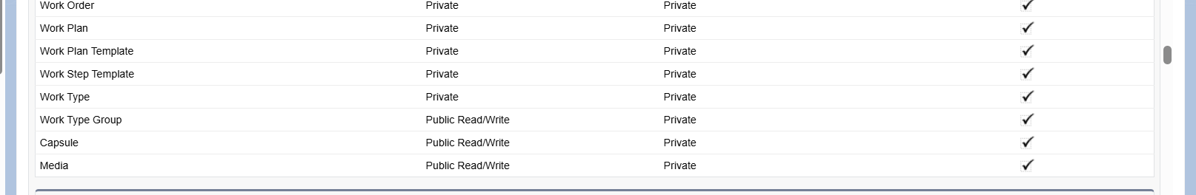

**→ Deployment Basics**

* Learned the deployment process using **SFDX** (Salesforce DX) by retrieving and deploying project components with a **package.xml** manifest.