Game Design Document

Fill up the Following document

1. Write the title of your project.

warfare

1. What is the goal of the game?

To avoid all the obstacles and get the to the goal

1. Write a brief story of your game?

There are two friends competing for the goal

1. Which are the playing characters of this game?

* Playing characters are the ones which respond to the user based on the input from the user
* Cars, monkeys, dinos, wizards etc, are the playing characters in the game.

|  |  |  |
| --- | --- | --- |
| Number | Character Name | What can this character do? |
| 1 | me | Try to reach the goal |
| 2 | friend | Try to reach the goal |
| 3 |  |  |
| 4 |  |  |
| 5 |  |  |
| 6 |  |  |
| 7 |  |  |
| 8 |  |  |

1. Which are the Non Playing Characters of this game?

* Non Playing characters are the ones which don't have an action or a behaviour when the user interacts with the game.
* Hurdles, stones, bananas, coins, etc are non playing characters in the game.

|  |  |  |
| --- | --- | --- |
| Number | Character Name | What can this character do? |
| 1 | obstacles | Try to stop them from reaching the goal |
| 2 |  |  |
| 3 |  |  |
| 4 |  |  |
| 5 |  |  |
| 6 |  |  |
| 7 |  |  |
| 8 |  |  |

Draw your imagination of this game. What does this game look like?

* Draw the game either on your computer or on paper,
* Add images of scenes of the game to show each of the playing and non-playing characters at least once.

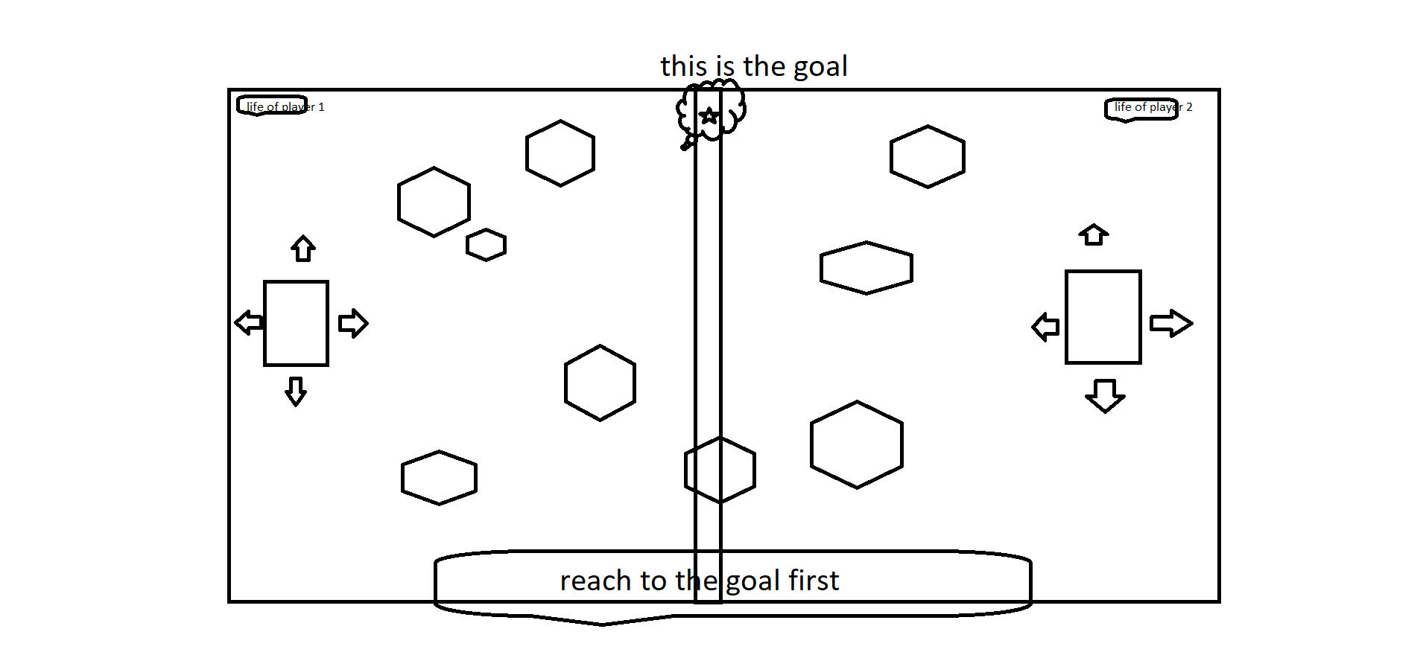

How do you plan to make your game engaging? life of player 1

It’s a multiplayer game