PupperCoin.sol

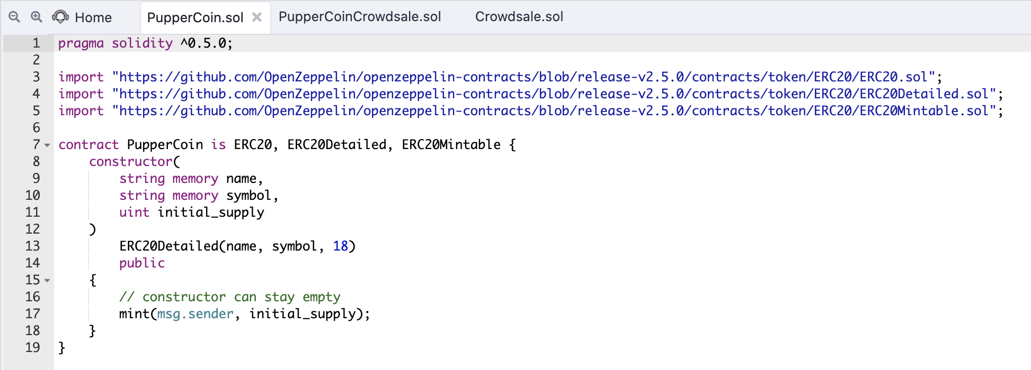

PupperCoinCrowdsale.sol

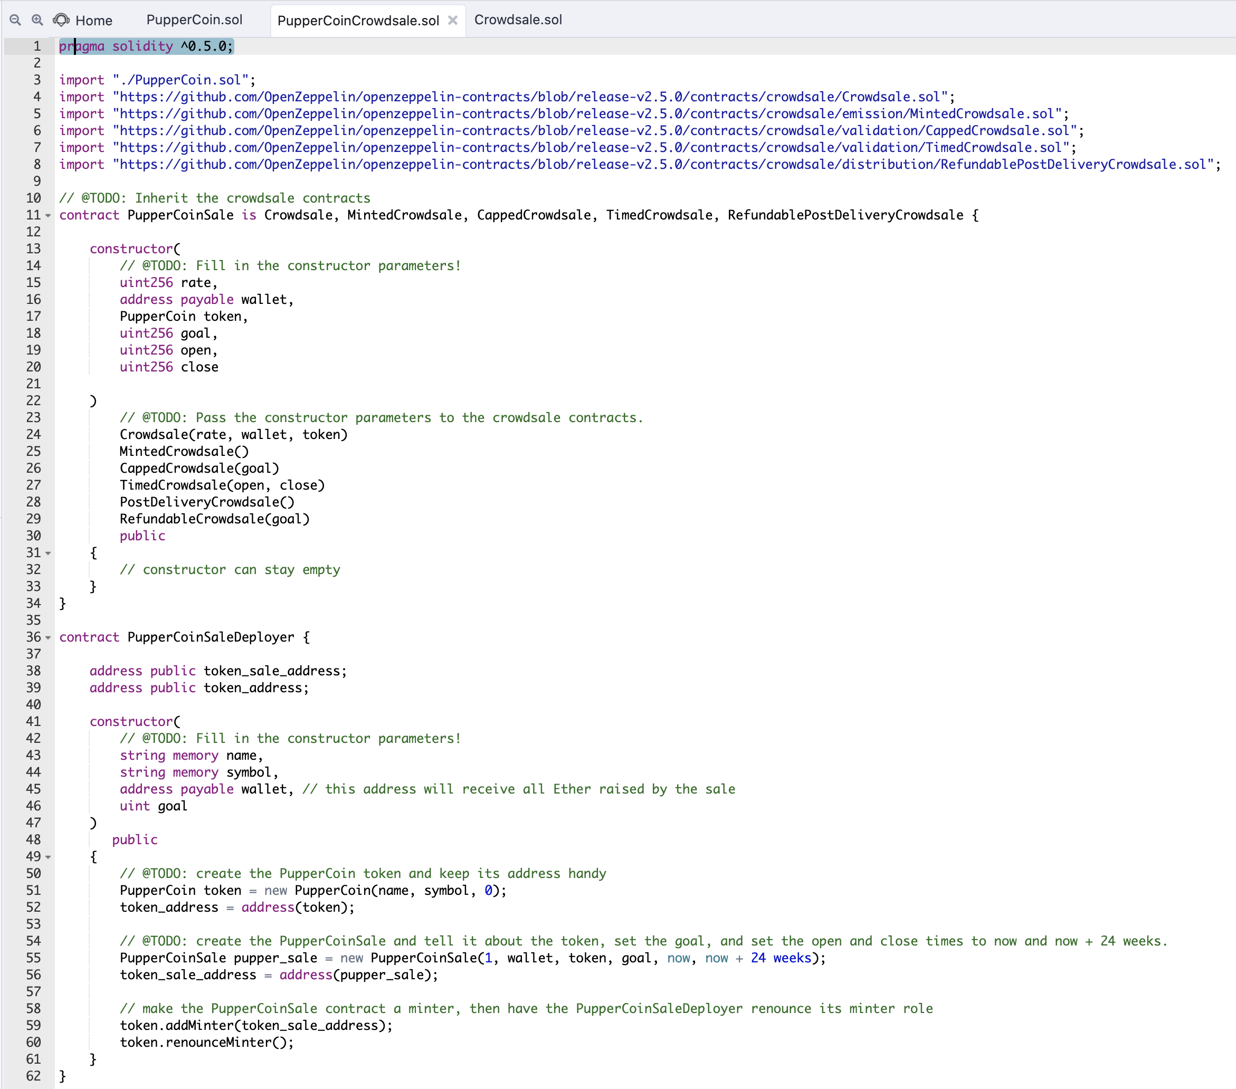

CrowdSale.sol

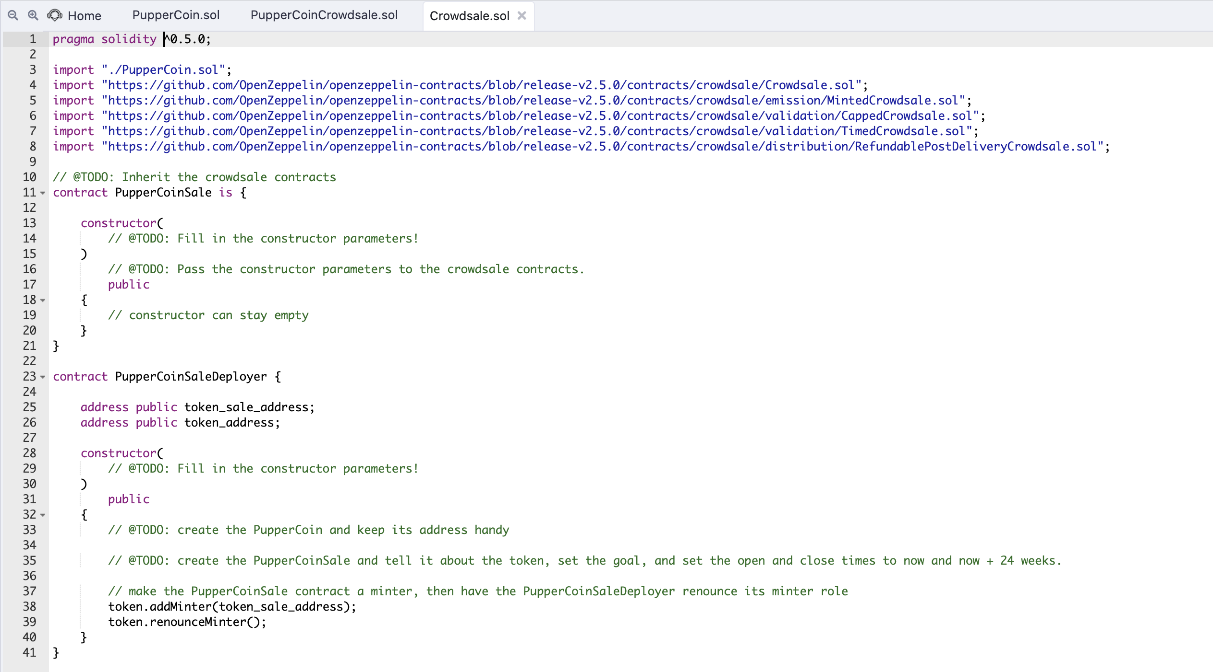

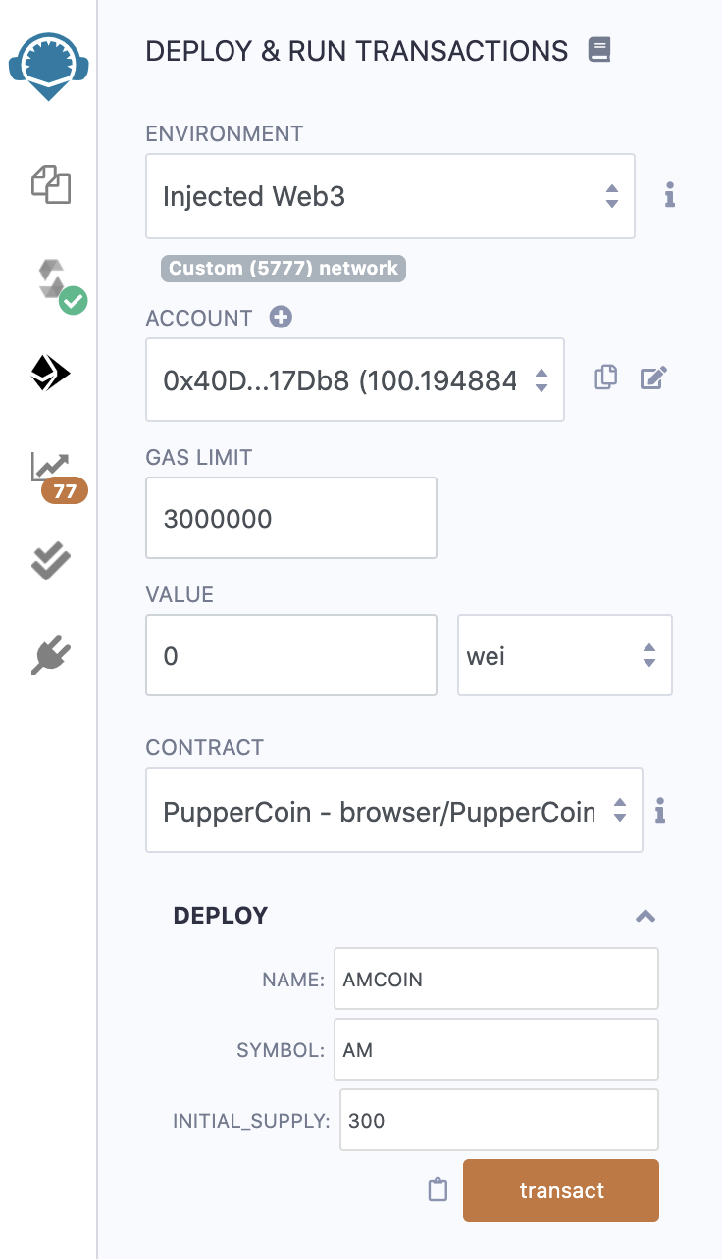

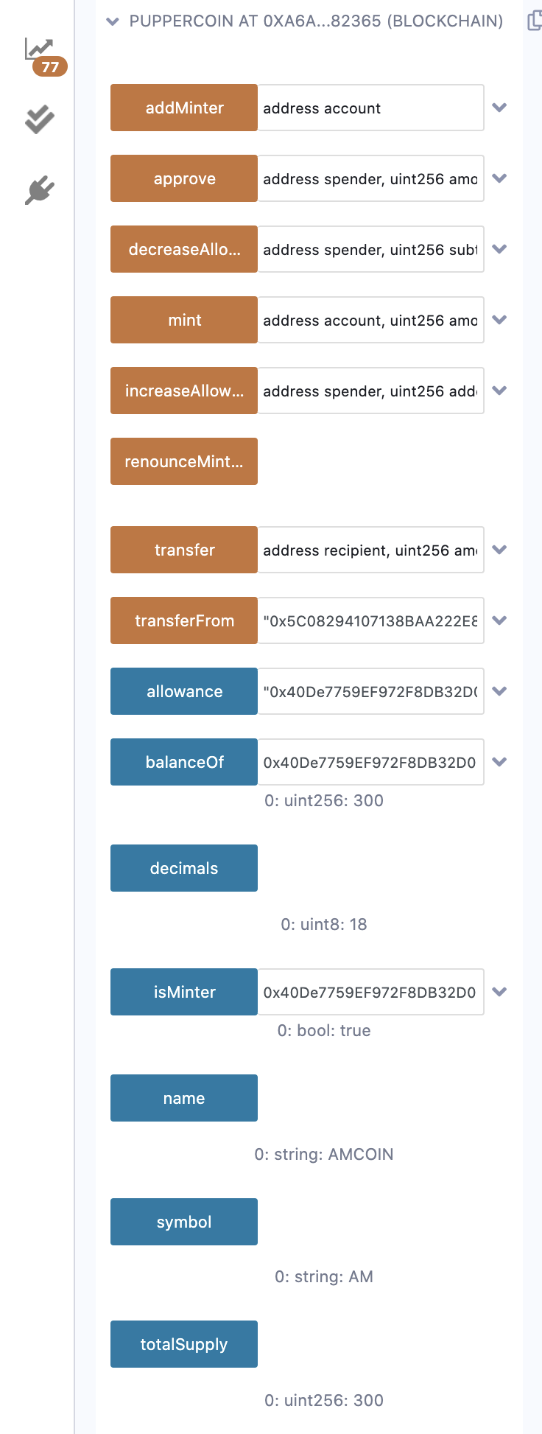

PupperCoin Contract:

**0xA6Aa4dcb9d4Af293D75FF39964fd56a3A7682365**

PupperCoinSaleDeployer Contact:

**0xA216de2248553AA03e16863fB3b41a95fC5A8D64**

Token Address:

0x0757d0E6CAc376EF405B5806aD5C87aF8F00Dc14

Token_sale Address:

0x9aCb5b7Bd63Ae02feF882fB996De61364D3E5256

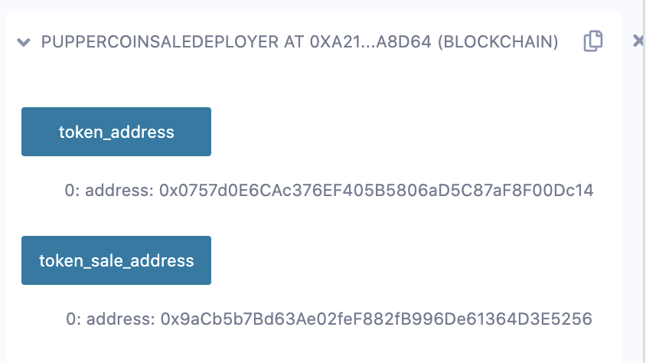

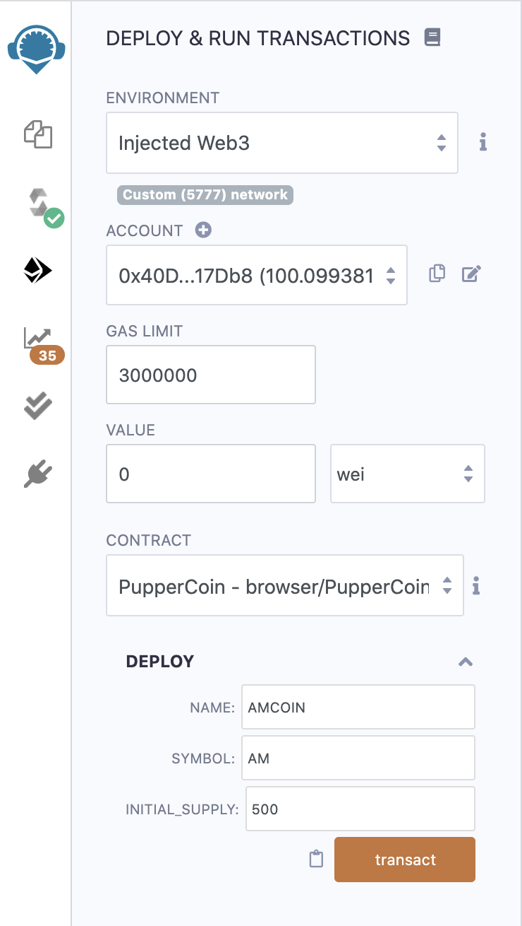

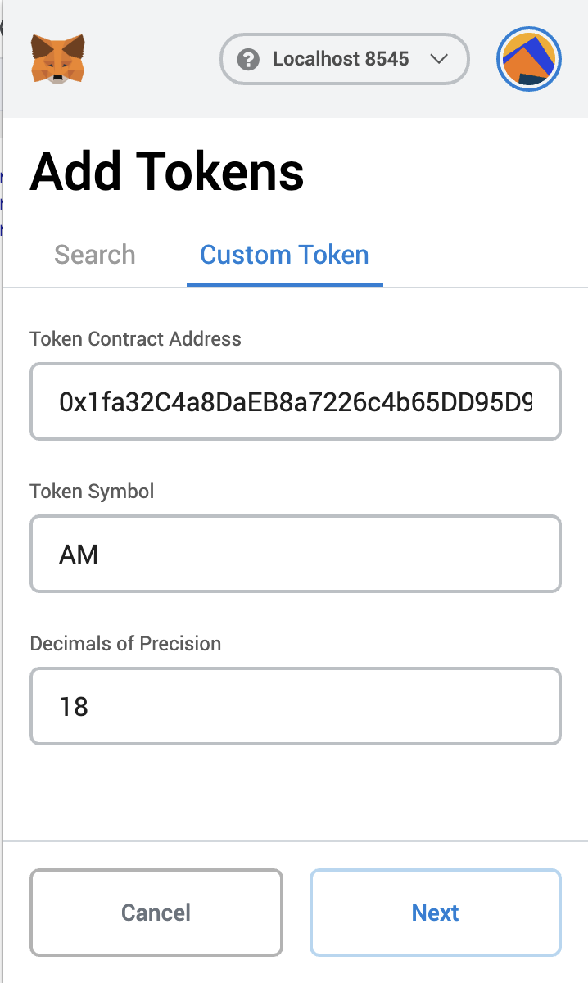

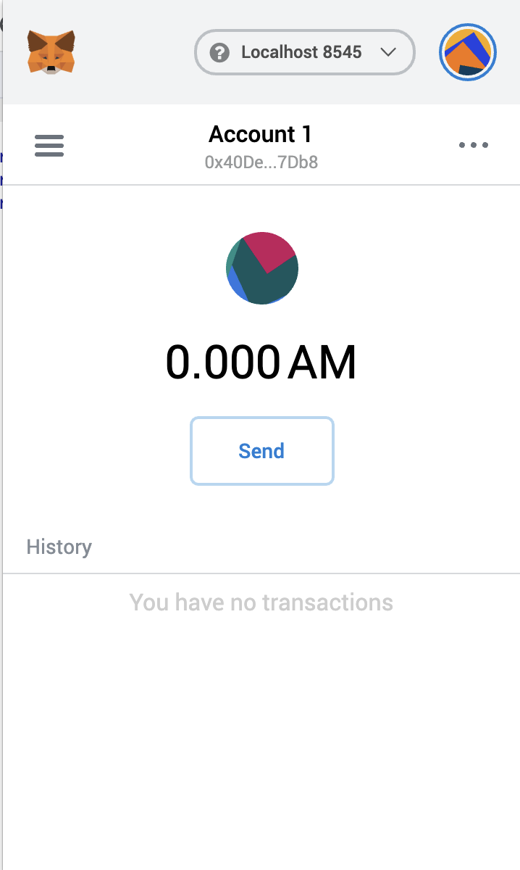

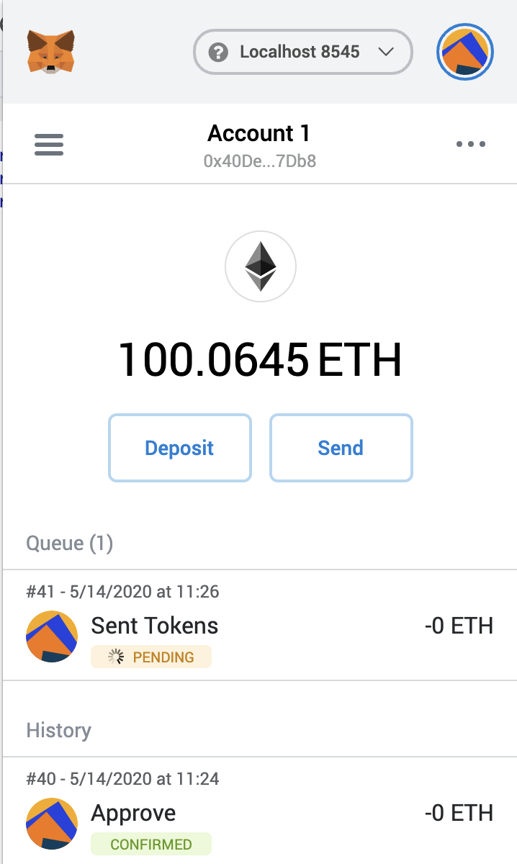

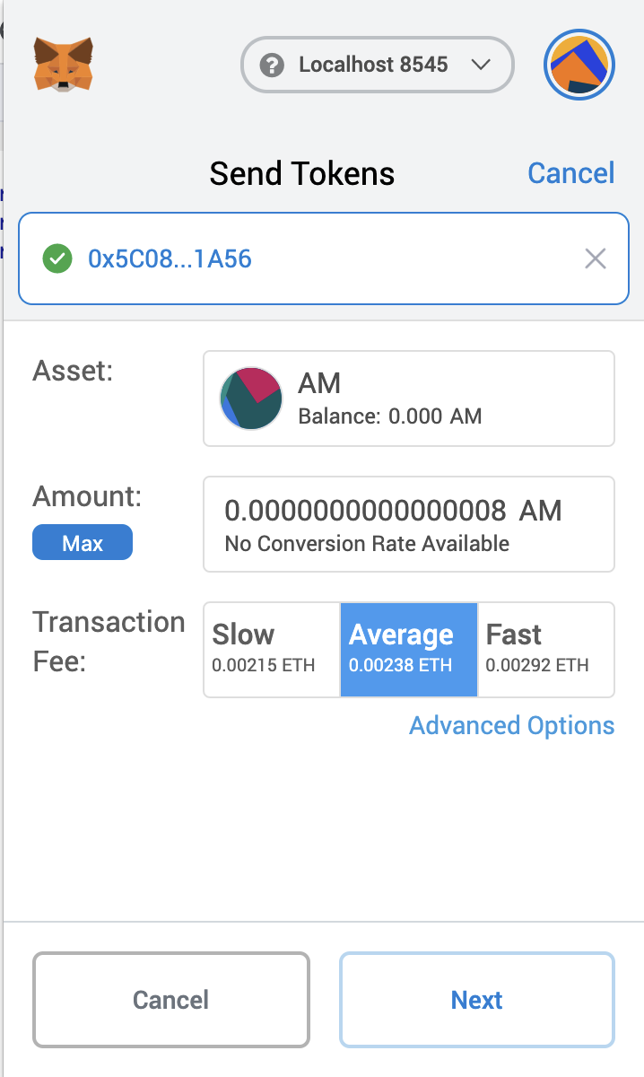

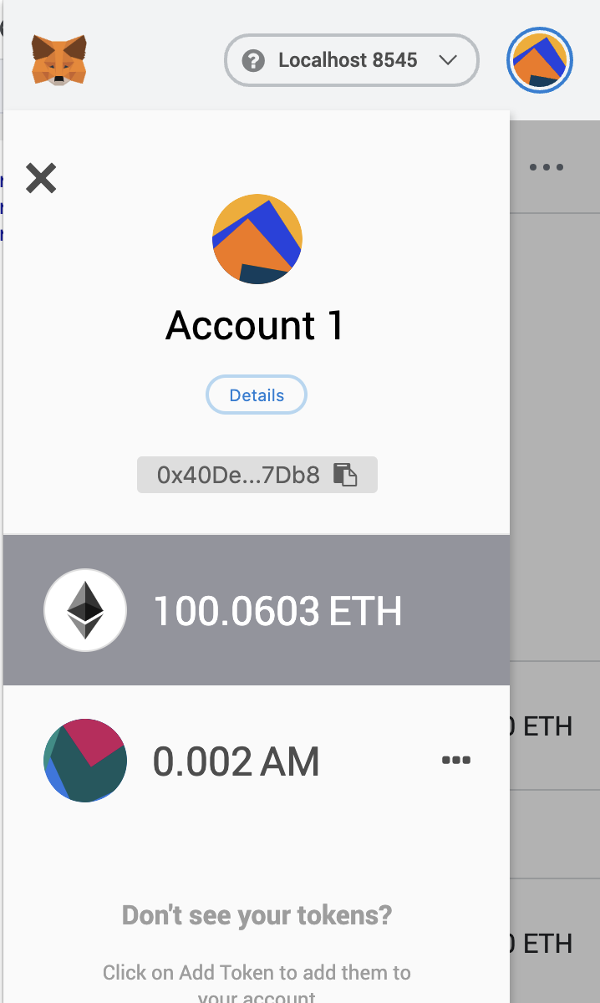

Kovan:

PupperCoin Contract:

**0x9980B36a12CE51575A5fA81d57A5DcF095bF0E03**

PupperCoinSaleDeployer Contact:

0xaeC8297997f697d4D37A28607C61df65167f5654

Token Address:

0xbF123b5509306f0812b7E7A0ce7900f4923aBF4F

Token_sale Address:

0x57cc0FeC5287f1b87b93FdB8cE8bae5Fd6D9Af6b

