[https://remix.ethereum.org/#optimize=false&evmVersion=null&version=soljson-v0.5.17+commit.d19bba13.js](https://remix.ethereum.org/" \l "optimize=false&evmVersion=null&version=soljson-v0.5.17+commit.d19bba13.js)

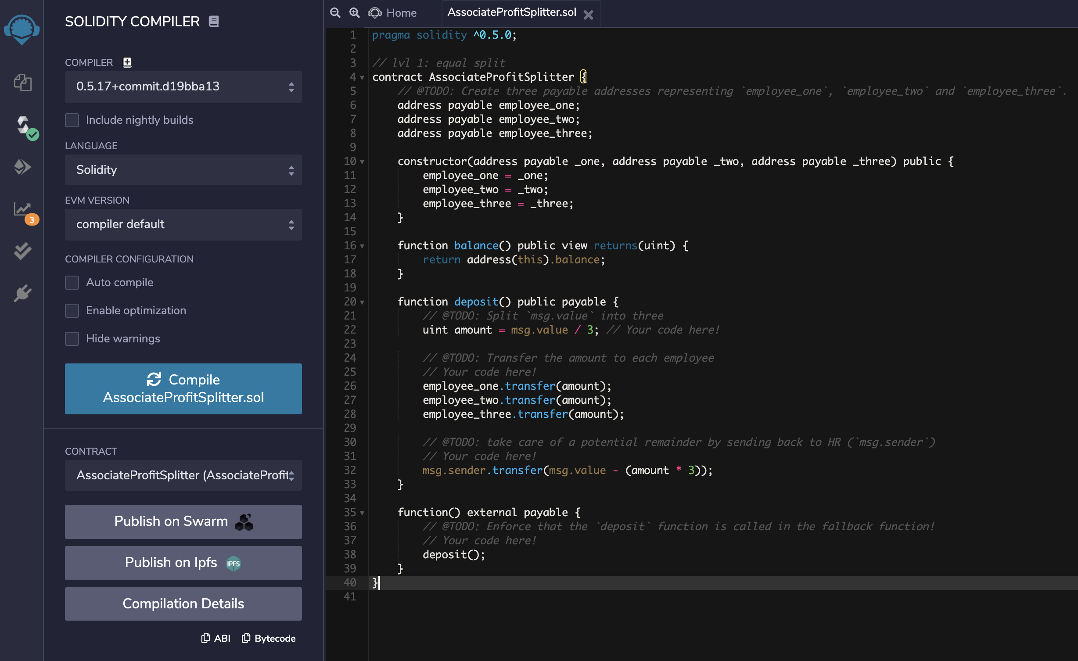

HR Address: **0x40De7759EF972F8DB32D0cf55b589d37ec817Db8**

Employee1 Address: **0x5C08294107138BAA222E84CF69FCBbC599081A56**

Employee2 Address: **0x750F788B29ED558D1bBE401f7E67bC699fbe79E7**

Employee3 Address: **0xbF2B8891a8D758dcaf50829Dc2356C199E0f3051**

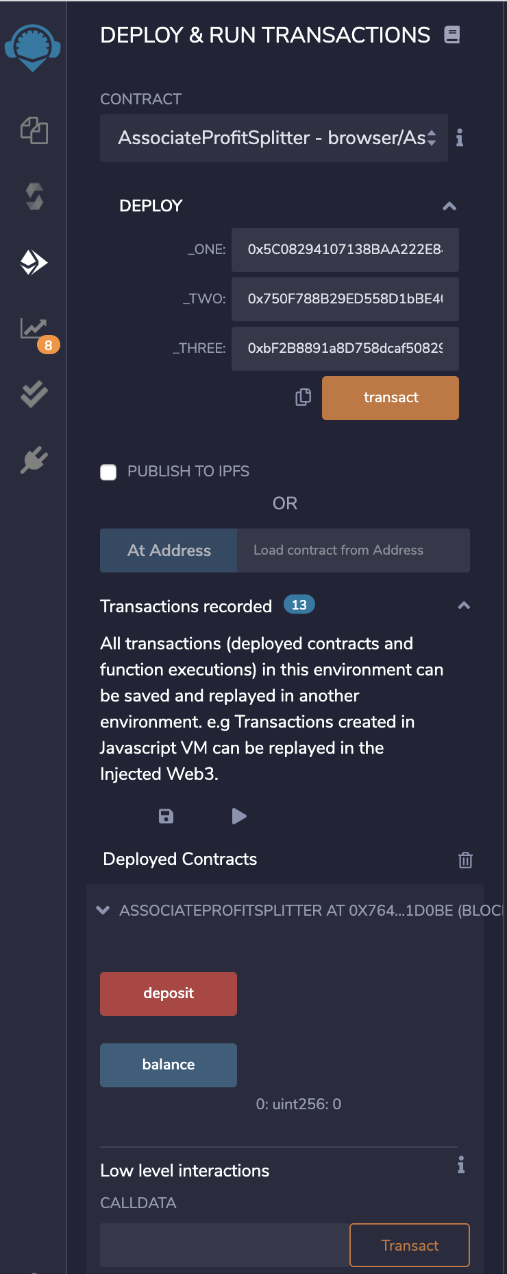

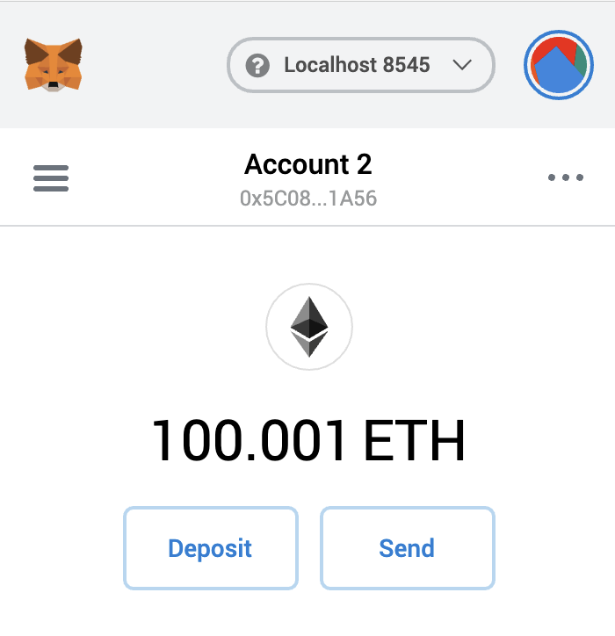

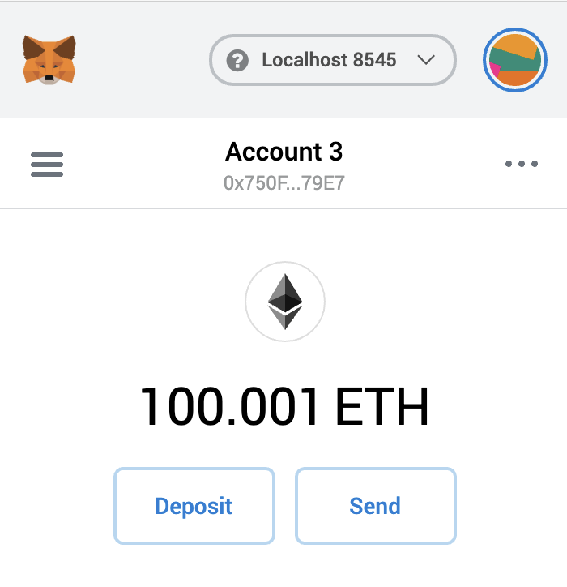

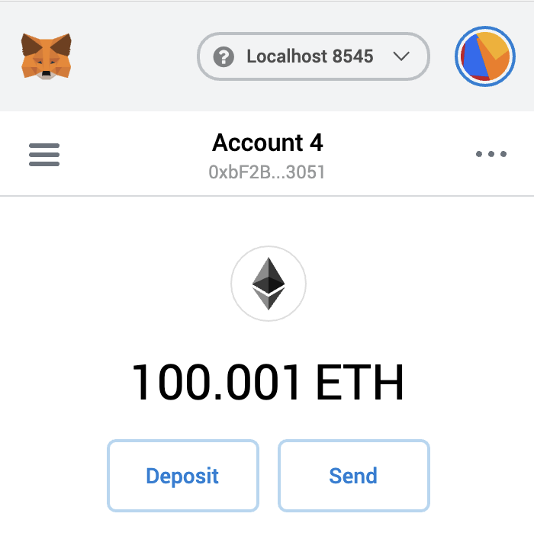

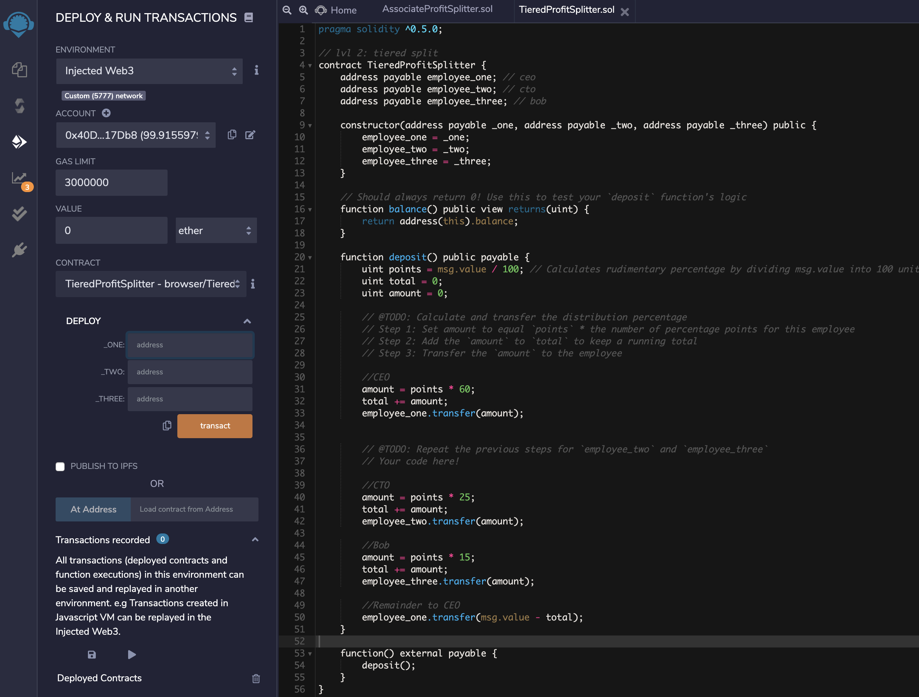

HR Address: **0x40De7759EF972F8DB32D0cf55b589d37ec817Db8**

CEO Address: **0x5C08294107138BAA222E84CF69FCBbC599081A56**

CTO Address: **0x750F788B29ED558D1bBE401f7E67bC699fbe79E7**

Bob Address: **0xbF2B8891a8D758dcaf50829Dc2356C199E0f3051**

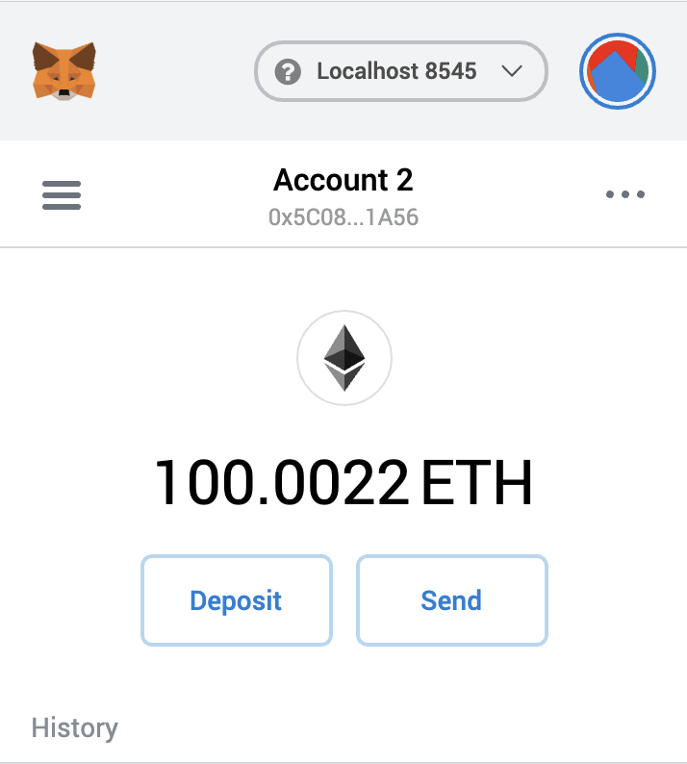

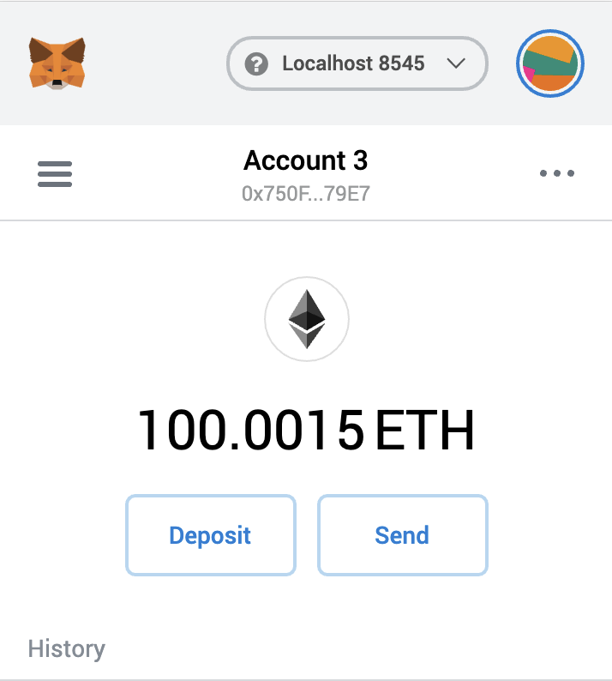

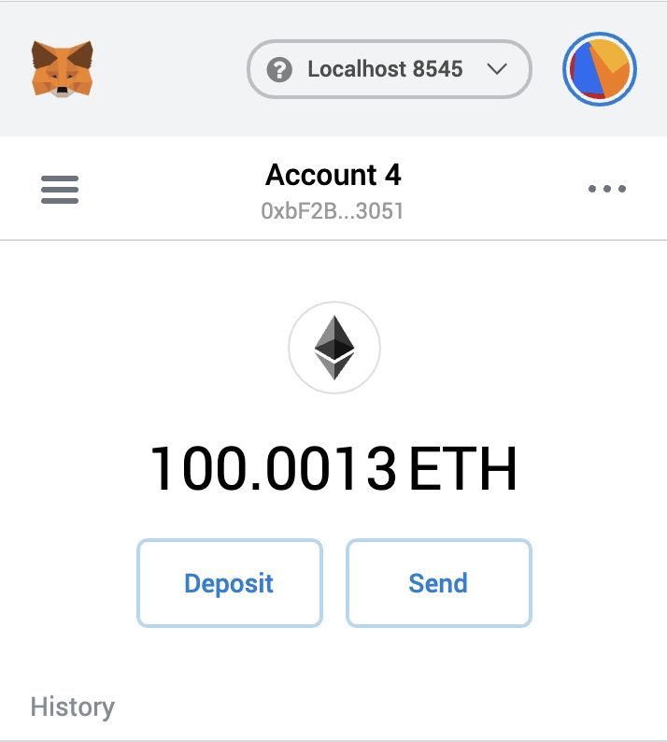

|  |
| --- |
| Pragma solidity ^0.5.0; |
|  |  |
|  | // lvl 3: equity plan |
|  | contract DeferredEquityPlan { |
|  | address human_resources; |
|  |  |
|  | address payable employee; // bob |
|  | bool active = true; |
|  |  |
|  | uint total_shares = 1000; |
|  | uint annual_distribution = 250; // 1000 shares over 4 years |
|  |  |
|  | uint start_time = now; // contract start time |
|  | uint unlock_time = now + 365 days; // will increment every year |
|  |  |
|  | uint public distributed_shares; // starts at 0 |
|  |  |
|  | constructor(address payable _employee) public { |
|  | human_resources = msg.sender; |
|  | employee = _employee; |
|  | } |
|  |  |
|  | function distribute() public { |
|  | require(msg.sender == human_resources || msg.sender == employee, "You are not authorized to execute this contract."); |
|  | require(active == true, "Contract not active."); |
|  | require(unlock_time <= now, "Shares have not vested yet!"); |
|  | require(distributed_shares < total_shares, "All shares have been distributed."); |
|  |  |
|  | unlock_time += 365 days; // lock for another year |
|  | distributed_shares = (now - start_time) / 365 days * annual_distribution; // calculate total shares from how many years have passed * annual_distribution |
|  |  |
|  | // double check in case the employee does not cash out until after 5+ years |
|  | if (distributed_shares > 1000) { |
|  | distributed_shares = 1000; |
|  | } |
|  | } |
|  |  |
|  | // human_resources and the employee can deactivate this contract at-will |
|  | function deactivate() public { |
|  | require(msg.sender == human_resources || msg.sender == employee, "You are not authorized to deactivate this contract."); |
|  | active = false; |
|  | } |
|  |  |
|  | function() external payable { |
|  | revert("Do not send Ether to this contract!"); |
|  | } |
|  | } |