MODUL 4

Application Layer: DHCP, DNS, and HTTP

TUJUAN:
- Memahami Application Layer: DHCP, DNS, and HTTP
- Memahami tentang DHCP

DASAR TEORI
Working with the Application Layer: DHCP, DNS, and HTTP


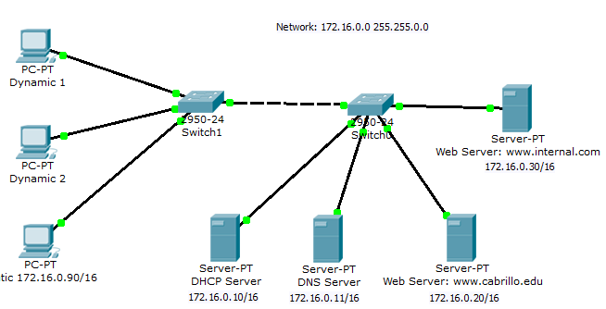
Figure 1: This is an example of what your final topology should look like.

Experiment Procedure:
- Start Packet Tracer using Realtime mode.

Configuring the DHCP Server
Add a server.

Global Settings of DHCP server:
  - Change the Display Name to “DHCP Server”
  - Set the Gateway to 172.16.0.1
FastEthernet:
  - Set the IP address to 172.16.0.10
  - Set the Subnet Mask to 255.255.0.0

HTTP:
  - Set HTTP Service and HTTPS Service to Off

DHCP:
  - Set the Default Gateway to 172.16.0.1
  - Set the DNS Server to 172.16.0.11
  - Set the Start IP Address to 172.16.0.100

DNS:
  - Set the Service to Off

- Configuring the DNS Server

Add a server.
Global Settings:
  - Change the Display Name to “DNS Server”
  - Set the Gateway to 172.16.0.1
FastEthernet:
  - Set the IP address to 172.16.0.11
  - Set the Subnet Mask to 255.255.0.0

HTTP:
  - Set HTTP Service and HTTPS Service to Off

DHCP:
  - Set the Service to Off

DNS:
  - Entering the www.tsrb.edu Domain Name
    - Enter for the Domain Name www.tsrb.edu
    - Enter for IP Address 172.16.0.20
    - Click Add
  - Entering the www.internal.com Domain Name
    - Enter for the Domain Name www.internal.com
    - Enter for IP Address 172.16.0.30
    - Click Add
- Configuring the www.tsrb.edu Web Server Add a server.
Global Settings:
  - Change the Display Name to “Web Server: www.tsrb.edu”
  - Set the Gateway to 172.16.0.1
FastEthernet:
  - Set the IP address to 172.16.0.20
  - Set the Subnet Mask to 255.255.0.0

DHCP:
  - Set the Service to Off

DNS:
  - Set the Service to Off

HTTP
  - Change the sentence, “<hr>Welcome to Packet Tracer 5.0, the best thing since..... Packet Tracer 4.0.” to “<hr> Welcome to Tsrb's public web page!” You may add other information as well.
- Configuring the www.internal.com Web Server Add a server.
Global Settings:

  - Change the Display Name to “Web Server: www.internal.com”
  - Set the Gateway to 172.16.0.1
FastEthernet:
  - Set the IP address to 172.16.0.30
  - Set the Subnet Mask to 255.255.0.0

DHCP:
  - Set the Service to Off

DNS:
  - Set the Service to Off

HTTP
- Change the sentence, “<hr>Welcome to Cisco Packet Tracer. Opening doors to new opportunities. Mind Wide Open to “<hr> This is the corporate internal network!” You may add other information as well.
- Configure Two Client Computers using DHCP Add two client computers.
Global Settings:
  - Change the Display Names to “Dynamic 1” and to “Dynamic 2” respectively
  - Set the Gateway/DNS to DHCP
FastEthernet:
  - Set the IP Configuration to DHCP
- Configure One Client Computers using Static IP Addressing Add two client computers.
Global Settings:
  - Change the Display Name to “Static”
  - Set the Gateway/DNS to Static
- Set Gateway to 172.16.0.1
- Set the DNS Server to 172.16.0.11
FastEthernet:
  - Be sure the configuration is set to Static
  - Set the IP address to 172.16.0.90
  - Set the Subnet Mask to 255.255.0.0
- Adding switches

  - Add two switches.
  - Connect the servers to one switch using a straight-through cable.
  - Connect the client computers to the other switch using a straight-through cable.
  - Interconnect the two switches using a crossover cable.
- Verify connectivity
  - Ping (ICMP)

    - From a client computer use the Desktop Command prompt to ping the other client computers and the servers.
    - Example: From the Dynamic 1 client, C> ping 172.16.0.20
    - The first one or two pings may fail, but you should receive a reply on the later pings. This is due to the ping timing out while the ARP process takes place (later).
  - Web Browser (HTTP)
    - On the client computers use the Desktop Web Browser, enter the URLs of the Web Servers www.tsrb.edu and www.internal.com.
    - You should see the web pages that you created on these servers.

Using Simulation Mode

Click on Simulation.
Note: To reset a simulation, click on “Reset Simulation” Click on Edit Filters
  - Choose Show All/None so that all the boxes (protocols) are unchecked.
  - Select (check) the following protocols: DHCP, ICMP, HTTP, DNS.

Check the Web Browser (HTTP)
  - On the client computers use the Desktop Web Browser, enter the URLs of the Web Servers www.tsrb.edu or www.internal.com.
  - Click on Auto Capture/Play (automatically forwards the packets) or Capture Forward (must keep clicking to advance the packets)

Check the DHCP
  - Reset the simulation by clicking on “Reset Simulation”
  - To view DHCP, on one of the “Dynamic “client computers using DHCP go to the Desktop Command prompt.
  - To have the client computer ask for new IP address and other information from the DHCP server, enter the command: C> ipconfig /renew

Questions (put the answer in your report)
- Repeat the experiment by putting router between the switch and the DNS and Web server as shown in figure 2.
- Explain the job of DNS server.
- Explain the job of the router in figure 2.


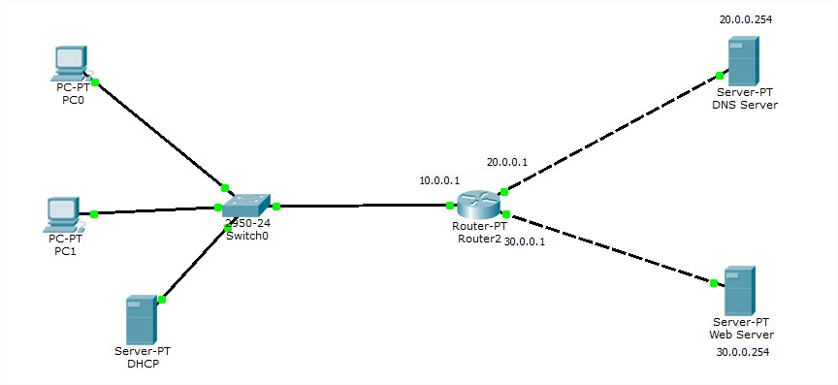

Figure 2

- ​

