Using Dijkstra’s Pathfinding Algorithm
Amelia Handley [40326169]
¹ Edinburgh Napier University
40326169@napier.live.ac.uk
Abstract. The abstract should summarize the contents of the paper in short terms, i.e. 150-250 words.
Keywords: First Keyword, Second Keyword, Third Keyword.
- Introduction
The coursework given was to enable a robot to navigate through an unknown series of caverns. These caverns were made up of tunnels of differing lengths. Each of the caves are connected by tunnels of varying length, with some only being one-directional or bi-directional. The task to develop a function software application to test for the shortest route within a network of caverns. Next, it was to ensure that the program was to run as quickly as possible by using an effective algorithm.
To enable the robot to navigate its way through the cavern network it has been given a connection matrix to determine which caves are connected. This matrix was made up of binary values. In addition, the coordinates to each of the caves were given to enable to algorithm to calculate the distance between each of the caverns.
- Dijkstra’s Pathfinding Algorithm
The algorithm which was used to develop a working software application to help the robot navigate through the caverns was Dijkstra’s pathfinding algorithm. The programming language Java was chosen to implement the algorithm. It resulted in the creation of two files first Coursework.java which contained functions and the main method for the program and a Cave.java which was the class that defined a cave.
- Implementation
  - Cave Class
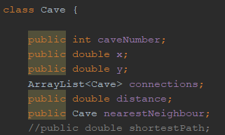
Image 1. Cave Class from source code

Contained within the cave class were the attributes that all the caves have. This includes a cave number to identify which cave it is, an x coordinate and a y coordinate. The connections were saved as an array list.
Within java the ArrayList class is used to store a collection of elements. An array list defers from an array as an array is a fixed size whereas an array list automatically changes its size. As we don’t know how many connections each cave will have, it was a suitable choice to use an array list.
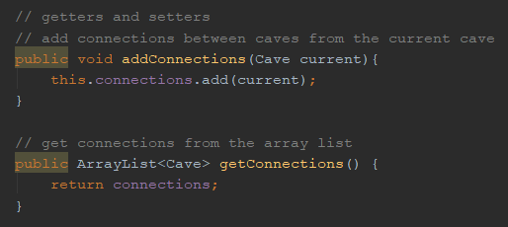
Image 2. Connections getters and setters
Getters and setters were created for the
  - Finding Each Cavern
The cavern files were stored in a particular format to be understood by the robot from an inputted file. It was a series of numbers split by a “,”. The first number (n) indicated the total number of caves in the cavern network. The next series of numbers were the coordinates for each of the caverns (n*2). After the coordinates the connection matrix (n*n) for the caverns was given as binary values - 1 meaning a cave was connected, 0 meaning it was not.
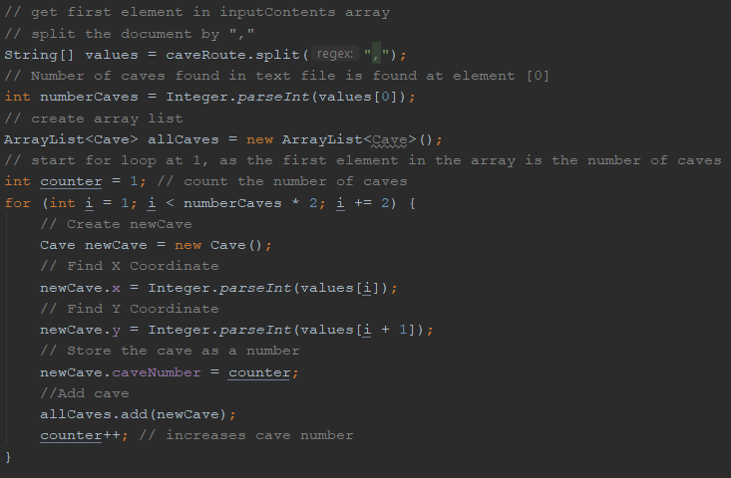
Image 2. Source code for finding each of the caverns.
To do this meant getting the input file and saving it was a list as a string. it was important saving the initial input as a string as java has a split() string which breaks a given string based on a specific expression [1]. So, in the case of the input file it was split by the “,” (see Image 2).
This was then saved to a one-dimensional array called values. An array is a suitable data structure as each entry into the array is identified by a key. For instance, the first element in the array is stored at point 0. This was used to find the number of caves by finding the first element in the array and saving it as a variable called numberCaves.
An array list was then made of our Cave object which defined what a cave was including the cave number, the x coordinate and y coordinate.
A for loop was used to iterate through each of the caves. The search starts at position 1, as position 0 of the array is the number of caves. It then goes through the array in by calling in numberCaves and multiplying it by 2 for each set of coordinates. The for loop also increase by 2 for each iteration for the same reason.
A new object is called newCave which inherits its variables from the Cave class. The x-coordinate is saved for the value that the for loop is currently on, and the y-coordinate saves the value next to it. Out width the loop there is a counter which will be used to save the cave number as it will increase with each iteration as well.
  - Calculating Distance
Now that we have saved each cave by its x-coordinate and y-coordinate a function was required to calculate the distance between each of the caves. This was done using Euclidean distance (Image 3):
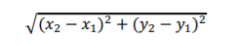
Image 3. Formula for Euclidean distance

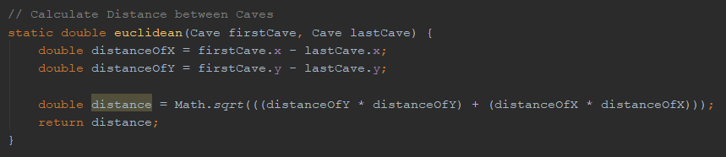
Image 4. Source code for calculating distance between two caves

The function requires an input from two caves. It will then get the coordinates for both the caves. Distance between the x and y coordinates is found within the caves was done by first subtracting the values from each other creating x and y to create two new variables distanceOfX and distanceOfY (see image 4).
Using the Math.sqrt() which returns a positive square root of a double value. The value calculate would be the distanceOfX squared plus the distanceOfY squared. This would return the distance between the caves.
  - Connection Matrix
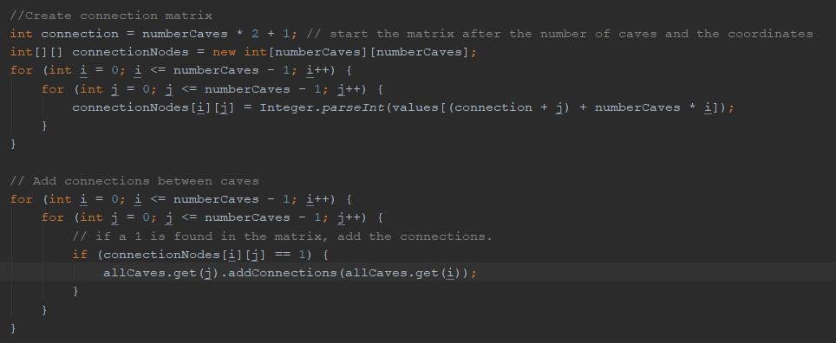
Image. Creation of Connection Matrix
A two-dimensional array was used to create the connection matrix from the input file. A 2-D array is a data structure which can be used to represent rows and columns, which is required to see which caves are connected to each other. The array is set to equal the number of caves in the cave - using the numberCaves variable from before to create the table. The table will go through the 2-D array for the number of caves in the network - minus 1 as arrays always start at 0 using a for loop.
The matrix is set to equal the values (the array of string variables initialized previously). It converts the values from string inputs to integers. The connection is equal to the number of caves multiplied by 2 plus 1 to get to the right position from the values array. You add j to the connection to get to the correct position in the column. Then number of caves multiplied by i to where the row is being chosen is added to give a position in the matrix.

Image 5. Creating Connections
Then, another for loop is used to search through the connection matrix. If a value of 1 is found in the matrix then it adds the connection using the setter method in the Cave Class called addConnections.
  - Finding Shortest Path
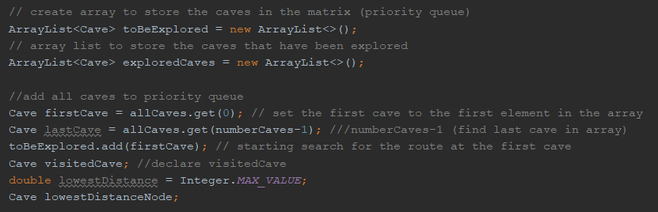
Image 6. Declaring variables needed to find the shortest path

To use Dijkstra’s pathfinding algorithm would mean finding the shortest path from the start cave to the last cave by searching each of the caves in the network. To do this the caves are added to a priority queue. The priority queue which was called toBeExplored (see Image 6). This will ensure that all the caves have been searched. There is another array list which will add all the caves that have been explored - called exploredCaves.

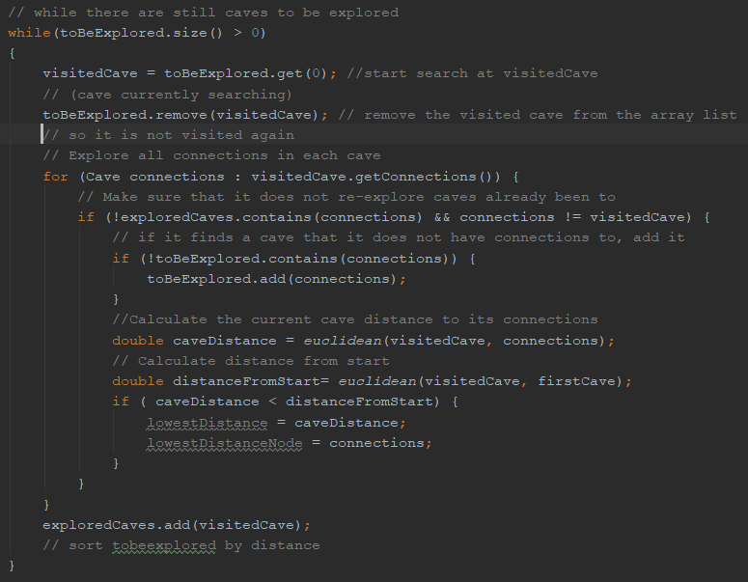
Image 7. The start of implementation for the search algorithm.

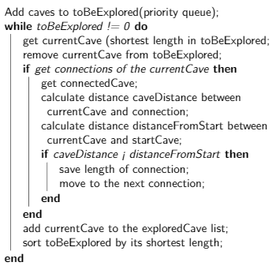
Within the main function there will be a while loop which will operate Djisktra’s pathfinding algorithm. It starts with a while loop which loops to see if there are still caves in the priority queue (or the toBeExplored array list). Whilst there are still caves to be explored, it starts the search at the visitedCave - which starts at the first cave. The cave that is being searched is then removed from the priority queue, so it is not searched again.
A for loop is used to go through all the connections of the caves. To ensure that caves that have been explored - in the array list exploredCave - are not re-explored. It does this by checking the current cave and the connections of the visited cave. If the cave is not in the exploredCave array and it is not in the connections array, then the algorithm checks to see the cave has connections. If it does not it adds it to the array.
Image : Pseudocode for first part of search algorithm.
The distance from the cave to the visited cave and its connections is then calculated using the Euclidean function created. It also checked the distance the visitedCave is from the start. If the current caveDistance is less than the start, then it the algorithm will add the distance of the connection and move to the next cave. To ensure that the program outlined in Image 7 would work, it would require a function to sort the priority queue by its shortest length. This would enable the program to find the shortest path in the next function.
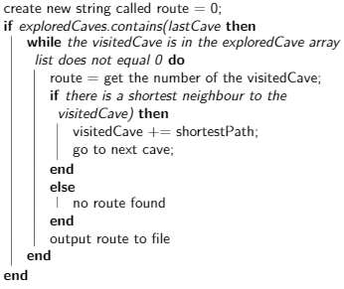
To ensure that the shortest path has been found, it would mean going back through the priority queue, which will have been sorted by its shortest length. Then, when looking at the visitedCave, the while loop will run as long as it does not equal 0. Once it reaches 0 it will mean that there are no caves left to explore in the algorithm (see Image ).
First, the cave number of the visitedCave is added to a variable called route, which will be used to store the numbers of each of the caves.
An if statement is used to go backwards in the array list to ensure that the path being followed is the shortest. It does this using the explored caves array list and if the shortest path is found it will save it. Then go to the next cave. If no neighbours are found, then the algorithm will determine that there is no route possible to take.
Image : Pseudocode for second part of search algorithm.
This resulting route would be printed to an output file.
- Conclusion

References
- Geeksforgeeks, https://www.geeksforgeeks.org/split-string-java-examples/, last accessed 2019/12/2

- Author, F.: Article title. Journal 2(5), 99–110 (2016).
- Author, F., Author, S.: Title of a proceedings paper. In: Editor, F., Editor, S. (eds.) CONFERENCE 2016, LNCS, vol. 9999, pp. 1–13. Springer, Heidelberg (2016).
- Author, F., Author, S., Author, T.: Book title. 2nd edn. Publisher, Location (1999).
- Author, F.: Contribution title. In: 9th International Proceedings on Proceedings, pp. 1–2. Publisher, Location (2010).
- LNCS Homepage, http://www.springer.com/lncs, last accessed 2016/11/21.

