Algorithms
Amelia Handley [40326169]
Edinburgh Napier University
40326169@live.napier.ac.uk
- Dijkstra’s Pathfinding Algorithm
  - Description
Dijkstra’s pathfinding algorithm is an algorithm used to find the shortest path between nodes within a graph, or in the context of this coursework caves within a cave network. It calculates the cost of the shortest paths from a given starting point to all the other caves in the network [1]. The algorithm finds the distance between each of the nodes and calculates the shortest path possible. Dijkstra’s pathfinding algorithm is a popular algorithm used for multiple reasons. An example would be Google maps which measures the shortest path given by a user between a source and a destination.
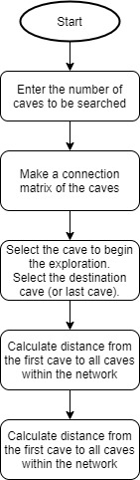
Dijkstra’s pathfinding algorithm can be simplified and split into stages (Image 1) [2]. The flowchart of the algorithm has been summarised to say the algorithm will compute the shortest paths from the starting cave to every node in the graph until it reaches the last cave.
So firstly, the number of caves is determined to let the algorithm know how many caves it must search through. Before the search can start the algorithm must also know which caves are connected to each other. This is called the connection matrix.
Then starting at the first cave, the algorithm is designed to update as it navigates through the connections of the caves. It does this by, firstly, removing the starting cave from the priority queue.
A priority queue is used to keep track of all the caves. It is a data structure which orders elements within it by a “priority” which is associated to it. In this case the priority queue is used to organize the caves by their shortest distance to the start. So, the starting point will be always be the first element, as it has a distance of 0 [1]. The rest of the caves are set to the maximum value as their distances are unknown. These distances will be updated as the algorithm will remember the shortest connection to each of the nodes.
So, whilst the priority queue is not empty, the algorithm will then look at the connection matrix to find all the neighbor caves and will start to explore them. Firstly, the algorithm must see if the neighbor cave is in the priority queue, and secondly see what the cost- or the distance of the tunnel - is. If the cave is not in the priority queue, then the algorithm checks if it has been visited. If it hasn’t been visited, then the cave gets added to the priority queue. The neighbours of that cave will then also be inspected as well.
This process continues until all the caves are found or until the priority queue is empty [1]. This will cause the program to terminate. The shortest path is constructed between the caves by going backwards and finding the shortest path between the caves (with it will have save). So, from the last cave the algorithm uses the predecessor of each cave until it finds the starting cave.
Image 1: Flow chart
Dijkstra’s
Algorithm [2]
  - Algorithm
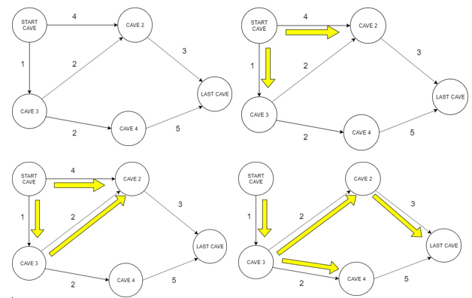
4
3
2
1
Image 2. Visualisation of Dijkstra’s Algorithm (adapted from [2]).

To visualise the stages above from image 1, image 2 can be used (adapted from an example [2]). The image describes the search stages from left to right. So, if the network of caves we were exploring had 5 caves within it we would start the search at the start cave.
The distance at the start cave will be set to 0, as it is the first cave, whilst the others will be set to the maximum amount as they are not known yet. The algorithm then looks at the connection matrix to see what caves the starting cave is connected to. In this case it is connected to caves 2 and 3 (Image 2. Part 1). The algorithm would then calculate the distance which would find that Cave 3 has the shorter route at 1 (Cave 2 has a distance of 4) (Image 2. Part 2)
The algorithm would then look at the connections of Cave 3 which are 2 and 4. The distance to cave 2 would be 1 + 2 = 3 which is less than the start node to cave 2. The algorithm also calculates the distance to Cave 4 which is 2. It gets added to the priority queue.The algorithm would then look from Cave 2 which is connected to that last cave. Currently the distance to Cave 2 is 3, then another 3 for distance is added to get to the last cave making the total distance 6 (Image 2. Part 4).
To check to see if a shorter path could be taken the algorithm will check the any caves it has yet to explore it checks the priority queue which it sees Cave 4. The algorithm then sees that Cave 4 has a connection to the last cave of 5 meaning that the overall distance was 8. Additionally, since there are no connections going from the last cave, the algorithm is terminated [2]. The final shortest path can be seen in Image 2 Part 4.
  - Evaluation
Dijskstra’s algorithm has an order of n2 meaning that it is suitable for a large problems so would work efficiently for a input file of 5,000 caves [9]. Additionally, Dijkstra is an simple algorithm to understand and implement regardless of the language used - although in some languages the processing time would be quicker. However, a significant disadvantage of the algorithm is that because it does a blind search, it consumes a lot of time and wastes resources as it looks through all the caves [3].
- Alternative Algorithm
  - A-Star Algorithm
An alternative algorithm to using Dijkstra’s pathfinding algorithm would be using an A-star (A*) search algorithm.
  - Evaluation of the Algorithm
A* can be seen as an extension of Dijkstra. This is because they use similar functions but where Dijkstra does a blind search on all the caves, the A* algorithm uses heuristics to guide its search [4]. A heuristic function is used to estimate the lowest path between the caves to the last cave. The heuristic should never overestimate the cost or the shortest path to reach the last cave [6].
In this case the heuristic would be advantageous as it will guess the likelihood of the cave being the best choice to reach the final cave [6]. A* evaluates each of the caves within the cave network by combining the cost to reach the cave with the cost to get the cave to the final cave.
So if g(n) represents the total distance from the starting cave to the current node, h(n) represents the heuristic estimated cost from the current cave to the last cave and f(n) represents the lowest cave for the neighbor cave then A* can be represented by the following formula:

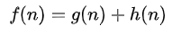
  - If the Problem were to Change
If the problem were to change so that the input file would include the path cost from taking a tunnel in a particular direction would not affect the choice of an A* algorithm. However, a condition for the A* algorithm to work is that the function used to estimate to distances must be admissible. This means that it must not overestimate the distance between two caves. For instance, if path cost cave 1 and cave 2 is 10 from each other then, the heuristic must estimate this distance to be at least 10. So, if the estimate function is not admissible it may lead to incorrect solution path being produced [8] or it would take the algorithm more attempts, making it take longer to find the solution. Therefore, an appropriate heuristic function must be implemented to stop this from happening.
  - Conclusion
An A* algorithm would be suitable for this coursework as the file read in to allow the robot to find the caves states the first and the last cave. This is because A-Star is a faster algorithm as it uses heuristics to guide its search. For this coursework the A* would be both a complete and optimal algorithm which will always find the shortest path in the cave network.

References
- Der Dijkstra-Algorithmus https://www-m9.ma.tum.de/graph-algorithms/spp-dijkstra/index_en.html, last accessed 2019/12/1
- Gupta, N., Mangla, K., Kumar Jha, A., Umar Md.: International Journal of New Technology and Research (IJNTR) ISSN:2454-4116, Volume-2, Issue-5, May 2016 Pages 122-124
- NYU Computer Science. https://cs.nyu.edu/courses/summer07/G22.2340-001/Presentations/Puthuparampil.pdf, last accessed 2019/12/2
- Russell, S., Norvig, P. Ernest, D.: Artificial Intelligence: A Modern Approach. 3rd edn. Prentice Hall, Upper Saddle River NJ (2010).
- Roy., B. A-Star Search Algorithm with step-by-step code., https://towardsdatascience.com/a-star-a-search-algorithm-eb495fb156bb
- Dechter, R., Pearl, J., Generalised Best-First Search Strategies and the Optimality of A*. Journal of the Association for Computing Machinery, Vol 32. No 3(1985)
- Duygulu, P., Chapter 4 Informed search and Exploration, http://www.cs.bilkent.edu.tr/~duygulu/Courses/CS461/Notes/HeuristicSearch.pdf, last accessed 2019/12/03
- Velden, L.: https://www-m9.ma.tum.de/graph-algorithms/spp-a-star/index_en.html, last accessed 2019/12/03
- Goyal, A., Mogha, P., Luthra, R., Sangwan, N.: Path Finding: A* OR Dijkstra’s?, ISSN:2321-1776, Volume-02,Issue-01, January 2014, pages 1-15.

