Using Dijkstra’s Pathfinding Algorithm
Amelia Handley [40326169]
¹ Edinburgh Napier University
40326169@napier.live.ac.uk
- Introduction
The aim of the coursework was to enable a robot to navigate through an unknown series of caverns. Each of the caves are connected by tunnels of varying length, with some only being one-directional or bi-directional. The task to develop a function software application to test for the shortest route within a network of caverns. The subsequent goal was to ensure that the program was to run as quickly as possible, by using an effective search algorithm.
- Dijkstra’s Pathfinding Algorithm
The algorithm which was used to develop a working software application to help the robot navigate through the caverns was Dijkstra’s pathfinding algorithm. To enable the robot to navigate its way through the cavern network it has been given a connection matrix to determine which caves are connected. This matrix was made up of binary values. Next, the distance between each of the caverns would have to be calculated using the coordinates of the caves.
- Implementation
The programming language Java was chosen to implement the algorithm. It resulted in the creation of two files first Coursework.java which contained functions and the main method for the program and a Cave.java which was the class that defined a cave.
  - Cave Class
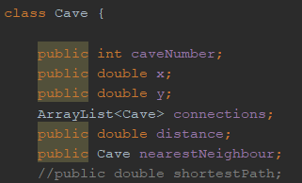
Image 1. Cave Class from source code from Cave.java

Contained within the cave class were the attributes that all the caves have. This includes a cave number to identify which cave it is, an x coordinate and a y coordinate. The connections were saved as an array list.
Within java the ArrayList class is used to store a collection of elements. An array list defers from an array as an array is a fixed size whereas an array list automatically changes its size. As we don’t know how many connections each cave will have, it was a suitable choice to use an array list.

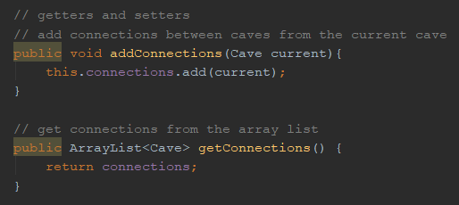
Image 2. Connections getters and setters from Cave.java
Getters and setters were created to add connections found within the connection matrix and get them when looking at each of the caves (Image 2).
  - Finding Each Cavern
The cavern files were stored in a particular format to be understood by the robot from an inputted file. It was a series of numbers split by a “,”. The first number (n) indicated the total number of caves in the cavern network. The next series of numbers were the coordinates for each of the caverns (n*2). After the coordinates the connection matrix (n*n) for the caverns was given as binary values - 1 meaning a cave was connected, 0 meaning it was not.
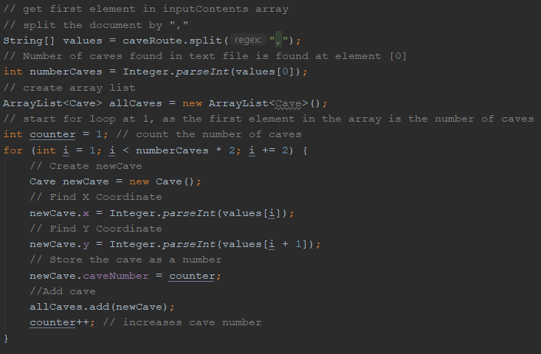
Image 3. Source code for finding each of the caverns from Coursework.java
To do this meant getting the input file and saving it as a list (as a string). It was important saving the initial input as a string as java has a split() string which breaks a given string based on a specific expression [1]. So, in the case of the input file it was split by the “,” to separate the values (see Image 3).
The caveRoute, which stores the inputted file, was then saved to a one-dimensional array called values. An array is a suitable data structure as each entry into the array can be identified by a key. For instance, the first element in the array is stored at point 0. This key attribute was used to find the number of caves by finding the first element in the array and saving it as a variable called numberCaves.
An array list was then made of our Cave object which defined what a cave was including the cave number, the x coordinate and y coordinate. An array list was used instead of an array as the algorithm does not know straight away how many caves there are in the network so it can dynamically grow in size. Also, like arrays, you can use a key to retrieve variables from it.
A for loop was used to iterate through each of the caves. The search starts at position 1-as position 0 of the array is the number of caves. It then goes through the array in by calling in numberCaves and multiplying it by 2 for each set of coordinates. The for loop also increases by 2 for each iteration for the same reason.
A new object is called newCave which inherits its variables from the Cave class. The x-coordinate is saved for the value that the for loop is currently on, and the y-coordinate saves the value next to it. Out width the loop there is a counter which will be used to save the cave number as it will increase with each iteration as well.
  - Calculating Distance
Now that we have saved each cave by its x-coordinate and y-coordinate a function was required to calculate the distance between each of the caves. This was done using Euclidean distance (Image 4):
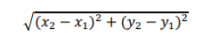
Image 4. Formula for Euclidean distance

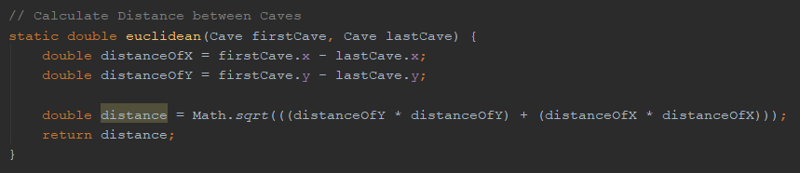
Image 5. Source code for calculating distance between two caves from Coursework.java

The function requires an input from two caves. It will then get the coordinates for both the caves. Distance between the x and y coordinates is found within the caves was done by first subtracting the values from each other creating x and y to create two new variables distanceOfX and distanceOfY (see Image 5).
Using the Math.sqrt() which returns a positive square root of a double value. The value calculate would be the distanceOfX squared plus the distanceOfY squared. This would return the distance between the caves.
  - Connection Matrix
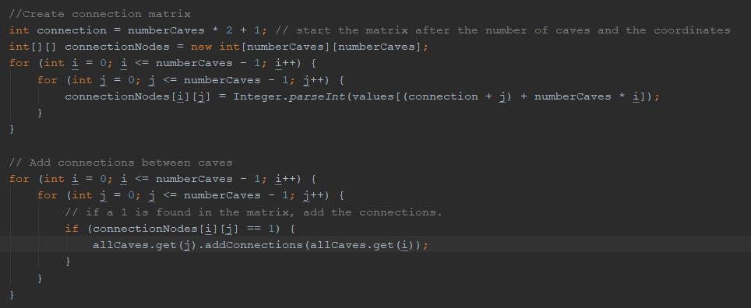
Image 6. Creation of Connection Matrix from Coursework.java

A two-dimensional array was used to create the connection matrix from the input file. A 2-D array is a data structure which can be used to represent rows and columns, which is required to create the matrix to see which caves are connected to each other (Image 6). The array is set to equal the number of caves in the cave - using the numberCaves variable from before to create the table. So, the size of the array will be numberCaves * numberCaves. The table will go through the 2-D array for the number of caves in the network - minus 1 as arrays always start at 0 using a for loop and we need to start the matrix at array position 1.
The matrix is set to equal the values (the array of string variables initialized previously). It converts the values from string inputs to integers using the parseInt method. The connection is equal to the number of caves multiplied by 2 plus 1 to get to the right position from the values array (i.e. where the matrix will start). You then add j to the connection to get to the correct position in the column. Then number of caves multiplied by i to where the row is being chosen is added to give a position in the matrix.

Image 7. Creating Connections from Coursework.java

Then, another for loop is used to search through the connection matrix (see Image 7). If a value of 1 is found in the matrix then it adds the connection using the setter method in the Cave Class called addConnections (Image 1).
  - Finding Shortest Path
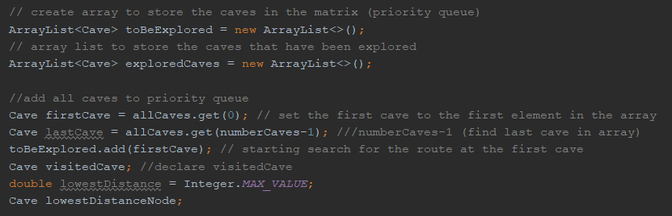
Image 8. Declaring variables needed to find the shortest path from Coursework.java

To use Dijkstra’s pathfinding algorithm would mean finding the shortest path from the start cave to the last cave by searching each of the caves in the network. To do this the caves are added to a priority queue. The priority queue was called toBeExplored (see Image 8). This will ensure that all the caves have been searched. There is another array list which will add all the caves that have been explored - called exploredCaves.

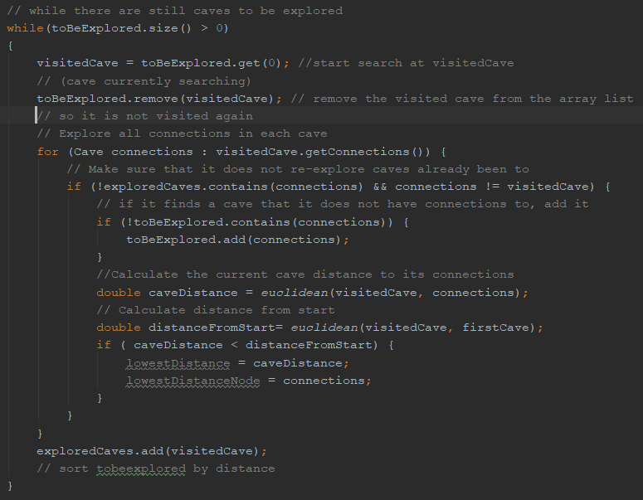
Image 9. The start of implementation for the search algorithm from Coursework.java

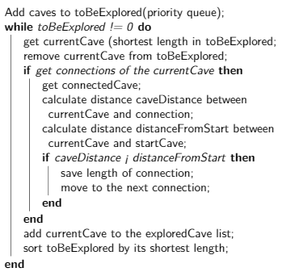
Within the main function there will be a while loop which will operate Djisktra’s pathfinding algorithm (Image 9). The pseudocode for the first part of the search algorithm can be seen in image 10. It starts with a while loop which loops to see if there are still caves in the priority queue (or the toBeExplored array list). Whilst there are still caves to be explored, it starts the search at the visitedCave - which starts at the first cave. The cave that is being searched is then removed from the priority queue, so it is not searched again.
A for loop is used to go through all the connections of the caves. To ensure that caves that have been explored - in the array list exploredCave - are not re-explored. It does this by checking the current cave and the connections of the visited cave. If the cave is not in the exploredCave array and it is not in the connections array, then the algorithm checks to see the cave has connections. If it does not it adds it to the array.
Image 10. Pseudocode for first part of search algorithm.
The distance from the cave to the visited cave and its connections is then calculated using the Euclidean function created. It also checked the distance the visitedCave is from the start. If the current caveDistance is less than the start, then it the algorithm will add the distance of the connection and move to the next cave. To ensure that the program outlined in Image 7 would work, it would require a function to sort the priority queue by its shortest length. This would enable the program to find the shortest path in the next function [2].
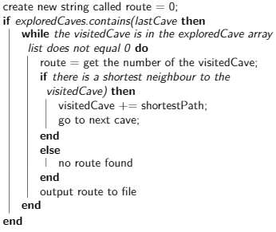
To ensure that the shortest path has been found, it would mean going back through the priority queue, which will have been sorted by its shortest length. Then, when looking at the visitedCave, the while loop will run as long as it does not equal 0. Once it reaches 0 it will mean that there are no caves left to explore in the algorithm (see Image 11).
First, the cave number of the visitedCave is added to a variable called route, which will be used to store the numbers of each of the caves.
An if statement is used to go backwards in the array list to ensure that the path being followed is the shortest. It does this using the explored caves array list and if the shortest path is found it will save it. Then go to the next cave. If no neighbours are found, then the algorithm will determine that there is no route possible to take.
Image 11. Pseudocode for second part of search algorithm.
This resulting route would be printed to an output file.
- Conclusion
To conclude, through the implementation of Dijkstra’s algorithm as detailed above would produce the shortest route possible. The source code produced for the assessment was able to find the shortest neighbour cave for each cave and calculate the overall distance from the start. Therefore, to make the program work would require the implementation of a function to sort the priority queue by its length and store the nearest neighbour to each cave.

References
- Geeksforgeeks, https://www.geeksforgeeks.org/split-string-java-examples/, last accessed 2019/12/2
- Baeldung, https://www.baeldung.com/java-dijkstra, last accessed 2019/12/3

