Data Visualisation
Amelia Handley [40326169]
¹ Edinburgh Napier University
40326169@live.napier.ac.uk
Abstract. Participants were asked to complete a set of three tasks in five different locations. These participants were recorded at each task and were timed. Also, the participants ages were recorded and were split into four age groups: under 16, young adult, middle-aged and older-aged.
A dataset containing 10000 measurements was explored finding relationships between the various attributes. It was found that in the dataset there were cases of outliers - data without the normal range - within two relationships: the participants age against the participant score for part A and the participants age band against the participants score for part B. In addition, there were five relationships in the attributes from the dataset. As well as a graph that has been fully optimised, meaning that…
- Outliers in the Dataset
  - Participants Age vs Participant Score for Part B
Throughout the exploration of the dataset it was found that were outliers found within the relationship between the participants and the participant score for test part B (see Fig. 1). The outliers can be considered so as they are out with the normal range of data [2]. The chart chosen to show this was a scatter plot. This is because both attributes being compared were continuous [3]. It also highlights the relationship between participants that are 0-100 years old as well as being between 0-100% score for part B. Whilst the outliers follow a similar trend to the rest of the graph, it shows ages between …… and a score of 153-163% - which is out with the possible data range of 0-100%.
  - Participants Age Band vs Participants Score for Part A
There was another instance of an outlier found within the relationship of the participants age band and the score for part A of the test. The chart used to show this relationship was a box plot. This is because it shows the relationship between the attributes. Also, it can be shown as well as highlighting outliers, as they are dots out with the “box” and “whiskers” of the chart [4]. From reviewing Figure 2, the attributes are split by male and female (see Fig. 2). They show a similar relationship and trend in data, examining the females scores show that there are negative outliers. Hence meaning that this is an outlier as it is not within the data range for the score A, for 0-100%.

- Relationships found in Dataset
  - Participants Age vs Participant Score for Part B
The participants age and the participant score showed a significant relationship. Using a scatter plot showed that there was a positive correlation between the attributes [5] (see Fig. 1). Meaning, that the chart showed that as the participants age increases, the participant score for part B also increases.
A scatter plot was used to show this relationship between the two continuous attributes [3]. ……..
  - Participants Age Band vs Participants Score for Part A
Examining the participants age band and the participants score for part A showed a positive correlation between the attributes (see Fig. 2). Young Adults (16-34 years old), Middle-aged adults (35-64 years old) and older adults (65 years plus) all displayed higher mean scores of around 65-76%. However, those under 16 years old had a mean of around 20% of the part A score. Thus, meaning that as the age of the participant increases, as does the score for part A.
To display this relationship, a box plot was used. Box plots can be used to show the average score of the participants within the “box” - showing the maximum, minimum and median scores per each age band [6].
  - Completion Time for each Participant vs their Age Band
The completion time to complete all three of the tasks was recorded for each of the participants. This was compared against the age band of the participants which showed a relationship when split by the Gender (see Fig. 3). For the males there is a slight increasing trend between the attributes as the completion time increases, so does the age band (or age) of the participants. This means that as the age of the participant increases, so does the completion time. Whilst for females there is a negative correlation between the completion time and the age band. Thus, meaning the older the participant, the less time it takes to complete all three of the activities.
To show this relationship a box plot was used.
  - Participants Score for Test C vs the Participants Age
Examining the dataset highlighted a significant between the participants score for test C and the age. At first, it appeared that there was no significant relationship that could be examined between the attributes until you split the participants score by the five locations. However, on review it appeared that there was a significant relationship between the attributes (see Fig. 4). In locations B, C and E it showed that there was no change in the score as the age increased, remaining 48%, 41% and 37% respectively. However, in location A it displays a decrease in the score for part c as the age increases, whilst location D showed an increasing trend in the score as the age increased.
To illustrate this relationship a bar chart was used. This is because the age band is a discrete attribute and the …
  - Completion Time of All Three Tests vs Participant Score for Part B

- Optimised Visualisation
For the optimised visualisation the relationship between the Participants Age Band vs Participants Score for Part A. Initially a box plot was used to display this relationship (see Fig. 2). Whilst the box plot is an effective visualisation choice for showing the average score of the participants for each age group and to highlight outliers, showing the relationship as a bar chart is more efficient. Not only is it simpler to read, but it shows the overall trend for all participants - not needing to separate the males and females. The bar chart function (geom_bar(stat="Identity")) in ggplot2 counts the total number of scores for each age band [3]. It also highlights how significant the difference is between the under 16 category compared with the young adult, middle-aged and older-adult - which are all nearly three times the number than the under 16.
….
- Conclusion

Appendices

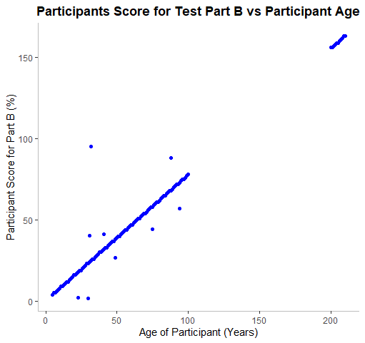
Fig. 1. Participant Score for Test B vs Age of Participant
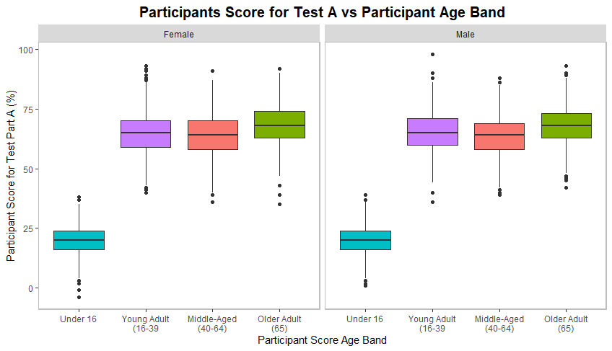
Fig. 2. Participant Score for Test A vs Participant Age Band, separated by Gender

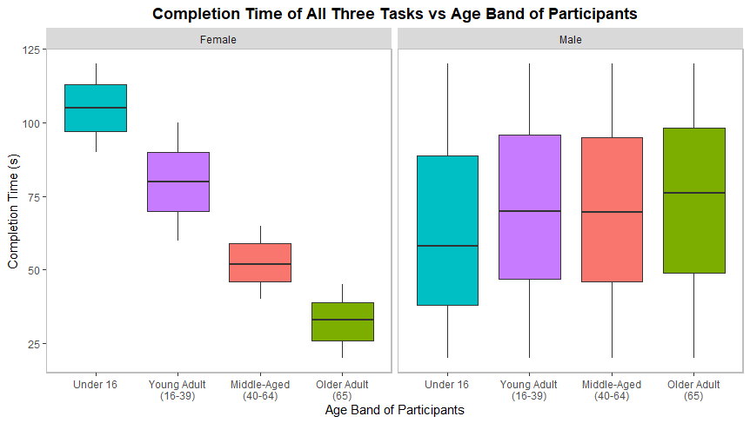
Fig. 3. Completion Time for each Participant vs their Age Band, separated by Gender

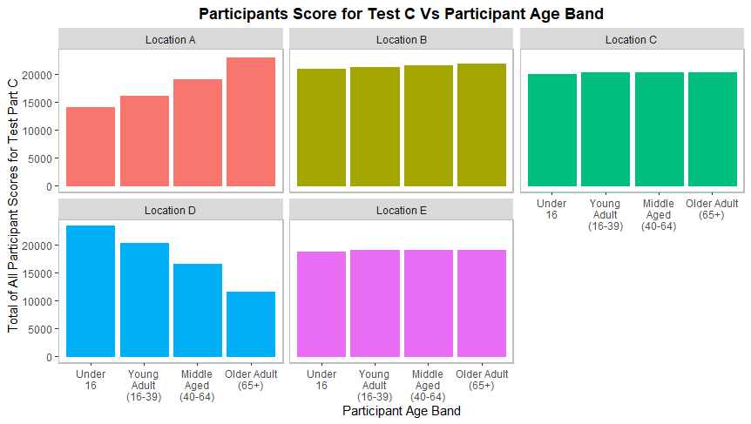

Fig. 4. Participants Score for Test C vs the Participants Age, separated by Location

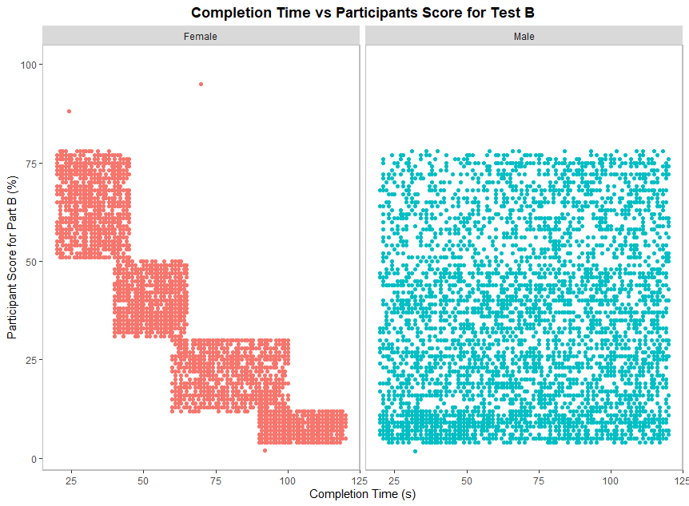
Fig. 5. Completion Time of All Three Tests vs the Participant Score for Part B (%)

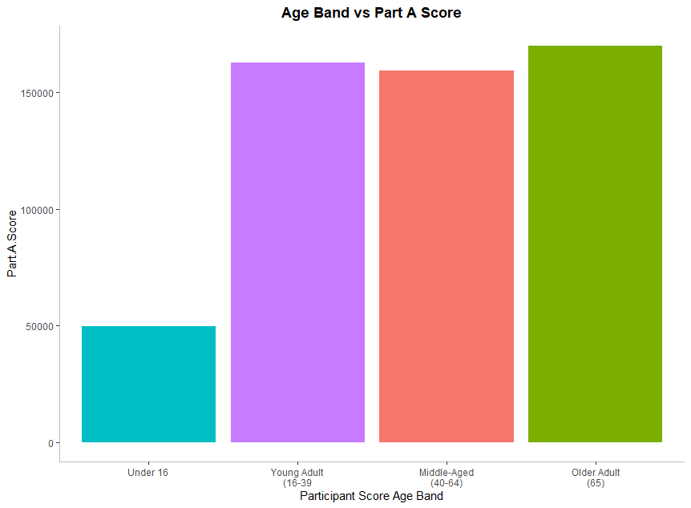
Fig. 6. Fully Visualised Bar Chart of Participant Score for Part A vs Participant Age Band

References

- Wickham H. Getting Started with ggplot2. In: ggplot2. Use R!. Springer, Cham (2016).
- Seeing Data, http://seeingdata.org/developing-visualisation-literacy/key-terms-in-visualisation/, last accessed 2019/10/23
- RStudio. Data Visualisation with GGplot2, https://rstudio.com/wp-content/uploads/2015/03/ggplot2-cheatsheet.pdf, last access 2019/10/23
- Engineering Statistics Handbook. What are outliers in the data?, https://www.itl.nist.gov/div898/handbook/prc/section1/prc16.htm, last accessed 2019/10/23
- Khan Academy. Scatterplots and Correlation Review, https://www.khanacademy.org/math/statistics-probability/describing-relationships-quantitative-data/introduction-to-scatterplots/a/scatterplots-and-correlation-review, last accessed 2019/10/23
- Understanding Boxplots, https://towardsdatascience.com/understanding-boxplots-5e2df7bcbd51, last accessed 2019/11/21.

- Author, F.: Article title. Journal 2(5), 99–110 (2016).
- Author, F., Author, S.: Title of a proceedings paper. In: Editor, F., Editor, S. (eds.) CONFERENCE 2016, LNCS, vol. 9999, pp. 1–13. Springer, Heidelberg (2016).
- Author, F., Author, S., Author, T.: Book title. 2nd edn. Publisher, Location (1999).
- Author, F.: Contribution title. In: 9th International Proceedings on Proceedings, pp. 1–2. Publisher, Location (2010).
- LNCS Homepage, http://www.springer.com/lncs, last accessed 2019/11/21.

