LAPORAN LARAVEL

XII RPL

NAMA:SALSABILLA

KELAS:XII RPL

***1.KODINGAN UNTUK BIODATACONTROLLER.PHP***

<?php

namespace App\Http\Controllers;

use App\Http\Controllers\Controller;

use Illuminate\Http\Request;

class BiodataController extends Controller

{

public function index($nama)

{

return $nama;

}

public function formulir()

{

return view('formulir');

}

public function proses(Request $request)

{

$nama = $request->input('nama');

$no_induk_siswa = $request->input('no_induk_siswa');

$alamat = $request->input('alamat');

$kompetensi_keahlian = $request->input('kompetensi_keahlian');

$jenis_kelamin = $request->input('jenis_kelamin');

$alamat_pkl = $request->input('alamat_pkl');

$no_hp_siswa = $request->input('no_hp_siswa');

$no_hp_ortu = $request->input('no_hp_ortu');

$pilihan_tempat = $request->input('pilihan_tempat');

$tgl = $request->input('tgl');

return "

<!DOCTYPE html>

<html>

<head>

<title>Biodata Peserta PKL</title>

<b><center>BIODATA PESERTA PKL</b>

<b><center>SMK NEGERI 1 LINTAU BUO</b></center></center>

<p>1. Nama Siswa: $nama</p>

<p>2. Nomor Induk Siswa: $no_induk_siswa</p>

<p>3. Kompetensi Keahlian: $kompetensi_keahlian</p>

<p>4. Jenis Kelamin: $jenis_kelamin</p>

<p>5. Tanggal Lahir: $tgl</p>

<p>6. Alamat Asal Siswa: $alamat</p>

<p>7. Alamat Tempat Tinggal Selama PKL: $alamat_pkl</p>

<p>8. Nomor HP Siswa: $no_hp_siswa</p>

<p>9. Nomor HP Orang Tua: $no_hp_ortu</p>

<p>10. Pilihan Tempat: $pilihan_tempat</p>

</html>";

}

}

***2.KODINGAN UNTUK REQUESTDATACONTROLLER.PHP:***

<?php

namespace App\Http\Controllers;

use App\Http\Controllers\Controller;

use Illuminate\Http\Request;

class RequestdataController extends Controller

{

public function index($nama)

{

return $nama;

}

}

***3.KODINGAN UNTUK DI WEB.PHP:***

Route::get('/kirim/{nama}','App\Http\Controllers\RequestdataController@index');

Route::get('/formulir','App\Http\Controllers\BiodataController@formulir');

Route::post('/formulir/proses','App\Http\Controllers\BiodataController@proses');

***4.KODINGAN UNTUK FORMULIR.BLADE.PHP:***

<!DOCTYPE html>

<html>

<head>

<title>Biodata Diri</title>

</head>

<body>

<form action="/formulir/proses" method="post">

<input type="hidden" name = "_token" value = "<?php echo csrf_token () ?> ">

<p align="center">FORMULIR PESERTA </p>

<p align="center">PRAKTEK KERJA LAPANGAN </p>

<p align="center">SMK NEGERI 1 LINTAU BUO </p>

<table width="474" border="0">

<tr>

<td width="184">1. Nama Siswa </td>

<td width="31"> : </td>

<td width="245"><input type="text" name="nama" id="nama" size="30">

</td>

</tr>

<tr>

<td width="184">2. No Induk Siswa </td>

<td width="31"> : </td>

<td width="245"><input type="text" name="no_induk_siswa">

</tr>

<tr>

<td width="184">3. Kompetensi Keahlian </td>

<td width="31"> : </td>

<td width="245"><input type="text" name="kompetensi_keahlian">

</td>

</tr>

<tr>

<td width="184">4. Jenis Kelamin </td>

<td width="31"> : </td>

<td width="184"><input type="radio" name="jenis_kelamin" value="Laki-Laki"> Laki-Laki

<input type="radio" name="jenis_kelamin" value="Perempuan"> Perempuan</tr>

<tr>

<td height="34">5. Tanggal Lahir </td>

<td>:</td>

<td><input type="date" name="tgl" id="tgl" size="30"></td>

</tr>

<tr>

<td>6. Alamat Siswa</td>

<td>:</td>

<td><textarea name="alamat" cols="30" rows="5" id="alamat"></textarea></td>

</tr>

<tr>

<td width="184">7. Alamat Tempat Tinggal Selama PKL </td>

<td>:</td>

<td><input type="text" name="alamat_pkl"></td>

</tr>

<tr>

<td width="184">8. No HP Siswa </td>

<td>:</td>

<td><input type="text" name="no_hp_siswa"></td>

</tr>

<tr>

<td width="184">9. No HP Orang Tua </td>

<td>:</td>

<td><input type="text" name="no_hp_ortu"></td>

</tr>

<tr>

<td width="184">10. Pilihan Tempat:</td>

<td>:</td>

<td><select id="pilihan_tempat" name="pilihan_tempat">

<option value="padang panjang">padang panjang</option>

<option value="Padang">Padang</option>

<option value="Bukittinggi">Bukittinggi</option>

<option value="Solok">Solok</option>

<option value="Payakumbuh">Payakumbuh</option>

</select>

</tr>

<tr>

<td></td>

<td></td>

<td> <input type="submit" value="simpan">

<input type="button" value="Batal">

</td>

</tr>

</table>

</form>

</body>

</html>

***BEGINI TAMPILAN HASIL UNTUK FORMULIR:***

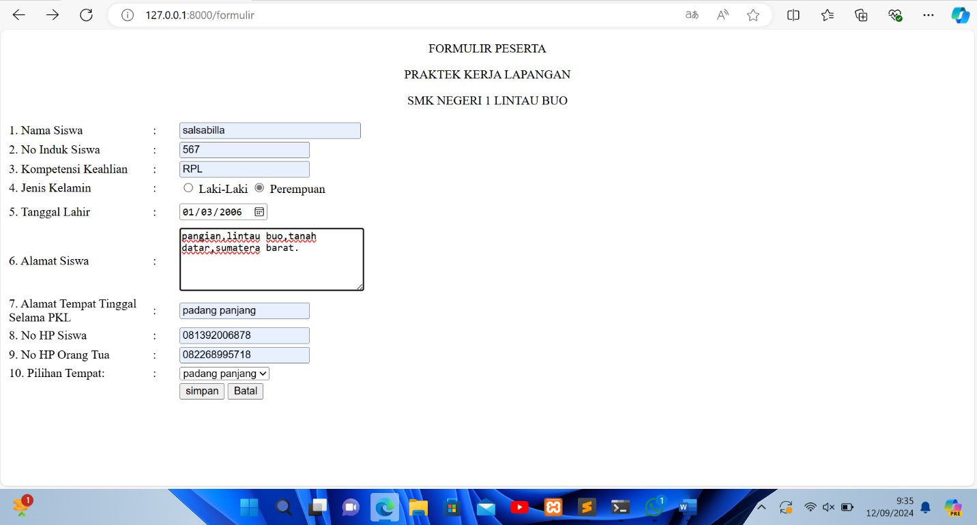

***BEGINI TAMPILAN HASIL UNTUK PROSES:***

