Amelia Doetsch, William Hanley, Alex Kaddis

PHY 6860—Project 2A

April 20, 2019

I. Cluster growth with the DLA Model

In this problem, the goal is to create a cluster on a 2-dimensional lattice using the DLA model. In this case, the cluster should have a radius of 100. This is to say that the cluster should stop growing once a particle is added onto the cluster at a position 100 units away from the initial particle. The starting radius and escape radius are also taken to be 100 for simplicity.

First, an initial particle is placed at the center of the lattice. Then, a new particle is released at a distance of 100 from the center particle. It then performs a random walk. If the particle lands on a point in the lattice that is next to an already occupied lattice point, then it is added onto the cluster. If the particle escapes (i.e. its distance from the center exceeds 100), then the random walk is terminated and that particle is disregarded.

This process of releasing particles and performing random walks is repeated until the desired radius is achieved.

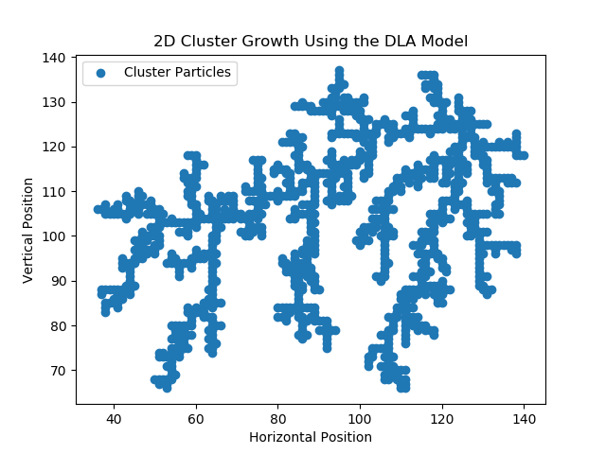

Figure 1: Results of part 1a