**American Boy – Estelle**

*[Chorus]*

Bmaj7 Gmaj7

Take me on a trip, I'd like to go some day

Em Em

Take me to New York, I'd love to see LA

Bmaj7 Gmaj7

I really want to come kick it with you

Em Gb7

You'll be my American boy

Bmaj7 Gmaj7

Can we get away this weekend?

Em

Take me to Broadway

Em

Let's go shopping baby then we'll go to a café

Bmaj7 Gmaj7

Let's go on the subway

Em

Take me to your hood

Em Bmaj7

I never been to Brooklyn and I'd like to see what's good

Gmaj7

Dress in all your fancy clothes

Em Em

Sneakers looking fresh to death, I'm loving those Shell Toes

Bmaj7

Walking that walk

Gmaj7

Talk that slick talk

Em Gb7

Likin' this American boy, American boy

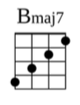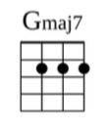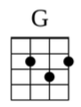

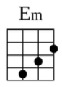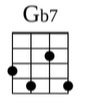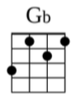

*[Repeat Chorus]*

Bmaj7 Gmaj7

Take me on a trip, I'd like to go some day

Em Em

Take me to Chicago, San Francisco Bay

Bmaj7 Gmaj7

I really want to come kick it with you

Em Gb7 Bmaj7

You'll be my American boy, American boy