**Bad Day – Daniel Powter**

**[C]** Where is the **[F]** moment when we need it the **[G]** most **[F]**-**[G]**

**[C]** You kick up the **[F]** leaves and the magic is **[G]** lost **[F]**-**[G]**

**[Am]** They tell me your **[G]** blue skies fade to **[F]** grey

They tell me your **[C]** passion's gone **[Dm]** away

And I don't **[Dm]** need no carrying **[G]** on

**[C]** Stand in the **[F]** line just to hit a new **[G]** low **[F]**-**[G]**

**[C]** You're faking a **[F]** smile with the coffee to **[G]** go **[F]**-**[G]**

**[Am]** You tell me your **[G]** life's been way off **[F]** line

You're falling to **[C]** pieces every **[Dm]** time

And I don't **[Dm]** need no carrying **[G]** on

***[Chorus]***

Cause you had a bad **[C]** day

You're taking one **[F]** down

You sing a sad **[Dm]** song just to turn it **[G]** around

You say you don't **[C]** know

You tell me don't **[F]** lie

You work at a **[Dm]** smile and you go for a **[G]** ride

You had a bad **[Am]** day

The camera don't **[G]** lie

You're coming back **[F]** down and you really don't **[C]** mind

You had a bad **[Dm]** day **[G]**

You had a bad **[C]** day

**[C]** **[F]** **[G]** **[F]**-**[G]** x2

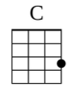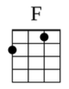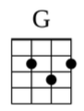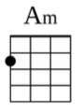

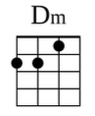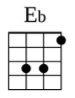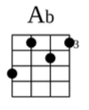

**[Am]** Well you need a **[G]** blue sky holi**[F]**day

The point is they **[C]** laugh at what you **[Dm]** say

And I don't **[Dm]** need no carrying **[G]** on

***(Repeat Chorus)***

**[Eb]** Sometimes the system goes on the blink

And the **[Ab]** whole thing it turns out wrong

You **[Eb]** might not make it back and you know

That you could **[Ab]** be well oh that strong

Well I'm not **[G]** wrong

**[C]** So where is the **[F]** passion when you need it the **[G]** most **[F]**-**[G]**

**[C]** You kick up the **[F]** leaves and the magic is **[G]** lost

***(Repeat Chorus)***