**Budapest – George Ezra**

G G

My house in Budapest my, my hidden treasure chest

G G

Golden grand piano, my beautiful castillo

C C G G

You, oh, you, oh I'd leave it all

G G

My acres of a land, I have achieved

G G

It may be hard for you to, stop and believe

C C G G

But for you, oh you, oh I'd leave it all

*[Chorus]*

D

Give me one good reason

C G G

Why I should never make a change,

D

And baby if you hold me

C G G

Then all of this will go away

G G

My many artifacts, the list goes on

G G

If you just say the words I, I'll up and run

C C G G

Oh to you, oh, you, oh I'd leave it all

*[Repeat Chorus]*

G G

My friends and family they, don't understand

G G

They fear they'’d lose so much if, you take my hand

C C G G

But for you, oh you, oh I'd lose it all

*[Repeat Chorus]*

G G

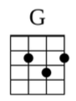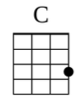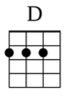

My house in Budapest my, my hidden treasure chest

G G

Golden grand piano, my beautiful castillo

C C G G

Oh for you, oh, you, oh I'd leave it all

Strum Patterns To Try:

1) **D D U D**

1 + 2 + 3 + 4 +

2) **D U D**

1 + 2 + 3 + 4 +

3) **D U D D U U D U**

1 e + a 2 e + a 3 e + a 4 e + a

4) **D U D U D D**

1 e + a 2 e + a 3 e + a 4 e + a