**Closing Time - Semisonic**

G D

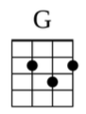 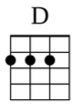

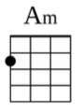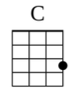

Closing time

Am C G D Am C

Open all the doors and let you out into the world

G D

Closing time

Am C G D Am C

Turn all of the lights on over every boy and every girl

G D

Closing time

Am C G D Am C

One last call for alcohol so finish your whiskey or beer

G D

Closing time

Am C G D Am C

You don't have to go home but you can't stay here

*[Chorus]*

G D Am C

I know who I want to take me home

G D Am C

I know who I want to take me home

G D Am C G D Am C

I know who I want to take me home, take me home

G D

Closing time

Am C G D Am C

Time for you to go out to the places you will be from

G D

Closing time

Am C G D

This room won't be open till your brothers or your sisters

Am C

come

G D Am C

So gather up your jackets move it to the exits

G D Am C

I hope you have found a friend

G D

Closing time

Am C G D Am C

Every new beginning comes from some other beginning's end, yeah

*[Repeat Chorus]*

G D Am C G D Am C G

Closing time, every new beginning comes from some other beginning's end