**Drops Of Jupiter - Train**

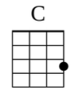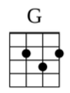

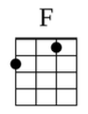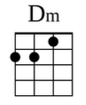

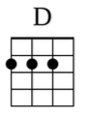

C

Now that she's back in the atmosphere

G F F

With drops of Jupiter in her hair, hey, hey

C

She acts like summer and walks like rain

G F F

Reminds me that there's time to change, hey, hey

C

Since the return from her stay on the moon

G F F

She listens like spring and she talks like June, hey, hey

G D

Tell me did you sail across the sun

F

Did you make it to the Milky Way to see the lights all faded

C

And that heaven is overrated

G D

Tell me, did you fall for a shooting star

Dm

One without a permanent scar

F C G F F

And did you miss me while you were looking for yourself out there

C

Now that she's back from that soul vacation

G F F

Tracing her way through the constellation, hey, hey

C

She checks out Mozart while she does tae-bo

G F F

Reminds me that there's time to grow, hey, hey

C

Now that she's back in the atmosphere

G F

I'm afraid that she might think of me as plain ol' Jane

F

Told a story about a man who was too afraid to fly so he never did land

G D

Tell me did the wind sweep you off your feet

F

Did you finally get the chance to dance along the light of day

C

And head back to the Milky Way

G D

And tell me, did Venus blow your mind

Dm

Was it everything you wanted to find

F C G F F

And did you miss me while you were looking for yourself out there

C

Can you imagine no love, pride, deep-fried chicken

G F F

Your best friend always sticking up for you even when I know you're wrong

C G

Can you imagine no 1st dance freezedried romance 5-hour phone conversation

F F

The best soy latte that you ever had, and me

G D

Tell me did the wind sweep you off your feet

F

Did you finally get the chance to dance along the light of day

C

And head back toward the Milky Way

G D

Tell me did you sail across the sun

F

Did you make it to the Milky Way to see the lights all faded

C

And that heaven is overrated

G D

Tell me, did you fall for a shooting star

Dm

One without a permanent scar

F C

And did you miss me while you were looking for yourself out there





