**Ex's and Oh's – Elle King**

Swing time: D DU UDU or D XU UXU

Am Am

Well, I had me a boy, turned him into a man

Am Am

I showed him all the things that he didn't understand

E7 Am Am

Whoa, and then I let him go

Am Am

Now, there's one in California who's been cursing my name

Am Am

'Cause I found me a better lover in the UK

E7 Am Am

Hey, hey, until I made my getaway

*(--Mute strings--)*

One, two, three, they gonna run back to me

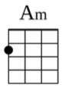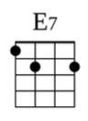

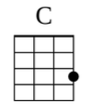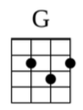

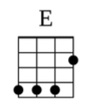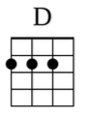

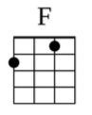

'Cause I'm the best baby that they never gotta keep

One, two, three, they gonna run back to me

They always wanna come, but they never wanna leave

C G Am

Ex's and oh, oh, oh's they haunt me

E C G

Like ghosts they want me to make 'em all

D F

They won't let go

Am

Ex's and oh's

Am Am

I had a summer lover down in New Orleans

Am Am

Kept him warm in the winter, left him frozen in the spring

E7 Am

My, my, how the seasons go by

Am Am

I get high, and I love to get low

Am Am

So the hearts keep breaking, and the heads just roll

E7 Am

You know that's how the story goes

*(--Mute strings--)*

One, two, three, they gonna run back to me

'Cause I'm the best baby that they never gotta keep

One, two, three, they gonna run back to me

They always wanna come, but they never wanna leave

C G Am

Ex's and the oh, oh, oh's they haunt me

E C G

Like ghosts they want me to make 'em all

D F

They won't let go

C G Am

My ex's and the oh, oh, oh's they haunt me

E C G

Like ghosts they want me to make 'em all

D F

They won't let go

Am

Ex's and oh's

*(--Mute strings--)*

One, two, three, they gonna run back to me

Coming over mountains and a-sailing over seas

One, two, three, they gonna run back to me

They always wanna come, but they never wanna leave









C G Am

My ex's and the oh, oh, oh's they haunt me

E C G

Like ghosts they want me to make 'em all

D F

They won't let go

C G Am

Ex's and the oh, oh, oh's they haunt me

E C G

Like ghosts they want me to make 'em all

D F

They won't let go

Am

Ex's and oh's