**Forget You – Cee Lo Green**

***[Chorus]***

I see you **[C]** driving round town with the **[D7]** girl I love

And I'm like **[F]** "Forget you!" **[C]** Ooh ooh ooh

I guess the **[C]** change in my pocket **[D7]** wasn't enough

And I'm like **[F]** "Forget you, and for**[C]**get her too."

**[C]** If I was richer, I'd **[D7]** still be with ya

**[F]** Now ain't that some xxxx – **[C]** Ain't that some xxxx -

And though there's **[C]** pain in my chest I still **[D7]** wish you the best

With a **[F]** "Forget you" **[C]** Ooh ooh ooh

Yeah I'm **[C]** sorry, I can't afford a **[D7]** Ferrari

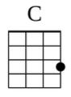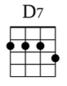

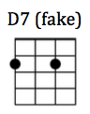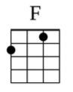

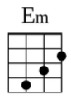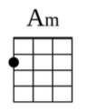

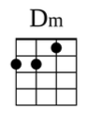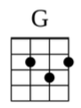

But **[F]** that don't mean I can't get you there **[C]**

I guess he's an **[C]** Xbox, and I'm more A**[D7]**tari

But the **[F]** way you play your game ain't fair **[C]**

I pity the **[C]** foo-oo-ol who **[D7]** falls in love with you

**[F]** Oh she's a gold digger, **[C]** just thought you should know xxxx

**[C]** Ooo-oo-oo, **[D7]** I got some news for you

**[F]** Yeah go run and tell your little boyfriend **[C]**

***(Repeat Chorus)***

Now **[C]** I know I had to **[D7]** borrow

**[F]** beg and steal and lie and cheat **[C]**

Tryin to **[C]** keep ya, tryin' to **[D7]** please ya

Cause **[F]** being in love with your xxxx ain't cheap **[C]**

I pity the **[C]** foo-oo-ol who **[D7]** falls in love with you

**[F]** Oh she's a gold digger, **[C]** just thought you should know xxxx

**[C]** Ooo-oo-oo, **[D7]** I got some news for you

**[F]** Ooh, I really hate your xxxx right now **[C]**

***(Repeat Chorus)***

Now **[Em]** baby, baby, baby  
Why you **[Am]** wanna wanna hurt me so **[Dm]** bad? *(So bad, so* ***[G]*** *bad, so bad)*

I **[Em]** tried to tell my momma but she **[Am]** told me

"This is one for your **[Dm]** dad" *(Your dad, your* ***[G]*** *dad, your dad)*

And I was like **[Em]**↓ ugh! Why? **[Am]**↓ Ugh! Why?

**[Dm]**↓ Ugh! Why-y **[G]**↓ la-a-dy?

**[Em]**↓ Oh! I love you, **[Am]**↓ oh!

I still love **[G]** you. Oooh!

***(Repeat Chorus)***