**Happy Days Theme Song – Misc Television**

Dashed chord pairs indicate to play each chord half as long as usual.

**C Am**

Sunday, Monday, Happy Days,

**Dm G**

Tuesday, Wednesday, Happy Days,

**Em Am**

Thursday, Friday, Happy Days.

**F - G F - G**

The weekend comes, my cycle hums,

**G7 G7**

Ready to race to you

**C Am**

These days are ours,

**F G**

Happy and free (Oh Happy Days)

**C Am**

These days are ours,

**F G**

Share them with me (Oh Happy Days)

**C C**

Goodbye gray sky, hello blue,

**F**

'Cause nothin' can hold me

F

When I hold you

**D D**

Feels so right, it can't be wrong,

**G G**

Rockin' and rollin' all week long

**C Am F G**

**C Am F G**

**C Am**

Sunday, Monday, Happy Days,

**Dm G**

Tuesday, Wednesday, Happy Days,

**Em Am**

Thursday, Friday, Happy Days.

**F - G F - G**

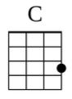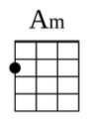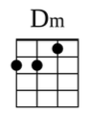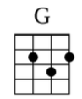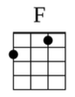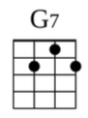

Saturday, what a day

**G7 G7**

Groovin' all week with you

**C Am**

These days are ours,

**F G**

Share them with me (Oh Happy Days)

**C Am**

These days are ours,

**F G**

Happy and free (Oh Happy Days)

**C Am**

These happy days are yours and

**F G**

Mine, these happy days are yours

**F C**

And mine, happy days!