**Hey Ya - Outkast**

Island Strum: D DU UDU. Play G only half as long; can use D D

C F

My baby don't mess around

F G Am Am

Because she loves me so, this I know for sure

C F

But does she really wanna

F G Am Am

But can't stand to see me walk out the door

C F

Don't try to fight the feeling

F G Am Am

Cause the thought alone is killing me right now

C F

Thank God for Mom and Dad

F G Am Am

For sticking two together like we don't know how

[Chorus]

C F F G Am Am

He-ey ya! Hey ya!

C F F G Am Am

He-ey ya! Hey ya!

C F

You think you got it, Oh you think you got it

F G Am Am

But got it just don't get it till there's nothing at all

C F

We get together, Oh we get together

F G Am Am

But separate's always better when there's feelings involved

C F

If what they say is "Nothing is forever"

F

Then what makes, then what makes,

G Am Am

Then what makes, then what makes, love the exception

C F

So why you why you why you why you why you

F G Am ↓

Are we so in denial when we know we're not happy here

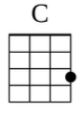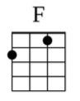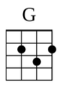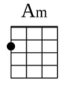

*[Repeat Chorus]*