**How Far I’ll Go - Moana**

*(Verse)*

**C Dm**

I've been staring at the edge of the water

**Am F**

'Long as I can remember, never really knowing why

**C Dm**

I wish I could be the perfect daughter

Strum Patterns To Try:

1) **D D U D**

1 + 2 + 3 + 4 +

2) **D U D**

1 + 2 + 3 + 4 +

3) **D U D D U U D U**

1 e + a 2 e + a 3 e + a 4 e + a

4) **D U D U D D**

1 e + a 2 e + a 3 e + a 4 e + a

**Am**

But I come back to the water

**F**

No matter how hard I try

**Am**

Every turn I take, every trail I track

**G**

Every path I make, every road leads back

**C**

To the place I know, where I can not go

**Fm** **↓**

Where I long to be

*(Chorus)*

**C G**

See the line where the sky meets the sea? It calls me

**Am F**

And no one knows, how far it goes

**C G**

If the wind in my sail on the sea stays behind me

**Am Fm** **↓**

One day I'll know, if I go there's just no telling how far I'll go

**C G Am F**

*(Verse)*

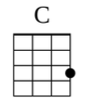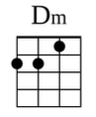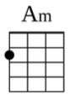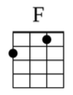

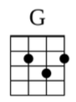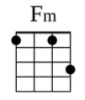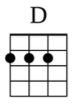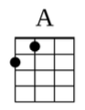

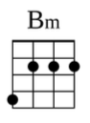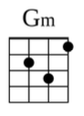

**C Dm**

I know, everybody on this island

**Am**

Seems so happy on this island

**F**

Everything is by design

**C Dm**

I know, everybody on this island

**Am**

Has a role on this island

**F**

So maybe I can roll with mine

**Am**

I can lead with pride, I can make us strong

**G**

I'll be satisfied if I play along

**C**

But the voice inside sings a different song

**Fm** **↓**

What is wrong with me?

*(Chorus)*

**C G**

See the light as it shines on the sea? It's blinding

**Am F**

But no one knows, how deep it goes

**C G**

And it seems like it's calling out to me, so come find me

**Am F**

And let me know, what's beyond that line, will I cross that line?

**D A**

See the line where the sky meets the sea? It calls me

**Bm G**

And no one knows, how far it goes

**D A**

If the wind in my sail on the sea stays behind me

**Bm Gm D**

One day I'll know, how far I'll go

