**How Long – Charlie Puth**

Am G

I'll admit, I was wrong

F Em

What else can I say, girl?

Am G F Em

Can't you blame my head and not my heart?

Am G F Em

I was drunk, I was gone, that don't make it right

Am G F Em

But I promise there were no feelings involved

*[Pre-Chorus]*

Riff:

(Low G)

xA|------------------------------|

xE|------------------------------|

xC|------------------------------|

xG|--2----2---4----4----5-4---2--|

"How long has this been going on?"

(High G)

xA|--0----0---2----2----3-2---0--|

xE|------------------------------|

xC|------------------------------|

xG|------------------------------|

"How long has this been going on?"

Am G F

She said, boy, tell me honestly

Em

Was it real or just for show? Yeah

Am G F

She said, save your apologies

Em

Baby, I just gotta know

*[Chorus]*

Am G F Em

How long has this been going on?

Am G

You've been creeping 'round on me

F Em

While you're calling me baby

Am G F Em

How long has this been going on?

Strum Patterns To Try:

1) **D U X D**

1 + 2 + 3 + 4 +

2) **D U U D U**

1 + 2 + 3 + 4 +

Am G

You've been acting so shady

F Em

I've been feeling it lately, baby

Am G F Em Am G F Em

Oooo ooo-oo, Oooo ooo-oo

Am G

I'll admit, it's my fault

F Em

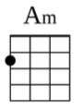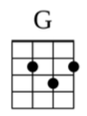

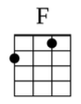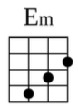

But you gotta believe me

Am G F Em

When I say it only happened once

Am G F Em

I tried and I tried, but you'll never see that

Am G F Em

You're the only one I wanna love, ooh, yeah

*[Repeat Pre-Chorus & Chorus]*