**Love Story – Taylor Swift**

**[C]** We were both young when I first saw you

**[G]** I close my eyes and the flashback starts

I'm standing **[Am]** there on a balcony in **[F]** summer air

**[C]** See the lights, see the party the ball gowns

**[G]** See you make your way through the crowd

And say **[Am]** hello, little did I **[F]** know

That **[Am]** you were Romeo you were **[F]** throwing pebbles

And my **[C]** daddy said stay away from **[G]** Juliet

And I was **[Am]** crying on the staircase

**[F]** Begging you please don't **[C]** go, **[G]** and I said

***[Chorus]***

**[C]** Romeo take me somewhere we can be alone

**[G]** I'll be waiting - all that's left to do is run

**[Am]** You'll be the prince and I'll be the princess

**[F]** It's a love story baby just say **[C]** yes

**[C]** So I sneak out to the garden to see you

**[G]** We keep quiet because we're dead if they knew

So close your **[Am]** eyes

Escape this town for a **[F]** little while

Cause **[Am]** you were Romeo I was a **[F]** scarlet letter

And my **[C]** daddy said stay away from **[G]** Juliet

But you **[Am]** were everything to me

And I was **[F]** begging you please don't **[C]** go **[G]** and I said

***(Repeat Chorus)***

**[C]** Romeo save me, they're tryin' to tell me how to feel

**[G]** This love is difficult, but it's real

**[Am]** Don’t be afraid, we'll make it out of this mess

**[F]** It's a love story baby just say **[C]** yes

**[G]** Oh, **[Am]** oh **[F]**

I got tired of **[Am]** waiting,

**[F]** Wondering if **[C]** you were ever coming a**[G]**round

My faith in you was **[Am]** fad**[F]**ing

When I **[C]** met you on the outskirts of **[G]** town and I said

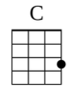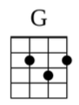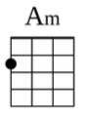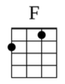

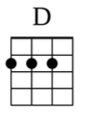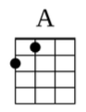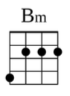

**[C]** Romeo save me I've been feeling so alone

**[G]** I keep waiting for you but you never come

Is **[Am]** this in my head, I don't know what to think

He **[F]** knelt to the ground and pulled out a ring and said

**[D]** Marry me Juliet you'll never have to be alone

I **[A]** love you and that's all I really know

I **[Bm]** talked to your dad go pick out a white dress

**[G]** It's a love story baby just say **[D]** yes

**[A]** Oh, **[Bm]** oh, **[G]** we were both young when I first saw **[D]** you